Data Analysis with AI Internship
PROJECT REPORT
AI-Powered Student Performance Analysis and Prediction System Using Python and Machine Learning
Submitted by
Dhruv (Modi Dhruv Bhaveshbhai)
B.Tech Mechanical Engineering, Government Engineering College, Patan
B.Sc. AI & Data Science, IIT Jodhpur
Technologies: Python · Pandas · NumPy · Matplotlib · Seaborn · Scikit-learn · SciPy · Streamlit · Joblib · Git/GitHub

Contents
1. Abstract
2. Introduction
3. Dataset
4. Tools and Project Structure
5. Data Cleaning and Preprocessing
6. Exploratory Data Analysis
7. Statistical Analysis
8. Feature Engineering and Leakage Control
9. Machine Learning
10. Prediction Function and Dashboard
11. Limitations, Ethics and Future Work
12. Conclusion
13. How to Run
14. References

1. Abstract
This project analyses a public student-performance dataset (395 students, 33 columns) and builds a regression model that estimates a student's final mathematics grade (G3, scale 0–20). The full workflow is covered: data collection, cleaning, exploratory analysis, statistical testing, feature engineering, machine learning, a validated prediction function and an interactive Streamlit dashboard.
- When earlier grades (G1, G2) are available, the selected model (Gradient Boosting) estimates the final grade with a test MAE of 1.06 grade points and R² of 0.85.
- Without earlier grades, predictive power is limited (best test R² = 0.23); habits and background alone explain little.
- All results are associations from observational data. Predictions are estimates, not guarantees.

2. Introduction

2.1 Problem statement
Schools collect attendance, study habits, earlier marks and final results, but raw tables do not directly provide insight. This project analyses student data to discover patterns associated with academic performance, to help identify students who may benefit from extra support, and to develop a model that estimates examination scores.

2.2 Objectives
- Collect and load a credible public dataset with Pandas.
- Inspect, validate and clean the data; separate raw and cleaned copies.
- Perform EDA, descriptive statistics and hypothesis tests; create professional charts.
- Build and compare regression models (baseline, linear, random forest, gradient boosting).
- Provide a reusable prediction function and an interactive dashboard.
- Document limitations, ethics and future improvements.

3. Dataset
- Name: Student Performance (Mathematics file student-mat.csv)
- Source: UCI Machine Learning Repository, dataset 320 — https://archive.ics.uci.edu/dataset/320/student+performance
- Origin: P. Cortez and A. Silva (2008), two Portuguese secondary schools.
- Size (from the loaded file): 395 rows × 33 columns (16 numeric, 17 categorical).
- Target: G3 — final grade, integer 0–20.
- Licence: listed on the UCI page as CC BY 4.0 (attribution required); re-check the page before redistributing.
- Reproducible loading: the code tries the official UCI zip, then a public mirror of the same file, then asks for a manual CSV placed in data/raw/. The mirror was used while building this project because the UCI host was not reachable from the build environment.

Table 1. Key columns
Column | Meaning
G1, G2 | First- and second-period grades (0–20)
G3 (target) | Final grade (0–20)
studytime | Weekly study group: 1 = <2 h, 2 = 2–5 h, 3 = 5–10 h, 4 = >10 h
failures | Past class failures (0–3)
absences | Number of school absences (0–93)
schoolsup / famsup / paid | Extra school support / family support / paid classes
higher | Wants to pursue higher education
Medu, Fedu | Parents' education level (0–4)
goout, Dalc, Walc, freetime, famrel, health | Lifestyle ratings on 1–5 scales

Important: the dataset has no attendance percentage and no study-hours column. These were not invented; absences and the studytime group are used instead.

4. Tools and Project Structure
- Python, Pandas, NumPy — data handling.
- Matplotlib, Seaborn — visualisation. SciPy — statistical tests.
- Scikit-learn — pipelines, models, validation, permutation importance. Joblib — saving models.
- Streamlit — dashboard. pytest — automated checks (11 tests pass). Git/GitHub — version control.
- Structure: data/raw and data/processed, notebooks/, src/ (data_cleaning, eda, train_model, predict), models/, visualizations/, dashboard/app.py, reports/, tests/.
- The notebook imports the same src/ modules, so there is a single version of the logic.

5. Data Cleaning and Preprocessing
Checks were run column by column and compared against the data dictionary.
Table 2. Before-and-after cleaning summary
Measure | Before | After
rows | 395 | 395
columns | 33 | 33
missing_values | 0 | 0
duplicate_rows | 0 | 0

- Missing values: none found, so no imputation was needed. The modelling pipeline still includes imputers fitted on training data only.
- Duplicates: none. Invalid labels and out-of-range numbers: none.
- Outliers were flagged with boxplots and the IQR rule: 15 students with high absences (max 75) and 1 older student (22). These are plausible, so they were kept.
- Zero grades: 38 students have G3 = 0. They are kept but investigated (Section 6.3).
- Categorical features are one-hot encoded and numeric features scaled inside the scikit-learn pipeline, which prevents data leakage.
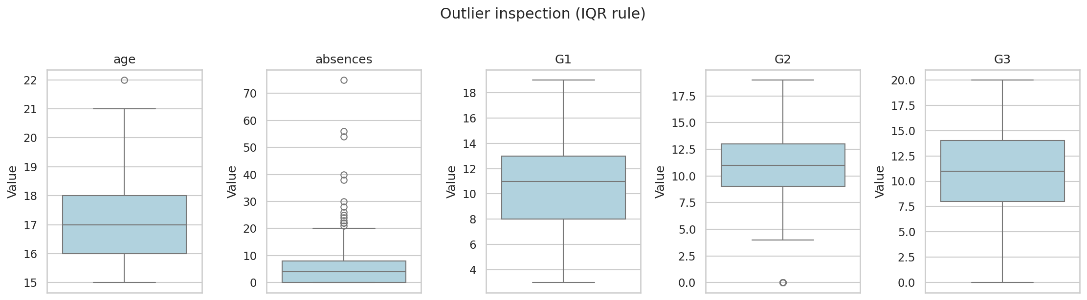
Figure 1. Outlier inspection with boxplots

6. Exploratory Data Analysis

6.1 Univariate analysis
Table 3. Descriptive statistics of key numeric variables
Variable | Count | Mean | Median | Mode | Std | Min | Max | Skew
age | 395 | 16.7 | 17 | 16 | 1.28 | 15 | 22 | 0.47
studytime | 395 | 2.04 | 2 | 2 | 0.84 | 1 | 4 | 0.63
failures | 395 | 0.33 | 0 | 0 | 0.74 | 0 | 3 | 2.39
absences | 395 | 5.71 | 4 | 0 | 8 | 0 | 75 | 3.67
G1 | 395 | 10.91 | 11 | 10 | 3.32 | 3 | 19 | 0.24
G2 | 395 | 10.71 | 11 | 9 | 3.76 | 0 | 19 | -0.43
G3 | 395 | 10.42 | 11 | 10 | 4.58 | 0 | 20 | -0.73

- Average final grade: 10.42 (95% CI 9.96–10.87); median 11; standard deviation 4.58.
- Distribution: left-skewed with a spike at 0; 67.1% have G3 ≥ 10. Shapiro–Wilk p < 0.001, so G3 is not normal and rank-based tests are used.
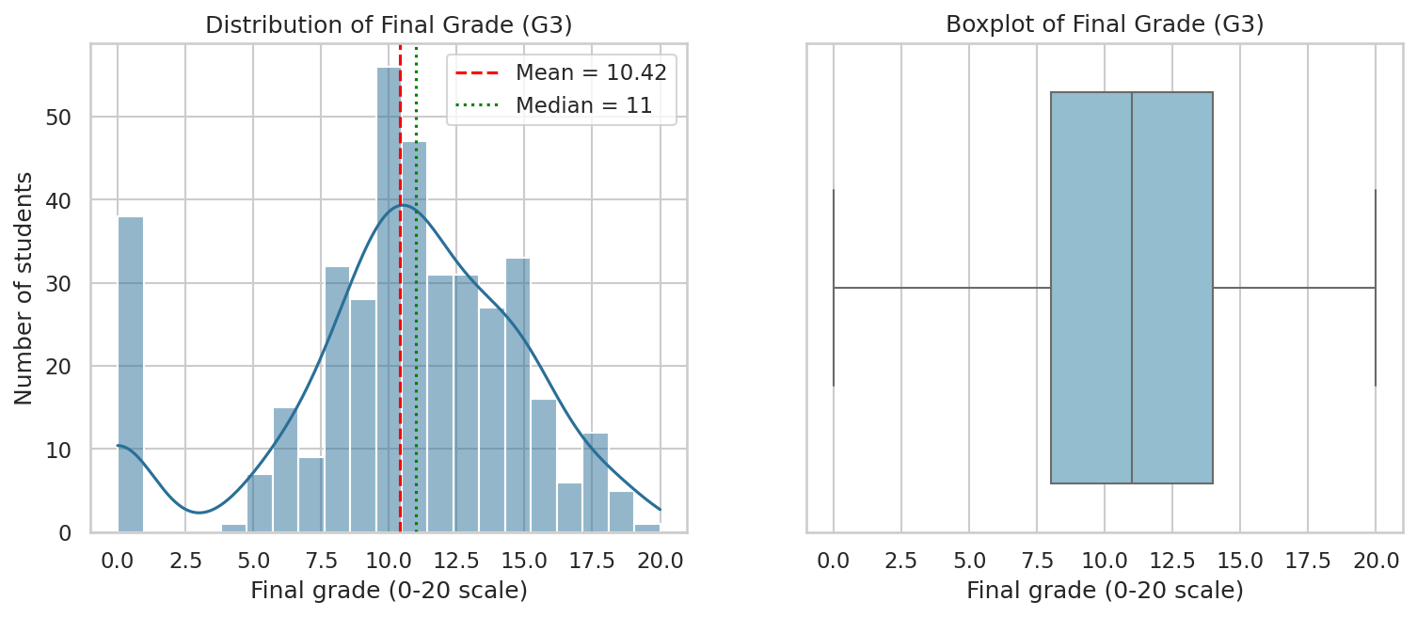
Figure 2. Distribution of the final grade (G3)
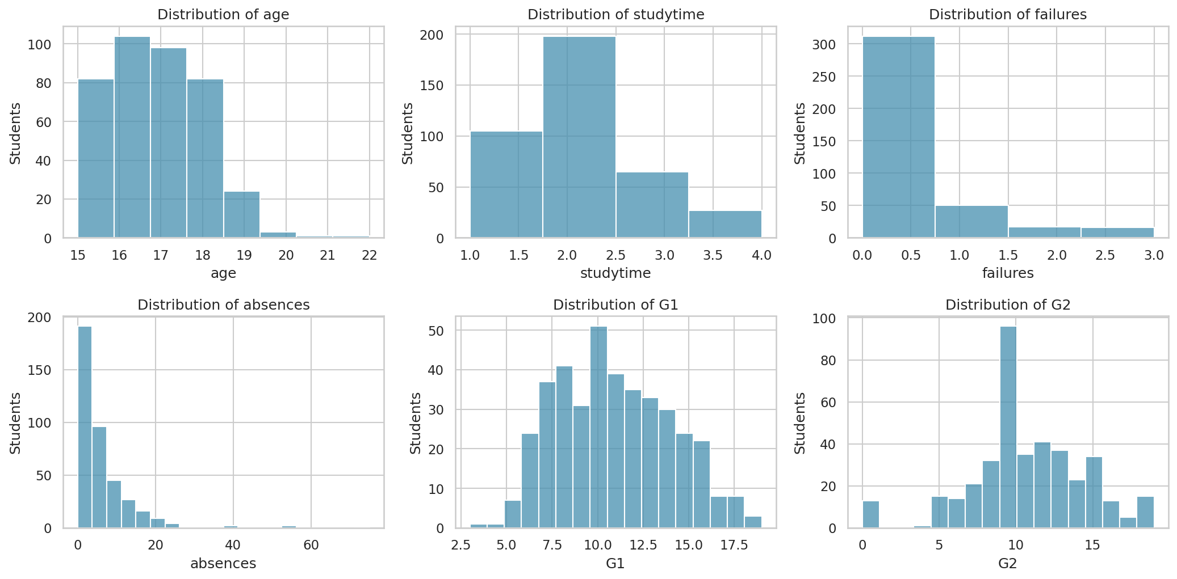
Figure 3. Distributions of key numeric variables

6.2 Bivariate and multivariate analysis
- G1 and G2 track G3 very closely — they will dominate any model that uses them.
- Absences show almost no linear relationship with G3 (explained in 6.3).
- Implication: students whose grades drop between periods are clear early targets for support.
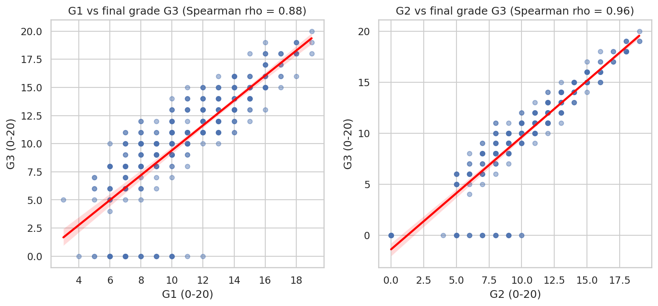
Figure 4. Earlier grades versus final grade
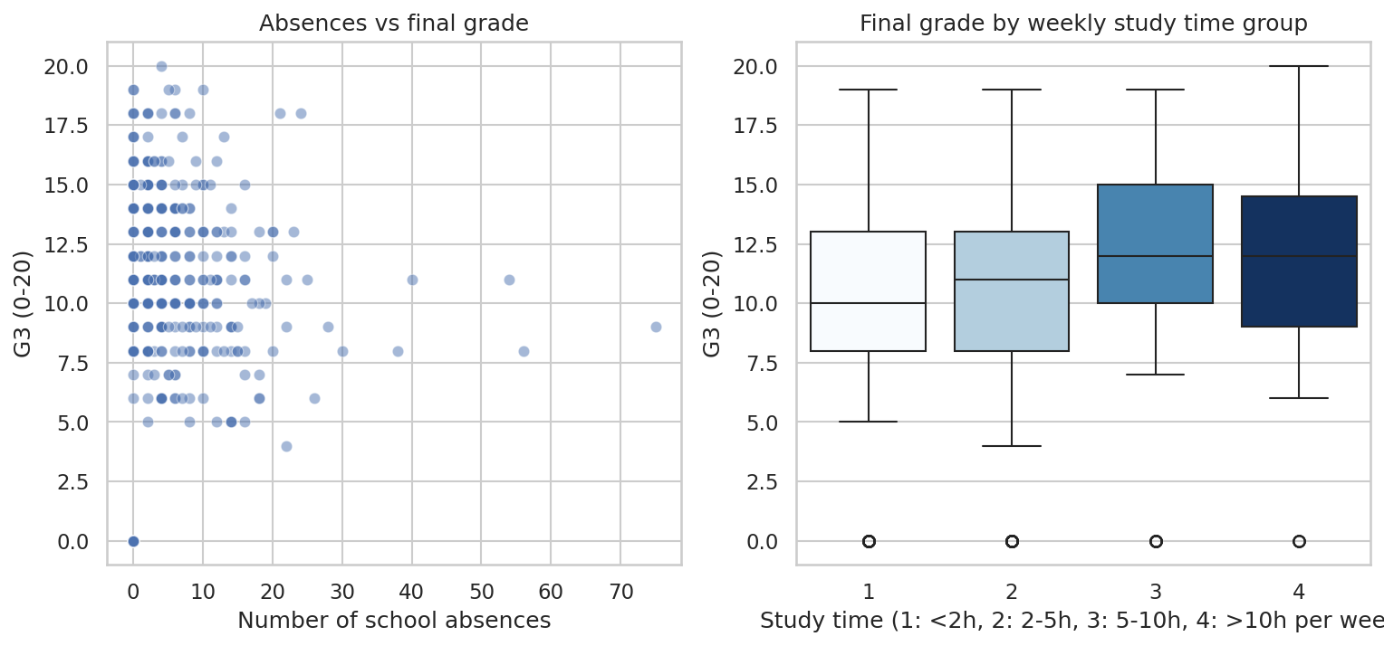
Figure 5. Absences and study time versus final grade
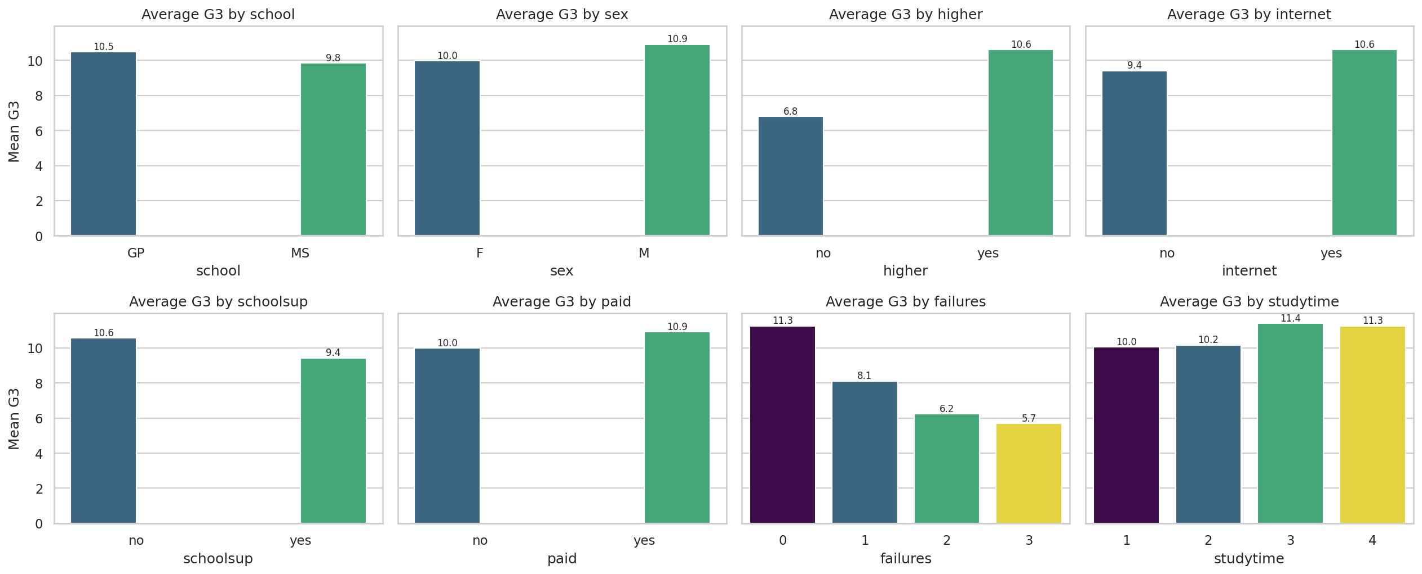
Figure 6. Average final grade by group
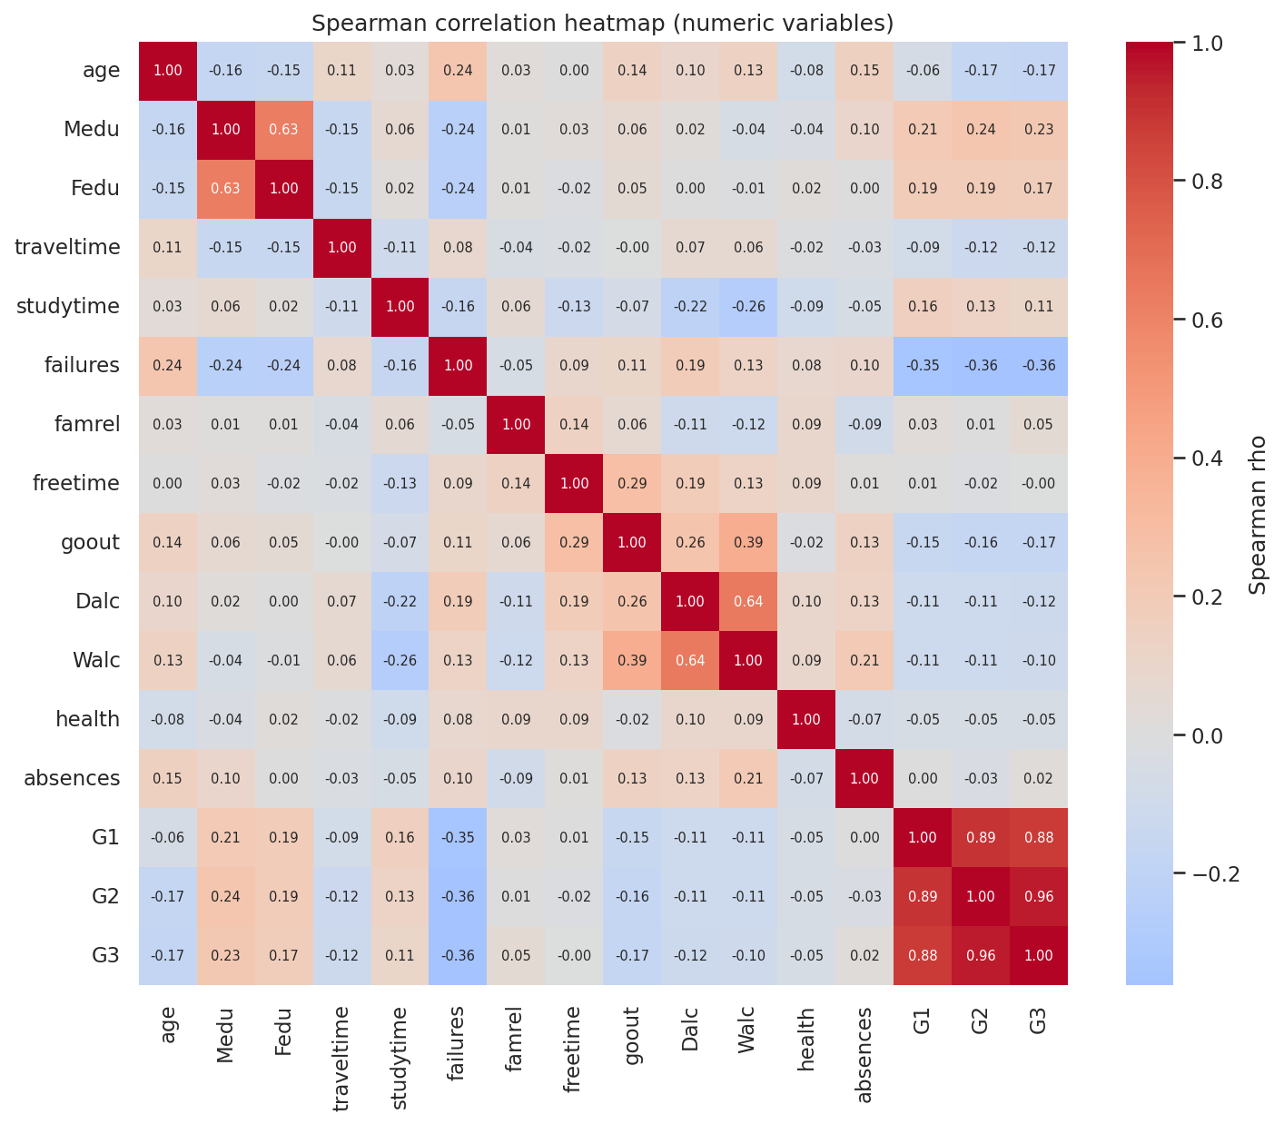
Figure 7. Spearman correlation heatmap

6.3 Students with a final grade of 0
Table 4. Average values: students with G3 = 0 versus the rest
Group | G1 | G2 | absences | failures | studytime
G3 = 0 | 7.53 | 4.66 | 0.00 | 0.92 | 1.97
G3 > 0 | 11.27 | 11.36 | 6.32 | 0.27 | 2.04

- All 38 students with G3 = 0 have exactly 0 absences and a very low G2 (about 4.7 versus 11.4).
- This pattern fits students who left or did not take the final assessment better than students who simply scored badly. This is an inference, not a confirmed fact.
- It explains why absences helps the model despite a near-zero correlation: the effect is non-linear.
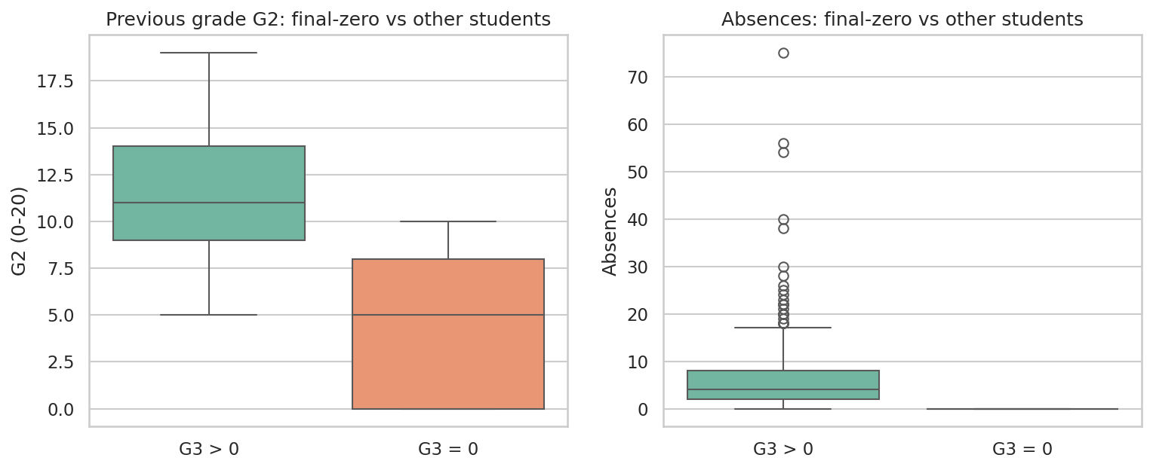
Figure 8. Zero-grade students compared with the rest

6.4 Confounding check
- Study time has only a weak overall association with G3 (Spearman ρ ≈ 0.1).
- Within each earlier-grade band the lines are roughly flat, so no clear study-time pattern remains once prior achievement is held roughly constant.
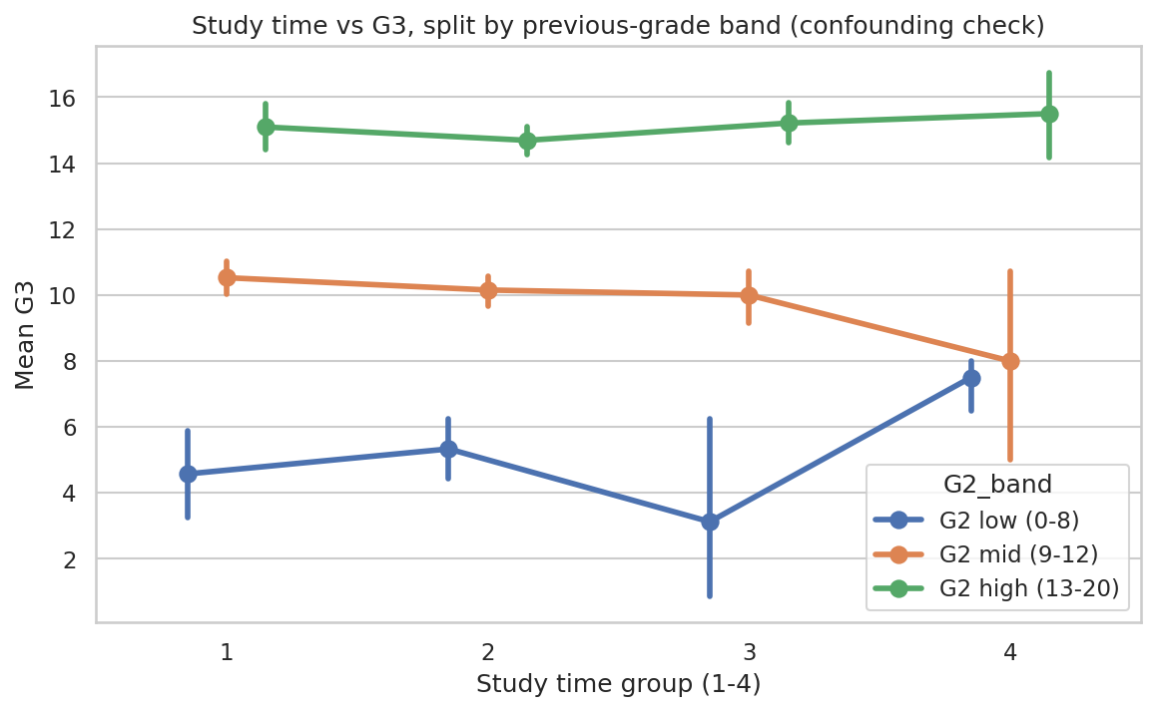
Figure 9. Study time versus G3, split by previous-grade band

7. Statistical Analysis
- Spearman correlation (ranks) is used because grades are bounded and G3 is not normal.
- Mann–Whitney U compares two groups; Kruskal–Wallis compares three or more.
- Effect sizes (Cohen's d, epsilon-squared) show practical importance; p-values only show statistical evidence.
- A Bonferroni-style flag is included because many tests were run and some will look significant by chance.
Table 5. Strongest Spearman correlations with G3
Feature | Spearman ρ | p-value | Strength
G2 | 0.957 | 0.0000 | strong
G1 | 0.878 | 0.0000 | strong
failures | -0.361 | 0.0000 | moderate
Medu | 0.225 | 0.0000 | weak
age | -0.173 | 0.0005 | weak
Fedu | 0.170 | 0.0007 | weak
goout | -0.166 | 0.0009 | weak
Dalc | -0.121 | 0.0162 | weak

Table 6. Largest binary-group differences in G3 (Mann–Whitney U)
Feature | Groups (A vs B) | Mean G3 (A / B) | Cohen's d | p-value | Survives Bonferroni
higher | no vs yes | 6.80 / 10.61 | 0.84 | 0.0006 | Yes
schoolsup | no vs yes | 10.56 / 9.43 | -0.25 | 0.0028 | Yes
address | R vs U | 9.51 / 10.67 | 0.25 | 0.0178 | No
internet | no vs yes | 9.41 / 10.62 | 0.26 | 0.0324 | No
sex | F vs M | 9.97 / 10.91 | 0.21 | 0.0407 | No

Table 7. Multi-level groups (Kruskal–Wallis)
Feature | H | p-value | Epsilon²
failures | 53.1 | 0.0000 | 0.128
Medu | 23.1 | 0.0000 | 0.051
Fedu | 14.1 | 0.0028 | 0.028
Mjob | 16.1 | 0.0029 | 0.031

- Failures is the strongest non-grade feature (moderate, negative). Parental education is weakly positive.
- higher = no has the largest gap, but only 20 students are in that group, so it must be treated with care.
- Sex, address and internet differences are small (d ≈ 0.2) and do not survive the multiple-testing check.
- These are associations only; nothing here proves that one factor causes higher marks.

8. Feature Engineering and Leakage Control
- Scenario A (with earlier grades): habits, background, G1, G2 and grade_trend = G2 − G1.
- Scenario B (early warning): habits and background only, no grades.
- G3 is never an input. Scenario B excludes G1 and G2, so it is a fair test without grades.
- Excluded for fairness: sex, address, family size, parents' cohabitation, parents' jobs, guardian, romantic status, nursery and school-choice reason. Predictions should not penalise family or personal circumstances.
- Split: 80% training (316 students), 20% test (79 students), random seed 42.

9. Machine Learning

9.1 Method
- Four models on the same split and the same 5-fold cross-validation: Dummy baseline, Linear Regression, Random Forest, Gradient Boosting.
- Each model is a scikit-learn Pipeline (imputer, scaler, one-hot encoder, estimator).
- Random Forest and Gradient Boosting were tuned with grid search on the training set only.
- The final model is chosen by cross-validation RMSE. The test set is evaluated once afterwards.
- Metrics: MAE (average error in grade points), RMSE (penalises large misses), R² (share of variance explained; ≤ 0 means no better than the mean).

9.2 Scenario A — with earlier grades
Table 8. Model comparison, Scenario A (CV = cross-validation on training data)
Model | CV RMSE | Test MAE | Test RMSE | Test R²
Dummy (mean baseline) | 4.56 | 3.65 | 4.55 | -0.01
Linear Regression | 1.88 | 1.44 | 2.19 | 0.77
Random Forest | 1.59 | 1.04 | 1.69 | 0.86
Gradient Boosting | 1.58 | 1.06 | 1.76 | 0.85

- Selected: Gradient Boosting (lowest CV RMSE). Test MAE 1.06, RMSE 1.76, R² 0.85.
- Random Forest and Gradient Boosting are nearly tied. Random Forest has slightly lower test error, but the test set is only 79 students, so this gap is not meaningful.
- Both ensembles cut the baseline error by well over half. Linear Regression is a reasonable but weaker model.
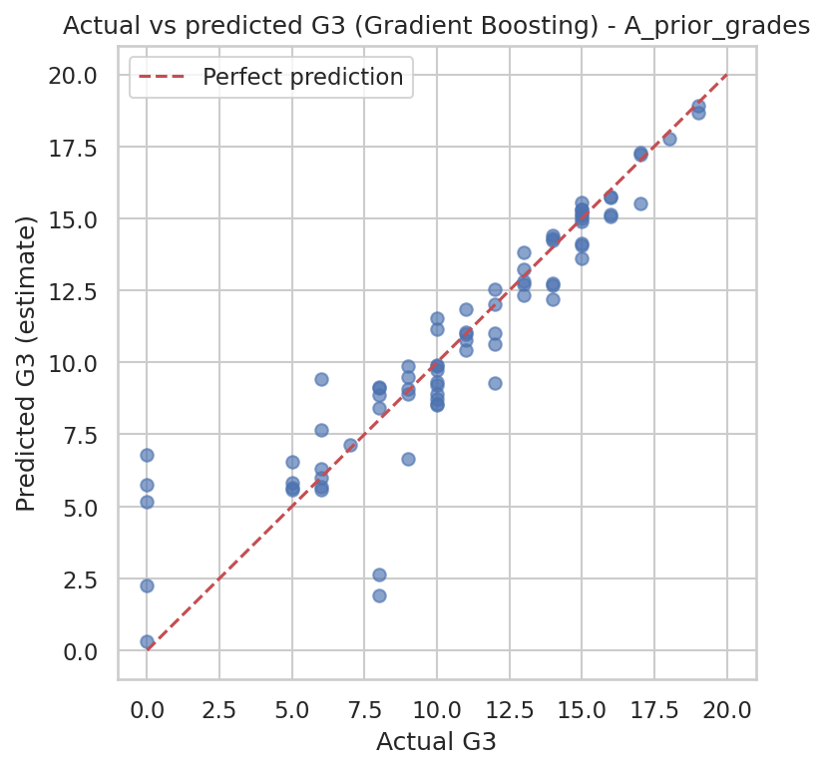
Figure 10. Actual versus predicted G3, Scenario A
Table 9. Permutation importance, Scenario A (increase in RMSE when shuffled)
Feature | Importance
G2 | 3.769
absences | 0.707
G1 | 0.151
famrel | 0.029
age | 0.028
activities | 0.016

- G2 dominates. Absences ranks second because of the zero-grade pattern, not because absences cause lower marks.

9.3 Scenario B — early warning (no grades)
Table 10. Model comparison, Scenario B
Model | CV RMSE | Test MAE | Test RMSE | Test R²
Dummy (mean baseline) | 4.56 | 3.65 | 4.55 | -0.01
Linear Regression | 4.39 | 3.72 | 4.44 | 0.04
Random Forest | 3.94 | 3.27 | 3.97 | 0.23
Gradient Boosting | 3.98 | 3.43 | 4.19 | 0.15

- Selected: Random Forest (lowest CV RMSE). Test MAE 3.27, RMSE 3.97, R² 0.23.
- Without grades the model is only modestly better than the baseline. This is an honest limitation: habits and background alone are weak predictors in this dataset.
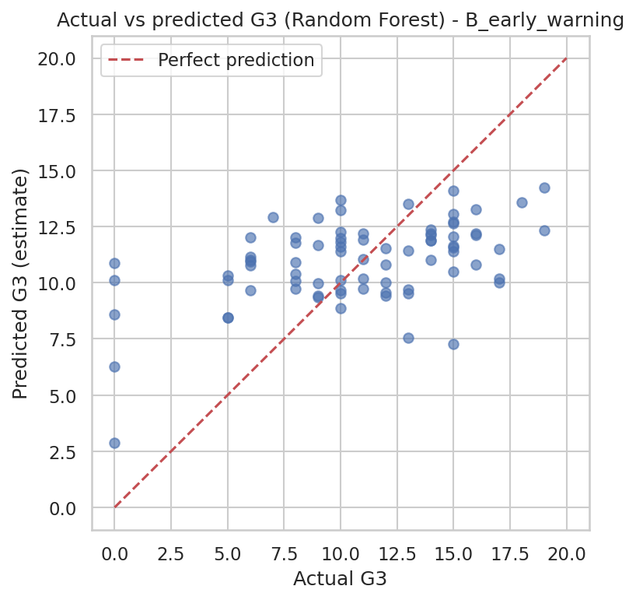
Figure 11. Actual versus predicted G3, Scenario B
Table 11. Permutation importance, Scenario B
Feature | Importance
failures | 0.583
absences | 0.491
goout | 0.233
age | 0.107
schoolsup | 0.093
Medu | 0.076

- Feature importance measures predictive contribution only. It does not show that changing a feature would change a student's grade.

10. Prediction Function and Dashboard

10.1 Prediction function
- predict_score(features, scenario) validates types and ranges, applies the saved pipeline and returns an estimate between 0 and 20.
- Invalid or missing inputs return a clear message instead of an error; the model is never retrained at prediction time.
- Automated tests cover valid input, wrong ranges, wrong labels, wrong types and missing fields.

10.2 Streamlit dashboard
- Overview: records, features, mean and median G3, summary statistics.
- Data Explorer: filters, column selection, numeric/categorical summaries, missing-value summary.
- Visual Analytics: distributions, relationships, group comparisons, correlation heatmap.
- Statistical Insights, Model Performance and Predict a Score pages.
- Run with: streamlit run dashboard/app.py

11. Limitations, Ethics and Future Work

11.1 Limitations
- Small sample: 395 students, two schools, one subject; results may not generalise.
- Small test set (79 students): metrics are uncertain and small model differences are not meaningful.
- No attendance percentage or exact study hours.
- Likely dropouts (G3 = 0) are hard to predict and affect every metric.
- Scenario A mostly says the final grade will resemble the last grade (G2).

11.2 Ethical considerations
- Estimates are for starting supportive conversations, never for labelling, grouping or penalising students.
- Sensitive and family attributes were excluded from the models.
- Correlation is not causation; importance scores are not causes.

11.3 Future work
- More data and repeated cross-validation for tighter estimates.
- A two-stage model (will the student sit the exam? then, what grade?).
- Fairness audit of prediction errors across groups; prediction intervals.
- Add the Portuguese-language file and real attendance data.

12. Conclusion
The project delivers the complete workflow from raw data to an interactive dashboard. Earlier grades allow reasonably accurate estimates, while habits and background alone do not. Reporting both results, the zero-grade finding and the limits openly is part of using data analysis responsibly.

13. How to Run
- pip install -r requirements.txt
- Open the notebook Dhruv_StudentPerformanceAnalysis.ipynb and run all cells; or run python -m src.data_cleaning, python -m src.eda, python -m src.train_model.
- streamlit run dashboard/app.py for the dashboard; pytest -q for the tests.

14. References
- Cortez, P., & Silva, A. (2008). Using data mining to predict secondary school student performance. In Proceedings of the 5th Future Business Technology Conference (FUBUTEC 2008), pp. 5–12.
- UCI Machine Learning Repository: Student Performance dataset — https://archive.ics.uci.edu/dataset/320/student+performance
- Pedregosa et al. (2011). Scikit-learn: Machine Learning in Python. Journal of Machine Learning Research, 12, 2825–2830.
Citation details above are given from memory; please verify them before submission.

