Week 1 Report: Foundations of CAD Design
CAD Design Intern | Skills: AutoCAD, SolidWorks, Drafting
Name: Modi Dhruv Bhaveshbhai
Programme: B.Tech Mechanical Engineering, Government Engineering College, Patan
Task: Week 1 - Foundations of CAD Design

1. Introduction
Computer-Aided Design (CAD) is the use of software to create, modify, analyse and document designs. It replaces manual drawing boards with precise digital models. In mechanical engineering, CAD is used for parts, assemblies, manufacturing drawings and simulation. This week I studied the core concepts, installed the tools and learned how professionals structure their CAD work.

2. Fundamentals of CAD

2.1 2D CAD vs 3D CAD
- 2D CAD: Flat drawings made of lines, arcs and circles. Used for plans, layouts and manufacturing drawings.
- 3D CAD: Solid models with volume, mass and material properties. Used for parts, assemblies and simulation.
- Workflow link: 2D drawings are usually generated from the 3D model for shop-floor use.

2.2 Core CAD concepts
- Sketches and constraints: 2D profiles with geometric relations (horizontal, tangent, concentric) and dimensions.
- Features: Extrude, revolve, sweep, loft, fillet, chamfer, hole and pattern.
- Assemblies: Parts are combined using mates (coincident, concentric, distance).
- Parametric design: Parametric modelling means changing a dimension updates the whole model.
- History-based modelling: A feature tree records the order of operations so the design can be edited later.

2.3 Drafting fundamentals
- Orthographic projection: Front, top and side views using first-angle or third-angle projection.
- Section views: Used to show internal details of a part.
- Dimensioning: Clear, non-repeated dimensions following standards such as ISO and ASME Y14.5.
- Tolerances: Linear, limit and geometric tolerances (GD&T) define allowed variation.
- Drawing sheet elements: Title block, scale, units, line types, layers and revision details.

3. Tools Studied
Tool | Main use | What I practised
AutoCAD | 2D drafting and detailing | Lines, circles, offset, trim, layers, dimension styles
SolidWorks | 3D part and assembly modelling | Sketches, extrude/cut, fillet, assembly mates, drawing views
Drafting standards | Communicating design to manufacturing | Views, dimensions, tolerances, title blocks

4. Setting Up the Environment
- Step 1: Checked system requirements (64-bit OS, adequate RAM, dedicated graphics preferred).
- Step 2: Installed AutoCAD (student/educational version) and SolidWorks Premium 2024 SP1.0.
- Step 3: Set units to millimetres, created drawing templates, and configured layers and dimension styles.
- Step 4: Set up SolidWorks document properties (MMGS units, ISO drafting standard) and a standard part template.
- Step 5: Created a project folder structure for parts, assemblies, drawings and exports.
- Step 6: Opened both tools and created a test sketch to confirm the setup works.

5. How Professionals Work
- Start from design requirements and constraints before opening the software.
- Sketch fully constrained profiles so models stay stable when edited.
- Name features, layers and files clearly and follow company standards.
- Use version control or revision tables for every drawing change.
- Reuse standard parts (fasteners, bearings) from libraries instead of redrawing.
- Review models and drawings for errors before release to manufacturing.
- Export in standard formats (STEP, DXF, PDF) for sharing with other teams.

6. Practice Exercise
- Drew a simple plate with holes in AutoCAD using layers and dimensions.
- Modelled the same plate in SolidWorks using extrude, cut and fillet features.
- Created a fully defined test sketch, the Slotted Link Plate (see Section 7), with a 20 mm hole, a 12 mm slot, R15, R30 and R50 arcs and linear dimensions.
- Generated a 2D drawing from the 3D model with front, top and side views.

7. Screenshot of Working Setup
The screenshot shows SOLIDWORKS Premium 2024 SP1.0 working in the MMGS unit system. The test sketch, Sketch3 of Slotted Link Plate.SLDPRT, is drawn on the Top Plane and is Fully Defined, as shown in the status bar.
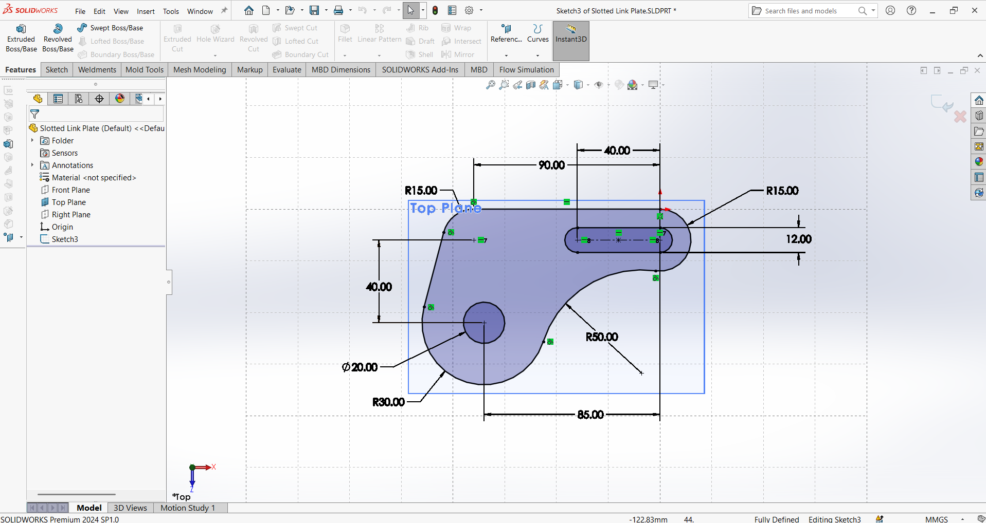
Figure 1: Working SolidWorks setup with the Slotted Link Plate test sketch

8. Key Learnings and Next Steps
- CAD is about design intent, not just drawing shapes.
- Constraints and clear structure make models easy to edit.
- Good drafting practice is as important as good modelling.
- Next: more complex parts, assemblies, and tolerance and GD&T practice.

