Project Name |  | Confidentiality Level
yhDBMS Project |  | For Recipients’ Reference Only
Project ID | Version | Document Code

yhDBMS Software Requirements Specification



Copyright © Ruankosoft Technologies(Shenzhen), Co., Ltd.
. All Rights Reserved
Revision Record
Date | Revision Version | CR ID /Defect ID | Sec No. | Change Description | Author
2017.  4.26 | Project Start  report |  |  | 何瑾月 | 何瑾月
2017.  4.27 | Software  Project  Planning |  |  | 闫小坤 | 闫小坤
2017.  4.28 | Software  Requirement |  |  | 何瑾月 | 何瑾月
2017.  4.29 | System  Design  Stage |  |  | 闫小坤 | 闫小坤
2017.  5.1 | Create  Project |  |  | 何瑾月 | 何瑾月
2017.  5.4 | Interface design |  |  | 何瑾月 | 何瑾月
2017.  5.6 | Data  Structure  Design |  |  | 闫小坤 | 闫小坤
2017.  5.8 | DML |  |  | 何瑾月 | 何瑾月
2017.  5.10 | DCL |  |  | 闫小坤 | 闫小坤
2017.  5.12 | Exception  Handing |  |  | 何瑾月 | 何瑾月
Content
1 Introduction 6
1.1 Purpose 6
1.2 Scope 6
2 General description 6
2.1 Software perspective 6
2.1.1 About the Project 6
2.1.2 Environment of Product 6
2.2 Software function 6
2.3 Actors 6
2.4 User characteristics 6
2.5 Assumptions & Dependencies 7
2.6 System Use Case 7
2.7 Sub-module Functional Requirements 1 7
2.7.1 Functional Requirements1 7
2.7.2 Functional Requirements2 8
2.8 Sub-module Functional Requirements2 9
2.8.1 Functional Requirements1 9
2.8.2 Functional Requirements2 9
2.9 Data Information 9
3 Interface Requirements 9
3.1 User Interface 9
3.2 Software Interface 10
4 Overall Design Constraints 10
4.1 Hardware Limitations 10
4.2 Technology Limitations 10
5 Software Quality Attributes 10
6 Requirements Classification 10

Abstract:
Database Management, Table Management, Field Management, Data Management
Index Management, Client Management, Transcation Management, Integrity Management
List of abbreviations: Describe abbreviations in this document, full spelling of the abbreviation and Chinese explanation should be provided.
Abbreviations | Full spelling | Chinese explanation
DML | data manipulation language | 数据操作语言，SQL中处理数据等操作统称为数据操纵语言
DCDCL | Data Control Language | 数据控制语言，用来授予或回收访问数据库的某种特权，并控制数据库操纵事务发生的时间及效果，对数据库实行监视等
DDL | data definition language | 数据定义语言，用于定义和管理 SQL 数据库中的所有对象的语言

Introduction

Purpose
1. To obtain kmowledge of business background, and learn the function of‘DBMS’.
2.To understand Microsoft Visual Studio 2013
3.To master++ Fundamental Programming. To master MFC framework,including MFC Dialog ,MFC SDI,Tree View and Basic Controls.
4.To master the DDL function, DML function and DCL function of the DBMS,
5.To understand OS conception, thread and process operation.

Scope
The system is used for win8,win10 system with the application of Microsoft Visual Studio 2012IDE.

General description
YhDBMS is a large-scale software which can manipulate and manage the database. It is used to establish，use and maintain the database, and called DBMS for short .It manages and controls the database in a unified manner to ensure and integrity of the database.

Software perspective

About the Project
This project is determined by the teacher. We team up to complete the project within the specified time.

Environment of Product
Development tool: Microsoft Visual Studio 2012,VC++6.0,etc
Technical application: C++ programming technique, MFC Dialog, MFC SDI, Tree View and OS conception, thread, process and file management.

Software function
Database Management, Table Management, Field Management, Data Management
Index Management, Client Management, Transcation Management, Integrity Management,
Database Maintenance and Security Management

Actors

Team leader: 15301144 He Jinyue

Team number:15301058 Yan Xiaokun

User characteristics
- MFC Dialog,MFC SDI,Tree View,List View and Basic Controls
- The DDL function,DML function and DCL function of the DBMS
- OS conception, thread, process and file management
- Microsoft Visual Studio 2012IDE
- C++ programming language

Assumptions & Dependencies
（1）time-delay We assign deadline to complete the project on time
(2) technical difficulties We can solve programs by watching Video and discuss.

System Use Case

Interface Requirements

User Interface
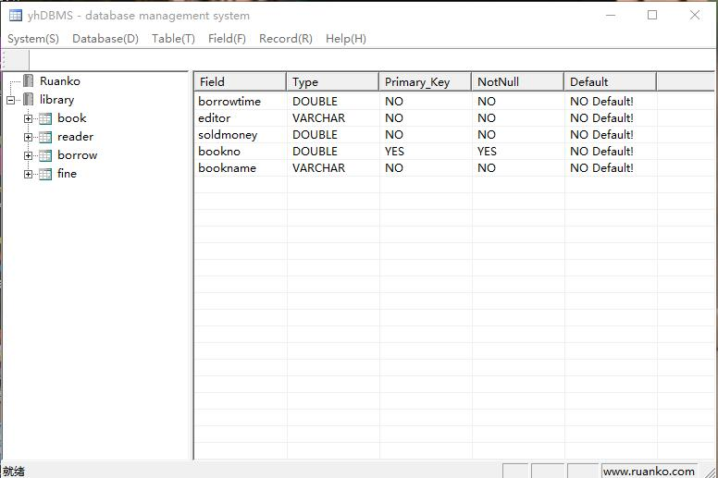

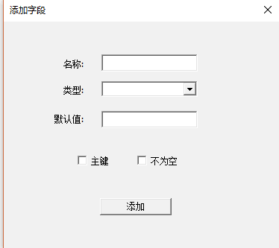

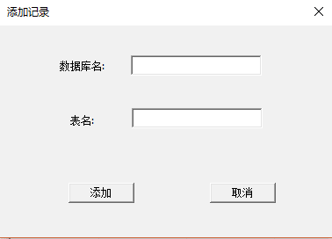

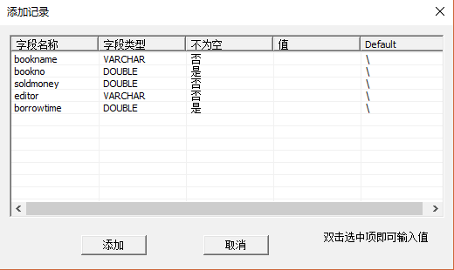

Overall Design Constraints

Hardware Limitations

Win7,win8,win10 system and the computer which needs enough space

Technology Limitations
C++ programming technique, MFC Dialog, MFC SDI, Tree View and OS conception, thread, process and file management.

Software Quality Attributes
Vs2013 or VC++6.0

Requirements Classification
Requirement ID | Requirement Name | Classification
Create DataBase | Mandatory
Open DataBase | Mandatory
Delete DataBase | Mandatory
Add Table | Mandatory
Delete Table | Mandatory
Modify Table | Mandatory
Add Field | Mandatory
Modify Field | Mandatory
Delete Field | Mandatory
Add Reccord | Important
Modify Record | Important
Interface better | Nice to have

