**HTML BASICS**

**Basic Structure of HTML:**

<!DOCTYPE html>

<html>

<head>

<title>Page Title</title>  *<!-- this is your title tag -->*

<meta charset="UTF-8">  *<!-- this is your meta tag -->*

<meta name="viewport" content="width=device-width, initial-scale=1.0">  *<!-- this is your meta tag for responsive design -->*

<link rel="stylesheet" href="style.css">  *<!-- this is your link to the CSS -->*

</head>

<body>

*<!-- Your whole Html should be here. -->*

</body>

</html>

**Imp Note:** *You Have to Follow this structure while writing Html Codes.*

* **Heading and Paragraph Tag:**

**Code:**

<!DOCTYPE html>  
<html>  
<head>  
<title>Page Title</title>  
</head>  
<body>  
  
<h1>This is a Heading</h1>  
<p>This is a paragraph.</p>  
  
</body>  
</html>

**Output:**

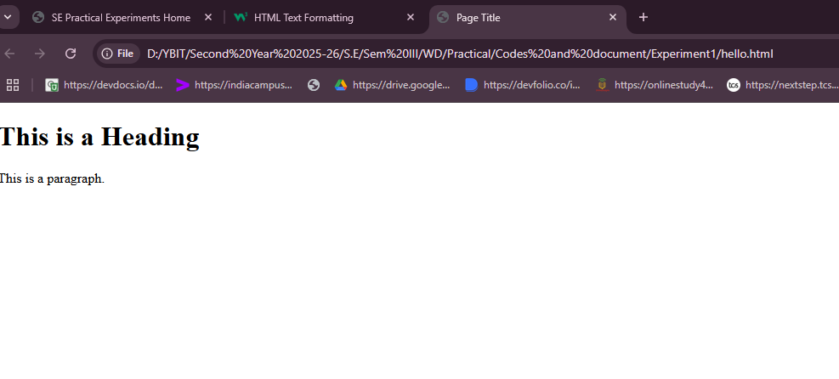

**Try this tag:**

<h2>Heading 2</h2>  
<h3>Heading 3</h3>  
<h4>Heading 4</h4>  
<h5>Heading 5</h5>  
<h6>Heading 6</h6>

* **HTML Text Formatting**
* <b> - Bold text
* <strong> - Important text
* <i> - Italic text
* <em> - Emphasized text
* <mark> - Marked text
* <small> - Smaller text
* <del> - Deleted text
* <ins> - Inserted text
* <sub> - Subscript text
* <sup> - Superscript text

**Code:**