**GROUP PROJECT OUTLINE**

College of Professional Studies

Northeastern University, Boston

**Presented By:** Group 6

ALY6980: Capstone Project

Prof. Roy Wada

Date of Submission: May 15, 2023

# **INTRODUCTION**

The composition of a company's board of directors is a critical factor that can impact on the company's performance. Directors bring diverse skills, experiences, and perspectives to the decision-making process, which can influence the overall direction and success of the company. In recent years, there has been a growing interest in understanding the characteristics of board members and how these characteristics impact company performance.

This analysis is based on data provided by FreeFloatMedia, which includes information about the directors of multiple companies between 2018 and 2023 and their influence on key performance indicators (KPIs) during their tenure. The purpose of this individual project is to explore the relationship between director characteristics and company performance, with a focus on age and gender.

The analysis will begin with a literature review to justify the research structure and methodology. Then, the project will describe the data source and the software platform used for the analysis. Next, the preliminary results of the analysis will be presented, including histograms of director age, the distribution of age by gender, and summary statistics for age by gender.

The findings of this analysis will have important implications for companies in terms of how they select and appoint directors to their boards. By understanding the factors that impact director characteristics and company performance, companies can make informed decisions that lead to better outcomes.

# **ANALYSIS**

The techniques used to explore the data include descriptive statistics, data visualization, and regression analysis. Descriptive statistics were used to summarize the age and gender characteristics of the board of directors, while data visualization techniques such as histograms were used to visualize the distribution of age and age by gender. Regression analysis was used to investigate the relationship between director age and KPIs. While one regression method is checking the relationship between performance indices, we also have other regression methods to analyze the relationship between the directors and the factors that are responsible for producing higher influence than others in the board.

To tackle the sponsor's business question of exploring the relationship between director characteristics and company performance, the analysis focused on age, gender and listed influence factors or drivers as key characteristics. As a team, we have break-down the mentioned factors as our individual research project and try to analyze the data in respective manner to have a holistic view of the data analysis in this provided dataset. Initially, the analysis used descriptive statistics and data visualization techniques to explore the age and gender composition of the board of directors, and regression analysis using Linear Regression paired with statistical correlation to investigate the relationship among the variables. These techniques were used to provide insights into the factors that impact company performance and guide decision-making around board appointments.

The research structure and analytical plan were justified based on a literature review of existing studies on the relationship between director characteristics and company performance. The literature review revealed that age and gender are important factors that impact the composition of the board of directors and have implications for company performance. Additionally, regression analysis was identified as an appropriate technique to investigate the relationship between director characteristics and KPIs. The analytical plan was designed to provide a comprehensive understanding of the factors that impact company performance and guide decision-making around board appointments.

# **PRELIMINARY RESULTS**

**Graph showing the average performance win rate for each performance category for each sector**

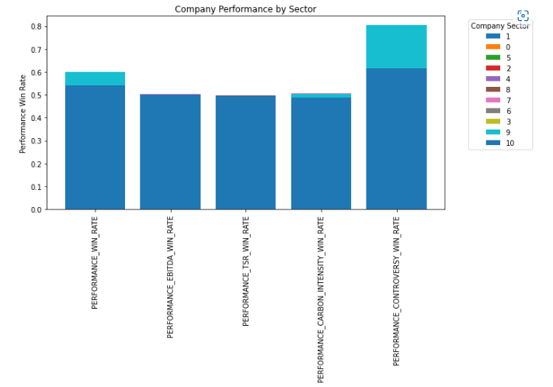

Results:  
 From the above graph we can observe that:

1. The performance win rate is higher for the performance categories of PERFORMANCE_WIN_RATE, PERFORMANCE_EBITDA_WIN_RATE, and PERFORMANCE_TSR_WIN_RATE.
2. The Information Technology sector has the highest win rate for most of the performance categories.
3. The Real Estate sector has the lowest win rate for most of the performance categories.

* **Histogram for the Performance Metrics:**

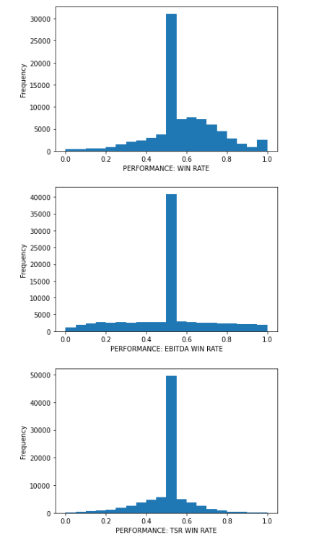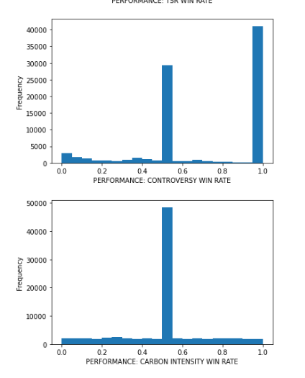

Results:

The histograms show the distribution of each of the five performance metrics columns, with the x-axis representing the value range and the y-axis representing the frequency count. Each column has a range of values from 0 to 1, with higher values indicating better performance. For the performance win rate metric, the highest frequency count is observed for values ranging from 0.45 to 0.5. This suggests that a significant number of companies have a win rate that falls within this range, and that there is a clustering of companies around this range. Similarly, for the performance: controversy win rate metric, the highest frequency count is observed for a value of 1.0, indicating that a significant number of companies have a perfect score on this metric. The second highest frequency count is observed for a value of 0.5, indicating that there is a clustering of companies with a score of 0.5 on this metric. For the majority of the columns, the frequency count is highest for values ranging from 0.45 to 0.5, indicating that there is a clustering of companies around this range for most performance metrics. While we can even observe that the graph is distributed over the entire value range.

* Descriptive Table:



Results:

The table above provides a count of non-numeric variables for each column in a dataset. It includes information on the name and gender of directors, the name, ticker symbol, and domicile of companies, as well as various influence drivers and performance metrics. The table shows the number of unique values for each column and the most frequent value for each column. The dataset contains 86,772 rows and 15 columns. The table indicates that there are 70,389 unique director names and 3 unique genders. Additionally, there are 9,529 unique company names and 8,956 unique ticker symbols. The dataset includes information on influence drivers such as advanced degrees, elite schools, CEO experience, founder-CEO-family connections, committee roles, and board connections. Finally, the performance metrics include win rates for various categories such as overall performance, EBITDA, TSR, carbon intensity, and controversy. The table provides a comprehensive summary of the non-numeric variables in the dataset.

# **CONCLUSION**

At the conclusion of the Capstone project, the team aims to deliver several key outcomes. These include the finalized Tableau dashboard, predictive models that can forecast director performance based on historical data, a comprehensive analysis of the impact of director age and influence metrics on performance, a comparison of director performance metrics across different countries and regions, and recommendations for stakeholders on how to use the dashboard and predictive models for better-informed decision-making regarding director performance and corporate governance. These deliverables will provide valuable insights and tools for stakeholders to improve governance practices and make informed decisions.

To share the work on LinkedIn or an online portfolio while honoring the terms of a non-disclosure agreement (NDA), it is crucial to ensure that no confidential or sensitive information is disclosed. Will focus on highlighting the skills, methodologies, and tools used in the project without revealing specific proprietary information. We will emphasize our contributions to the data analysis process, the insights gained, and the impact of the project on improving corporate governance. We will Avoid mentioning any confidential data, company names, or specific details that may violate the NDA. Instead, we will present our work in a general and informative manner that showcases our expertise and proficiency in data analysis and visualization.

# **REFERENCES**