Report by K B Hall Reporter on the South East Water Board Overview

Introduction
Strategic Management Consultants Limited was appointed to report to Ofwat on South East Water at the end of March 2001. With the review of two June Returns now complete, we have acquired a solid foundation of knowledge of the Company and are well placed for the challenges of the forthcoming price review.

Commentary on the Board Overview

Key outputs and service delivery

Overall performance
South East Water’s overall performance on the key outputs and service delivery shows steady progress on most measures.

Levels of service Indicators
The two water service performance measures, pressure and interruptions, have shown significant improvement in the report year and are at or close to the best reported since the base year, comfortably within the Monitoring Plan targets.

It is reported that all written complaints were dealt with within 10 days despite an increase of 62% in the number. While the Company has suggested that the increase is due to better facilities for making complaints, we have not explored this in our review.

Telephone answering times measured on the same basis as in previous years have improved substantially with 88.8% answered within 30 seconds. In addition, calls abandoned have reduced by nearly an order of magnitude. Performance at JR01 reflected initial problems experienced on outsourcing the call centre in early 2000.

While billing contacts answered in 5 working days (99.4%) have dropped slightly from last year (99.6%), it is still above the industry average at JR01 (99.1%).

Quality improvement programme
Three quality targets were due to be delivered in the report year.

Plumbosolvency control obligations to install water conditioning treatment plants were essentially delivered on time.

There was a shortfall in the section 19, milestone 1, obligation for rehabilitation of distribution mains. After a slow start in 2000-01, the Company has accelerated sharply and achieved its FD target for the report year but did not recover the backlog from the previous year. As resources have been increased significantly, we expect a further acceleration in output in the current year. Plans to catch up on this backlog by 31 December 2003 have been agreed with the DWI.

Improvements at a treatment works where deterioration had resulted in a coliform problem were delivered on time. This was an addition to the agreed quality programme as the problem and obligation arose after PR99.

Serviceability - maintaining service to customers
Serviceability to customers has remained essentially stable over the period.

Expenditure and Financial performance measures
The reasons for the increase in capital expenditure and operating expenditure are summarised appropriately in the Company’s Overview.

Key supporting information

Capital works activity
Lines 13 to 15 of table D show a backlog of work with respect to the monitoring plan target partly due to the shortfall on the quality programme for mains rehabilitation referred to above. The remainder is due to South East Water’s decision to suspend some capital maintenance pending development of its distribution system risk model; this is now complete. With increased resources, we expect to see the backlog reducing and valid judgements on progress should be possible after JR03.

Water balance
The key trends in the water balance are a reduction of distribution input at the same time as an increase in water delivered.

With continued effort, further significant reductions in leakage have been achieved.
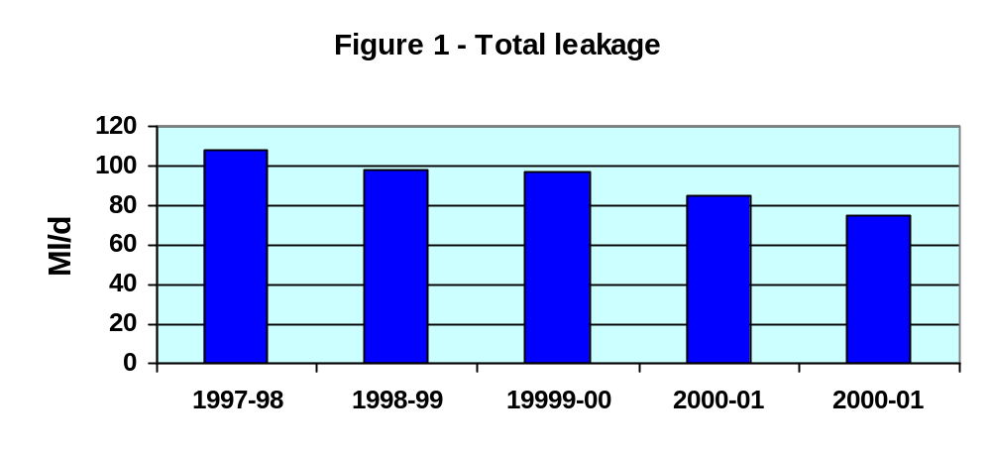

The increase in water delivered is the net effect of an increase in both measured household and non household components with a reduction in the unmeasured household component as shown below.
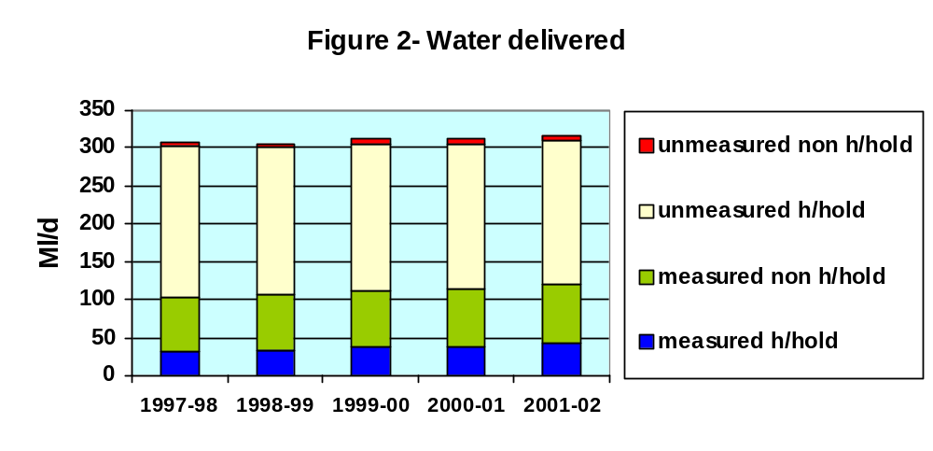
On the supply side of the water balance, the Darwell scheme is progressing with construction programmed to start in September 2003. After earlier delays, due to a need for additional investigations, we believe that the remaining significant risk to delivery of the scheme by the revised target date of 2005 is planning consent. Resulting delays in capital expenditure have been partly offset by increased and effective expenditure on leakage reduction.

Bad debt
While table D shows reduced percentage revenue outstanding less than 48 months, the exceptional debt write off in 2000-01 (£2.15m) needs to be taken into account when interpreting these figures. South East Water has commented that bad debt has increased by 17% during the year.

Efficiencies
South East Water has reported capital efficiency savings in the report year of £2.1m. While we are convinced that the Company has achieved significant efficiency savings and some are quantified appropriately, procurement efficiencies are calculated with respect to the previous contract rates without allowance for the efficiency targets set at PR99.

General commentary on areas identified by Ofwat

June Return process
At JR01 following SMC’s first review at South East Water, I commented that while much of the June Return was based on sound processes, in some areas we found shortcomings that, in our view, compromised data quality to varying degrees. We had some particular concerns with respect to levels of service indicators. While I am pleased to report that there has been progress, many of the concerns identified last year remain. The corollary is that there have, in our view, been few improvements in the confidence grades that we agreed last year.

From discussions during the review, we are aware that that much of South East Water’s attention in the report year has been focussed on the improvement to business systems aimed both at operational efficiency and effectiveness as well as to provide the foundation for its PR04 business plan. Our review has only touched indirectly on these matters.

Consistency between the Board Overview and supporting documents
To the extent that our review permits, we have been able to confirm the accuracy of statements and supporting numerical data made by South East Water in its Board Overview with the following exceptions in the table on page 2 of the overview:

- The percentage of telephone contacts answered within 30 seconds (90.6% of calls answered) is on different basis to table A (88.76% of calls received)
- The percentage of bills based on a meter reading at JR01 was 99.8%
- For DG7 and DG9, the word “not” should be deleted.

In addition, we found the following inconsistencies in the overview text and table A:

- The number of lead failures reported to DWI was two (three in overview)
- Mains relined figures in the overview are inconsistent with table D (JR02 141.7 c.f. 136.05 in table D; JR01 59.1 c.f. 75.31 in table D)
- Table A line 12 (141.7) refers to mains relined in the report year (a figure inconsistent with table D) rather than mains rehabilitated in the calendar year as required by the definition. From the DWI return and prior years figure, we believe the correct figure to be 113.9Km.

Co-operation and access
Challenges raised during our review of South East Water’s June Return have created numerous demands on its staff and most have been resolved. We have been able to complete our work within the time scale in which the Company has been able to respond to these challenges.

I am pleased to have the opportunity to record SMC’s appreciation for the assistance and co-operation of South East Water’s management and staff

K B Hall
Strategic Management Consultants
21 June 2002

