Chapter 1

Key Outputs and Service Delivery

Table A - Water Services

SERVICE OUTPUTS AND PERFORMANCE

Severn Trent recognises the need for continuing improvement and evolution in the performance standards against which it is to be assessed but believes it is important that such changes should not be applied retrospectively as a basis for “ex post” assessment part way through a review period. Consistent with this view, and while recognising some changes to the definitions may be appropriate in the lead-up to PR04, the Company maintains its position that, for the purposes of AMP3 monitoring, performance assessments must be based on the previously agreed definitions.

Low Pressure (DG2):
The Company achieved 0.078% of properties at risk of low pressure. In total 3598 properties have been removed from the register during the year as a result of company action. We are therefore ahead of our target as set out in the Monitoring Plan, to ensure that the number of properties experiencing low pressure at March 2005 is no higher than the March 1999 position.

 | 98/99 | 99/00 | 00/01 | 01/02
Start Year | 5,415 | 4,595 | 4,655 | 4591
Improvements | (5,934) | (1,531) | (3,148) | (3,598)
Additions | 5,115 | 1,591 | 3,084 | 1549
End Year | 4,595 | 4,655 | 4,591 | 2542
% of total properties served | 0.14 | 0.15 | 0.14 | 0.078

Interruptions to supply (DG3):

Major Incident - Telford
The company experienced a major supply interruption in Telford last September (10/09/01). The interruption was significant not only in terms of the size of main (21 inch) and the scale of properties affected (15,500), but more so because of the difficulties in obtaining access and the complexity of the repair, leading to a maximum duration of the interruption of 32hrs. Events such as this with its particular complexities cannot be predicted and are largely outside management control.

As the table below shows, excluding the Telford incident, the underlying DG3 position remains sound, falling well within the Ofwat “acceptable” range category at 0.49, with data for the last 3 years showing an improving trend.

DG3 – Interruptions to supply
 | 1998/99 | 1999/00 | 2000/01 | 2001/02
Ofwat Performance Index | 0.54 | 0.95 | 0.87 | 0.49  (excl Telford)

Billing Contacts (DG6),
The Company has maintained its level of service in the Ofwat “Good” category, with 99.24% of billing contacts answered within 5 days

Written Complaints (DG7)
The Company has maintained its level of service in the Ofwat “Good” category, with 99.5% of written complaints answered within 10 days.

Meter reading (DG8)
The Company has improved on its 2000/01 performance and was close to achieving the Ofwat “Good” category despite the continued restrictions caused by the Foot and Mouth Regulations. 98.3% of metered customers received a bill based on an actual reading. Excluding the impact of the Foot and Mouth Regulations, underlying performance would have been in the “Good” category, ie above 99.5%.

Telephone responses (DG9)
The Company achieved its best ever telephone performance despite some technical problems at the beginning of the year. It improved its level of service on the previous year’s performance, with 90.6% of telephone calls answered within 30 seconds, maintaining it in the Ofwat “Acceptable” category.

We are nevertheless concerned with the Ofwat changes to DG9 reporting requirements. Our main concern is that the changes for purposes of AMP3 monitoring amount to retrospective regulation. The 1999 Final Determination states that the outputs required, and for which provision was made, included “maintenance of the levels of service already achieved…” Our March 2000 Monitoring Plan clearly states that this applies “using the same criteria as (then) applied by the DGWS (Director General of Water Services)”.

Secondly, the changes to DG9 reporting requirements are preventing us from optimising the use of new technologies in this area.

These points were made in our letters of 7 February and 18 March 2002, and reinforced by Water UK in Pamela Taylor’s letter of 4 April. They were also subject of our discussion with Philip Fletcher in May 2002.

All of these levels of performance (except DG8, affected by the overhang of Foot and Mouth) are in line with Monitoring Plan targets.

 | 1998/99 | 1999/00 | 2000/01 | 2001/02
DG6 - Billing queries  % answered <5 days  Ofwat category | 99.2  Good | 99.6  Good | 99.1  Good | 99.24  Good
DG7 - Written complaints  % answered <10 days  Ofwat category | 99.6  Good | 99.9  Good | 99.2  Good | 99.5  Good
DG8 - Meter Reading  % read and billed in the year  Ofwat category | 99.7  Good | 99.51  Good | 96.7  Not Graded (affected by Foot and Mouth) | 98.3  Acceptable  (affected by Foot and Mouth)
DG9 - Telephone Response (Received calls)  % calls answered < 30 sec  Ofwat category | 88.0  Needs Improvement | 87.1  Acceptable | 88.8  Acceptable | 90.6  Acceptable

MAINTAINING COMPLIANCE WITH THE DRINKING WATER QUALITY REGULATIONS

Over the last eleven years, our customers have benefited from continuing improvements in drinking water quality. Current standards and compliance are amongst the highest in the world and the number of exceedances against maximum permissible limits has fallen considerably since 1990. The small number of exceedances that do occur are minor in nature and have no effect on health.

Against this background, our aim, as expressed in the Monitoring Plan, is to maintain compliance against existing standards, as currently measured by the DWI, within the record levels achieved during the 5 years to December 1999. As can be seen below we have achieved this with a compliance level of 99.91% during the 12 months to December 2001. On this basis our performance has been rated by the DWI as “significantly above average”, both for our overall compliance and against the Inspectorate’s own operational index.

 | 1995 | 1996 | 1997 | 1998 | 1999 | 2000 | 2001
Water Quality Compliance % | 99.83 | 99.83 | 99.89 | 99.88 | 99.91 | 99.90 | 99.91

This has been achieved by a continuing tight focus on water quality including action teams to investigate every failure, supported by a programme of cleaning service reservoirs on a regular basis to ensure water quality is maintained. The net result is that the level of maintenance activity on water services is currently higher than originally assumed.
DELIVERING THE DRINKING WATER COMPLIANCE PROGRAMME

The foot and mouth outbreak has had an impact on many schemes in the Capital Investment Programme. Projects requiring access to private land and certain Severn Trent Water sites were subject to restrictions causing delays. This had an impact on projects not only at the construction stage but also in the design stage. As a result of these delays, we are currently forecasting that 6 projects will not meet the original DWI obligation dates. The DWI have been advised of our revised forecast completion dates and we are awaiting their formal comment and feedback. In addition there are a further 4 projects where completion by the due date is regarded as very tight. Appendix 1 shows the progress against milestone dates for all schemes in the AMP3 Programme that are required for compliance with DWI Statements of Intent.

A revised programme to meet the new Lead standard has been agreed with DWI (with the exception of the details of one project). As reported in last year’s June Return, this involves additional treatment, rather than replacement of communication pipes at this stage. The need for communication pipe replacement will not be clarified until the treatment programme is completed. The programme involves less capex than originally planned in the AMP3 period, but higher opex (see also Chapter 6 reference to IDOK implications).

Section 19 Distribution Undertaking
Sign-off by DWI of AMP2 programme
We have provided the DWI with sufficient evidence that the work carried out for the AMP2 S19 Distribution Undertaking meets the post rehab survey criteria to enable them to sign it off.
AMP3 programme
The 1999 Price Determination assumed a total length of 1900 km to be rehabilitated under the S19 undertaking, with 1025 km to be delivered by March 2002. By the end of the report year the Company had rehabilitated 959 km of mains in accordance with the S19 Undertaking.
Our Business Plan Submission and the Determination assumptions were based on an approach that focussed on rehabilitation of all mains in DMAs meeting the Pre-Renovation Assessment criteria. The revised DWI protocol now requires Pre-Renovation justification for each length of main. As a result of this, the total length of main to be renovated is still uncertain. As better information emerges, minor alterations are being made to the detailed annexes to the Undertaking by agreement with the DWI. We have not yet done the pre-surveys for the additional District Metered Areas involved, but believe that we will substantially achieve the 1900km commitment. We will be better able to predict the exact final length in next year’s June Return.

Table B - Sewerage Services

Key Outputs and Service Delivery

DG5 (Incidents of domestic properties subject to internal sewer flooding).
During the Report Year there has been a decrease in the incidence of sewer flooding due to “other causes” from 692 to 602. In contrast, the reported number of incidents of property flooding from overloaded sewers (excluding extreme events) increased by 44% from 356 incidents in 2000/01 to 514 in 2001/02. This increase was due to a 47% increase in the number of storms causing flooding during the year. To alleviate the situation the company has introduced a number of low-cost interim flood relief measures. These measures were applied to 158 properties during the year and were successful in preventing internal flooding. The properties have been left on the "At Risk" registers because it is not yet clear that these solutions can be seen as permanent. In the meantime, however, they should reduce the number of incidents.

Severn Trent is actively involved in climate change research and believes there is growing evidence that climate change is taking place. Research recently published by the Met Office Hadley Centre for Climate Prediction and Research (April 2002 report sponsored by DEFRA) continues to point to rainstorms of an increasing frequency and intensity resulting in increased sewer loads which expose the inadequate capacity of many local sewerage systems. We continue to be concerned that 19th century sewers will not be able to cope with 21st century storm conditions and that a start will need to be made in AMP4 on the accelerated replacement of undersized sewers with inadequate design capacity.

Despite the slight increase in overall flooding incidents (6%) we still expect to meet the Ofwat target of no more than 0.025% of properties (excluding the impact of severe storms) being subject to internal sewage flooding by the end of the AMP3 period. Achieving this target will be assisted by resolving problems at 1575 properties on the DG5 “at risk” registers (gross) during the Period (see below).

In addition, since September 2001 we have been using a Met Office weather forecasting tool called MIST, which allows us to identify areas that may be affected by extreme weather, days and/or hours in advance. By aligning this data with known “hot spots” and “at risk” properties we have started to introduce temporary measures to reduce incidents of flooding. As yet it is too early to comment on the success of this project but it is hoped that tangible benefits will be experienced this year.

DG5 (at risk registers)
The Company achieved a gross reduction of 282 in the number of properties shown on its "at risk" registers. We have completed 401 of the 1,575 improvements required over the AMP3 period. This work is ahead of the output delivery and spending assumptions shown in the Final Determination, and reflected in the Company’s Monitoring Plan.

Changes to the DG5 Registers
(2 in 10 and 1 in 10 combined)
 | 98/99 | 99/00 | 00/01 | 01/02
Start of Year | 2249 | 1844 | 1650 | 1573
Improvements | (674) | (659) | (119) | (282)
Additions | 269 | 465 | 42 | 206
End of Year | 1844 | 1650 | 1573 | 1497
% of total properties served at risk | .05 | .05 | .04 | .04

Of itself the AMP3 target will not be sufficient to remove all 1,650 properties shown on the Company’s at risk registers at April 2000. From this standpoint, we welcome and support the general principle, set out in Ofwat’s consultation on sewer flooding that additional sewer flooding schemes could be seen as qualifying for IDOK/logging up purposes. For this to work in practice, however, formally agreed IDOK/logging up procedures will need to be in place.
During the course of tackling properties on the DG5 register, and indeed addressing other schemes within the AMP3 programme, we apply a policy of trying to resolve Other Flooded Areas (OFAs) which are in the immediate area of the construction work. As a result, during the Report Year we have removed 233 of the currently known OFAs on our registers.
Effluent discharge compliance
In our Monitoring Plan we set ourselves the aim of maintaining compliance against existing quality consents, as assessed by the Environment Agency at that time, within the record levels established during AMP2 (see graph below). The introduction of more extensive flow measurement required under the UWWTD may reveal some hitherto unknown breaches of flow consent conditions that may then prompt the imposition of tighter quality consents. As acknowledged in the Final Determination, any resulting expenditure would be the subject of a claim for IDOK or logging up.

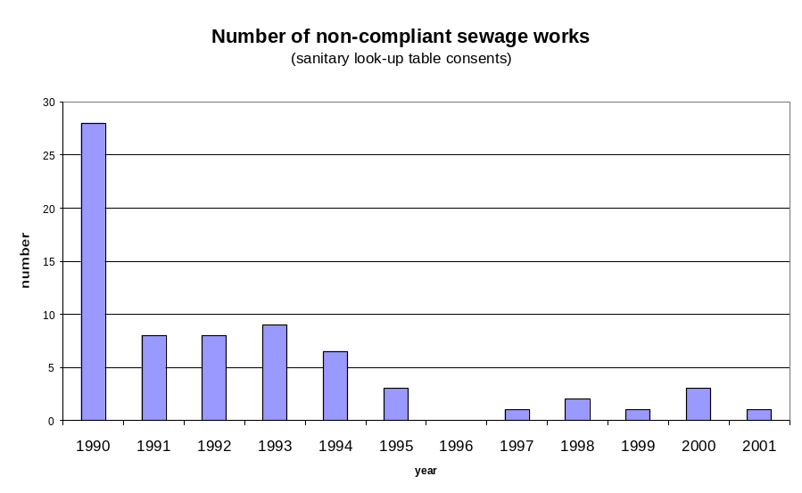

During the report year only 1 works failed against sanitary look-up table consents giving a compliance level of 99.9%, consistent with our Monitoring Plan aim to maintain performance within the record levels achieved during AMP2. The total population equivalent of the failing works was 0.03% of the Company total. Therefore, at 99.97% the Company was virtually 100% compliant on this basis, maintaining performance in the range achieved during the 5 years to December 1999.

% Compliance with Sanitary Look-up Table Consents
 | 1995 | 1996 | 1997 | 1998 | 1999 | 2000 | 2001
Sewage Treatment Works compliant | 99.6% | 100% | 99.9% | 99.7% | 99.9% | 99.7% | 99.9%
Population Equivalent compliant | 99.94% | 100% | 99.996% | 99.996% | 99.994% | 99.96% | 99.97%

DELIVERING THE QUALITY ENHANCEMENT PROGRAMME- SEWERAGE SERVICE

As for water supply, the foot and mouth outbreak has had an impact in delaying some schemes. These delays and the subsequent programme changes have significantly reduced our scope to make further changes to the programme without compromising output delivery over the remainder of AMP3.

Appendix 2 shows the project key milestone dates for major schemes in the AMP3 programme (as per Annex F to the Ofwat letter dated 28 November 2000). This shows that we are on target to meet the EA completion dates on 4 of the 5 continuous discharge projects. The delay on the Bromsgrove scheme is a result of the EA’s request for river flood modelling.

MAINTAINING SERVICEABILITY TO CUSTOMERS

The key serviceability indicators for the Report Year are shown below and, for the most part, confirm a stable or improving trend over the period since 1992/93.

Report year |  | 92/93 | 93/94 | 94/95 | 95/96 | 96/97 | 97/98 | 98/99 | 99/00 | 00/01 | 01/02
Water services
Water mains networks
Mains bursts per 1000km | nr/1000km | 212 | 193 | 206 | 297 | 257 | 181 | 168 | 172 | 165 | 154
Extent of low pressure problems (DG2) | % of properties | 0.6 | 0.48 | 0.58 | 1.17 | 0.3 | 0.17 | 0.14 | 0.15 | 0.14 | 0.08
Unplanned interrruptions to supplies greater than 12 hrs (DG3) | % of properties | 0.72 | 0.29 | 0.2 | 0.16 | 0.04 | 0.04 | 0.09 | 0.04 | 0.19 | 0.37
Nr of zones failing for iron | nr | 98 | 79 | 72 | 45 | 41 | 28 | 30 | 17 | 20 | 26
Water Treatment works
Nr of WTWs where enforcement action is being considered: coliforms standard | nr | 0 | 0 | 0 | 0 | 0 | 0 | 0 | 0 | 1 | 0
Percentage of determinations at WTW containing coliforms | % | 0.15 | 0.13 | 0.08 | 0.11 | 0.06 | 0.05 | 0.08 | 0.10 | 0.10 | 0.06
Sewerage services
Sewer networks
Sewer collapses per 1000km | nr/1000km | 11 | 12 | 10 | 5 | 8 | 7 | 5 | 7 | 11 | 10
Nr of pollution incidents at CSO's and sewers (categories 1 to 3) | nr |  |  |  | 298 | 301 | 326 | 291 | 183 | 238 | 193
Properties flooded in the year (overloaded sewers) | nr | 478 | 578 | 518 | 396 | 409 | 1284 | 601 | 1204 | 258 | 356
Sewage Treatment Works
Percentage of sewage treatment works failing numeric consents | % | 2.3 | 3 | 2.2 | 1.80 | 0.8 | 2.48 | 1.29 | 0.9 | 2.09 | 1.77
Percentage of P.E. served by non-compliant works failing LUT consents (97/98 adjusted for Ofwat definition change) | % |  |  |  | 0.04 | 0 | 0.004 | 0 | 0.01 | 0.04 | 0.03

Based on the data shown above, the trend in pollution incidents at Combined Storm Overflows (CSOs) and foul sewers shows a continuing downward trend with the number of incidents falling again in 2001/02 after a slight increase last year.

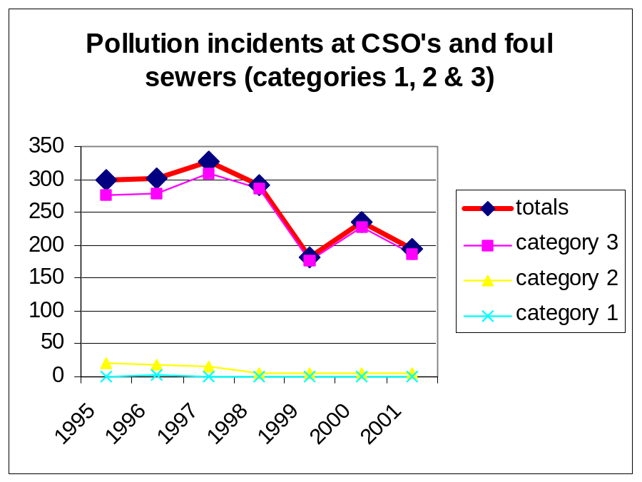
However, we must emphasise that we do not accept that this measure as currently reported is of any value as a serviceability indicator. Of this year’s total of 193 pollution incidents 187 are Category 3. Large proportions of these Category 3 incidents are not within the control of the company. We currently estimate that around 60% are wholly or partly due to third party actions and weather is a significant factor in many others. Furthermore, we have concerns over the accuracy recorded by the EA. These concerns also apply to all of the other Category 3 pollution incidents as used by Ofwat as performance measures, for example in the Overall Performance Assessment.

To address these problems of responsibility and accuracy, together with issues of timely and appropriate reporting, a joint STW/EA workshop was held recently to analyse the root causes of problems and identify achievable ways forward.

Sewage Treatment Works
The number of sewage treatment works failing numeric consents shows a stable trend. The apparent deterioration in Percentage of Population Eqivalent. served by non-compliant works failing Look Up Table consents reflects the very small number of works that fail, the fact that they are all very small works, and the sensitivity of the measure to the population equivalent of the individual works that failed this year (3000 p.e.,)

S101A Sewers
This remains an area of considerable uncertainty and customer dissatisfaction. There is increasing political and customer service pressure on the company to move forward on S101A schemes which are being stalled because of continuing regulatory and legal uncertainties. This is a matter which needs to be properly clarified and resolved in the lead up to PR04. In the interim some additional unfunded S101A schemes will be carried out in AMP3 which we would expect to see fully funded and recognised as part of any Interim Determination or Logging Up claim. Further details are provided in Chapter 6.

