BOARD’S OVERVIEW

EXECUTIVE SUMMARY

- Performance against most service measures was comparable to our high standards of recent years and customer satisfaction levels remain high. We failed to meet our leakage target but are determined to recover our position in 2002-03. Our DG3 performance improved to “acceptable” but still requires significant improvement.

- Water resources remained healthy at the end of 2001-02. By year-end the proportion of domestic customers paying by meter had passed the 50% mark.

- After excluding some atypical savings, our overall opex spend was higher than that allowed in the Final Determination, supporting our opinion that the Determination was very tough.

- Our total capital spend was £264m, which included a small amount of discretionary expenditure on sewer flooding, odour and low pressure. We have delivered all our capital outputs in accordance with the determination investment programmes for both water and waste water. Our most significant completion in 2001-02 was the new sewage treatment works at Lowestoft, our biggest single capital project since 1989.

- We have incurred significant costs on sludge treatment which we believe are eligible for logging up and look forward to discussing these as part of the AMP4 negotiations. We are also keen to resolve how to deal with the costs of any additional sewer flooding investment we might undertake during the current quinquennium.

- We look forward to completing our ring-fencing and financial restructuring plan in the near future and delivering its benefits to all stakeholders.

All figures in this Overview represent the combined performance of Anglian Water and Hartlepool Water, which have operated under a single licence since 1 April 2000.

Chapter 1 Key Outputs and Service Delivery – (Tables A and B)

The changes in our key customer service measures from 2000/01 are shown below :

Service measure | Unit | 2001/02 performance | 2000/01 performance
DG2 Properties at risk of receiving low water pressure | Nr (year end) | 5,217 | 4,785
DG3 Unplanned supply interruptions (excluding planned overruns) | Overall Performance Score | 1.98 | 2.35
DG4 Customers experiencing supply restrictions | Nr | 0 | 0
DG5 Properties at risk of sewage flooding twice in 10 years | % (year end) | 0.033 | 0.034
DG6 Billing queries answered within 5 days | % | 99.1 | 99.1
DG7 Written complaints answered within 10 days | % | 100.0 | 100.0
DG8 Metered bills based on actual readings | % | 99.7 | 99.7
DG9 Telephone calls answered within 30 seconds | % | 92.7 | 91.1

The number of properties on our DG2 register rose by 432 (net) in 2001-02. This was primarily due to the addition of over 700 properties in Great Notley, Essex. These properties, along with a number of others already on the register, will be removed on completion of a booster pumping station project in 2002-03. Rezoning and another booster station project in 2002-03 will also remove from the register 78 Lincolnshire properties added in 2001-02.

We were pleased to see some improvement in our DG3 performance though still far from satisfied with our Overall Performance Score. Seven incidents accounted for half of our OPS, all as a result of burst mains. The senior level working group established after the poor performance of 2001-02 has initiated some process changes and a programme of staff briefing to remind all relevant staff of the DG3 drivers. We anticipate these initiatives will lead to continued improvement in performance in 2002-03.

We fully support your review of the approach to assessing telephone answering performance in the light of technological developments in call centre telephony. We believe you accept our view that a 30 second watershed is not appropriate in an IVR environment. The report year figure quoted above for DG9 is consistent with our prior year reporting methodology. The extensive use of IVR technology at our Lincoln call centre means that our DG9 performance appears a lot poorer when measured strictly against the reporting requirements. However measured, our telephone answering performance in 2001-02 was comparable to that of recent years and we expect this is how it will be presented in published figures.

Our ongoing customer tracking survey continues to reflect high levels of satisfaction among our customers. Over the 12 months to March 2002 86% of customers said they were very or fairly satisfied with overall service.

Drinking water service
We have rehabilitated 704km of unlined iron main for quality reasons at 31st March 2002 as part of our commitment to rehabilitate 895 km by 31st September 2002. This shows us marginally ahead against our cumulative target of 694km by March 2002, despite earlier delays due to loss of access resulting from the Foot and Mouth Restrictions. We anticipate completing the remaining 191km by September 2002.

The quality mains work comprises the main element of our water investment programme. Other outputs in the year included
- completion of work to met undertakings at North Pickenham (for nitrate), Does Corner (iron and manganese) and Pilsgate (hydrocarbons)
- completion of the cryptosporidium investment at 4 surface water sites
- progress with Impact of Abstraction investigations at sites under the National Environment Programme, including East Ruston, Strumpshaw and Quiddenham

We consider there are no shortfalls against the outputs expectations of the Determination for the water service.

Sewerage service
We continued to make good progress in delivering the outputs expected of us for AMP3. Overall we consider ourselves to be ahead of programme in terms of completed outputs, and on track for delivering the outputs scheduled for later in the quinquennium.

The most significant scheme in 2001-02 was the new STW at Lowestoft in Suffolk, which is our biggest single capital project since 1989. The first streams flowed through the works in autumn 2001, with the remaining streams commissioned in time for the 2002 bathing season.

The table below summarises our delivery of outputs against expectations for this first year of the AMP3 programme. Our only shortfall, a minor one, relates to first time sewerage schemes. In addition to earlier difficulties with access restrictions as a result of the foot and mouth epidemic, we have also met with significant planning obstructions at three of our sites planned for delivery in 2001/2. We have therefore deferred these in our programme, brought forward 2 other sites to compensate, and will catch up the outstanding site in 2002-03.

Description | Required by programme to end 01-02 | Delivered by end 01-02
Nr of intermittent discharges to be improved | 22 | 30
Nr of STW completed under AMP2 programme | 5 | 5
UWWTD - Nr of Improvements | 18 | 19
Bathing Waters Directive - Nr of improvements | 0 | 0
Shellfish Waters Directive - Nr of Improvements | 0 | 2
Freshwater Fish Directive - Nr of Improvements | 9 | 11
Habitat’s Directive & SSSI’s - Nr of Improvements | 2 | 2
S101A First time sewerage - Nr of Improvements | 23 | 22
River Quality Objectives - Nr of Improvements | 10 | 12

Chapter 2 Expenditure and Financial Performance Measures - (Table C)

2001/02 Profit and Loss Account
(historical costs, report year prices, appointed business only)

 | 01/02 (£m) | 00/01 (£m)
Turnover | 717.9 | 687.4
Operating costs | (415.7) | (411.0)
Operating income | 3.3 | 1.8
Exceptional items | (26.8) | (12.2)
Operating profit | 278.6 | 266.0
Other income | 1.1 | 0.6
Net interest | (102.7) | (120.1)
Tax | 28.6 | (26.7)
Profit | 205.6 | 119.8
Dividends | 0 | (910.2)
Retained profit | 205.6 | (790.3)

In comparison with 2000/01, the 2001/02 results showed an improvement in operating profit (after exceptional charges) from £266.0 million to £278.6 million. The changes in profitability arose as follows:-

TOTAL
£m
Turnover | 30.5
Operating costs | (4.7)
Operating income | 1.5
Exceptional items | (14.6)
Change in operating profit | 12.7

The increase in turnover was largely attributable to the effect of the price limits for 2001-02 (K = 1.0) . Other factors included the impact of growth and tariff changes offset by the continuing effect of customers transferring to meters.

The increase in operating costs arose as follows:-

 | £m
Operating expenditure | (9.4)
Depreciation | 14.1
Infrastructure renewals charge | 0.0
 | 4.7

The reduction in operating expenditure was attributable to some atypical savings of £15.4m. These arose from the release of provisions made in previous years to cover increases in rates (£10.9m) and other costs (£4.9m). These savings masked upwards pressures on costs arising from the impact of new capital schemes, meeting higher sludge standards, bad debt provision and the introduction of the Climate Change Levy in April 2001.

The increased depreciation reflects the continuing impact of high capital expenditure on short life assets. Expenditure of £264m for 2001/02 included some investment in additional outputs, beyond what was expected in the Determination, to meet our customers’ needs. These included £2.4m to resolve sewer flooding problems and deal with odour problems at sewage treatment works.

Exceptional costs related to re-organisation and redundancy costs (£4.4m) and costs related to the restructuring of debt (£22.5m).

No dividend was paid to Anglian Water plc for 2001-02. Of the 2000-01 dividend £799.2m has not yet been paid and will be reversed in full or in part as a consequence of the debt refinancing programme which the company is currently undertaking.

The balance sheet at 31 March 2002 reflected net debt of £1,984.5 million (2000/01 : 1,583.7m). Interest charges reflect the cost of long-term borrowings taken on since privatisation. The average debt servicing cost is higher than current interest rates, reflecting the market conditions prevailing at the time the funding was secured.

In 2001 we raised $435m from the US private placement market to finance AWS. AWS is currently seeking to arrange a refinancing of its capital through proposals agreed with Ofwat in May 2002. As a result of this refinancing AWS will prefund the next 12 months' enhancement capital expenditure and will be in an improved position to raise its ongoing finance for capital expenditure more effectively.

Chapter 3 Key Supporting Information - (Tables D and E)

WATER SERVICE
We maintained our high level of compliance with water quality standards in 2001. Of all tests conducted in our sampling programme 99.64% were compliant with quality standards compared with 99.63% in 2000.

Water resources
Rainfall declined during 2001-02 from the exceptional total for the previous 12 months. Total rainfall for 2001-02 was 112% of the long-term average, with 97% of the long term average rainfall for the last 6 months reflecting the downward trend. Overall water resources fell from the exceptionally high level of 2001 but still remain healthy at around average. There have been no restrictions on the use of water during the year.

We reported on the position against our 1999 Water Resources Plan in the Annual review to the Environment Agency in September. This was accepted by the Agency with no significant comments on our water resources position. We have continued to progress the permissions required to extend Wing WTW at the appropriate time, but this remains a protracted process due to the Habitats Regulations.

We commented last year about difficulties in securing a renewal of the North Pickenham licence because of the requirements of the Habitats Regulations. We still await an decision on the Appeal which was heard in July 2001. We believe this case indicates the difficulty in determining the renewal of time-limited licences under the Habitats Regulations and remain concerned about the potential implications for the Review of Consents in the AMP4 period.

We have calculated our Security of Supply Index for our 5 water resources zones as 91. This reflects a shortfall in the water available to meet dry year demand, including the full allocation for exports, in our Western Zone. We are monitoring the water taken by our neighbouring water companies and will bring forward our plans to extend Wing WTW if required.

We continue to implement the Water Efficiency Strategy accepted by Ofwat in February 2001.

Leakage
Our performance on leakage declined significantly on the previous year, rising to 224.3 Ml/d from 194.2Ml/d in 2000-01. The causes of this were
- exceptionally wet ground conditions which reduced both customer and company leak detection and reporting
- poorer repair response times
- sudden rises in network failures during cold spells in January 2001 and January 2002

We observe that recovering leakage performance from this base will be challenging but are determined to hit our target for 2002-03. Our action plan includes increasing resources for detection and achieving a reduction in repair response times through improved performance management. We are attracted to the emerging industry view that it may be more appropriate to assess leakage performance over longer time period, say five years, than the current annual cycle and commend your consideration of this.

Meter installation
During 2001-02 29,274 domestic customers opted to switch to measured bills. This represents a reduction in the corresponding number for 2000-01, but still 5% more optants than were allowed for in price limits. Taking the first two years of AMP3 together the number of households switching to measured charges exceeds the number allowed for in price limits by over 30%, with consequent impacts on our profitability.

The proportion of our domestic properties where customers pay for water by measured charge rose in 2001-02 from 45.2% in 2000-01 to 48.4% (mid-year figures). By the end of 2001-02 more than half of our domestic customers were paying by measured charge.

Service measure | Unit | 2001/02 performance | 2000-01 performance
Leakage | Ml/d | 224.3 | 194.2
% of domestic properties where customers pay by meter (mid-year figures) | % | 48.4 | 45.2

SEWERAGE SERVICE
The trend of the last few years of improving performance of our STWs reversed at the end of 2001-02 with an increase in the percentage of population equivalent served by works non-compliant with look-up table consents. We anticipate an improvement in performance in 2002-03.

In comparison with 2001, the total number of Category 2 and 3 sewage related pollution incidents increased in 2002. However, if this is placed in a historical context the increase is not significant, as shown in the table and graph below.

A new QA system for sewerage operations was instigated in January 2001. This is specifically intended, in time, to reduce the number and severity of pollution events.

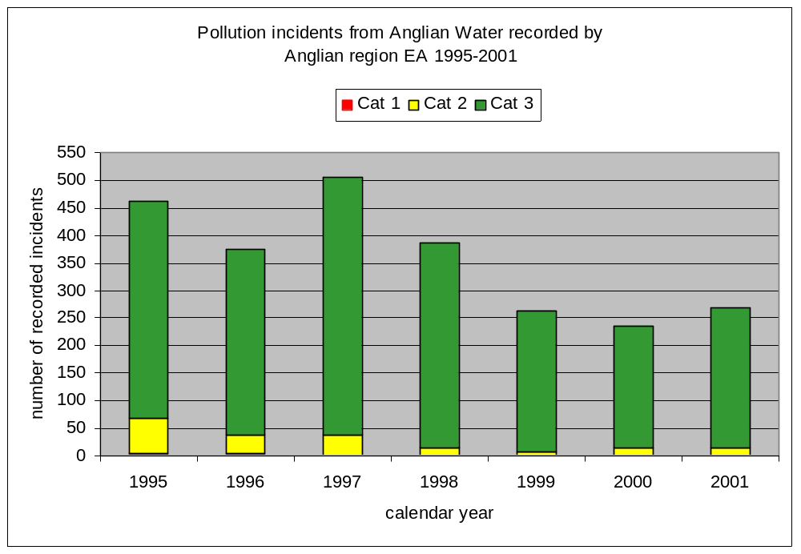
In terms of samples, the bathing water results in 2001 were the best ever for the Anglian region:-

- 41 of the 42 bathing waters affected by AW discharges passed the mandatory standard. Only 4 out of the 840 samples taken by the EA exceeded this standard - the fewest ever for the region.
- Guideline compliance increased from 40% of bathing waters in 2000 to 60% in 2001, with 77% of the samples taken by the EA compliant with this 'Blue Flag' standard. Again, this was the best ever result for the region.

Key coastal sewage works have been upgraded in the year at Ingoldmells, King's Lynn, Cromer, Mundesley, Caister, Lowestoft, Clacton and Jaywick. The first complete bathing season to benefit from this latest investment will be 2002.

Service measure | Unit | 2001 performance | 2000 performance
Equivalent population served by STWs not compliant with LUT consent | % | 0.85 | 0.11
Bathing waters compliant with mandatory standards | % | 97.6 | 100.0

Chapter 4 Efficiencies

Operating expenditure
After exceptional costs are removed, we outperformed the assumptions of the Final Determination by X%. However, operating expenditure was substantially assisted by atypical savings arising from the release of provisions made in prior years. If these atypical savings are excluded, operating expenditure would be seen to have exceeded the assumptions of the Final Determination. This supports our belief that the efficiency assumptions employed to derive opex allowances at PR99 were exceptionally challenging.

(£m) | Water | Sewerage | Total
Determination | XXX | XXX | XXX
Actual after exceptionals | XXX | XXX | XXX
Variance (£m) | XXX | XXX | XXX
Variance (%) | XXX | XXX | XXX
all figures in £m at 01/02 prices

Capital expenditure
Gross capital investment for 2001/02 was £264m. Of this, 38% was spent on the water service and 62% on the sewerage service. We have delivered all the outputs expected of us to date. Additionally we have invested in outputs beyond what was expected in the Determination to meet our customers’ needs. These include resolving sewer flooding and odour problems and dealing with low pressure.

The table below shows our cumulative expenditure for the first 2 two years against Ofwat’s 1999 Determination investment figures.

(£m) | Water | Sewerage | Total
Determination | XXX | XXX | XXX
Actual | XXX | XXX | XXX
Variance | XXX | XXX | XXX
Variance (%) | XXX | XXX | XXX
Figures may not add due to rounding; all figures in £m at 01/02prices;

Overall, we have varied to date against Ofwat’s capex profile by X%. In part we attribute this to efficiency savings which, for the quality programme, we assess at X%. We also consider that we have reallocated sums to fund outputs not allowed for at the last price review, such as additional meters and solutions to sewer flooding problems. However, at this stage of the quinquennium we consider that the majority of the variances are attributable to differences in assumption on the timing of spend. We intend by 2005, for example, to spend our AMP3 allowance on maintenance so any variances in this programme at this stage are best portrayed as profiling differences.

On efficiencies, we set ourselves a target to meet all required outputs for X% less than the overall 5 year Determination provisions. Efficiency savings have been achieved through the combined effect of a number of different initiatives :-

- value management (doing the right thing at the right time at the right cost),
- innovative techniques which stem from our R&D programme,
- managing risk better,
- a Process Framework Agreement designed to increase efficiency by promoting a team approach to construction contracts.
- Strategic sourcing to maximise benefits through regional procurement contracts.

Programme & Project management, new process have been implemented to provide greater focus on delivering capital efficiency through PRINCE2 methodology

Chapter 5 Competition

AWS has begun supplying two large industrial customers in the North East with high purity water via a cross-border supply from Hartlepool Water. The high purity water is used for process use in the power and chemical industries. This project is the largest of its kind.

During 2001-02, we received a request to provide a bulk supply and bulk discharge to a competitor wishing to supply a large user within the Anglian Water region. We have responded to this request.

We have received no new formal requests for access to our networks during 2001-02. The two applications received during 2000-01 are being considered further by the applicants.

During the year we reviewed the role of H2Go within the Group. H2go Ltd has ceased to operate within the regulated competitive market and the majority of its employees have transferred into AWS. H2Go remains an associate in the Group but pursues opportunities wholly distinct from the activities of AWS.

We note with interest the Government’s announcement to open up competition further to non-domestic customers through common carriage arrangements. We look forward to commenting on the Government’s consultation paper expected later in 2002.

OTHER ISSUES
We believe we have a strong case for logging up some costs relating to sludge treatment given the changes in the Regulations compared to the assumptions on which we based our submission for AMP3. We look forward to discussing this with you as part of the AMP4 negotiations or as part of an IDOK reference.

We are keen to make progress on sewer flooding before the next quinquennium and look forward to receiving your response to our recent letter about how the additional costs would be dealt with.

We look forward to completing our ring-fencing and financial restructuring plan in the near future and delivering its benefits to all stakeholders.

I confirm that this Overview has been endorsed by the Executive directors of the AWS Board.

Roy Pointer

Managing Director, Anglian Water Services Ltd

