CONTENTS |  | Page
Executive Summary |  | 2
Chapter 1 | Key Outputs and Service Delivery | 4
Chapter 2 | Financial Performance Measures | 11
Chapter 3 | Key Supporting Information | 15
Chapter 4 | Efficiencies | 16
Chapter 5 | Competition | 17
Tables | A to E

EXECUTIVE SUMMARY

2001/02 has been another successful year as we continue to be ahead of the commitments we made to customers after the 1999 Price Determination.

Service and compliance performance has continued to improve with our best ever performance on water quality, sewer flooding, DG2, DG3, leakage and category 1 and 2 pollution incidents. We were very pleased to be ranked 4th out of the 10 water and sewerage companies in Ofwat’s overall performance assessment for 2000/01. Our score has increased further in 2001/02 and we plan to continue to improve.

[

1

]

We are continuing to outperform the operating costs allowed in the price determination and deliver capital efficiencies aimed at maintaining our position as one of the most efficient companies in the industry. Nevertheless the ability to absorb new obligations is reduced as our financial ratios continue to tighten as a result of the 1999 Price Determination. These continuing pressures may make it necessary for us to apply for a review of prices prior to the next Periodic Review. Items which may trigger this include:

- Cryptosporidium
- Bromates
- Bad debts
- COPI
- Incineration directive
- Case between Severn Trent and British Waterways Board
- Area flooding following Thames case
- Landfill Directive
- Nitrates-impact on sludge to land-expected for 1 January 2003

The impact of the ban on disconnections continues to be clearly evident with bad debt write offs and the increase to the bad debt provision being around £4 million per annum higher since the legislation came into effect. This year we have been able to stem the increase in arrears as a percentage of revenue by, increased use of external debt agencies, court action at an earlier stage and court enforcement actions such as attachment of earnings. We also now categorise our customers into risk groups depending upon their previous credit history with ourselves and tailor our approach accordingly. However, this has led to increased collection costs.
CHAPTER 1: KEY OUTPUTS AND SERVICE DELIVERY

Water overall performance

- Our performance against key measures for the water service is set out in Table 1 below.

Table 1: Water service measures
 | 1997/98 | 1998/99 | 1999/00 | 2000/01 | 2001/02
DG2-water pressure: nr of props  DG3-unplanned supply interruptions:  >6 hours nr of props  >12 hours nr of props  >24 hours nr of props  DG4-restrictions on water use  Drinking Water Inspectorate Overall Performance Index  Total leakage Ml/day  Achieved leakage target  Cat 1 & 2 pollution incidents water | 6,331  10,436  1,038  137  0  377  yes  n/r | 986  8,085  404  50  0  99.27  342  yes  n/r | 345  9,720  289  3  0  99.49  317  yes  n/r | 201  4,740  694  32  0  99.59  304  yes  1 | 189  3,968  683  250  0  99.78  297  yes  0

- With the exception of interruptions to supplies for greater than 24 hours, 2001/02 is the best year ever for the water service. Key features include:

- DG2- we are considerably ahead of our monitoring plan commitment of 400 properties by 2005 and minimum performance of 500 properties.

- Our DG3 unplanned interruptions overall performance score has improved from 0.26 in 2000/01 to 0.24 in 2001/02, as a result of further improvements in incident handling and awareness amongst both Internal Operational and External Contract teams. The apparent increase in interruptions greater than 24 hours is due to properties not having received adequate warnings for planned interruptions. If these were excluded the figure would be only 2 (>6 hours would be 3,649 and >12 hours would be 435). The customers affected have received compensation and measures have been put in place to ensure properties are adequately warned in future.

- There has been a significant improvement in water quality particularly due to the reduction in iron as a result of section 19 work. We also achieved our highest ever performance on overall compliance at 99.91% (2000:99.89%) which beats our Monitoring Plan commitment of achieving 99.9% by 2005.

- A particularly cold spell in January/February 2002 resulted in approximately 1,000 extra bursts compared with similar cold spells in the past. Action was taken to increase leakage detection activity which has ensured that the leakage target was met.
Sewerage overall performance

- Our performance against key measures for the sewerage service is set out in Table 2 below.

Table 2: Sewerage service measures
 | 1997/98 | 1998/99 | 1999/00 | 2000/01 | 2001/02
Number of props flooded (capacity)  Number of props flooded (other causes)  Props at risk of flooding 2 in 10 years  Props at risk of flooding 1 in 10 years  % PE of WWTW’s in breach of consent (LUT)  % PE of WWTW’s in breach of consent (UWWTD and UV disinfection)  Number of Cat 1 & 2 incidents  Number of Cat 3 incidents  Unsatisfactory sludge disposal | 307  507  171  324  0  n/r  37  n/r  0% | 179  473  149  377  0  n/r  37  n/r  0% | 215  428  149  426  3.5  n/r  26  n/r  0% | 128*  412  113  325  0  n/r  14  284  0% | 96*  397  112  280  1.2  1.0  10  287  0%
* excluding 16 props in 2000/01 and 44 props in 2001/02 relating to severe weather events

- There have been significant improvements in sewer flooding and category 1 and 2 incidents. Key points to note are:

- Sewer flooding (capacity): 140 properties flooded during the year however 44 related to severe weather events. We are on track to reach the target level of 100 incidents in a normal year by 2005. Flooding was limited to uninhabited cellars only for 40% of the properties affected.

- Sewer flooding (other causes): As noted in previous returns the preponderance of cellars in Yorkshire relative to other regions makes this a difficult area for us. For nearly 60% of the properties affected flooding was limited to uninhabited cellars only. If these properties were excluded from the measure we would rank fourth rather than eighth across the industry. Nevertheless our performance continues to improve and we plan to improve further.

- Sewage works failures: We are disappointed that the EA is reporting 2 sewage works failures. However we consider the failure at Garforth was due to an erroneous sample and we have disputed this with the Environment Agency. In the case of Harrogate North, investment is being put in place to address the underlying problems. There were trivial failures at Bridlington and Whitby coastal works where in both cases the UV dosage was below the consent level for a short time during one 24 hour period. There were no bathing water failures attributable to our works.

- Cat 1,2 and 3: The improved performance is due to vigilance and a dedicated team being established. We have plans in place to further reduce the level of incidents.

Customer service overall performance

- Our performance against key measures for customer service is set out in Table 3 below.

Table 3: Customer Service measures
 | 1997/98  % | 1998/99  % | 1999/00  % | 2000/01  % | 2001/02  %
DG6 Billing contacts dealt with within 5 days  DG7 Written complaints dealt with within 10 days  DG8 Metered customers receiving bills based on meter readings  DG9 Proportion of calls answered within 30 seconds | 93.3  99.2  99.3  93.1 | 99.6  99.3  99.8  95.2 | 100  99.9  99.9  95.9 | 100  99.9  99.9  96.9 | 100  99.4  99.9  94.7

- All customer service measures continue to be at high levels and above those achieved in 1997/98. The high level performance of 99.9% of customers receiving at least one bill based on a meter reading has been achieved despite considerable access difficulties caused by the foot and mouth epidemic. Due to significant effort and initiatives employed by both Yorkshire Water and Yorkshire Electricity, only one property in Yorkshire is continuing to refuse access for fear of contamination.

Progress on the delivery of quality improvement programmes

Water

Table 4: Delivery of Water Quality outputs
Quality Driver | 2001/02 | 2001/02
 | Monitoring Plan Outputs | Revised Output Target* | Outputs Achieved |  | Cumulative  Total to date
THMs | 0 | 0 | 0 |  | 1
Nitrates | 0 | 0 | 0 |  | 2
Pesticides | 0 | 0 | 2 |  | 2
Colour | 1 | 1 | 1 |  | 1
Plumbosolvency | 0 | 3 | 13 |  | 17
Cryptosporidium | 0 | 0 | 0 |  | 2

Distribution – length in kms
Aluminium, iron, manganese, PAH and turbidity | 623 | 603 | 639 |  | 1077
*Following the Foot and Mouth epidemic, DWI has issued revised regulatory compliance dates.

- Despite the impact of the Foot and Mouth epidemic, all the water quality outputs were delivered in line with revised dates agreed with the DWI. Additional outputs have been delivered to reduce the risk from cryptosporidium, and to deliver benefits to customers with increased plumbosolvency control.

- Expenditure on the renovation of water mains to address quality problems has enabled us to rehabilitate 639km of distribution mains in 2001/02. The requirements of the DWI mains rehabilitation Milestone 1 package, which was revised to reflect the impact of the Foot and Mouth epidemic, were delivered by December 2001.

- There has been no capital expenditure on lead communication pipes during the report year. This is in line with the lead strategy approved by the DWI in which plumbosolvency treatment schemes are being completed and optimised prior to undertaking any lead renewals.

Sewerage

Table 5: Delivery of Sewerage Quality outputs
Quality Driver | 2001/02 Monitoring Plan  Outputs | 2001/02 Achieved Outputs | 2001/02  Population  Equivalent | Cumulative to date
 |  |  |  | Achieved  Outputs | Population  Equivalent
Urban Waste Water Treatment Directive | 31 | 38* | 96,702 | 43* | 100,402
Flows to Full Treatment | 10 | 10 | 39,028 | 10 | 39,028
Freshwater Fisheries Directive | 28 | 27 | 137,945 | 35 | 227,085
River Quality Objectives | 60 | 60 | 234,298 | 75 | 654,776
Unsatisfactory Intermittent Discharges | 159 | 181 | na | 299 | na
* AMP3 schemes only. If AMP2 schemes are included the output figure for 2001/02 is 39 and the cumulative to date figure is 59

- Our performance in 2001/02 reinforces our resolve to deliver on time all outputs and benefits required in the challenging environmental programme.

- During 2001/02, all the monitoring plan outputs relating to the Urban Waste Water Treatment Directive (UWWTD), Freshwater Fish Directive (FFD) and River Quality Objectives (RQO) were achieved by the due dates with the exception of Kirkby Malzeard. This scheme was delayed as a result of the restrictions arising from the Foot and Mouth epidemic.

- In addition we have completed improvements at a number of works ahead of schedule. These include West Haddlesey and Chapel Haddlesey, (6 IWO outputs).

- During 2001/02 eight unsatisfactory CSO’s were improved and improvements at 173 Emergency Overflows were delivered against a target of 159.
Maintaining serviceability to customers

- A key element that has contributed to achieving our success, has been due to the steps we have made in our understanding and the management of risk. [
1 ]

Water

- 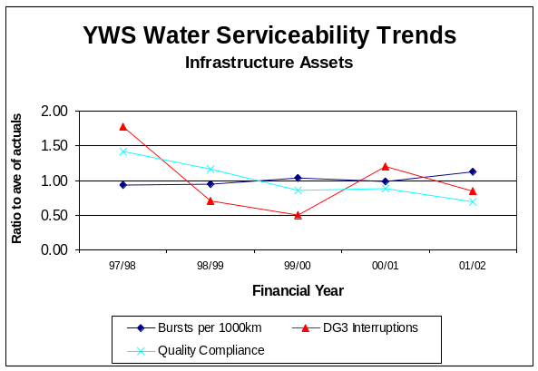The graphs below show the trends for the water infrastructure and non-infrastructure assets:-
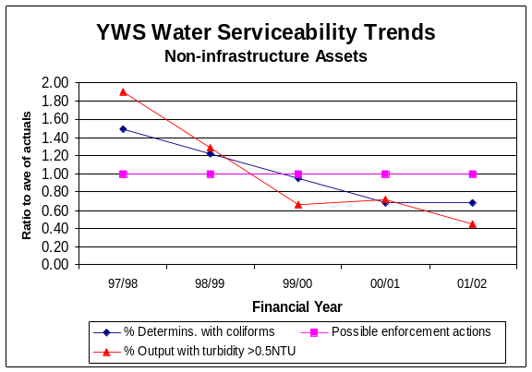

Infrastructure Assets

- [
1 ]
Non-infrastructure Assets

- The improving trend with respect to turbidity is not a good measure of serviceability in the short term. The improvements have been driven by focused investment and operational procedures including:

- Significant, quality funded, investment which has a beneficial effect on turbidity values in final waters eg the addition of further treatment stages such as GAC or manganese removal filters.
- Significant Company investment in the monitoring and control of treatment processes, especially turbidity aimed at minimising the risk from cryptosporidium.
- The adoption by the Company of tighter operational standards for treatment processes
- The reduction in outputs from treatment works as a result of raw water condition deteriorating. The closure of old treatment works and a number of small rural sites where chlorination was the only process.

- [ 1 ]

Sewerage

- 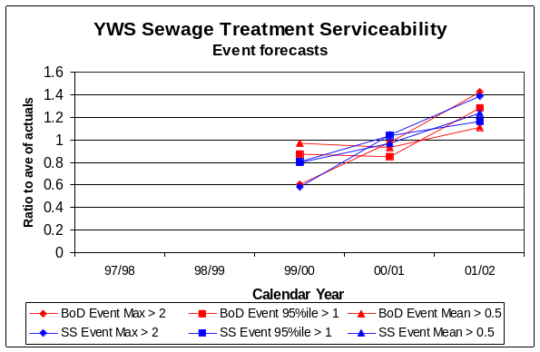The graphs below show the trends for the sewerage infrastructure and non-infrastructure assets:-
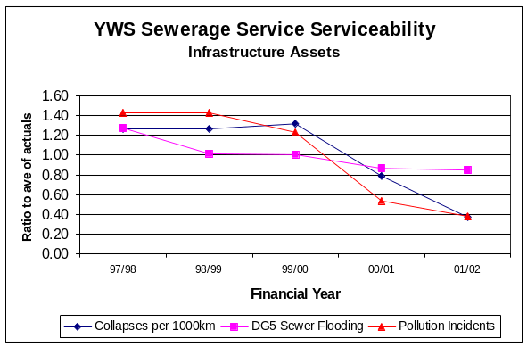

Infrastructure Assets

- [ 1 ]

- [ 1 ]

Non-infrastructure Assets

- [ 2 ]

- [ 4 ]

CHAPTER 2: FINANCIAL PERFORMANCE MEASURES

- Table 6 below shows the financial results for the regulated business for the financial year 2001/02 compared with 2000/01.

Table 6: Financial results for the regulated business at outturn prices
 | 2000/01*  £m | 2001/02  £m
Turnover  Operating costs  Historical cost depreciation  Infrastructure renewals charge  Operating income  Goodwill amortisation | 542.6  (218.2)  (89.2)  (30.8)  6.7  (0.9) | 560.4  (213.4)  (92.7)  (33.5)  2.3  (1.0)
Operating profit  Other income  Interest | 210.2  2.0  (56.9) | 222.1  1.5  (64.1)
Profit before tax  Taxation  Deferred tax | 155.3  (18.8)  (11.7) | 159.5  1.6  (15.6)
Profit for year  Dividends | 124.8  (193.5) | 145.5  (98.3)
Retained profit | (68.7) | 47.2
Key ratios:  Interest cover  Dividend cover (excluding efficiency dividend)  Gearing (Debt/(Debt+Equity)) | 3.7  1.3  38.9% | 3.5  1.5  40.1%
Net cashflow from operating activities  Net debt | 337.1  960.7 | 348.0  1,042.0
* 2000/01 figures have been adjusted to incorporate restated figures submitted to OFWAT in October 2001 which reduced both turnover and operating costs by £1.0m to eliminate the double-counting of recharges to Loop. A similar adjustment of £0.8m has been included in current year figures. In addition, comparative figures have been restated to include a deferred tax charge which has been introduced into this year's numbers for the first time and necessitated a substantial prior year adjustment.

Profitability

- Profit before tax increased by £4.2m (2.7%) to £159.5m from 2000/01, chiefly due to the increase in turnover and reduction in operating costs decribed below. These have been offset by increases in depreciation (£3.5m) and infrastructure renewals charge (£2.7m), arising from the increased capital programme, and a reduction in operating income of £4.4m, principally due to a large one-off asset sale in 2000/01. Increased interest charges of £7.2m have also impacted on profitability. There has been a significant reduction in the tax charge for 2001/02 due to an increase in capital expenditure eligible for 100% tax allowances and a tax credit of £5 million in respect of previous years. A deferred tax charge has been included in the accounts to comply with FRS 19 and a comparative figure has been calculated for 2000/01.
Turnover

Regulated turnover increased by £17.8m (3.3%) compared with the weighted average charges increase of 3.2%. There has been an increase in income from new domestic and commercial customers of £3.7m, but this has been offset by a reduction in income of £3.4m arising due to domestic meter options. [ 2 ]

Operating costs

- Regulated operating costs have reduced by £4.8m (2.2%) from £218.2m in 2000/01 to £213.3m, which represents an outperformance of the Final Determination figure by [ 1 ]. There have been significant efficiency savings of [ 1 ] offset by the operating cost effects of capital schemes of [ 1 ]. A reduction in restructuring costs of £2.8m has also contributed.

- Significant additional costs not allowed for in the Final Determination have also been incurred. These include:

- Additional monitoring for cryptosporidium
- Additional pumping and chemical costs due to increased demand for water as a result of dry weather
- Deteriorating raw water quality resulting in additional chemical and pumping costs
- Dealing with a higher than normal level of burst mains
- Restructuring
- Climate change levy
- Bad debts

- Deteriorating raw water quality is a significant issue for us due to a large proportion of our water deriving from upland supplies. We would expect this factor to be taken into account in Ofwat’s comparative efficiency analysis.

Dividends

- The base dividend was increased by 2.7% in line with our forecast of RPI. The reduction compared to last year is due to the efficiency dividend paid in 2000/01.

Financial ratios

- Interest cover continues to reduce and gearing increase as net debt increases.

Capital Investment

- Our overall capital investment in 2001/02 was £325 million, compared with [ 1 ]
- The foot and mouth epidemic had a considerable impact on the delivery of some water quality schemes, particularly those that involved pipe laying across agricultural land.[ 1 ]

- Within the waste water quality programme one scheme at Kirkby Malzeard, was delayed beyond the original regulatory compliance date due to the foot and mouth epidemic.

Capital maintenance and broad equivalence

- During 2001/02, expenditure on the capital maintenance of non-infrastructure assets amounted to £95.3 million, compared with Current Cost Depreciation (CCD) on base assets of £122.1 million. As such there is not a demonstration of broad equivalence between CCD on base assets and capital maintenance expenditure on non-infrastructure assets, nor is it anticipated that broad equivalence will occur over the remainder of the AMP3 period. However, we believe this is due to insufficient maintenance expenditure having been allowed at the 1999 Final Determination and therefore our actual capital maintenance expenditure being artificially low.

- Capital investment on infrastructure renewals (net) amounted to £47.1 million in 2001/02, which is consistent with the forecast expenditure on which the infrastructure renewals charge is based.

Financial impact of logging up items

Potential new obligations

- [

1

]

- [

1

]

- [

1

]

- [

1

]

- [

1

]

- [

1

]

- [

1
]

Relevant Change of Circumstance

- [
1

]

Notified Item

- [

1
]

CHAPTER 3: KEY SUPPORTING INFORMATION

Capital Maintenance Activity

- Water service and sewerage service activity levels are in many areas ahead of those indicated in our Monitoring Plan. This has included capital expenditure greater than £0.5 million on each of ten water treatment works and eight major sewage treatment works.

Enhanced Service Level Activity

- Our improved service levels are shown in Tables 1 and 2 of Chapter 1. In our Monitoring Plan we committed to provide enhanced service levels on DG2 (inadequate pressure), and we are well-placed to meet the commitment made.

- With respect to DG5 (sewer flooding), our capital expenditure of around £2.8 million in 2001/02 has contributed to the improvements made in this level of service.

Water Resources, Supply and Demand

- We carried out the “Annual Review of the Final Water Resources Plan” in accordance with EA guidance in September 2001. The following changes to the original plan were reported:

- The incorporation of the area formerly supplied by York Waterworks plc
- A revised demand forecast following Ofwat’s final determination of price limits
- A revised regional leakage target of 301 Ml/d for 2001/02 and 300 Ml/d for 2002/03

- Dry weather conditions during 2001/02 led to an increase in customer demand with a significant summer peak in July. The dry year effect was estimated at 24 Ml/d which is just under half the dry year demand included in the Water Resources Plan. We have calculated the security of supply index score in accordance with the guidance set out in RD 23/01. The score for both the company’s planned level of service and the reference level of service given in the 1997 Reassessment of Water Company Yields is 100.

- During 2001/02 21,011 customers opted to be charged by meter and 648 were metered as they met the criteria for selective metering. We continue to build on the progress we have made in promoting the efficient use of water with both households and businesses.

- The implementation of the 1999 Water Resource Plan with its twin-track approach towards water resource management, through the renewal of the time-limited licences and demand management through leakage reduction, ensures a flexible response to year on year changes in available resources and demand.

- The abstraction licence studies funded as part of the 1999 Final Determination quality investment relating to habitats are progressing and the results will be reported to the EA and English Nature over the coming year. They will be incorporated in the assessment of the supply/demand balance for PR04.

CHAPTER 4: EFFICIENCIES

Capital Efficiencies

- [

1

]

- The capital efficiencies are being delivered through positive management actions across a range of initiatives. These include innovative procurement processes with the development of new contracting strategies for capital schemes together with framework contracts for the supply and replacement of key items of equipment. Our Research and Development Team have developed modifications to treatment processes to facilitate delivery of a range of quality enhancement outputs which will enable these to be delivered at reduced whole life costs.

Operating cost efficiencies

- We have delivered net efficiency savings against the 1999 final determination base operating costs of [ ], during 2001/02. The reduction in operating costs has been achieved primarily through the implementation of our Change Programme of organisational development and business process improvement. This has involved;

- Devolvement of budgets and business planning to operational managers
- Managing employee numbers
- Controlling day-to-day operating costs
- Utilising new computer systems
- Improving working practices.

- The savings have been achieved whilst maintaining and improving outputs and customer service.
CHAPTER 5: COMPETITION

Inset appointments

- YWS has not been involved with any inset appointment proposals in 2001/02.

Common Carriage

- Development of the YWS Network Access Code and documentation continues in line with recent Ofwat guidance. We remain involved in industry research initiatives looking at the development of competition, access codes and commercial frameworks and have responded positively to Ofwat consultation and information requirements regarding access prices.

Provision of new water mains and service pipes

- YWS is updating its policy on the self lay of water mains and service pipes in line with the guidance issued by Ofwat.

Development of competition

- On 19th March 2002, Environment Minister Michael Meacher announced the Government’s proposals for developing competition via common carriage. The proposals restrict common carriage opportunities to non-household customers using more than 50 Ml/a, and there will be a requirement for new entrants to be licensed. Whilst we note that these proposals reduce the potential for risks to public health and de-averaging of charges compared with universal common carriage, we remain concerned that the development of competition should be within a well managed and sustainable framework. At present there seem to be substantial risks and uncertainties for customers, the environment and water companies.

- The previous Director General opposed mergers between the water and sewerage companies on the grounds that this would lead to the loss of comparators, and thus reduce his ability to use comparative competition in the exercise of his duties. We believe that Ofwat should now review this approach and particularly its valuation of comparators which we believe has overstated their value, and that mergers should be allowed to proceed where the benefits of merging exceed the value of the lost comparator.

Signed on behalf of the Yorkshire Water Services Limited Board of Directors

Signed………………………………………………. Date…………………..

Kevin Whiteman, Managing Director, Yorkshire Water Services Limited

