Name: Oscar Boateng Acheampong

Date: November 16th, 2022

Assignment No.: Module 6.2 - Movies Setup

Github: <https://github.com/dboat10/csd-310.git>

db_init_2022 execution

Show Tables

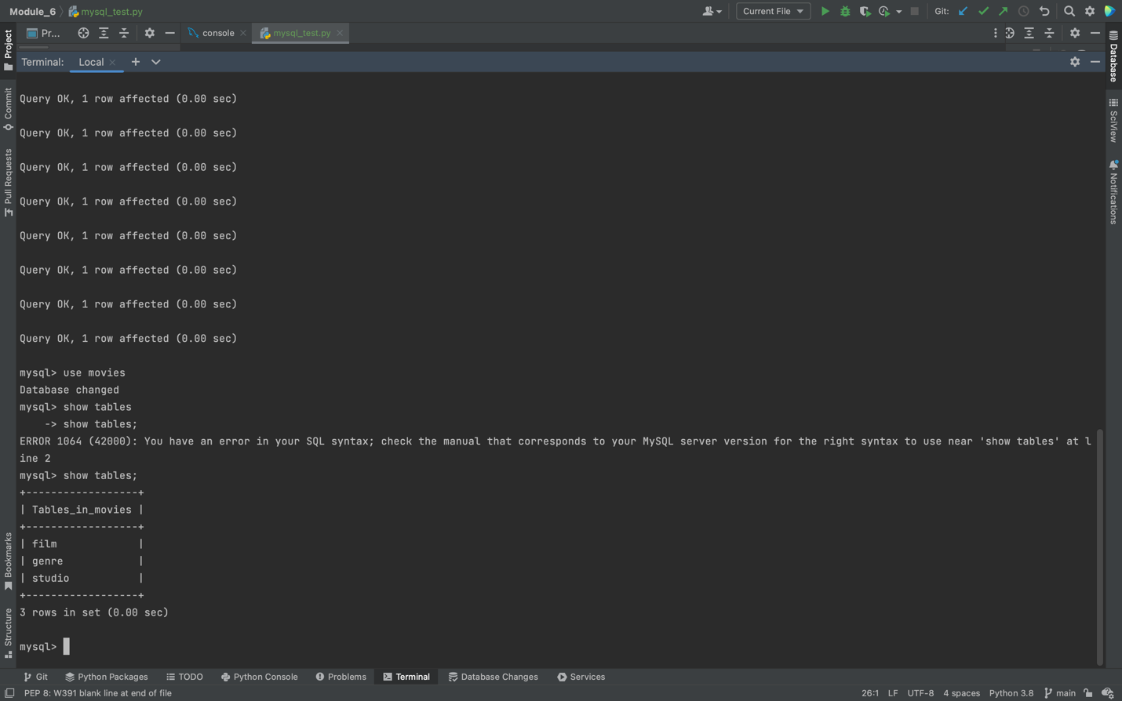

Mysql_test.py

