Name: Oscar Boateng Acheampong

Date: November 23rd, 2022

Assignment No.: Module 7.2 – Table Queries

Git Link: <https://github.com/dboat10/csd-310.git>

Query Result

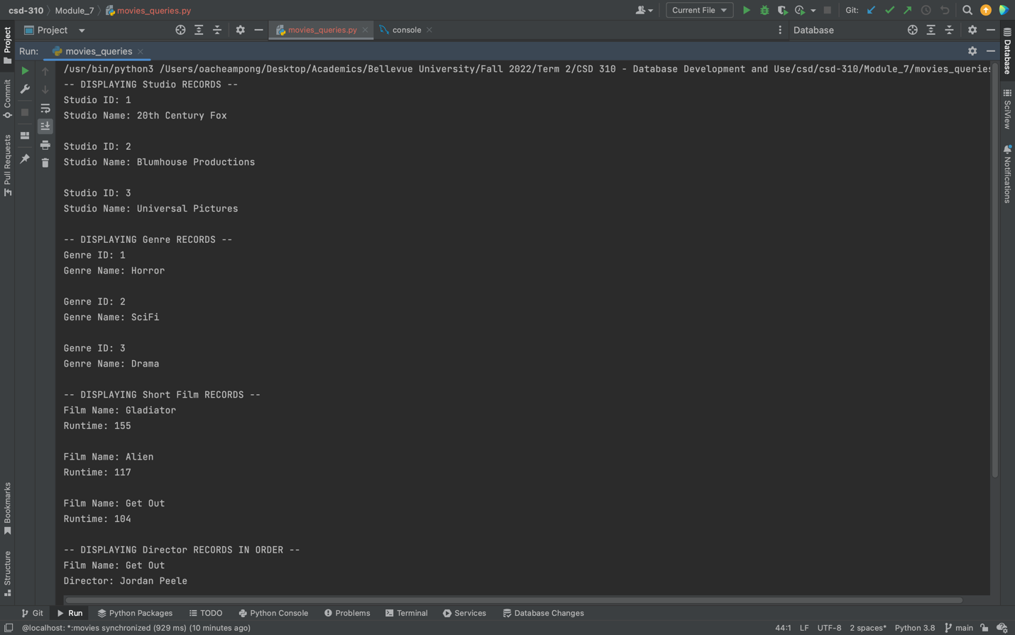

Director Result…

