Name: Oscar Boateng Acheampong

Date: October 30th, 2022

Assignment No.: Module 2.3 Data Models

ERD

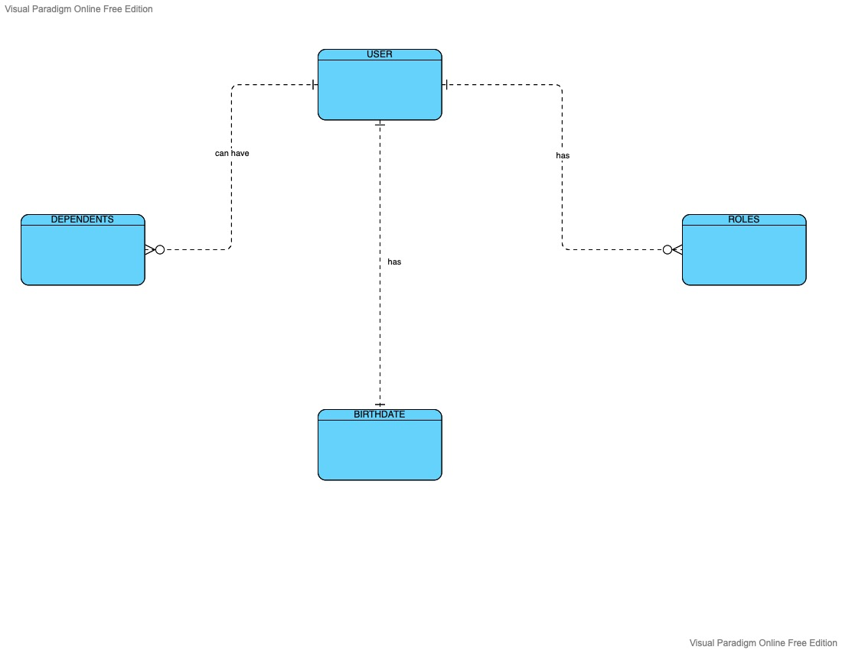

NoSQL Database Structure

