Hannah and the birth of Samuel

1 Samuel 1:1-2:11
Key Verse: 1:10-11

- Introduction
- Where does 1 Samuel fit chronologically in the history of Israel — in what time period is it? (1 Sa 4:18; 7:15-17) What makes 1 Samuel a significant book in Israel’s history? What transition occurs to the nation in the course of 1 Samuel?

- Look up the following passages in Judges and note what you learn about these times: (Judges 2:11-19; 17:6; 18:1; 19:1; 21:25) What can you learn from the following chart?

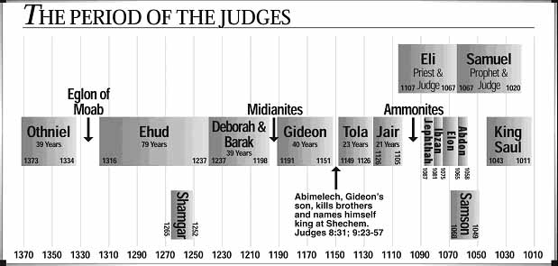

- Do an observation study on 1 Samuel 1:1-2:11. Write down any key repeated words or phrases.

- Hannah prays with a vow (1:1-20)
- How is Elkanah’s family described? (1:1-2; Jdg21:25; for more on Elkanah, see 1Ch6:1,25-27) What were the agonies of this family and how were these exposed in their annual worship at Shiloh? (1:3-8) What does “the Lord had closed Hannah’s womb” imply? Why was Hannah not satisfied with Elkanah’s love? (1:8)

- Read 1:9-11. What was Hannah’s condition? What did she do and how was she different from Peninnah? In her prayer, about what was she mainly concerned? (1:11a) For what did she ask God? What did she vow to God, and what does this reveal about her?

- How is Hannah’s prayer described? (1:12-13a,15-16) Why did she devote herself to prayer like this? (Ps18:6) Who was Eli, how did he misunderstand, and why? (1:9,13b-14) How did she answer respectfully, and how did he bless her? (1:15-17) After prayer, how was she different? (1:18; 1Jn5:14-15) How did God answer her? (1:19-20)

- Look up the meaning of Samuel’s name. Does his name tell you anything about the reason for his existence? Look at the birth of the following men and how each compares with the birth of Samuel. Is there anything they hold in common? If so, what and how? (a. Isaac—Genesis 11:29-30; 15:2-4; 17:15-19; 18:9-14 b. Jacob and Esau—Genesis 25:19-26 c. Samson—Judges 13:1-7, 24-25 d. John—Luke 1:5-17)

- In light of what you have learned in respect to the birth of these men, look at the birth of others and see what we can learn. (a. Genesis 29:30-32 b. Genesis 30:1-2, 22-24 c. Deuteronomy 32:39 d. Ruth 4:13 e. Psalm 139:13-16) What have you learned about a person’s existence? What does this tell you about the value of a person’s life?

- Hannah keeps her vow (1:21-28)
- How did Elkanah continue to serve God and give a good influence to Hannah? (1:21-23) What was her plan? (1:22)

- After being childless for so long, how might Hannah have felt toward Samuel? After weaning him, what did she do? (1:24-25) What did she say to Eli? (1:26-28) In what ways did she express her faith? (see also 2:11) How did God continue to bless her? (2:20-21)

- Hannah praises the Lord (2:1-11)
- In her prayer, what was Hannah’s source of joy? (2:1) Through her struggles what did she come to learn about God and his sovereignty? (2:2-9) What was her vision? (2:10)

