<< Path Engine >>
- How to organize your data.
    - Export the data using the terrain tool
    - wfifXXX.peh files and wfifXXX.pep files.
  - Organize the above files into the following folders.

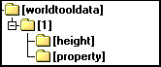

    - Create a folder with a terrain table index.
    - In the above figure, "1" is the folder.
    - Create a worldinfo.xml file in the folder and write it in the following format.
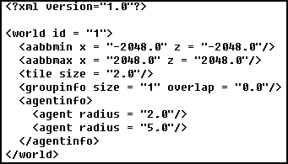
      - world id : world table index.
      - aabbmin : The minimum location of the terrain.
      - aabbmax : Maximum location of the terrain.
      - tile size : Size of tiles (dungeon: 2, main world: 4)
      - groupinfo : About building pass data
        - size : Information about how many fields are to be exported.
        - overlap : distance of overlap between groups.
      - agentinfo : Information on MOB and NPCs making directions
        - agent radius: building information of MOB and NPC with corresponding size as radius
    - Height Put wfifXXX.peh files in the folder.
    - Property Put the wfifXXX.pep files in the folder.

  - Launch the provided "NaviTool".

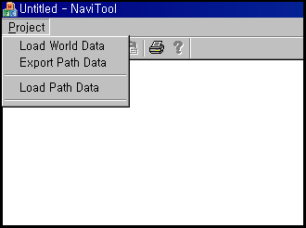

  - Load World Data to load the previously configured data.
    - In the above example, 1.B. You can specify the "worldtooldata" folder in the figure provided in.
  - If you click Export Path Data to specify a folder, the path data used in the actual game will be exported to that folder. You can pass the data from here to the server team.

< Note >
I did not explain the function called Load Path Data in the above figure. I will update this document when I provide additional functions in the future.

