Dan Bonnett
CMPSCI 381 Lab 12
Final Project
Due Date: 5/03/2016

Honor Code: This work is my own unless otherwise cited.

Server output when user enters GET http://cs.allegheny.ed/sites/rroos/index.html HTTP/1.1
This request is not a forbidden request and no cache file exists for it yet.

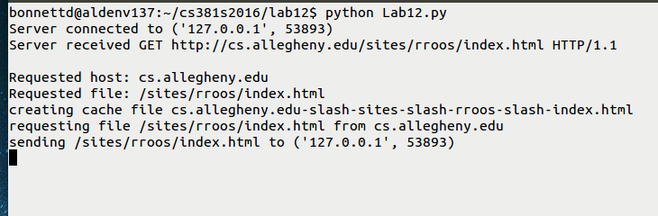
Client output for the same test:

bonnettd@aldenv137:~/cs381s2016/lab12$ telnet localhost 12345
Trying ::1...
Trying 127.0.0.1...
Connected to localhost.
Escape character is '^]'.
GET http://cs.allegheny.edu/sites/rroos/index.html HTTP/1.1
HTTP/1.1 200 OK
Date: Fri, 29 Apr 2016 02:13:46 GMT
Server: Apache/2.2.22 (Ubuntu)
Last-Modified: Fri, 22 Jan 2016 01:33:28 GMT
ETag: "1a2c2d-10fe-529e234c2a5bb"
Accept-Ranges: bytes
Content-Length: 4350
Vary: Accept-Encoding
Connection: close
Content-Type: text/html

<!DOCTYPE html>
<html class="full" lang="en">

<head>
<meta charset="UTF-8">
<meta name="viewport" content="width=device-width, initial-scale=1.0">
<!--<meta name="description" content="">-->
<!--<meta name="author" content="">-->

<title>Bob Roos</title>
…. many lines omitted
</html>
Connection closed by foreign host.

Server output for the second time the user enters
GET http://cs.allegheny.edu/sites/rroos/index.html HTTP/1.1
The cache file for this site already exists this time.

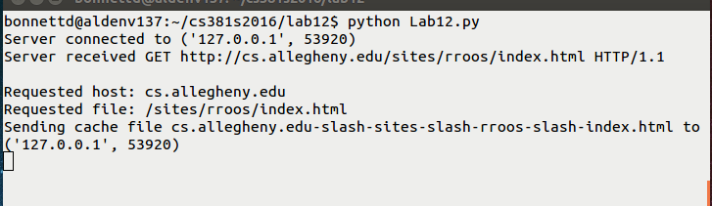
Client output for the same test:

bonnettd@aldenv137:~/cs381s2016/lab12$ telnet localhost 12345
Trying ::1...
Trying 127.0.0.1...
Connected to localhost.
Escape character is '^]'.
GET http://cs.allegheny.edu/sites/rroos/index.html HTTP/1.1
HTTP/1.1 200 OK
Date: Fri, 29 Apr 2016 02:13:46 GMT
Server: Apache/2.2.22 (Ubuntu)
Last-Modified: Fri, 22 Jan 2016 01:33:28 GMT
ETag: "1a2c2d-10fe-529e234c2a5bb"
Accept-Ranges: bytes
Content-Length: 4350
Vary: Accept-Encoding
Connection: close
Content-Type: text/html

<!DOCTYPE html>
<html class="full" lang="en">

<head>
<meta charset="UTF-8">
<meta name="viewport" content="width=device-width, initial-scale=1.0">
<!--<meta name="description" content="">-->
<!--<meta name="author" content="">-->

<title>Bob Roos</title>
…. many lines omitted
</html>
Connection closed by foreign host.
Server output when user enters
GET http://cs.allegheny.edu/sites/jwenskovitch HTTP/1.1
This is a forbidden request.
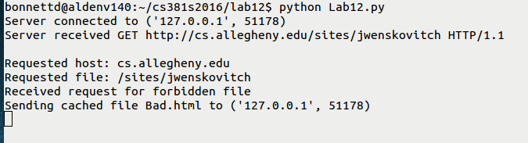
Client output for the same run:

GET http://cs.allegheny.edu/sites/jwenskovitch HTTP/1.1
HTTP/1.1 403 Forbidden
Date: Thu, 28 Apr 2016 20:12:05 GMT
Server: Apache
Location:
Vary: Accept-Encoding
Expires: Thu, 28 Apr 2016 20:17:05 GMT
Keep-Alive: timeout=10, max=41
Connection: Close
Content-Type: text/html; charset=iso-8859-1

<!DOCTYPE HTML PUBLIC "-//IETF//DTD HTML 2.0//EN">
<html><head>
<title>403 Bad Request</title>
</head><body>
<h1>403 Forbidden</h1>
<p>You are not allowed to access this site "http://aldenv29.allegheny.edu/sites/jwenskovitch/".</p>
<hr>
<address>Apache/2.2.22 (Ubuntu) Server at aldenv29.allegheny.edu Port 80</address>
</body></html>
Connection closed by foreign host.

Server Output when user enters GET http://apple.com/iphone HTTP/1.1
This is a forbidden request.

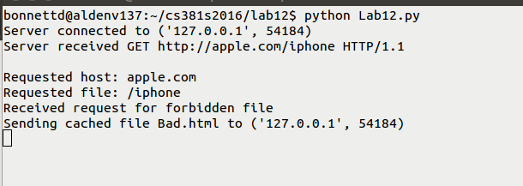

Client output for the same run:

GET http://apple.com/iphone HTTP/1.1
HTTP/1.1 403 Forbidden
Date: Thu, 28 Apr 2016 20:12:05 GMT
Server: Apache
Location:
Vary: Accept-Encoding
Expires: Thu, 28 Apr 2016 20:17:05 GMT
Keep-Alive: timeout=10, max=41
Connection: Close
Content-Type: text/html; charset=iso-8859-1

<!DOCTYPE HTML PUBLIC "-//IETF//DTD HTML 2.0//EN">
<html><head>
<title>403 Bad Request</title>
</head><body>
<h1>403 Forbidden</h1>
<p>You are not allowed to access this site "http://aldenv29.allegheny.edu/sites/jwenskovitch/".</p>
<hr>
<address>Apache/2.2.22 (Ubuntu) Server at aldenv29.allegheny.edu Port 80</address>
</body></html>
Connection closed by foreign host.

