A

Mini-Project Report
on

Student Grade Prediction

Submitted as partial fulfilment for the award of

BACHELOR OF TECHNOLOGY DEGREE
Session 2022-23
in

Computer Science & Engineering (Data Science)
Submitted By:
Chaman Pandey 200097540021
Aman Soni 2000971540007
Ambrish Kumar 2000971540008
Under the guidance of:

Mr. Mohit Chowdhary

Assistant Professor



DEPARTMENT OF COMPUTER SCIENCE AND ENGINEERING
GALGOTIAS COLLEGE OF ENGINEERING AND TECHNOLOGY, GREATER NOIDA

AFFILIATED TO
DR. A.P.J ABDUL KALAM TECHNICAL UNIVERSITY, LUCKNOW, UP
(Formerly UPTU)

 | GALGOTIAS COLLEGE OF ENGINEERING & TECHNOLOGY  GREATER NOIDA, UTTER PRADESH, INDIA- 201306.

CERTIFICATE

This is to certify that the mini-project report entitled “Student Grade Prediction” submitted by Mr./Ms. Chaman Pandey Roll no : 2000971540021 , Mr. Aman Soni Roll No : 2000971540007, Mr. Ambrish Kumar Roll No: 2000971540008 to the Galgotias College of Engineering & Technology, Greater Noida, Utter Pradesh, affiliated to Dr. A.P.J. Abdul Kalam Technical University Lucknow, Uttar Pradesh in partial fulfillment for the award of Degree of Bachelor of Technology in Computer science & Engineering is a bonafide record of the project work carried out by them under my supervision during the year 2021-2022.

Mr. Mohit Chowdhary (Project Coordinator)  Assistant professor  Deptt. of CSE | Dr. Vishnu Sharma  Professor and Head  Deptt. of CSE

GALGOTIAS COLLEGE OF ENGINEERING & TECHNOLOGY
GREATER NOIDA, UTTER PRADESH, INDIA- 201306.

ACKNOWLEDGEMENT
We have taken efforts in this project. However, it would not have been possible without the kind support and help of many individuals and organizations. We would like to extend my sincere thanks to all of them.
We are extremely indebted to Dr. Vishnu Sharma, HOD, Department of Computer Science and Engineering, GCET and Mr. Mohit Chowdhary, Project Coordinator, Department of Computer Science and Engineering, GCET for their valuable suggestions and constant support throughout my project tenure. We would also like to express our sincere thanks to all faculty and staff members of Department of Computer Science and Engineering, GCET for their support in completing this project on time.

We also express gratitude towards our parents for their kind co-operation and encouragement which helped me in completion of this project. Our thanks and appreciations also go to our friends in developing the project and all the people who have willingly helped me out with their abilities.

Chaman Pandey

Aman Soni

Ambrish Kumar

ABSTRACT

Logistic regression is a classification model in machine learning, extensively used in clinical analysis. It uses probabilistic estimations which helps in understanding the relationship between the dependent variable and one or more independent variables. Diabetes, being one of the most common diseases around the world, when detected early, may prevent the progression of the disease and avoid other complications. In this work, we design a prediction model, that predicts whether a patient has diabetes, based on certain diagnostic measurements included in the dataset, and explore various techniques to boost the performance and accuracy.

TABLE OF CONTENT

S. No. | CONTENT | PAGE NO.
 | TITLE PAGE  CERTIFICATE  ACKNOLEDGEMENT  ABSTRACT | i  ii  iii  iv
1. | INTRODUCTION | 1
2. | LITERATURE REVIEW  2.1. RELATED LITERATURE REVIEW | 2
3. | PROBLEM FORMULATION (PROBLEM STATEMENT)  3.1. DESCRIPTION OF PROBLEM DOMAIN  3.2. PROBLEM STATEMENT | 4
4. | PROPOSED WORK AND SYSTEM DESIGN  4.1. SYSTEM REQUIREMENTS  4.2. SYSTEM DESIGN | 5
5. | IMPLEMENTATION  5.1. EXPERIMENTAL SETUP (TRAINING AND TESTING PHASE)  5.2. DATASET DECRIPTION | 9
6. | RESULT AND DEMONSTRATION  6.1. RESULT ANALYSIS | 13
7. | CONTRIBUTION OF PROJECT TO THE SOCIETY | 15
8. | CONCLUSION, LIMITATION AND FUTURE SCOPE  8.1. CONCLUSION  8.2. LIMITATION  8.3. FUTURE SCOPE | 16
9. | REFERENCES | 17

Introduction

In the present educational systems, student performance is getting worsen everyday gradually. Predicting student performance in advance can help students as well as their teachers to keep track of progress of the student. Many educational institutes have adopted continuous evaluation system today. Such systems are favourable to the students in improving their performance . The purpose of the continuous evaluation system is to help the regular students in their academics. In continuous evaluation system, unit tests or class tests are conducted at regular period. To have consistent performance in the final grade it is required to appear in all the unit tests or class test. The core function of Student Grade Prediction is to help the student to know his/her performance in advance by using univariance Linear Regression Model. Such techniques would help the students to improve their performance based on the predicted grade and would enable teachers to identify those individuals who might need assistance.
CHAPTER 2
LITERATURE REVIEW & RECENT WORK

2.1. Related Literature Review
Numerous research studies have been conducted to predict students’ academic performance either to facilitate degree planning or to determine students at risk.
2.1. MATRIX FACTORIZATION
(Thai-Nghe et al., 2011) proposed matrix factorization models for predicting student performance of Algebra and Bridge to Algebra courses. The factorization techniques are useful in case of sparse data and absence of students’ background knowledge and tasks. They split the data into trainset and testset. The data represents the log files of interactions between students and computer aided tutoring systems. (Thai-Nghe et al., 2011) extended the research and used tensor-based factorization to predict student success. They formulated the problem of predicting student performance as a recommender system problem and proposed tensor-based factorization techniques to add the temporal effect of student performance. The system saves success/failure logs of students on exercises as they interact with the system.
2.2. PERSONALIZED MULTI-LINEAR REGRESSION MODELS (PLMR)
Grade prediction accuracy using Matrix Factorization (MF) method degrades when dealing with small sample sizes. (Elbadrawy et al., 2016) investigated different recommender system techniques to accurately predict the students’ next term course grades as well as within the class assessment performance of George Mason University (GMU), University of Minnesota (UMN) and Stanford University (SU). Their study revealed that both Personalized Multi-Linear Regression models (PLMR) and advance Matrix Factorization (MF) techniques could predict next term grades with lower error rate than traditional methods. PLMR was also useful for predicting grades on assessments within a traditional class or online course by incorporating features captured through students’ interaction with LMS and MOOC server logs.
2.3. REGRESSION AND CLASSIFICATION MODELS
The final grade prediction based on the limited initial data of students and courses is a challenging task because, at the beginning of undergraduate studies, most of the students are motivated and perform well in the first semester but as the time passed there might be a decrease in motivation and performance of the students. (Meier et al., 2016) proposed an algorithm to predict the final grade of an individual student when the expected accuracy of the prediction is sufficient. The algorithm can be used in both regression and classification settings to predict students’ performance in a course and classify them into two groups (the student who perform well and the student who perform poorly). Their study showed that in-class exams were better predictors of the overall performance of a student than the homework assignment. The study also demonstrated that timely prediction of the performance of each student would allow instructors to intervene accordingly. (Zimmermann et al., 2015) considered regression models in combination with variable selection and variable aggregation approach to predict the performance of graduate students and their aggregates. They have used a dataset of 171 students from Eidgen¨ossische Technische Hochschule (ETH) Z¨urich, Switzerland. According to their findings, the undergraduate performance of the students could explain 54% of the variance in graduatelevel performance. By analyzing the structure of the undergraduate program, they assessed a set of students’ abilities. Their results can be used as a methodological basis for deriving principle guidelines for admissions committees.
2.4. MULTILAYER PERCEPTRON NEURAL NETWORK
Educational Data Mining utilizes data mining techniques to discover novel knowledge originating in educational settings (Baker and Yacef, 2009). EDM can be used for decision making in refining repetitive curricula and admission criteria of educational institutions (Calders and Pechenizkiy, 2012). (Saarela and K¨arkk¨ainen, 2015) applied the EDM approach to analyze the effects of core Computer Science courses and provide novel information for refining repetitive curricula to enhance the success rate of the students. They utilized the historical log file of all the students of the Department of Mathematical Information Technology (DMIT) at the University of Jyv¨askyl¨a in Finland. They analyzed patterns observed in the historical log file from the student database for enhanced profiling of the core courses and the indication of study skills that support timely and successful graduation. They trained multilayer perceptron neural network model with crossvalidation to demonstrate the constructed nonlinear regression model. In their study, they found that the general learning capabilities can better predict the students’ success than specific IT skills.
2.5. FACTORIZATION MACHINES (FM)
Next term grade prediction methods are developed to predict the grades that a student will obtain in the courses for the next term. (Sweeney et al., 2015) developed a system for predicting students’ grades using simple baselines and MF-based methods for the dataset of George Mason University (GMU). Their study showed that Factorization Machines (FM) model achieved the lowest prediction error and can be used to predict both cold-start and non-cold-start predictions accurately. In subsequent studies, (Sweeney et al., 2016) explored a variety of methods that leverage content features. They used FM, Random Forests (RF), and the Personalized MultiLinear Regression (PMLR) models to learn patterns from historical transcript data of students along with additional information about the courses and the instructors teaching them. Their study showed that hybrid FM-RF and the PMLR models achieved the lowest prediction error and could be used to predict grades for both new and returning students.
2.6. DROPOUT EARLY WARNING SYSTEM (DEWS) Dropout early warning systems help higher education institutions to identify students at risk, and to identify interventions that may help to increase the student retention rate of the institutes. (Knowles, 2015) utilized the Wisconsin DEWS approach to predict the student dropout risk. They introduced flexible series of DEWS software modules that can adapt to new data, new algorithms, and new outcome variables to predict the dropout risk as well as impute key predictors.
2.7. HIDDEN MARKOV MODEL AND BAYESIAN KNOWLEDGE TRACING
Hidden Markov model has been used widely to model student learning. (Van De Sande, 2013) investigated solutions of hidden Markov model and concluded that the utilization of a maximum likelihood test should be the preferred method for finding parameter values for the hidden Markov Model. (Hawkins et al., 2014) in a separate study developed and analyzed a new fitting procedure for Bayesian Knowledge Tracing and concluded that empirical probabilities had the comparable predictive accuracy to that of expectation maximization. In Table 1, we have systematically summarized the studies that are related to our study in a comprehensive way to present a big picture of literature. Our work is related to grade prediction systems, recommender systems, and early warning systems within the context of education. In our study, the approach is to use machine learning techniques to predict course grades of students. We used the state of the art techniques that are described and implemented in this section to do a comparative analysis of different techniques that can predict students’ GPA in registered courses. We also develop a model that can be used in a tutoring system indicating the weak students in the course to the instructor and providing early warnings to the student if he/she needs to work hard to complete the course.

CHAPTER 3

PROBLEM FORMULATION

3.1 Description of problem Domain
Machine Learning with EDM has gained much more attention in the last few years. Many machine learning techniques, such as collaborative filtering (Toscher and Jahrer, 2010), matrix factorization (Thai-Nghe et al., 2011), and artificial neural networks (Wang and Liao, 2011) are being used to predict students’ GPA or grades. In this section, we will describe these machine learning techniques and how they are being used to predict students’ GPA in registered courses within the context of education.

3.2. Problem Statement

The problem statement can be defined as follows ”Given a dataset containing attribute of 396 Portuguese students where using the features available from dataset and define classification algorithms to identify whether the student performs good in final grade exam, also to evaluate different machine learning models on the dataset.”

CHAPTER 4

PROPOSED WORK AND SYSTEM DESIGN

4.1. Proposed Work
This data approach student achievement in secondary education of two Portuguese schools. The data attributes include student grades, demographic, social and school-related features) and it was collected by using school reports and questionnaires. Two datasets are provided regarding the performance in two distinct subjects: Mathematics (mat) and Portuguese language (por). In [Cortez and Silva, 2008], the two data sets were modeled under binary/five-level classification and regression tasks. Important note: the target attribute G3 has a strong correlation with attributes G2 and G1. This occurs because G3 is the final year grade (issued at the 3rd period), while G1 and G2 correspond to the 1st and 2nd period grades. It is more difficult to predict G3 without G2 and G1, but such prediction is much more useful (see paper source for more details).
Attribute Information:
- school - student's school (binary: 'GP' - Gabriel Pereira or 'MS' - Mousinho da Silveira)⎫
- sex - student's sex (binary: 'F' - female or 'M' - male)⎫
- age - student's age (numeric: from 15 to 22)⎫
- address - student's home address type (binary: 'U' - urban or 'R' - rural)⎫
- famsize - family size (binary: 'LE3' - less or equal to 3 or 'GT3' - greater than 3)⎫
- Pstatus - parent's cohabitation status (binary: 'T' - living together or 'A' - apart)⎫
- Medu - mother's education (numeric: 0 - none, 1 - primary education (4th grade), 2 - “⎫ 5th to 9th grade, 3 - “ secondary education or 4 - “ higher education)
- Fedu - father's education (numeric: 0 - none, 1 - primary education (4th grade), 2 - “ 5th⎫ to 9th grade, 3 - “ secondary education or 4 - “ higher education)
- Mjob - mother's job (nominal: 'teacher', 'health' care related, civil 'services' (e.g.⎫ administrative or police), 'at_home' or 'other')
- Fjob - father's job (nominal: 'teacher', 'health' care related, civil 'services' (e.g.⎫ administrative or police), 'at_home' or 'other') reason - reason to choose this school (nominal: close to 'home', school 'reputation',⎫ 'course' preference or 'other')
- guardian - student's guardian (nominal: 'mother', 'father' or 'other')⎫
- traveltime - home to school travel time (numeric: 1 -⎫ 1 hour)
- studytime - weekly study time (numeric: 1 -⎫ 10 hours)
- failures - number of past class failures (numeric: n if 1⎫<=n
4.2. SYSTEM REQUIREMENTS

SYSTEM DESIGN:

Logical Design :
4.1.1.LOGICAL DESIGN :
Data inputs are taken from user. The data are the basic details like number of pregnancies , insulin level , glucose level etc. That data taken from the user is matched with the data stored in the csv file which is collected from the website of PIMA Indian diabetes.
Using logistic regression , the data is matched and then result is predicted according to that.

4.1.2. HARDWARE REQUIREMENTS AND TECHNOLOGIES USED:
The hardware best compatible will be Intel Core i5 (2.4 GHz). Other requirements include SSD hard disk with sufficient storage, RAM of 4GB, and other basic PC components.

4.1.3. SOFTWARE REQUIREMENTS AND TECHNOLOGIES USED:
1. Python & Interpreter
- Python is an interpreted high-level general-purpose programming language.
- Its design philosophy emphasizes code readability with its use of significant indentation.
- Its language constructs as well as its object-oriented approach aim to help programmers write clear, logical code for small and large-scale projects.
2. IDE
- An integrated development environment (IDE) is a software application that provides comprehensive facilities to computer programmers for software development.
- An IDE normally consists of at least a source code editor, build automation tools and a debugger.
- We are using Virtual Studio Code for this project.
3. LIBRARIES
- PANDAS :
pandas is a Python package providing fast, flexible, and expressive data structures designed to make working with “relational” or “labeled” data both easy and intuitive. It aims to be the fundamental high-level building block for doing practical, real-world data analysis in Python. Additionally, it has the broader goal of becoming the most powerful and flexible open source data analysis/manipulation tool available in any language. It is already well on its way toward this goal.
- NUMPY :
NumPy (Numerical Python) is an open source Python library that’s used in almost every field of science and engineering. It’s the universal standard for working with numerical data in Python, and it’s at the core of the scientific Python and PyData ecosystems.
- MATPLOTLIB :
Matplotlib is a comprehensive library for creating static, animated, and interactive visualizations in Python. Matplotlib makes easy things easy and hard things possible.
- Create publication quality plots.
- Make interactive figures that can zoom, pan, update.
- Customize visual style and layout.
- Export to many file formats .
- Embed in JupyterLab and Graphical User Interfaces.
- Use a rich array of third-party packages built on Matplotlib.

CHAPTER 5

IMPLEMENTATION

5.1. PROPOSED METHODOLOGY :
Since universities are prestigious places of higher education, students’ retention in these universities is a matter of high concern. It has been found that most of the students’ drop-out from the universities during their first year is due to lack of proper support in undergraduate courses. Due to this reason, the first year of the undergraduate student is referred as a “make or break” year. Without getting any support on the course domain and its complexity, it may demotivate a student and can be the cause to withdraw the course. There is a great need to develop an appropriate solution to assist students retention at higher education institutions. Early grade prediction is one of the solutions that have a tendency to monitor students’ progress in the degree courses at the University and will lead to improving the students’ learning process based on predicted grades. Using machine learning with Educational Data Mining can improve the learning process of students. Different models can be developed to predict students’ grades in the enrolled courses, which provide valuable information to facilitate students’ retention in those courses. This information can be used to early identify students at-risk based on which a system can 1 suggest the instructors to provide special attention to those students. This information can also help in predicting the students’ grades in different courses to monitor their performance in a better way that can enhance the students’ retention rate of the universities. Using various packages such as cufflinks, seaborn & matplotlib to represent the data along with different attributes graphically or pictorially to analyse the dataset for predicting the Final Grade(G3).
5.2. DATA PREPARATION:
This data approach student achievement in secondary education of two Portuguese schools. The data attributes include student grades, demographic, social and school-related features) and it was collected by using school reports and questionnaires. Two datasets are provided regarding the performance in two distinct subjects: Mathematics (mat) and Portuguese language (por). In [Cortez and Silva, 2008], the two data sets were modeled under binary/five-level classification and regression tasks. Important note: the target attribute G3 has a strong correlation with attributes G2 and G1. This occurs because G3 is the final year grade (issued at the 3rd period), while G1 and G2 correspond to the 1st and 2nd period grades. It is more difficult to predict G3 without G2 and G1, but such prediction is much more useful

5.2. TRAINING AND EVALUATION OF MODEL :
We have stored the data set stored in CSV format in which data of 768 patients is taken and the file name is “diabetes.csv”.

5.3. MAIN LOGIC FOR THE MODEL :
We will take entries from the user and those will be matched with the data stored in the CSV file and accordingly the most accurate possible result is shown.

We have used the following code:

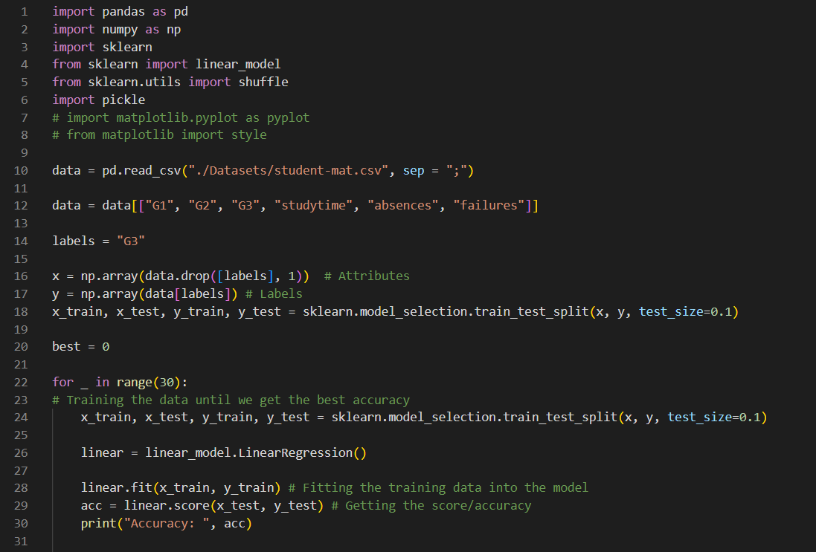

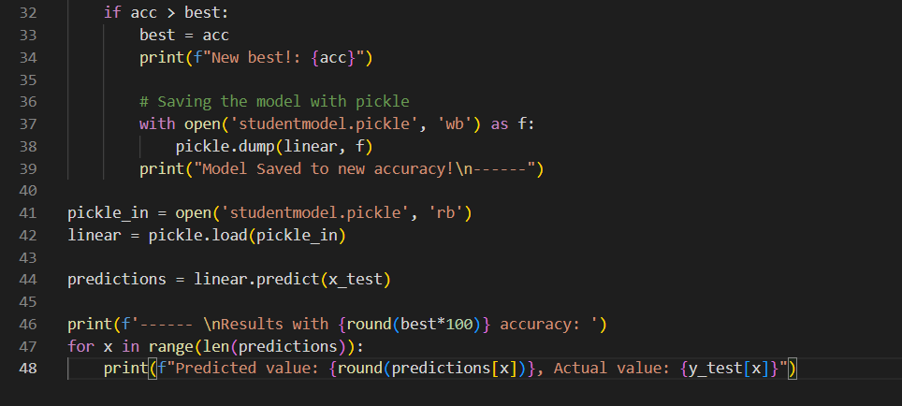

CHAPTER 6

RESULTS AND DEMONSTRATION
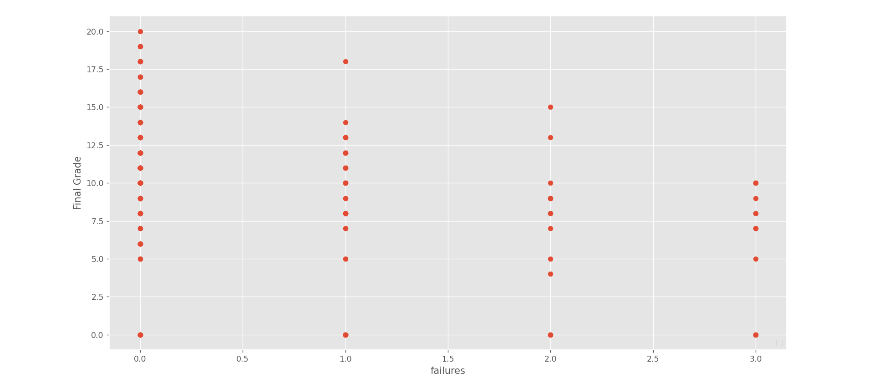

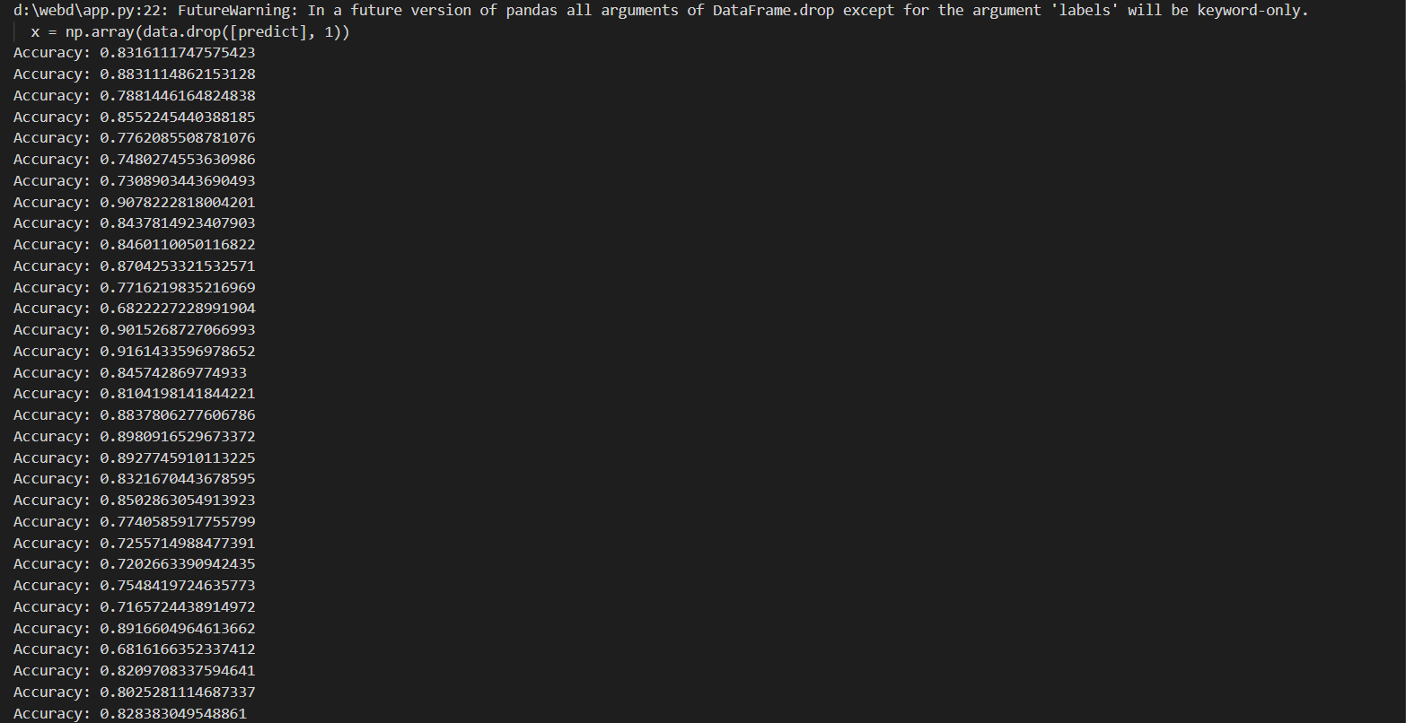

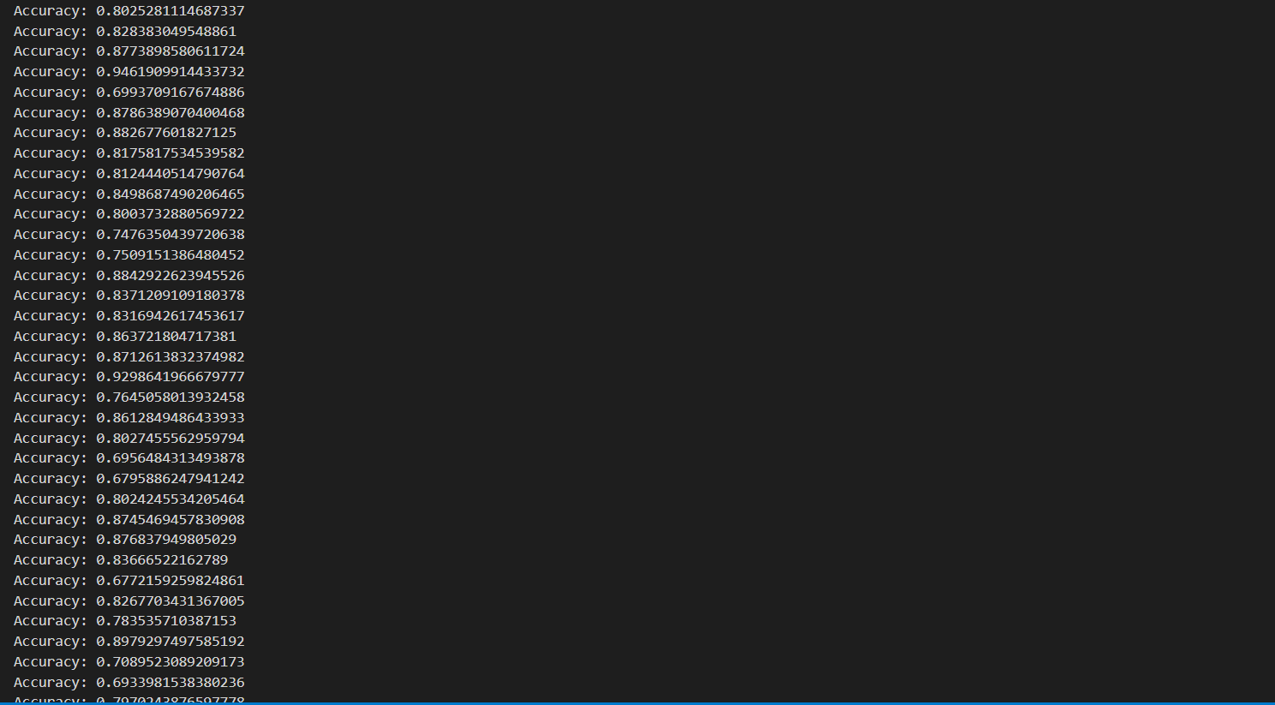

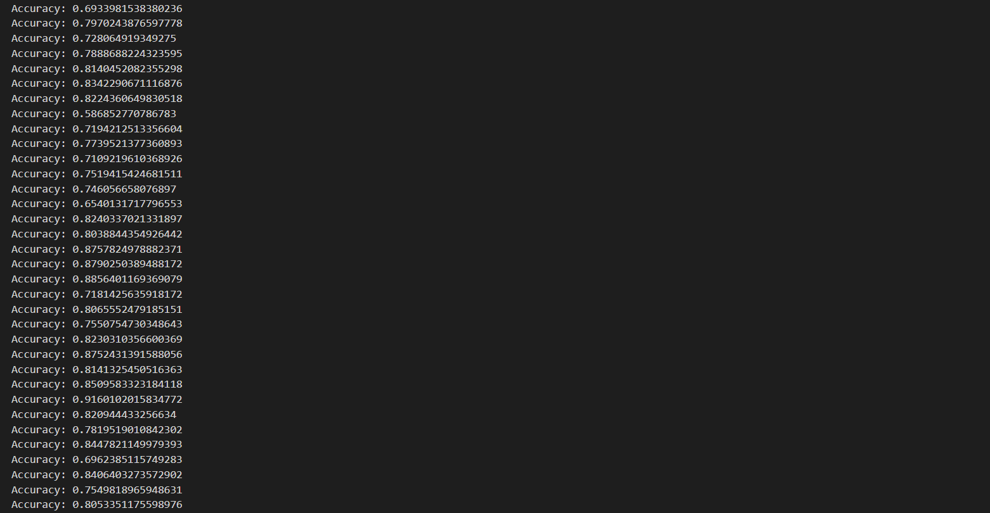

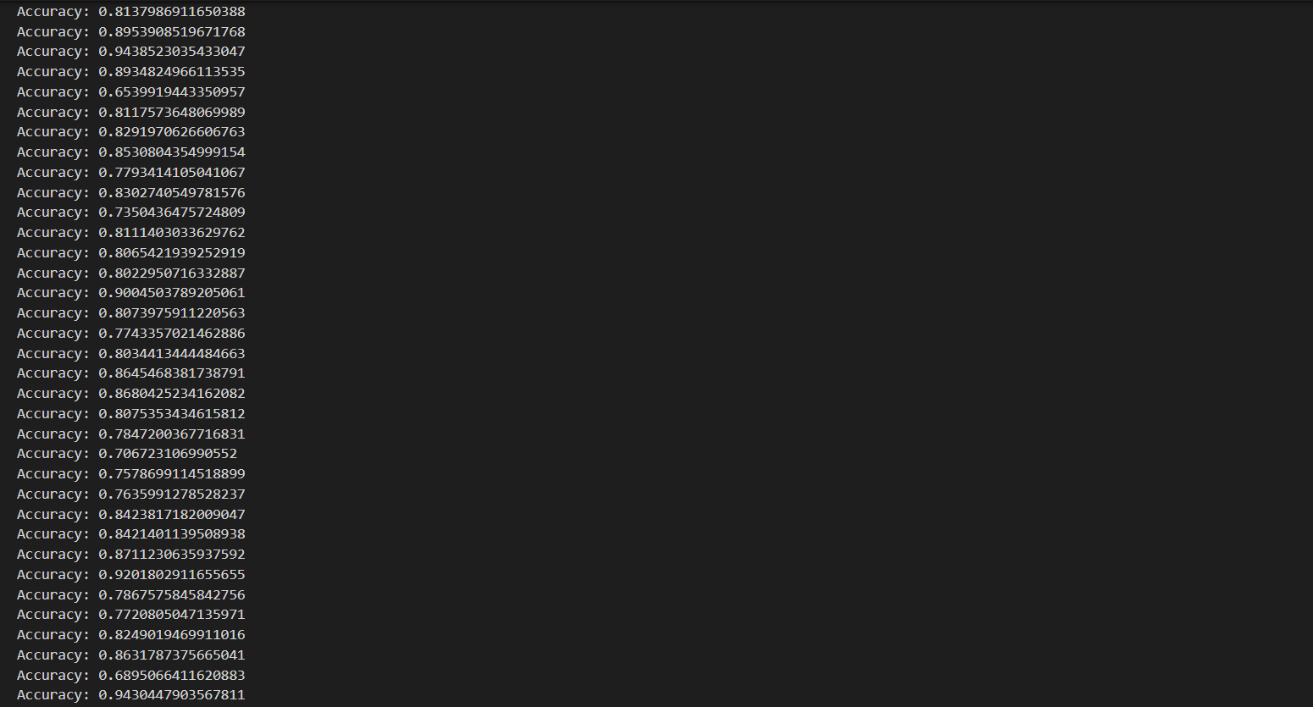
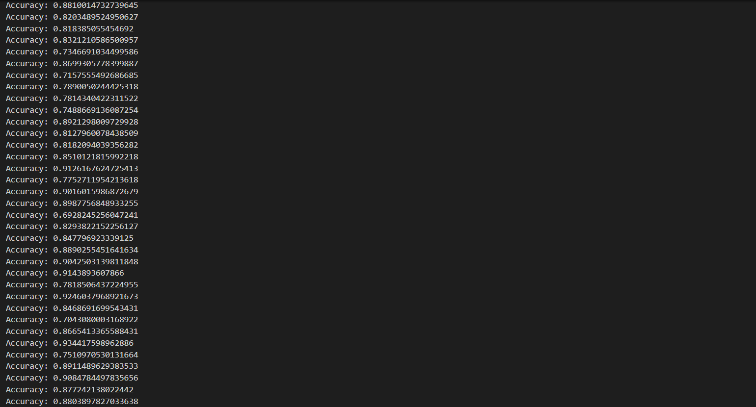
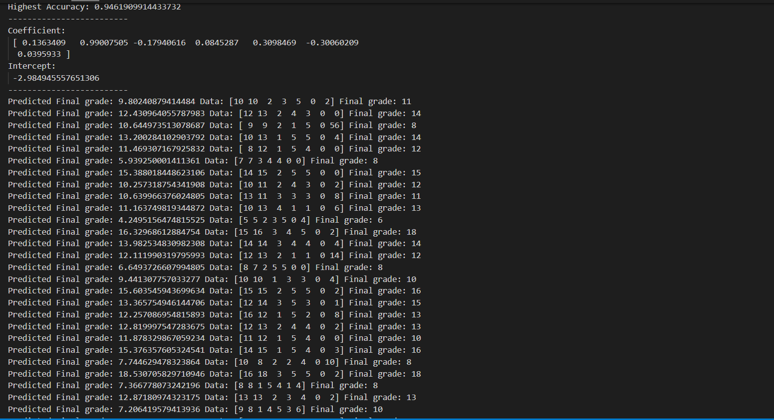
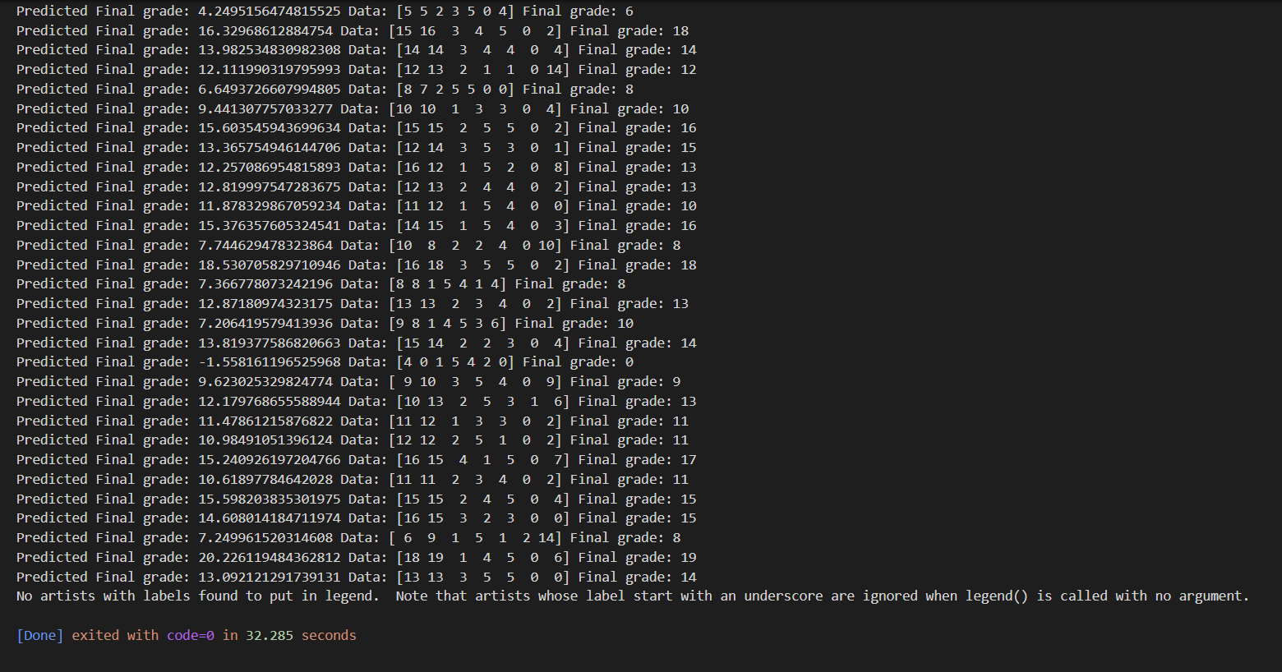
CHAPTER 7

CONTRIBUTION OF PROJECT TO THE SOCIETY

In the world of open education systems, students have flexibility to learn anything with ease as the learning content is easily available. But this facility can make student complacent. Therefore, it becomes difficult to predict the student’s performance in advance. In this project, an attempt is made to help the student to know his performance in advance.
This is done by using univariate linear regression model. This would help students to improve their performance based on predicted grades and would enable teachers to identify those individuals who need assistance.
The Main Objective of “Student Grade Prediction Application” is to implement a simple algorithmic model that predicts the score of an individual student at he /she end of the year. “G3” or the final grade is our label (output) and the rest of the columns will be our features (inputs).

CHAPTER 8

CONCLUSION, LIMITATION AND FUTURE SCOPE

8.1. Conclusion
Logistic Regression has been shown to be one of the efficient algorithms in building prediction models. The accuracy of the model does not only depend on the algorithm chosen, but also on other factors. Data-preprocessing is one such factor. Removing redundant and null values is essential in improving performance.
The normalization of values, when the features differ by large scale, also plays an important role. In this paper, we have seen that feature selection plays a significant role in increasing the accuracy and reducing the runtime.
Combining various algorithms, as observed in the ensemble techniques, serves as a factor in improving the performance of the model. Cross-validation also holds an essential role to boost accuracy.
.
8.2. Future Scope

Data cleaning and analysis can be better done and other machine learning algorithms can be applied on the model to improve the accuracy. Increased dataset will give out more accurate predictions. To improve the results, a dataset with sufficient features and increase in quantity must be obtained. Further research must be conducted in enhancing the existing machine learning techniques to work in real time and develop an efficient model. Also, the models developed must be tested on data with different volumes to test its scalability and performance. In future work, the result of regression on balanced dataset can be studied by changing the data distribution. This can be done by selecting a sample of dataset or removing certain records to balance the type of data.

CHAPTER 9

REFERENCES

[1] Sumati Pathak, Rohit Raja, Vaibhav Sharma, Srinivas Ambala, ICT Utilization and Improving Student Performance in Higher Education, International Journal of Recent Technology and Engineering (IJRTE) at Volume-8 Issue-2, pp. 5120-5124, July 2019.
[2] Laxmikant Tiwari, Rohit Raja, Vaibhav Sharma, Rohit Miri, Adaptive Neuro Fuzzy Inference System Based Fusion of Medical Image, International Journal of Research In Electronics And Computer
Engineering, Vol 7, Iss. 2, pp. 2086-2091, ISSN: 2393-9028 (PRINT) |ISSN: 2348-2281 (ONLINE).
[3] Sumati Pathak, Rohit Raja, Vaibhav Sharma, and K. Ramya Laxmi, A Framework of ICT Implementation on Higher Educational Institution with Data Mining Approach, European Journal of Engineering Research and Science, ISSN (Online): 2506-8016,
[4] Sumati Pathak, Rohit Raja, Vaibhav Sharma The Impact of ICT in Higher Education. Published in IJRECE Vol. 7 Issue 1 January-March, 2019. ISSN: 2393-9028 (PRINT) ISSN: 2348-2281 (ONLINE) ISSN: 2393-9028 (PRINT). Vol 7, Issue 1, pp 1650-1656.
[5] Rakesh Kumar Lenka, Amiya Kumar Rath, Zhiyuan Tan, Suraj Sharma, Deepak Puthal, N V R Simha, Rohit Raja, Shankar Sharan Tripathi, and Mukesh Prasad Building Scalable Cyber-Physical-Social Networking Infrastructure Using IoT and Low Power Sensors, , Vol. 6, Iss. 1, pp. 30162-30173, Print ISSN: 2169-3536, Online ISSN: 2169-3536, Digital Object Identifier: 10.1109/ACCESS.2018.2842760. (SCI Index)
[6] Rohit Raja, Tilendra Shishir Sinha, Raj Kumar Patra and Shrikant Tiwari(2018), Physiological Trait Based Biometrical Authentication of Human-Face Using LGXP and ANN Techniques, Int. J. of Information and Computer Security, Vol. 10, Nos. 2/3, pp. 303- 320. (Scopus Index)
[7] Rohit Raja, Tilendra Shishir Sinha, Ravi Prakash Dubey (2016), Soft Computing and LGXP Techniques for Ear Authentication using Progressive Switching Pattern, Published in International Journal of Engineering and Future Technology, Vol. 2, Iss. 2, pp.66-86, ISSN: 2455-6432.
[8] Rohit Raja, Tilendra Shishir Sinha, Ravi Prakash Dubey (2016), Orientation Calculation of human Face Using Symbolic techniques and ANFIS, Published in International Journal of Engineering and Future Technology, Vol. 7, Iss.7, pp. 37-50, ISSN: 2455-6432.
[9] Rehmat Khan, Rohit Raja (2016) Introducing L1- Sparse Representation Classification for facial expression, Published in Imperial Journal of Interdisciplinary Research (IJIR), Vol. 2, Iss. 4, pp. 115- 122, ISSN: 2454-1362.
[10] Nikita Rawat, Rohit Raja (2016), A Survey on Vehicle Tracking with Various Techniques”, International Journal of Advanced Research in Computer Engineering and Technology (IJARCET), Vol. 5 Iss. 2, pp. 374-377, ISSN: 2278-1323.
[11] Nikita Rawat, Rohit Raja (2016), Moving Vehicle Detection and Tracking using Modified Mean Shift Method and Kalman Filter and Research, International Journal of New Technology and Research (IJNTR), Vol. 2, Iss. 5, pp. 96-100, ISSN: 2454-4116.
[12] Rohit Raja, Tilendra Shishir Sinha, Ravi Prakash Dubey (2015), Recognition of human-face from side-view using progressive switching pattern and soft-computing technique, Association for the Advancement of Modelling and Simulation Techniques in Enterprises, Advance B, Vol. 58, N 1, pp. 14-34, ISSN:-1240-4543. (Scopus Index)
[13] Rohit Raja, Tilendra Shishir Sinha, Ravi Prakash Dubey (2015), Biometrical Authentication of Twins from Side-View using Hybrid Approach, (BJSTH) Bharat Journal of Science Technology and Humanities, , ISSN: 2454-6151.
[14] Rohit Raja, Tilendra Shishir Sinha, Ravi Prakash Dubey (2015), An Empirical Analysis for Detection of Occlusion for face image parallel to the surface plain using Soft-Computing technique, Mats Journal of Engineering & Vol. I (1), pp. 1-6Technology, Vol. 1, Iss. 2, pp. 95-102, ISSN 2394-0549.
[15] Rehmat Khan, Rohit Raja (2015) Neural Network Allied With Recognition of Facial Expressions of Basic Emotions, International Journal of Emerging Trends in Science and Technology, Vol. 2, Iss. 11, pp. 3311-3315, ISSN: 2348-9480. A. C. Bhensle and Rohit Raja (2014), An efficient face recognition using PCA and Euclidean Distance classification, International Journal of Computer Science and Mobile Computing, Vol. 3 Issue.6, pp. 407-413. ISSN: 2320–088X.

ANNEXURE

import pandas as pd
import numpy as np
import sklearn
from sklearn import linear_model
from sklearn.utils import shuffle
import pickle
# import matplotlib.pyplot as pyplot
# from matplotlib import style

data = pd.read_csv("./Datasets/student-mat.csv", sep = ";")

data = data[["G1", "G2", "G3", "studytime", "absences", "failures"]]

labels = "G3"

x = np.array(data.drop([labels], 1)) # Attributes
y = np.array(data[labels]) # Labels
x_train, x_test, y_train, y_test = sklearn.model_selection.train_test_split(x, y, test_size=0.1)

best = 0

for _ in range(30):
# Training the data until we get the best accuracy
x_train, x_test, y_train, y_test = sklearn.model_selection.train_test_split(x, y, test_size=0.1)

linear = linear_model.LinearRegression()

linear.fit(x_train, y_train) # Fitting the training data into the model
acc = linear.score(x_test, y_test) # Getting the score/accuracy
print("Accuracy: ", acc)

if acc > best:
best = acc
print(f"New best!: {acc}")

# Saving the model with pickle
with open('studentmodel.pickle', 'wb') as f:
pickle.dump(linear, f)
print("Model Saved to new accuracy!\n------")

pickle_in = open('studentmodel.pickle', 'rb')
linear = pickle.load(pickle_in)

predictions = linear.predict(x_test)

print(f'------ \nResults with {round(best*100)} accuracy: ')
for x in range(len(predictions)):
print(f"Predicted value: {round(predictions[x])}, Actual value: {y_test[x]}")

