5. (20 points) Write/Draw a ladder logic program that will turn on a light after 20 seconds and turn the same light off after another 20 seconds. Start the program by turning on a switch. The on switch is X101 and the light output is Y201. (Click commands are on the last page.)

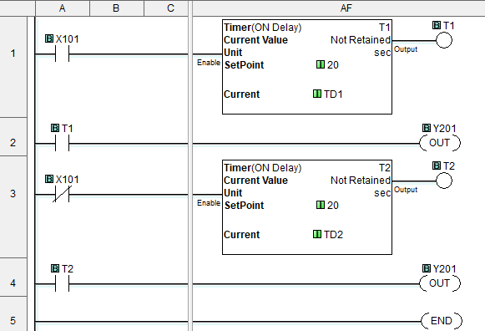

6. (30 points) Write/Draw a ladder logic program that will count the number of people entering a building and the number of people leaving the same building. There are three entry/exit points to the building that have sensors to count the number of people entering and leaving. We want to know how many people entered during the day, how many left during the same day, and how many are currently in the building. Start the program by turning on a switch. Use X101, X102, and X103 as the three input sensors. Use X104, X105 and X106 as the three exit sensors. (Click commands are on the last page.)

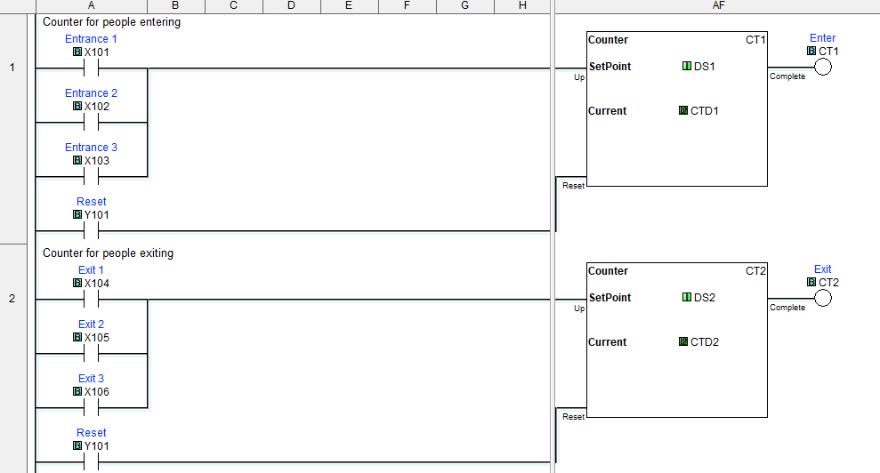

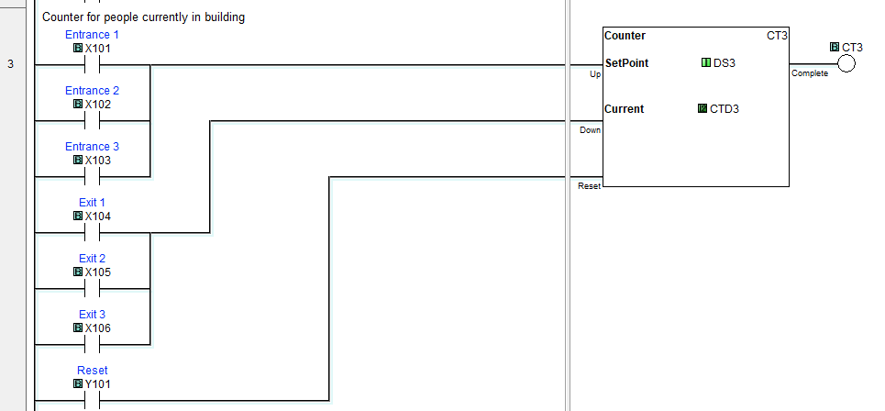

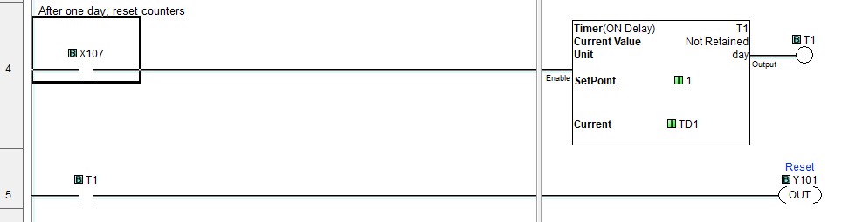

7) (30 points) Write a process control program in ladder logic that will do the following:

Fill a tank with water, heat it to 40oC, Empty the tank into a sump, Repeat. (Click commands are on the last page.)

The tank is full when DF1 = 2.0.

The tank is empty when DF1 = 0.5.

The water is 40oC when DF2 = 2.0

The pump is turned on by X101. On = 1.

The drain valve is controlled by X102. Open = 1.

The heater is controlled by X103. On = 1.

Add a 1 second delay before turning the pump off when DF1 indicates the tank is full.

Add a 1 second delay before turning the heater off and emptying the tank when DF2 indicates the water has reached 40oC.

Add a ten second delay after DF1 indicates the tank is empty before turning the pump on and closing the drain valve.

Use CLICK ladder logic as your programming language. You may want to create a flow chart.

