Figure 1.0
MTCARS Miles per Cylinder Plot

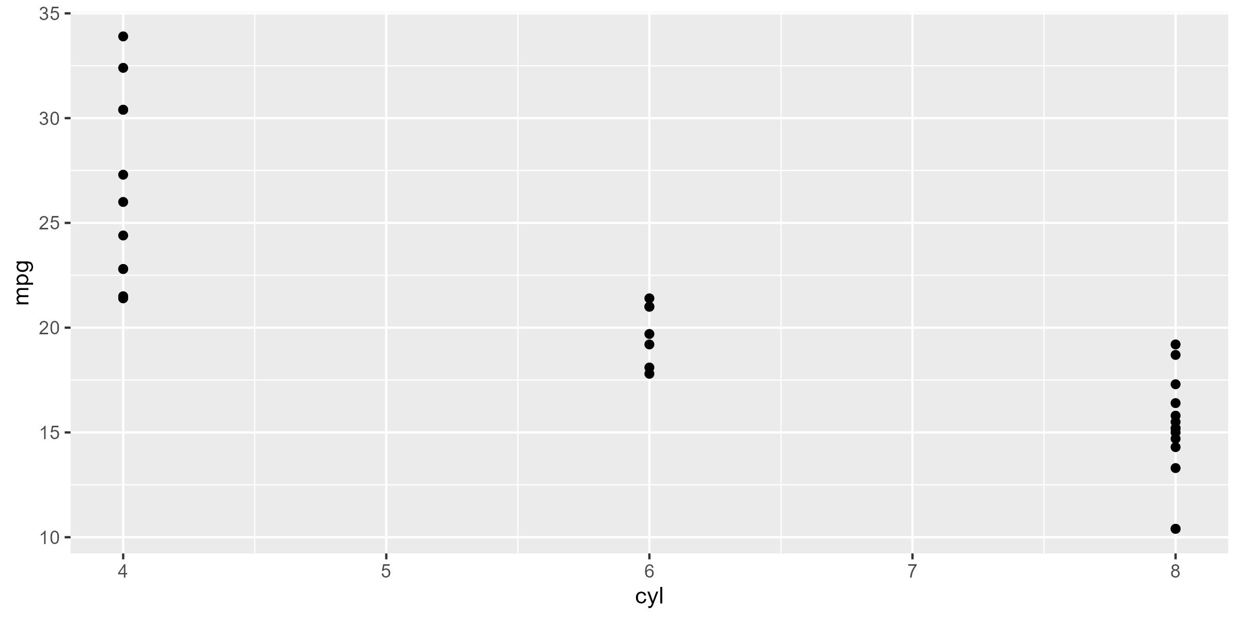

* Motor Trend, 1974

