Package Validation for “procs”
Background: The “procs” package simulates some SAS® procedures in R. The package was written to make it easier for SAS® programmers to work in R. The package was also written to align statistical output between SAS® and R, as the native R functions do not necessarily match SAS®. This “pre-validation” will reduce the number of discrepancies in statistical output, and speed the process of analysis.
Purpose: The purpose of this document is to validate the R “procs” package against equivalent SAS® output.
Methodology: For this validation, first a test was defined that could be accomplished in both SAS® and R. Then a programmer wrote a small script in each language that produced similar results. The results were compared visually to ensure a match. Any discrepancies would be investigated and resolved either by modifying the comparison scripts, or modifying the “procs” package code until it matched SAS®. Comparison code and results were documented.
SAS Version: 9.04.01M8P02222023
R Version: 4.6.1
Procs Version: 1.1.0
Author: David J. Bosak, Chief Software Architect, Archytas Clinical Solutions
Contributor: Yifei Chen
Last Modified Date: 8/29/2026

Change History
Date | Item | Procs Version
2023/06/23 | Initial version. | 0.0.9007
2023/06/24 | Created first few tests for each function. | 0.0.9007
2023/07/05 | Discovered discrepancy in Procs-means-009 Upper 95% confidence limit. Had to change code to add alpha option and one-sided confidence limit calculation. | 0.0.9007
2023/07/08 | Resolved discrepancy on confidence limits. Added test means-010 to confirm two-sided CL. | 0.0.9008
2023/07/10 | Added Procs-means-011 tests for means t-test and p-value. | 0.0.9008
2023/07/11 | Added Procs-means-012 test for Uncorrected Sum of Squares. | 0.0.9008
2023/07/20 | Added Procs-means-013 test for skewness and kurtosis. | 0.0.9008
2023/07/25 | Added ability to use factors for sorting proc_freq output. | 0.0.9008
2023/07/26 | Fixed Fisher’s exact test for Cell 1.1. This was off when table was sorted properly. | 0.0.9008
2023/07/29 | Incremented to version 1.0.0 for CRAN submission. | 1.0.0
2023/08/08 | Incremented to version 1.0.2 for CRAN fixes | 1.0.2
2023/08/10 | Fixed zero-fill row on proc_freq() when user supplied a factor. | 1.0.2
2023/08/11 | Fixed n-way class summaries on proc_means() when multiple class vars are present. | 1.0.2
2023/08/13 | Fixed some labels on proc_means() report output. | 1.0.2
2023/08/18 | Add means-015 for more complicated statistics with by variable. | 1.0.2
2023/09/04 | Upgrade version and prepare for CRAN submission. | 1.0.3
2023/12/17 | Add validation for proc_ttest(). | 1.0.4
2023/12/20 | Reran all comparisons and made a few fixes. | 1.0.4
2024/01/20 | Bug fixes. No changes to validation. | 1.0.5
2024/03/02 | Added validation for proc_reg(). | 1.0.6
2025/07/26 | Added validation for adjusted chisq | 1.0.7
2026/03/19 | Added plots to proc_test(), proc_reg(), and proc_freq(). Added weight var vardef to proc_means(). | 1.0.8
2026/05/28 | Added sides options to proc_ttest(). Added freq and weight parameters to proc_ttest(). | 1.0.9
2026/08/29 | Added proc_glm(). | 1.1.0

Freq Data
SAS | R
data Color;  input Region Eyes $ Hair $ Count @@;  label Eyes ='Eye Color'  Hair ='Hair Color'  Region='Geographic Region';  datalines;  1 blue fair 23 1 blue red 7 1 blue medium 24  1 blue dark 11 1 green fair 19 1 green red 7  1 green medium 18 1 green dark 14 1 brown fair 34  1 brown red 5 1 brown medium 41 1 brown dark 40  1 brown black 3 2 blue fair 46 2 blue red 21  2 blue medium 44 2 blue dark 40 2 blue black 6  2 green fair 50 2 green red 31 2 green medium 37  2 green dark 23 2 brown fair 56 2 brown red 42  2 brown medium 53 2 brown dark 54 2 brown black 13  ; | dat <- read.table(header = TRUE, text = '  Region Eyes Hair Count  1 blue fair 23  1 blue dark 11  1 green medium 18  1 brown red 5  1 brown black 3  2 blue medium 44  2 green fair 50  2 green dark 23  2 brown medium 53  1 blue red 7  1 green fair 19  1 green dark 14  1 brown medium 41  2 blue fair 46  2 blue dark 40  2 green red 31  2 brown fair 56  2 brown dark 54  1 blue medium 24  1 green red 7  1 brown fair 34  1 brown dark 40  2 blue red 21  2 blue black 6  2 green medium 37  2 brown red 42  2 brown black 13  ')
** Above input data will be used for all frequency comparisons unless data is provided in the script itself.

proc_freq-001
SAS Code and Output
proc freq data=Color;  tables Eyes Hair Eyes*Hair / out=FreqCount outexpect sparse;  weight Count;  title 'Eye and Hair Color of European Children';  run; | 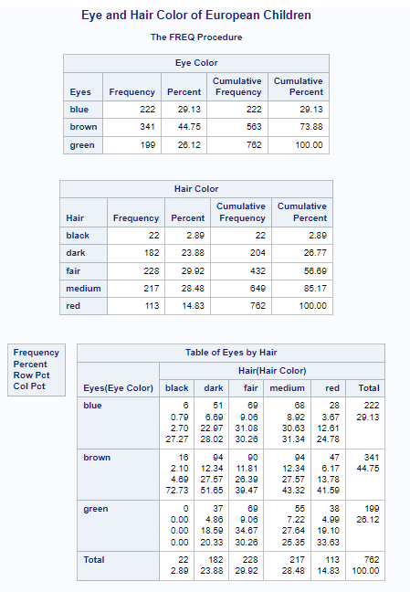
R Code and Output
library(procs)  proc_freq(dat, tables = v(Eyes, Hair, Eyes * Hair), weight = Count,  title = "Eye and Hair Color of European Children") | 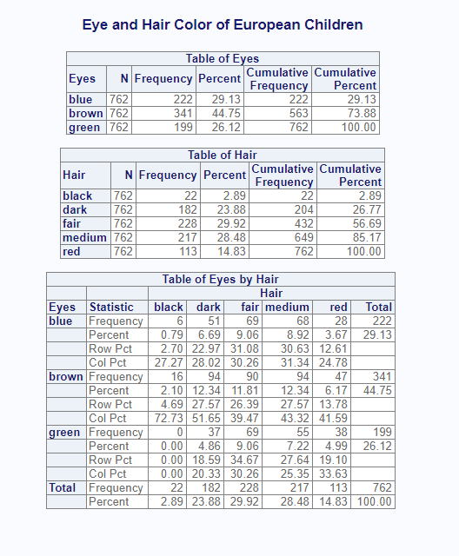
Comparison | Results
Compare basic one and two way frequencies with weight option. | Pass

proc_freq-002
SAS Code and Output
proc freq data=Color nlevels;  tables Eyes Hair Eyes*Hair / out=FreqCount outexpect sparse;  title 'Eye and Hair Color of European Children';  run; | 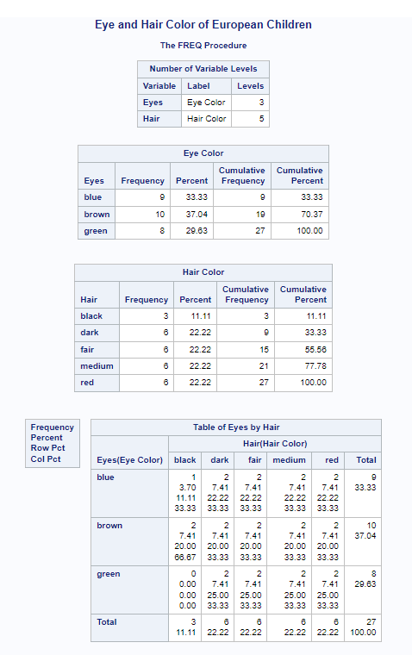
R Code and Output
proc_freq(dat, tables = v(Eyes, Hair, Eyes * Hair),  title = "Eye and Hair Color of European Children",  options = v(nlevels)) | 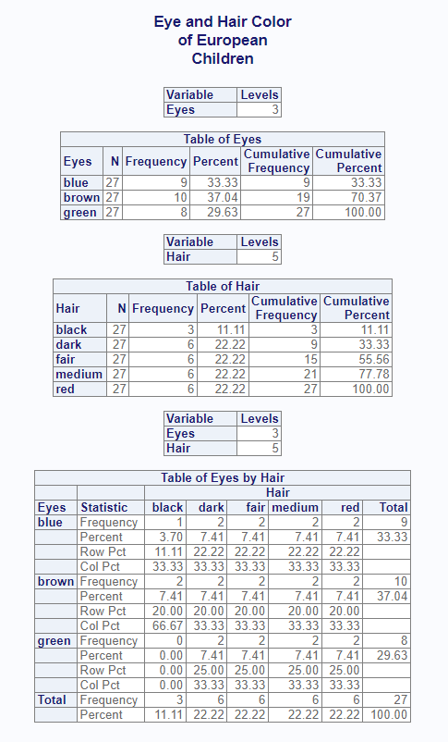
Comparison | Result
Compare basic frequencies with no weight and nlevels option. | Pass

proc_freq-003
SAS Code and Output
data SummerSchool;  input Gender $ Internship $ Enrollment $ Count @@;  datalines;  boys yes yes 35 boys no no 27  boys no yes 14 girls yes no 10  girls yes yes 32 girls no no 23  girls no yes 53 girls . no 25  boys yes . 29 girls . no 29  ;  proc freq data=SummerSchool order=data nlevels;  tables Internship / out = Fork missing;  options missing=. mi;  run; | 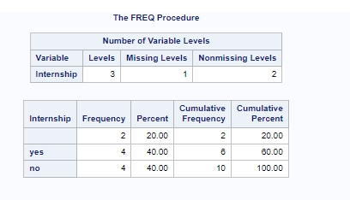
R Code and Output
prtm <- read.table(header = TRUE, text = '  sex internship enrollment count  1 boys yes yes 35  2 boys no yes 14  3 girls yes yes 32  4 girls no yes 53  5 boys yes NA 29  6 boys no no 27  7 girls yes no 10  8 girls no no 23  9 girls NA yes 25  10 girls NA no 29')  res <- proc_freq(prtm, tables = v(internship),  options = v(nlevels, missing)) | 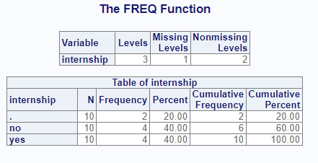
Comparison | Result
Compare basic frequencies with nlevels and missing options. | Pass

proc_freq-004
SAS Code and Output
data SummerSchool;  input Gender $ Internship $ Enrollment $ Count @@;  datalines;  boys yes yes 35 boys yes no 29  boys no yes 14 boys no no 27  girls yes yes 32 girls yes no 10  girls no yes 53 girls no no 23  ;  proc freq data=SummerSchool order=data;  tables Internship * Enrollment / out = Fork chisq;  by Gender;  weight Count;  run;
  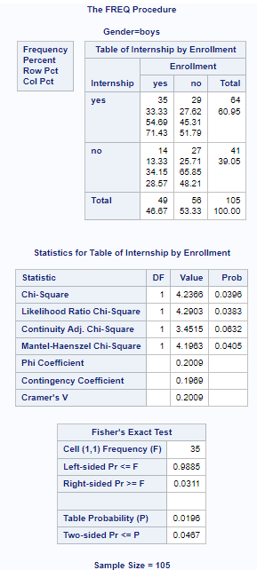 | 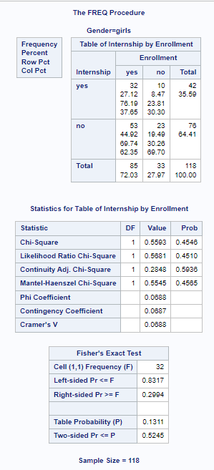
R Code and Output
prt <- read.table(header = TRUE, text = '  sex internship enrollment count  1 boys yes yes 35  2 boys no yes 14  3 girls yes yes 32  4 girls no yes 53  5 boys yes no 29  6 boys no no 27  7 girls yes no 10  8 girls no no 23')  prt$enrollment <- factor(prt$enrollment, c("yes", "no"))  prt$internship <- factor(prt$internship, c("yes", "no"))  proc_freq(prt, tables = "internship * enrollment",  options = ChiSq,  by = "sex",  weight = "count") | 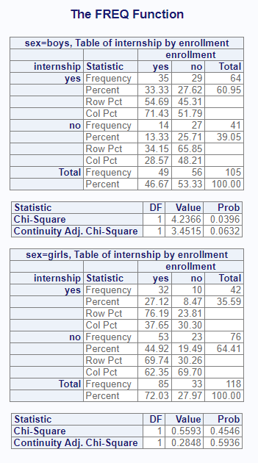
Comparison | Result
Compare two way with chisquare statistic. Also add continuity adjusted Chisq v1.0.7. | Pass.

proc_freq-005
SAS Code and Output
data SummerSchool;
input Gender $ Internship $ Enrollment $ Count @@;
datalines;
boys yes yes 35 boys yes no 29
boys no yes 14 boys no no 27
girls yes yes 32 girls yes no 10
girls no yes 53 girls no no 23
;

proc freq data=SummerSchool order=data;
tables Internship * Enrollment / out = Fork chisq;
by Gender;
weight Count;
run;
R Code and Output
prt <- read.table(header = TRUE, text = '  sex internship enrollment count  1 boys yes yes 35  2 boys no yes 14  3 girls yes yes 32  4 girls no yes 53  5 boys yes no 29  6 boys no no 27  7 girls yes no 10  8 girls no no 23')  prt$enrollment <- factor(prt$enrollment, c("yes", "no"))  prt$internship <- factor(prt$internship, c("yes", "no"))  proc_freq(prt, tables = "internship * enrollment",  options = Fisher,  by = "sex",  weight = "count") | 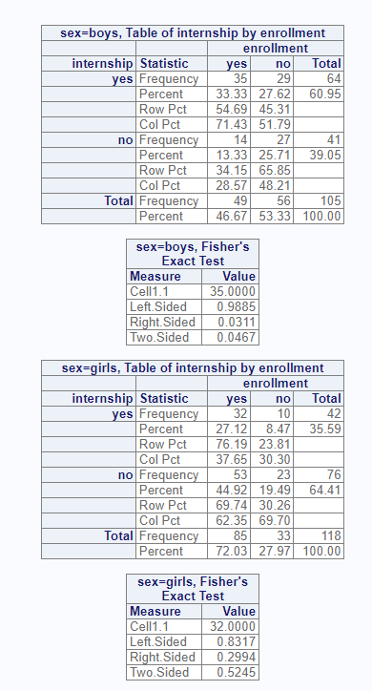
Comparison | Result
Compare two way with Fisher’s Exact statistic. | Pass.

proc_freq-006
SAS Code and Output
proc freq data = Color order = freq;  tables Hair /plots = freqplot;  weight Count;  run; | 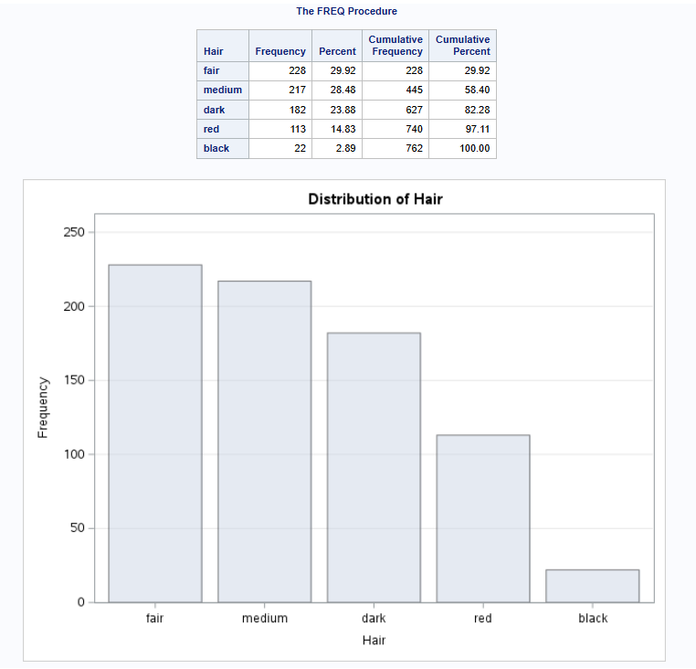
R Code and Output
proc_freq(dat, tables = Hair, weight = Count,  order = freq,  plots = TRUE) | 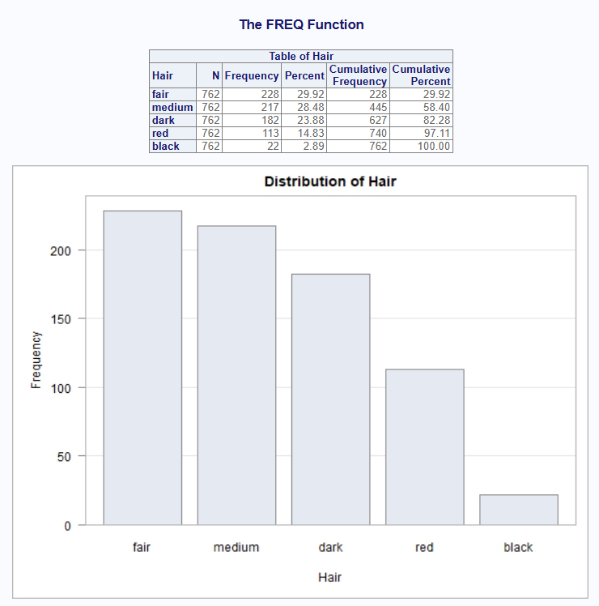
Comparison | Result
Order parameter and basic frequency plot. | Pass.

proc_freq-007
SAS Code and Output
proc freq data = Color;  tables Eyes /plots = freqplot(type = dotplot orient = horizontal);  weight Count;  run; | 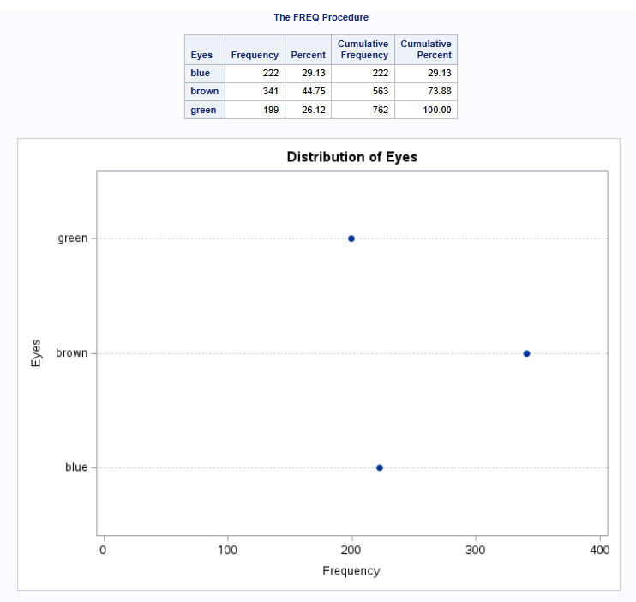
R Code and Output
proc_freq(dat, tables = Eyes, weight = Count,  title = "Eye and Hair Color of European Children",  plots = freqplot("dotplot", orient = "horizontal")) | 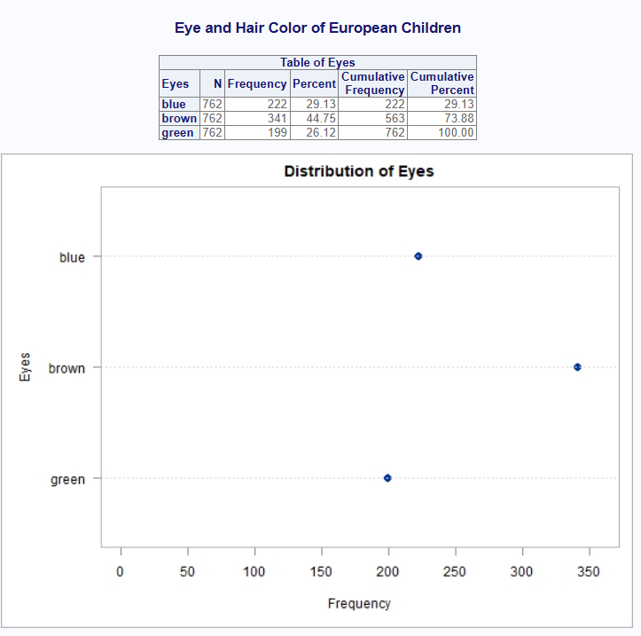
Comparison | Result
dotplot | Order and default orientation is different from SAS. Not sure why SAS reversed it. I like this better because it is consistent with the table. Pass.

proc_freq-008
SAS Code and Output
proc freq data = Color;  tables Hair /plots = freqplot(type = barchart orient = horizontal);  weight Count;  run; | 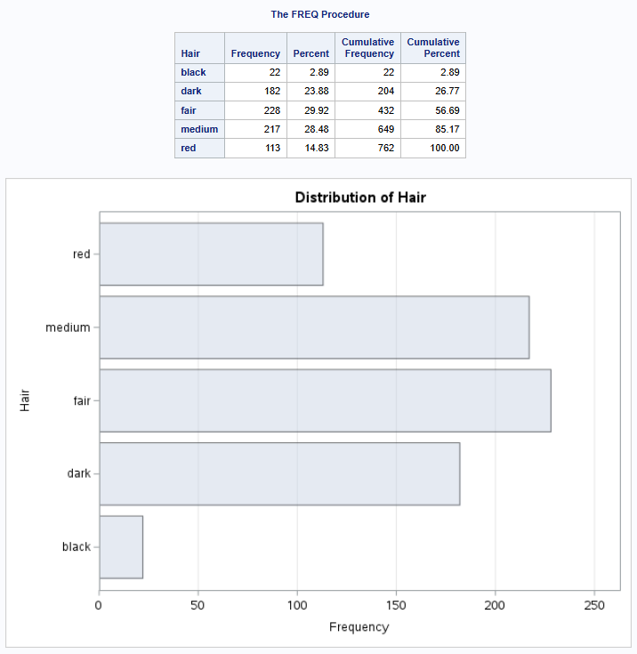
R Code and Output
proc_freq(dat, tables = Hair, weight = Count,  title = "Eye and Hair Color of European Children",  plots = freqplot("barchart", orient = "horizontal")) | 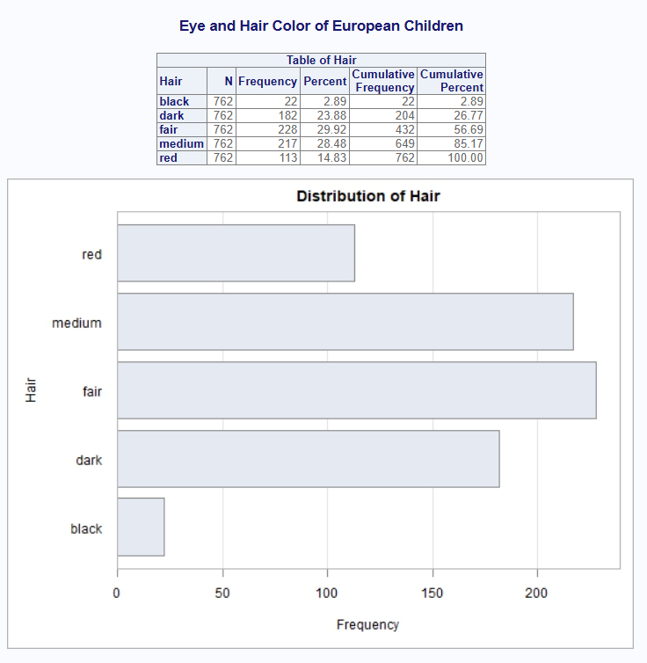
Comparison | Result
Horizontal bar chart | Pass.

proc_freq-009
SAS Code and Output
proc freq data = Color;  tables Eyes * Hair /plots = freqplot(twoway = cluster);  weight Count;  run; | 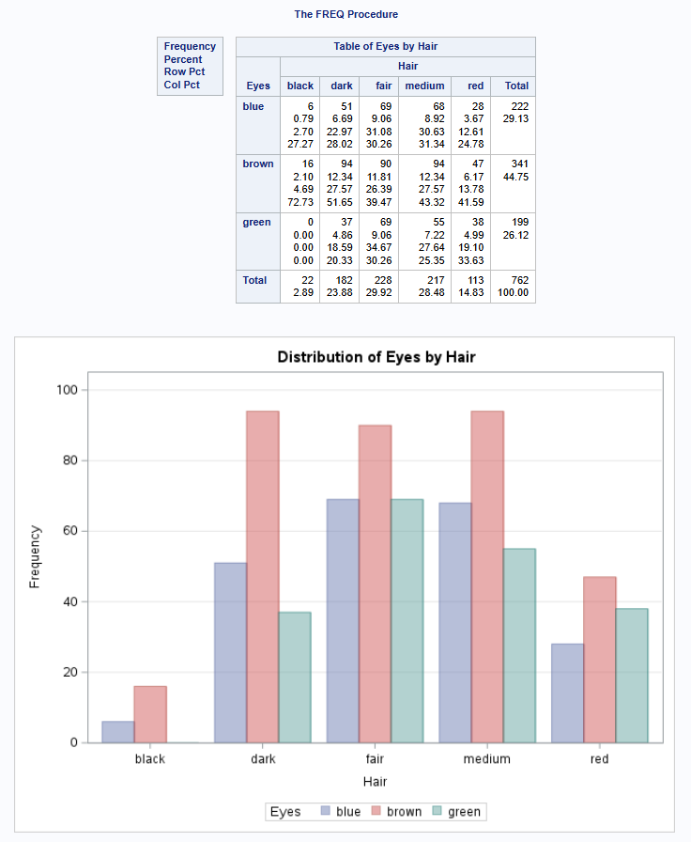
R Code and Output
proc_freq(dat, tables = Eyes * Hair, weight = Count,  title = "Eye and Hair Color of European Children",  plots = freqplot("barchart", twoway = "cluster")) | 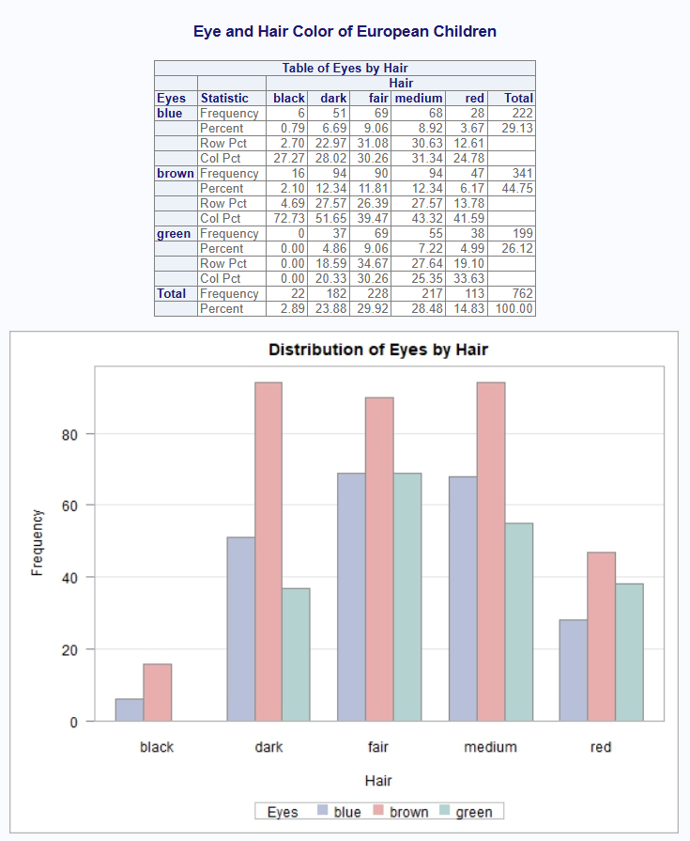
Comparison | Result
Clustered bar chart | Pass.

proc_freq-010
SAS Code and Output
proc freq data = Color;  tables Eyes * Hair /plots = freqplot(twoway = stacked);  weight Count;  run; | 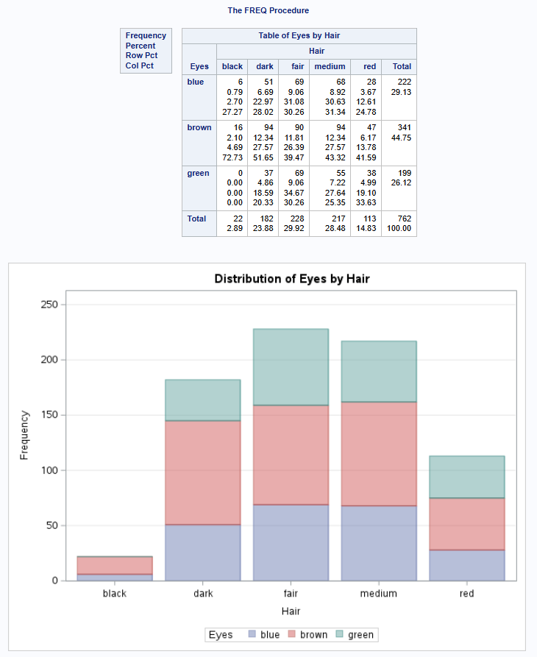
R Code and Output
proc_freq(dat, tables = Eyes * Hair, weight = Count,  plots = freqplot("barchart", twoway = "stacked")) | 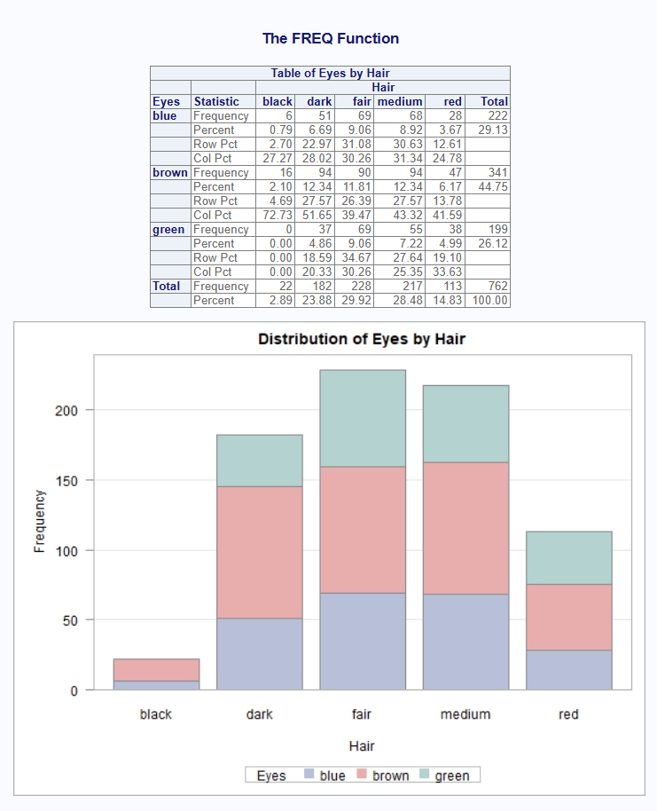
Comparison | Result
Stacked bar chart | Pass.

Means Data
SAS | R
data cake;  input LastName $ 1-12 Age 13-14 PresentScore 16-17  TasteScore 19-20 Flavor $ 23-32 Layers 34 ;  datalines;  Orlando 27 93 80 Vanilla 1  Ramey 32 84 72 Rum 2  Goldston 46 68 75 Vanilla 1  Roe 38 79 73 Vanilla 2  Larsen 23 77 84 Chocolate 3  Davis 51 86 91 Spice 3  Strickland 19 82 79 Chocolate 1  Nguyen 57 77 84 Vanilla 3  Hildenbrand 33 81 83 Chocolate 1  Byron 62 72 87 Vanilla 2  Sanders 26 56 79 Chocolate 1  Jaeger 43 66 74 1  Davis 28 69 75 Chocolate 2  Conrad 69 85 94 Vanilla 1  Walters 55 67 72 Chocolate 2  Rossburger 28 78 81 Spice 2  Matthew 42 81 92 Chocolate 2  Becker 36 62 83 Spice 2  Anderson 27 87 85 Chocolate 1  Merritt 62 73 84 Chocolate 1  ; | datm <- read.table(header = TRUE, text = '  LastName Age PresentScore TasteScore Flavor Layers  Orlando 27 93 80 Vanilla 1  Ramey 32 84 72 Rum 2  Goldston 46 68 75 Vanilla 1  Roe 38 79 73 Vanilla 2  Larsen 23 77 84 Chocolate 3  Davis 51 86 91 Spice 3  Strickland 19 82 79 Chocolate 1  Nguyen 57 77 84 Vanilla 3  Hildenbrand 33 81 83 Chocolate 1  Byron 62 72 87 Vanilla 2  Sanders 26 56 79 Chocolate 1  Jaeger 43 66 74 NA 1  Davis 28 69 75 Chocolate 2  Conrad 69 85 94 Vanilla 1  Walters 55 67 72 Chocolate 2  Rossburger 28 78 81 Spice 2  Matthew 42 81 92 Chocolate 2  Becker 36 62 83 Spice 2  Anderson 27 87 85 Chocolate 1  Merritt 62 73 84 Chocolate 1  ')
** Above input data will be used for all means comparisons unless data is provided in the script itself.

proc_means-001
SAS Code and Output
proc means data=cake n mean median stddev min max maxdec=4;  var Age PresentScore TasteScore layers;  title 'Summary of Presentation and Taste Scores';  output out=outdata;  run; | 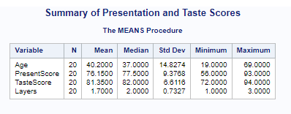
R Code and Output
proc_means(datm, var = v(Age, PresentScore, TasteScore, Layers),  stats = c("n", "mean", "median", "std", "min", "max"),  options = v(maxdec = 4),  titles = "Summary of Presentation and Taste Scores") | 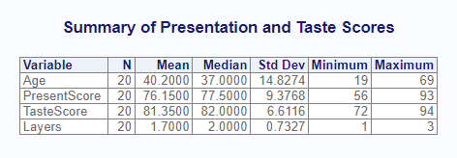
Comparison | Result
Simple Proc means on multiple variables. | Pass

proc_means-002
SAS Code and Output
proc means data=cake nmiss median mode lclm uclm stderr maxdec=4;  var Age PresentScore TasteScore layers;  title 'Summary of Presentation and Taste Scores';  output out=outdata;  run; | 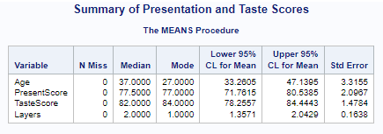
R Code and Output
proc_means(datm, v(Age, PresentScore, TasteScore, Layers),  stats = v(nmiss, median, mode, clm, stderr),  options = v(maxdec = 4),  titles = "Summary of Presentation and Taste Scores") | 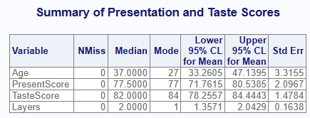
Comparison | Result
Comparison of more statistics options. | Pass

proc_means-003
SAS Code and Output
proc sort data=cake out=cake2;  by Layers;  run;  proc means data=cake2 n mean median stddev min max maxdec=4;  var Age PresentScore TasteScore;  title 'Summary of Presentation and Taste Scores';  by Layers;  output out=outdata;  run; | 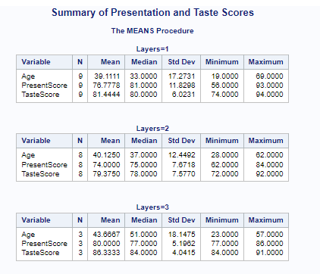
R Code and Output
proc_means(datm, var = v(Age, PresentScore, TasteScore),  stats = c("n", "mean", "median", "std", "min", "max"),  by = "Layers",  options = v(maxdec = 4),  titles = "Summary of Presentation and Taste Scores") | 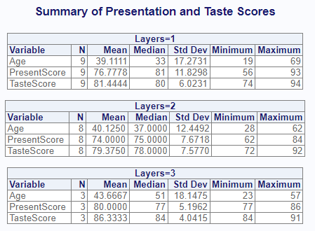
Comparison | Result
Comparison of by variable. | Pass

proc_means-004
SAS Code and Output
proc sort data=cake out=cake2;  by Layers;  run;  proc means data=cake2 n mean median stddev min max maxdec=4;  var Age PresentScore TasteScore;  title 'Summary of Presentation and Taste Scores';  class Layers;  output out=outdata;  run; | 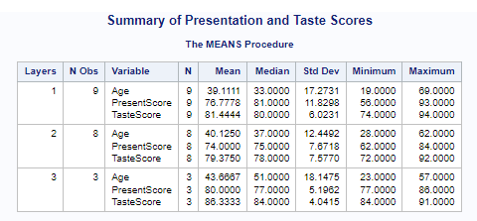
R Code and Output
proc_means(datm, var = v(Age, PresentScore, TasteScore),  stats = c("n", "mean", "median", "std", "min", "max"),  class = "Layers",  options = v(maxdec = 4),  titles = "Summary of Presentation and Taste Scores") | 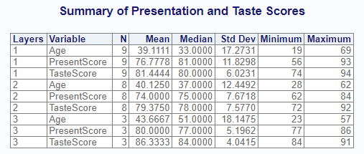
Comparison | Result
Comparison of class variable. | Pass

proc_means-005
SAS Code and Output
data cake2;  set cake;  if (_n_ = 5) then do;  PresentScore = .;  end;  run;  proc means data=cake2 n nmiss mean median lclm uclm stddev maxdec=4;  var PresentScore TasteScore;  title 'Summary of Presentation and Taste Scores';  output out=outdata;  run; | 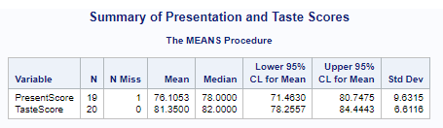
R Code and Output
datm2 <- datm  datm2[5, "PresentScore"] <- NA  proc_means(datm2, var = c("PresentScore", "TasteScore"),  stats = c("n", "nmiss", "mean", "median", "mode", "clm", "std"),  titles = "My first title for Means",  options = v(notype, nonobs, maxdec=4)) | 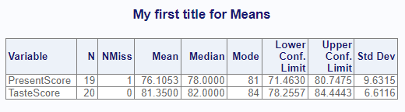
Comparison | Result
Comparison of class variable. | Pass

proc_means-006
SAS Code and Output
proc means data=cake css cv lclm mode n maxdec=4;  var Age PresentScore TasteScore layers;  title 'Summary of Presentation and Taste Scores';  output out=outdata;  run; | 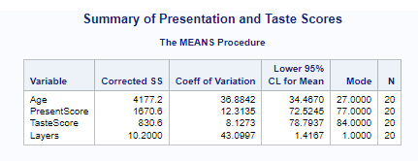
R Code and Output
proc_means(datm, var = v(Age, PresentScore, TasteScore, Layers),  stats = c("css", "cv", "lclm", "mode", "nobs"),  options = v(maxdec = 4),  titles = "Summary of Presentation and Taste Scores") | 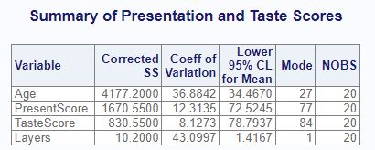
Comparison | Result
Comparison of more statistics options. | Pass, except SAS doesn’t have NOBS keyword.

proc_means-007
SAS Code and Output
proc means data=cake p1 p5 p10 p20 p25 p30 p40 p50 maxdec=4;  var Age PresentScore TasteScore layers;  title 'Summary of Presentation and Taste Scores';  output out=outdata;  run; | 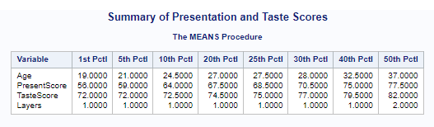
R Code and Output
proc_means(datm, var = v(Age, PresentScore, TasteScore, Layers),  stats = c("p1", "p5", "p10", "p20", "p25", "p30", "p40", "p50"),  options = v(maxdec = 4),  titles = "Summary of Presentation and Taste Scores") | 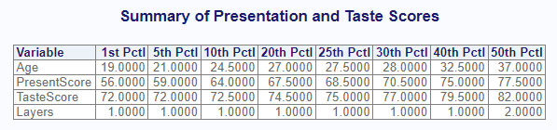
Comparison | Result
Comparison of more statistics options. | Pass

proc_means-008
SAS Code and Output
proc means data=cake p60 p70 p75 p80 p90 p95 p99 maxdec=4;  var Age PresentScore TasteScore layers;  title 'Summary of Presentation and Taste Scores';  output out=outdata;  run; | 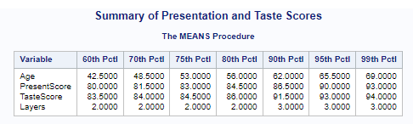
R Code and Output
proc_means(datm, var = v(Age, PresentScore, TasteScore, Layers),  stats = c("p60", "p70", "p75", "p80", "p90", "p95", "p99"),  options = v(maxdec = 4),  titles = "Summary of Presentation and Taste Scores") | 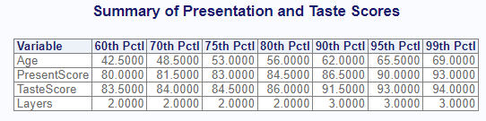
Comparison | Result
Comparison of more statistics options. | Pass

proc_means-009
SAS Code and Output
proc means data=cake q1 q3 qrange range sum uclm var maxdec=4;  var Age PresentScore TasteScore layers;  title 'Summary of Presentation and Taste Scores';  output out=outdata;  run; | 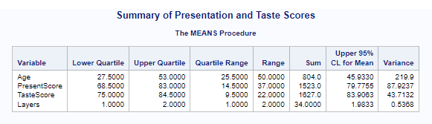
R Code and Output
proc_means(datm, var = v(Age, PresentScore, TasteScore, Layers),  stats = c("q1", "q3", "qrange", "range", "sum", "uclm", "vari"),  options = v(maxdec = 4),  titles = "Summary of Presentation and Taste Scores") | 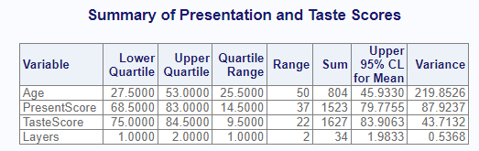
Comparison | Result
Comparison of more statistics options. | Pass

proc_means-010
SAS Code and Output
proc means data=cake mean clm alpha = 0.1 maxdec=4;  var PresentScore TasteScore;  title 'Summary of Presentation and Taste Scores';  output out=outdata;  run; | 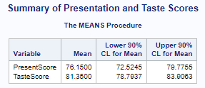
R Code and Output
proc_means(datm, var = v(PresentScore, TasteScore),  stats = v(mean, clm),  options = v(alpha = 0.1, maxdec=4),  titles = "Summary of Presentation and Taste Scores") | 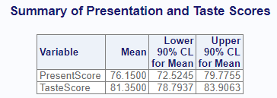
Comparison | Result
Comparison of 90% confidence limit with alpha option. | Pass

proc_means-011
SAS Code and Output
DATA WEIGHT;  INPUT WBEFORE WAFTER;  * Calculate WLOSS in the DATA step *;  WLOSS=WAFTER-WBEFORE;  DATALINES;  200 190  175 154  188 176  198 193  197 198  310 240  245 204  202 178  ;  run;  PROC MEANS N MEAN T PRT;  VAR WLOSS;  TITLE 'Paired t-test example using PROC MEANS';  RUN; | 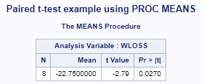
R Code and Output
datp <- read.table(header = TRUE, text = '  WBEFORE WAFTER  200 190  175 154  188 176  198 193  197 198  310 240  245 204  202 178')  datp$WLOSS <- datp$WAFTER - datp$WBEFORE  res <- proc_means(datp, var = WLOSS,  stats = v(n, mean, t, prt),  titles = c("Paired t-test example")) | 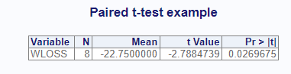
Comparison | Result
Comparison of hypothesis tests. | Pass

proc_means-012
SAS Code and Output
proc means data=cake n mean uss;  var Age PresentScore TasteScore Layers;  title 'Summary of Presentation and Taste Scores';  output out=outdata;  run; | 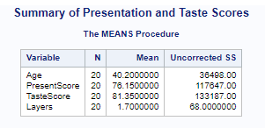
R Code and Output
proc_means(datm, var = v(Age, PresentScore, TasteScore, Layers),  stats = v(n, mean, uss),  titles = c("Test")) | 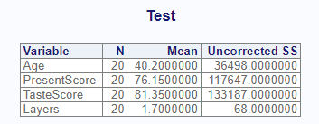
Comparison | Result
Test USS statistics. | Pass

proc_means-013
SAS Code and Output
proc means data=cake n mean skewness kurtosis maxdec = 8;  var Age PresentScore TasteScore Layers;  title 'Summary of Presentation and Taste Scores';  output out=outdata;  run; | 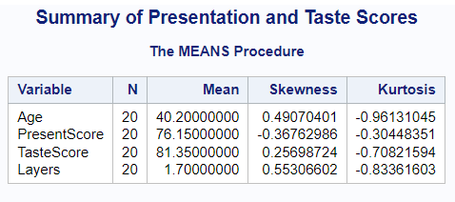
R Code and Output
proc_means(datm, var = v(Age, PresentScore, TasteScore, Layers),  stats = v(n, mean, skew, kurt),  titles = c("Test"),  options = c(maxdec = 8)) | 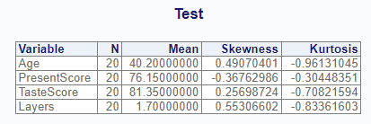
Comparison | Result
Test Skewness and Kurtosis | Pass

proc_means-014
SAS Data | R Data
data cake2;  input LastName $ 1-12 Age 13-14 PresentScore 16-17  TasteScore 19-20 Flavor $ 23-32 Layers 34 Region 36;  datalines;  Orlando 27 93 80 Vanilla 1 1  Ramey 32 84 72 Rum 2 1  Goldston 46 68 75 Vanilla 1 1  Roe 38 79 73 Vanilla 2 1  Larsen 23 77 84 Chocolate 3 1  Davis 51 86 91 Spice 3 1  Strickland 19 82 79 Chocolate 1 1  Nguyen 57 77 84 Vanilla 3 1  Hildenbrand 33 81 83 Chocolate 1 1  Byron 62 72 87 Vanilla 2 1  Sanders 26 56 79 Chocolate 1 2  Jaeger 43 66 74 1 2  Davis 28 69 75 Chocolate 2 2  Conrad 69 85 94 Vanilla 1 2  Walters 55 67 72 Chocolate 2 2  Rossburger 28 78 81 Spice 2 2  Matthew 42 81 92 Chocolate 2 2  Becker 36 62 83 Spice 2 2  Anderson 27 87 85 Chocolate 1 2  Merritt 62 73 84 Chocolate 1 2  ; | datmr <- read.table(header = TRUE, text = '  LastName Age PresentScore TasteScore Flavor Layers Region  Orlando 27 93 80 Vanilla 1 1  Ramey 32 84 72 Rum 2 1  Goldston 46 68 75 Vanilla 1 1  Roe 38 79 73 Vanilla 2 1  Larsen 23 77 84 Chocolate 3 1  Davis 51 86 91 Spice 3 1  Strickland 19 82 79 Chocolate 1 1  Nguyen 57 77 84 Vanilla 3 1  Hildenbrand 33 81 83 Chocolate 1 1  Byron 62 72 87 Vanilla 2 1  Sanders 26 56 79 Chocolate 1 2  Jaeger 43 66 74 NA 1 2  Davis 28 69 75 Chocolate 2 2  Conrad 69 85 94 Vanilla 1 2  Walters 55 67 72 Chocolate 2 2  Rossburger 28 78 81 Spice 2 2  Matthew 42 81 92 Chocolate 2 2  Becker 36 62 83 Spice 2 2  Anderson 27 87 85 Chocolate 1 2  Merritt 62 73 84 Chocolate 1 2  ')
SAS Code and Output
proc means data=cake2 n min max mean stddev maxdec=4;  var Age PresentScore TasteScore;  title 'Summary of Presentation and Taste Scores';  class Region Layers;  output out=mdata;  run; | 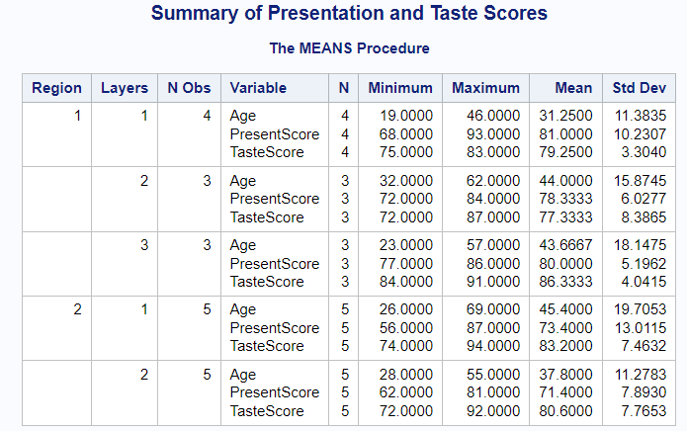
R Code and Output
res <- proc_means(datmr,  var = c("Age", "PresentScore", "TasteScore"),  stats = c("n", "min", "max","mean", "std"),  output = c("out", "report"),  class = c("Region", "Layers"),  titles = "My first title for Means",  options = c("long", maxdec = 4)) | 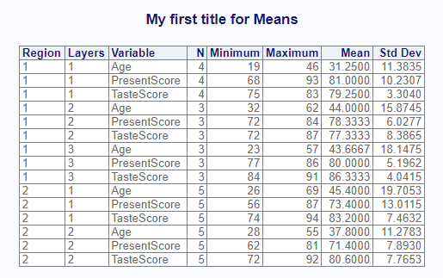
Comparison | Result
Test multiple class variables | Pass

proc_means-015
SAS Data | R Data
data cake;  input LastName $ 1-12 Age 13-14 PresentScore 16-17  TasteScore 19-20 Flavor $ 23-32 Layers 34 Region 36;  datalines;  Orlando 27 93 80 Vanilla 3 1  Ramey 32 84 72 Rum 2 1  Goldston 46 68 75 Vanilla 1 1  Roe 38 79 73 Vanilla 2 1  Larsen 23 77 84 Chocolate 3 1  Davis 51 86 91 Spice 3 1  Strickland 19 82 79 Chocolate 1 1  Nguyen 57 77 84 Vanilla 3 1  Hildenbrand 33 81 83 Chocolate 1 1  Byron 62 72 87 Vanilla 2 1  Sanders 26 56 79 Chocolate 1 1  Jaeger 43 66 74 1 2  Davis 28 69 75 Chocolate 2 2  Conrad 69 85 94 Vanilla 1 2  Walters 55 67 72 Chocolate 2 2  Rossburger 28 78 81 Spice 2 2  Matthew 42 81 92 Chocolate 2 2  Becker 36 62 83 Spice 2 2  Anderson 27 87 85 Chocolate 1 2  Merritt 62 73 84 Chocolate 1 2  ; | datsp <- datm  datsp$Layers[1] <- 3
SAS Code and Output
proc sort data=cake out=cake2;  by Layers;  run;  proc means data=cake2 kurt skew cv clm maxdec = 8;  var Age PresentScore TasteScore;  title 'Summary of Presentation and Taste Scores';  by Layers;  output out=mdata;  run; | 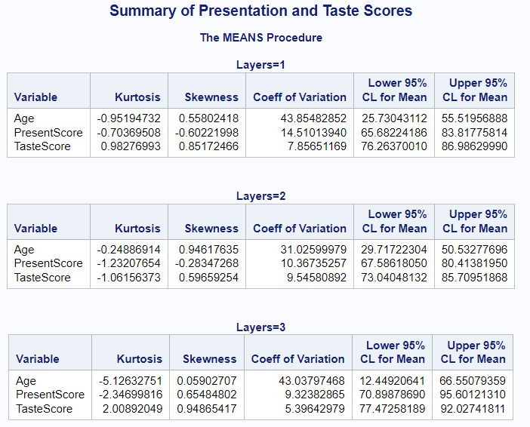
R Code and Output
proc_means(datsp, var = c("Age", "PresentScore", "TasteScore"),  stats = c("kurtosis", "skew", "cv", "clm"),  by = c("Layers"),  options = c(maxdec = 8)  ) | 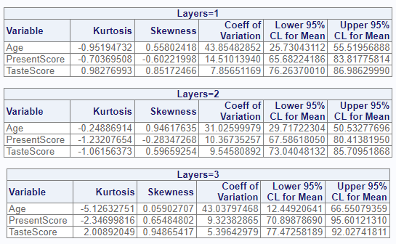
Comparison | Result
Test more complicated statistics with by variables and low sample sizes. | Pass

proc_means-016
SAS Data | R Data
data dat2;  input Name $ Assessment $ Score Weight;  datalines;  Smith Quiz1 85 0.05  Smith Quiz2 25 0.05  Smith Midterm 85 0.35  Smith Quiz3 . 0.05  Smith Quiz4 62 0.05  Smith Final 93 0.45  Wang Quiz1 100 0.05  Wang Quiz2 96 0.05  Wang Midterm 98 0.35  Wang Quiz3 105 0.05  Wang Quiz4 87 .  Wang Final 96 0.45  ;  run; | dat2 <- read.table(header = TRUE, text = '  Name Assessment Score Weight  Smith Quiz1 85 0.05  Smith Quiz2 25 0.05  Smith Midterm 85 0.35  Smith Quiz3 NA 0.05  Smith Quiz4 62 0.05  Smith Final 93 0.45  Wang Quiz1 100 0.05  Wang Quiz2 96 0.05  Wang Midterm 98 0.35  Wang Quiz3 105 0.05  Wang Quiz4 87 NA  Wang Final 96 0.45')

SAS Code and Output
proc means data = dat2 n mean median mode  std var stderr lclm uclm cv;  var Score;  class Name;  run; | 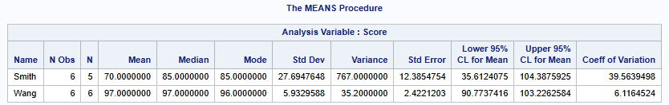
R Code and Output
proc_means(dat2, var = Score,  stats = c("nobs", "n", "mean", "median", "mode", "std", "vari",  "stderr", "lclm", "uclm", "cv"),  class = Name) | 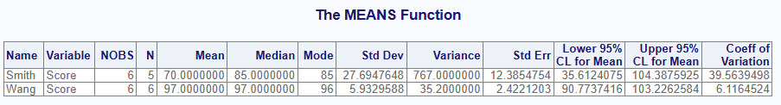
Comparison | Result
Test stats no weight. | Pass

proc_means-017
SAS Code and Output
proc means data = dat2 n mean median mode  std var stderr lclm uclm cv;  var Score;  weight Weight;  class Name;  run; | 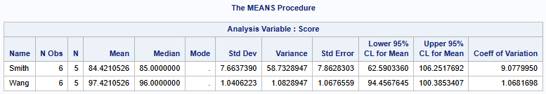
R Code and Output
proc_means(dat2, var = Score,  stats = c("nobs", "n", "mean", "median", "mode", "std",  "vari", "stderr", "lclm", "uclm", "cv"),  weight = Weight,  class = Name) | 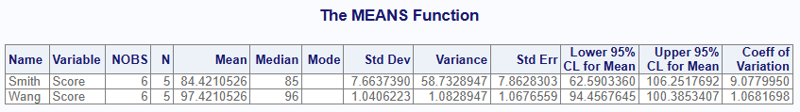
Comparison | Result
Test stats with weight default vardef. | Pass

SAS Code and Output
proc means data = dat2 n mean median mode  std var stderr lclm uclm cv vardef = WGT; var Score;  weight Weight; class Name;  run; | 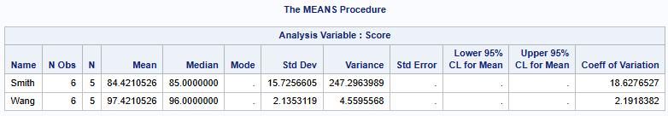
R Code and Output
proc_means(dat2, var = Score,  stats = c("nobs", "n", "mean", "median", "mode", "std",  "vari", "stderr", "lclm", "uclm","cv"),  weight = Weight, class = Name,  options = c(vardef = "wgt")) | 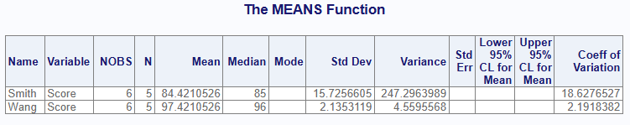
Comparison | Result
Test stats with weight and vardef = wgt. | Pass

proc_means-018

proc_means-019
SAS Code and Output
proc means data = dat2 n mean median mode  std var stderr lclm uclm cv vardef = DF;  var Score; weight Weight;  class Name;  run; | 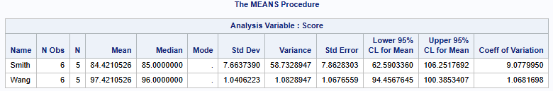
R Code and Output
proc_means(dat2, var = Score,  stats = c("nobs", "n", "mean", "median", "mode", "std",  "vari", "stderr", "lclm", "uclm", "cv"),  weight = Weight, class = Name,  options = c(vardef = "df")) | 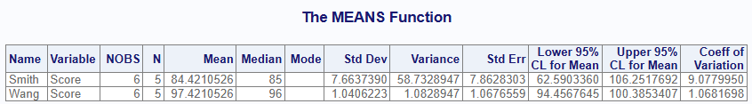
Comparison | Result
Test stats with weight vardef = DF. | Pass

proc_means-020
SAS Code and Output
proc means data = dat2 n mean median mode  std var stderr lclm uclm cv vardef = WDF;  var Score; weight Weight;  class Name;  run; | 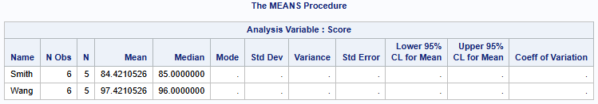
R Code and Output
proc_means(dat2, var = Score,  stats = c("nobs", "n", "mean", "median", "mode", "std",  "vari", "stderr", "lclm", "uclm", "cv"),  weight = Weight, class = Name,  options = c(vardef = "wdf")) | 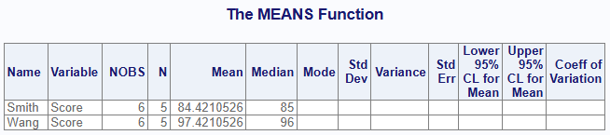
Comparison | Result
Test stats with weight vardef = WDF. | Pass

proc_means-021
SAS Code and Output
proc means data = dat2 n mean median mode  std var stderr lclm uclm cv vardef = N;  var Score; weight Weight;  class Name;  run; | 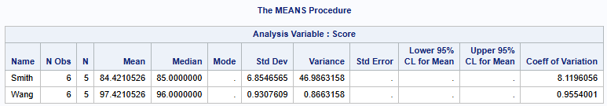
R Code and Output
proc_means(dat2, var = Score,  stats = c("nobs", "n", "mean", "median", "mode", "std",  "vari", "stderr", "lclm", "uclm", "cv"),  weight = Weight, class = Name,  options = c(vardef = "n")) | 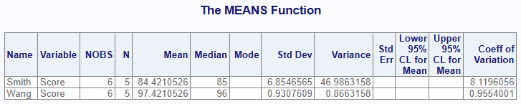
Comparison | Result
Test stats with weight vardef = N. | Pass

proc_means-022
SAS Code and Output
proc means data = dat2  n p10 p25 p75 p90 t prt skew kurt;  var Score;  class Name;  run; | 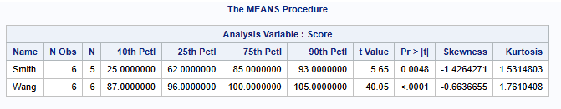
R Code and Output
proc_means(dat2, var = Score,  stats = c("nobs", "n", "p10",  "p25", "p75", "p90",  "t", "prt", "skew", "kurt"),  class = Name,  options = c(vardef = "df")) | 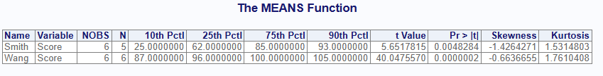
Comparison | Result
More statistics. | Pass

proc_means-023
SAS Code and Output
proc means data = dat2 vardef = DF  n p10 p25 p75 p90 t prt skew kurt;  var Score;  class Name;  weight Weight;  run; | 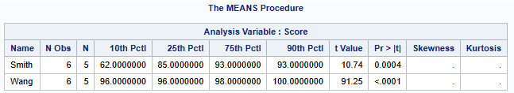
R Code and Output
proc_means(dat2, var = Score,  stats = c("nobs", "n", "p10", "p25", "p75", "p90", "t", "prt", "skew", "kurt"),  weight = Weight,  class = Name,  options = c(vardef = "df")) | 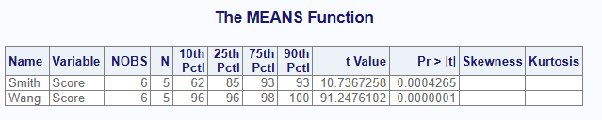
Comparison | Result
More statistics with weight | Pass

proc_means-024
SAS Code and Output
proc means data = dat2 vardef = wgt  n p10 p25 p75 p90 t prt skew kurt;  var Score;  class Name;  weight Weight;  run; | 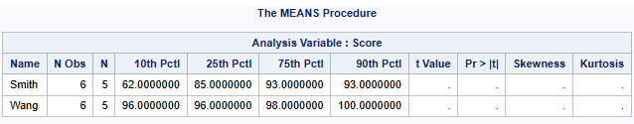
R Code and Output
proc_means(dat2, var = Score,  stats = c("nobs", "n", "p10", "p25", "p75", "p90", "t", "prt", "skew", "kurt"),  weight = Weight,  class = Name,  options = c(vardef = "wgt")) | 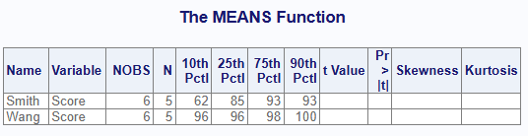
Comparison | Result
 | Pass

proc_means-025
SAS Code and Output
proc means data = dat2 vardef = n  n p10 p25 p75 p90 t prt skew kurt;  var Score;  class Name;  weight Weight;  run; | 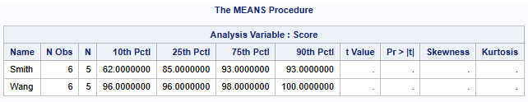
R Code and Output
proc_means(dat2, var = Score,  stats = c("nobs", "n", "p10", "p25", "p75", "p90", "t", "prt", "skew", "kurt"),  weight = Weight,  class = Name,  options = c(vardef = "n")) | 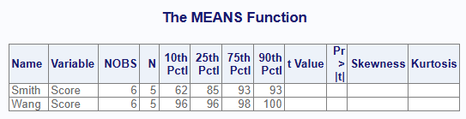
Comparison | Result
 | Pass

proc_means-026
SAS Code and Output
proc means data = dat2 vardef = df  n mean uss;  var Score;  class Name;  weight Weight;  run; | 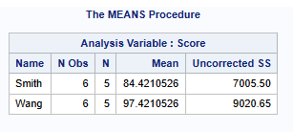
R Code and Output
proc_means(dat2, var = Score,  stats = c("nobs", "n", "mean", "uss"),  weight = Weight,  class = Name,  options = c(vardef = "df")) | 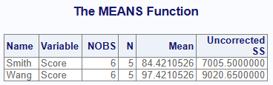
Comparison | Result
Test weighted USS statistics. | Pass

Transpose Data
SAS | R
data score;  input Student $9. +1 StudentID $ Section $ Test1 Test2 Final;  datalines;  Capalleti 0545 1 94 91 87  Dubose 1252 2 51 65 91  Engles 1167 1 95 97 97  Grant 1230 2 63 75 80  Krupski 2527 2 80 76 71  Lundsford 4860 1 92 40 86  McBane 0674 1 75 78 72  ; | score <- read.table(header = TRUE,  colClasses = c(Student = "character", StudentID = "character",  Section = "character"), text = '  Student StudentID Section Test1 Test2 Final  Capalleti "0545" "1" 94 91 87  Dubose "1252" "2" 51 65 91  Engles "1167" "1" 95 97 97  Grant "1230" "2" 63 75 80  Krupski "2527" "2" 80 76 71  Lundsford "4860" "1" 92 40 86  McBane "0674" "1" 75 78 72  ', stringsAsFactors = FALSE)

proc_transpose-001
SAS Code and Output
proc transpose data=score out=score_transposed name = Exam;  id Student;  run;  proc print data=score_transposed noobs;  title 'Student Test Scores in Variables';  run; | 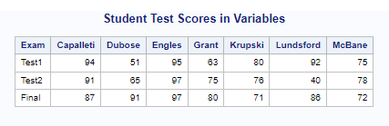
R Code and Output
res <- proc_transpose(score, var = c("Test1", "Test2", "Final"),  id = Student, name = "Exam")  proc_print(res, titles = "Student Test Scores in Variables") | 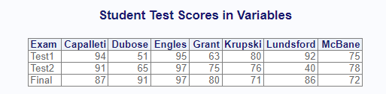
Comparison | Results
Perform basic transpose with ID variable and name. | Pass

proc_transpose-002
SAS Code and Output
proc transpose data=score out=score_transposed  prefix = Student suffix= score name = Exam;  run;  proc print data=score_transposed noobs;  title 'Student Test Scores in Variables';  run; | 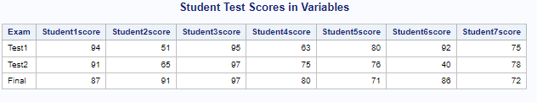
R Code and Output
res <- proc_transpose(score, var = c("Test1", "Test2", "Final"),  name = "Exam", prefix = "Student", suffix = "score")  proc_print(res, titles = "Student Test Scores in Variables") | 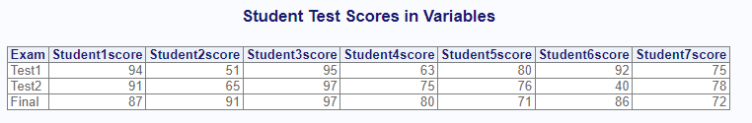
Comparison | Results
Perform basic transpose with prefix and suffix. | Pass

proc_transpose-003
SAS Code and Output
proc sort data = score out = score_sorted;  by Section;  run;  proc transpose data=score_sorted out=score_transposed name = Exam;  id Student;  by Section;  run;  proc print data=score_transposed noobs;  title 'Student Test Scores in Variables';  run; | 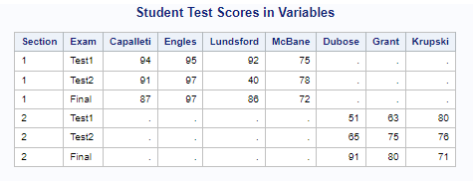
R Code and Output
res <- proc_transpose(score, var = c("Test1", "Test2", "Final"),  name = "Exam", id = "Student", by = "Section")  proc_print(res, titles = "Student Test Scores in Variables") | 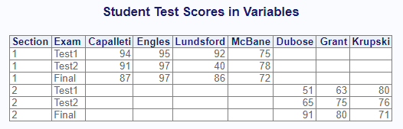
Comparison | Results
Perform basic transpose with by group. | Pass

proc_transpose-004
SAS Code and Output
proc means data = score nonobs;  output out = stats;  run;  data score2 (keep = Group _STAT_ Test1 Test2 Final) ;  set stats (drop =_TYPE_ _FREQ_);  Group = "Group1";  run;  proc print data=score2 noobs;  title 'Student Test Scores in Variables';  run; | 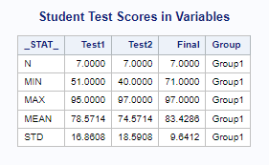
R Code and Output
stats <- proc_means(score, options = v(notype, nonobs))  res1 <- data.frame(Group = "Group1", stats)  res2 <- proc_transpose(res1, copy = "Group",  name = "STAT", id = "VAR")  proc_print(res2, titles = "Student Test Scores in Variables") | 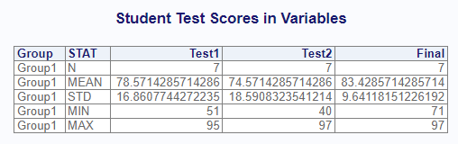
Comparison | Results
Perform basic transpose with copy parameter. | Pass. Differences that SAS proc means puts stats in rows anyway, as doesn’t need to be transformed. Also, data step does not reorder columns. Procs package tries to improve on both of these issues.

T-Test Data
SAS | R
data cls;  set sashelp.class;  if _n_ < 10 then do;  region = 'A';  end;  else do;  region = 'B';  end;  run; | cls <- read.table(header = TRUE, text = '  Name Sex Age Height Weight region  Alfred M 14 69.0 112.5 A  Alice F 13 56.5 84.0 A  Barbara F 13 65.3 98.0 A  Carol F 14 62.8 102.5 A  Henry M 14 63.5 102.5 A  James M 12 57.3 83.0 A  Jane F 12 59.8 84.5 A  Janet F 15 62.5 112.5 A  Jeffrey M 13 62.5 84.0 A  John M 12 59.0 99.5 B  Joyce F 11 51.3 50.5 B  Judy F 14 64.3 90.0 B  Louise F 12 56.3 77.0 B  Mary F 15 66.5 112.0 B  Philip M 16 72.0 150.0 B  Robert M 12 64.8 128.0 B  Ronald M 15 67.0 133.0 B  Thomas M 11 57.5 85.0 B  William M 15 66.5 112.0 B')

proc_ttest-001
SAS Code and Output
proc ttest data=cls  h0=65  alpha=0.05;  var Height;  run; | 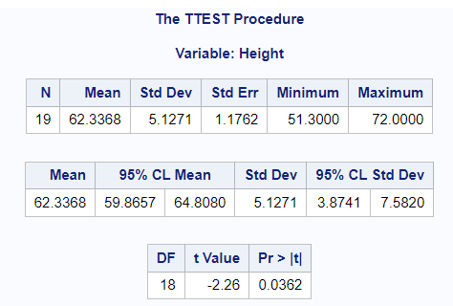
R Code and Output
proc_ttest(cls,  var = c("Height"),  options = c("h0" = 65, "alpha" = 0.05)) | 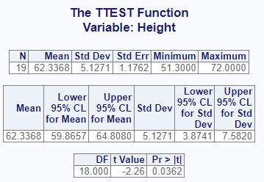
Comparison | Results
Perform basic T-Test on single variable. | Pass.

proc_ttest-002
SAS Code and Output
proc ttest data=cls alpha=0.05;  paired weight * height;  run; | 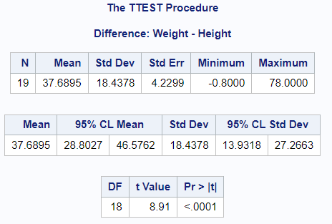
R Code and Output
proc_ttest(cls,  paired = "Weight * Height",  options = c("alpha" = 0.05)) | 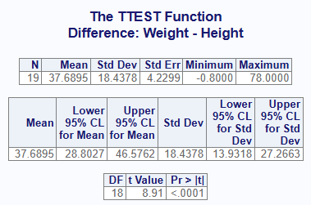
Comparison | Results
Perform basic T-Test on paired variables. | Pass.

proc_ttest-003
SAS Code and Output
proc ttest data=cls alpha=0.05;  class sex;  var height;  run; | 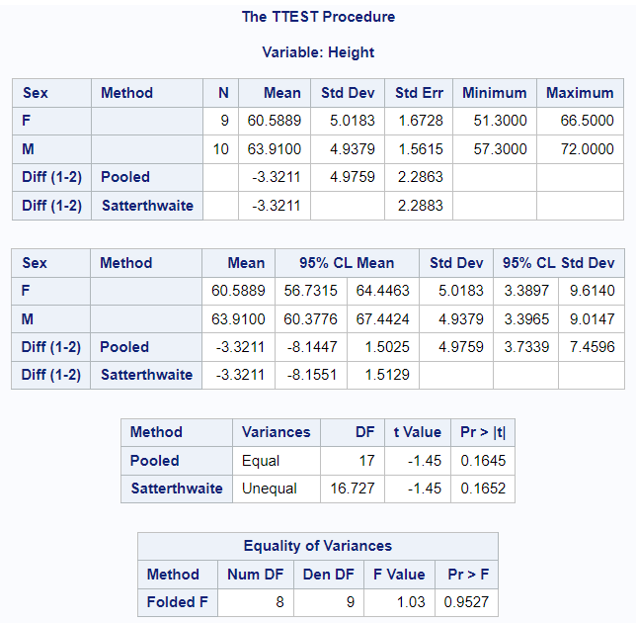
R Code and Output
proc_ttest(cls,  var = "Height",  class = "Sex",  options = c("alpha" = 0.05)) | 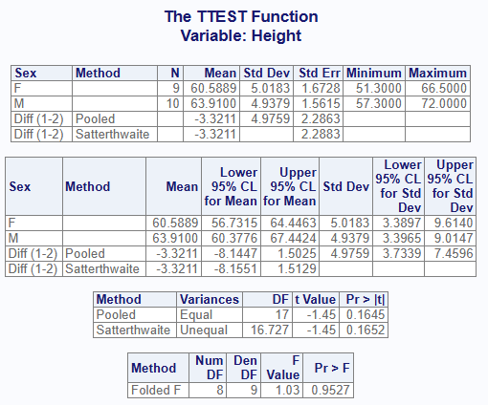
Comparison | Results
Perform basic T-Test on variable with class. | Pass.

proc_ttest-004
SAS Code and Output
proc ttest data=cls  h0=65  alpha=0.1;  var Height;  by region;  run; | 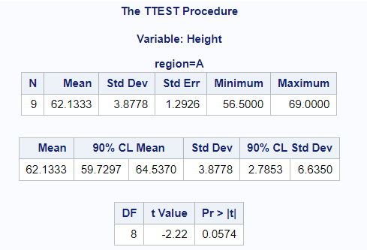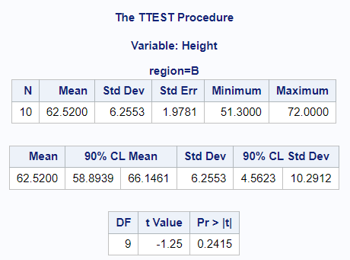
R Code and Output
proc_ttest(cls,  var = c("Height"),  by = "region",  options = c("h0" = 65, "alpha" = 0.05)) | 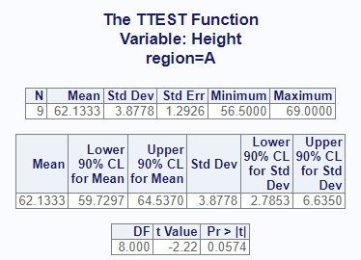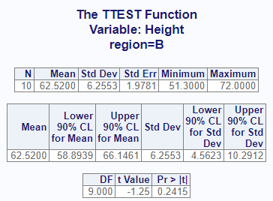
Comparison | Results
Perform T-Test on single variable with by. | Pass.

proc_ttest-005
SAS Code and Output
proc ttest data=cls alpha=0.1;  paired weight * height;  by region;  run; | 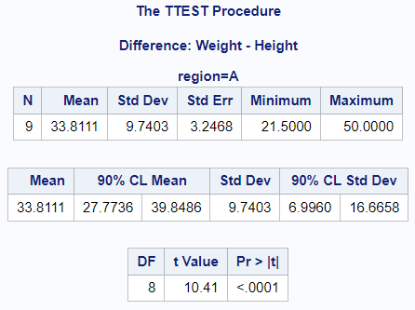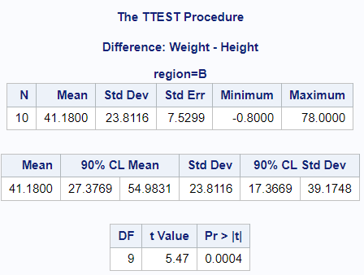
R Code and Output
proc_ttest(cls,  paired = "Weight * Height",  by = "region",  options = c("alpha" = 0.1)) | 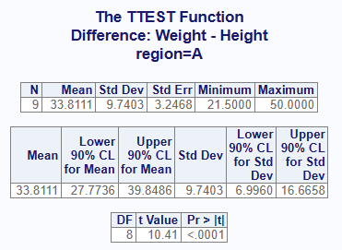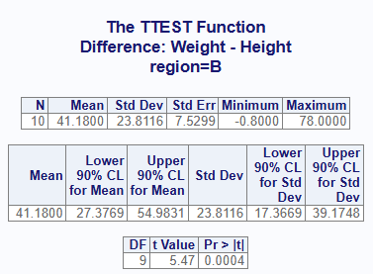
Comparison | Results
Perform T-Test on paired variables with by. | Pass.

proc_ttest-006
SAS Code and Output
proc ttest data=cls alpha=0.1;  class sex;  var height;  by region;  run; | 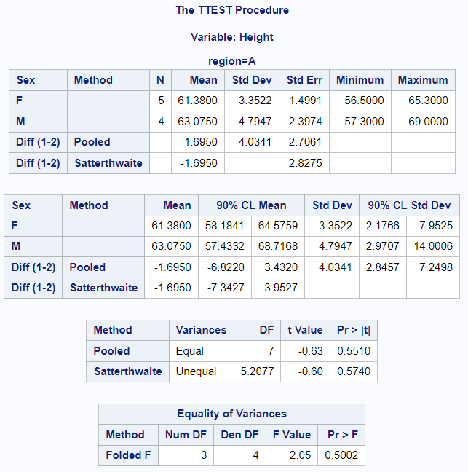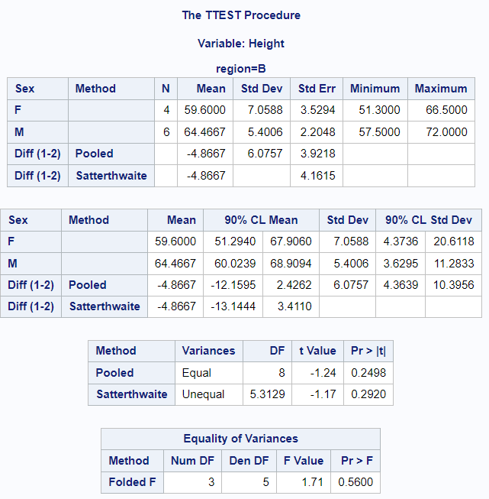
R Code and Output
proc_ttest(cls,  var = "Height",  class = "Sex",  by = "region",  options = c("alpha" = 0.1)) | 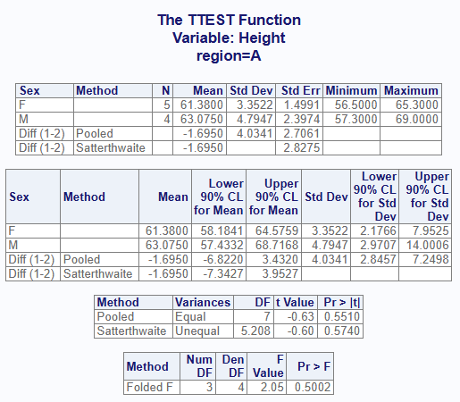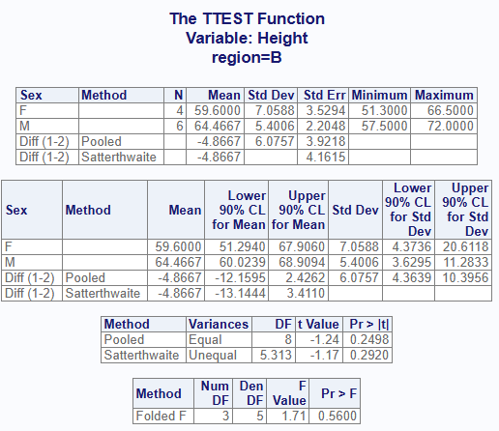
Comparison | Results
Perform T-Test on unpaired variable with by. | Pass. Initially F Value and CL values were not coming out.

proc_ttest-007
SAS Code and Output
proc ttest data=cls alpha=0.1;  class sex;  var Weight;  by region;  run; | 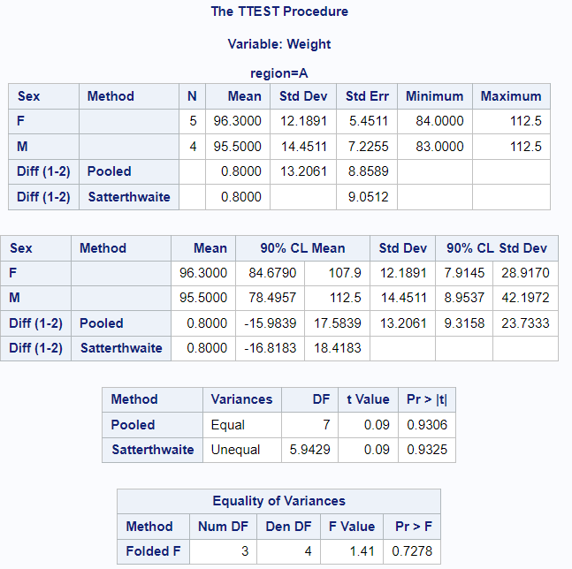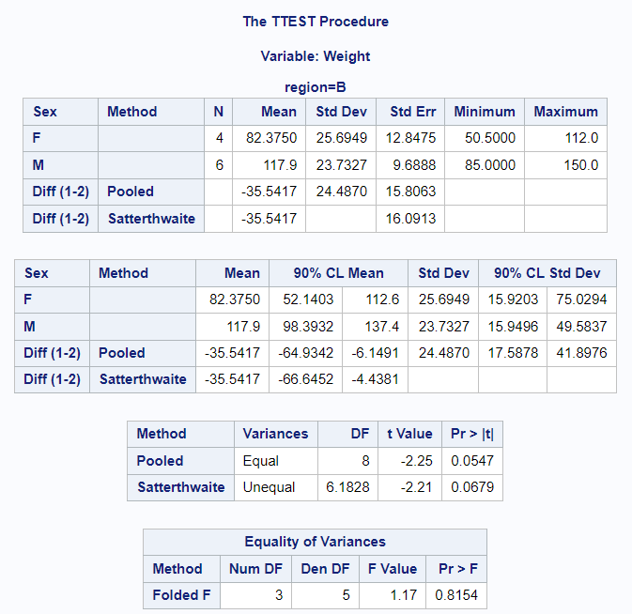
R Code and Output
proc_ttest(cls,  var = "Weight",  class = "Sex",  by = "region",  options = c("alpha" = 0.1)) | 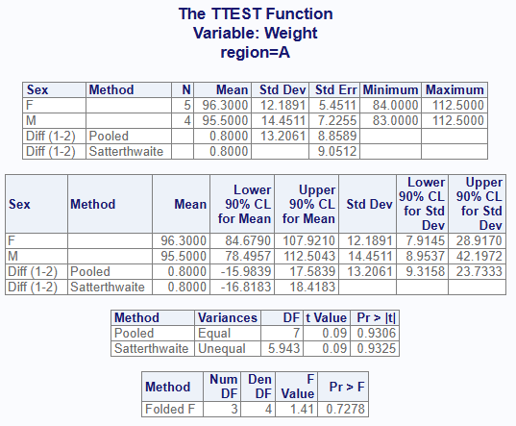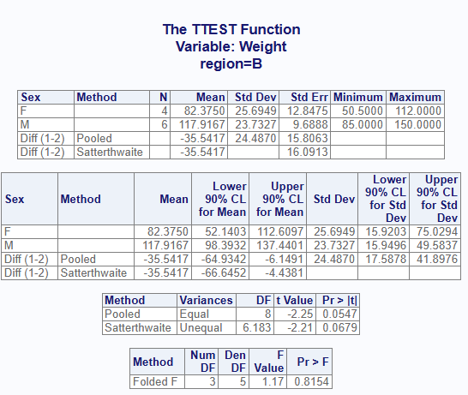
Comparison | Results
Perform T-Test on unpaired variable with by. | Pass. More testing to ensure it is coming out with different variables.

proc_ttest-008
SAS Code and Output
proc ttest data=cls alpha=0.1;  class sex;  var Age;  by region;  run; | 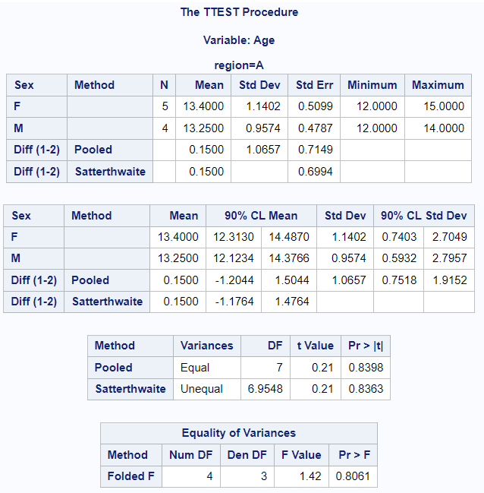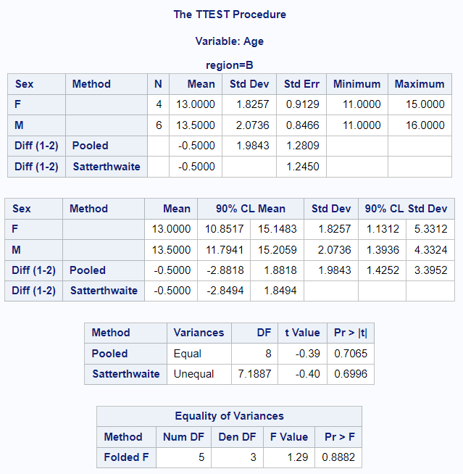
R Code and Output
proc_ttest(cls,  var = "Age",  class = "Sex",  by = "region",  options = c("alpha" = 0.1)) | 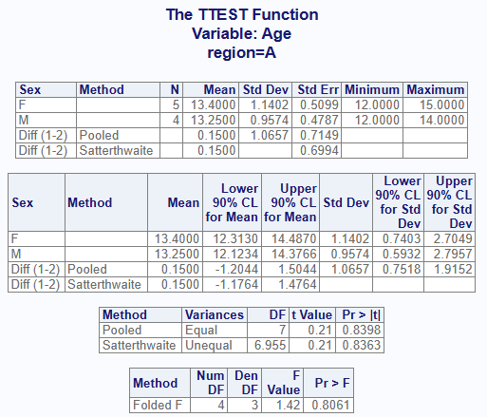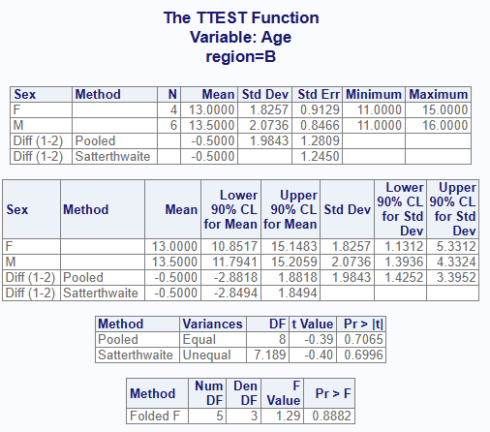
Comparison | Results
Perform T-Test on unpaired variable with by. | Pass. Another test with a different variable.

proc_ttest-009A
SAS Code and Output
proc ttest data=cls alpha=0.1;  class sex;  var Height Weight Age;  by region;  run; | 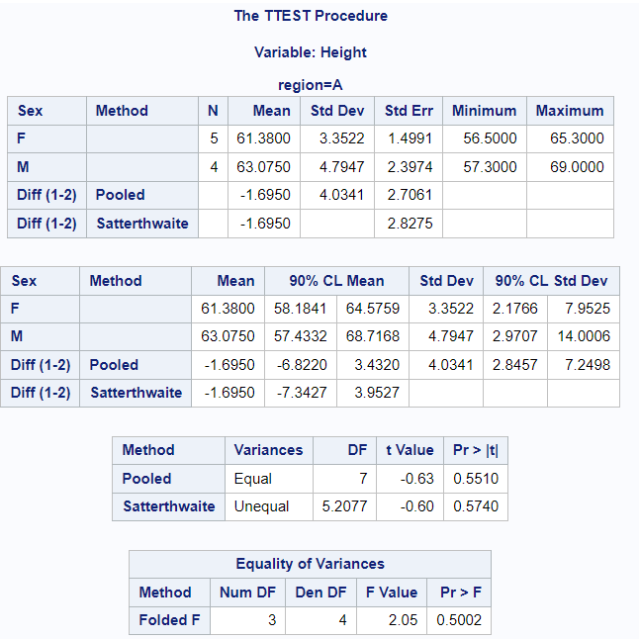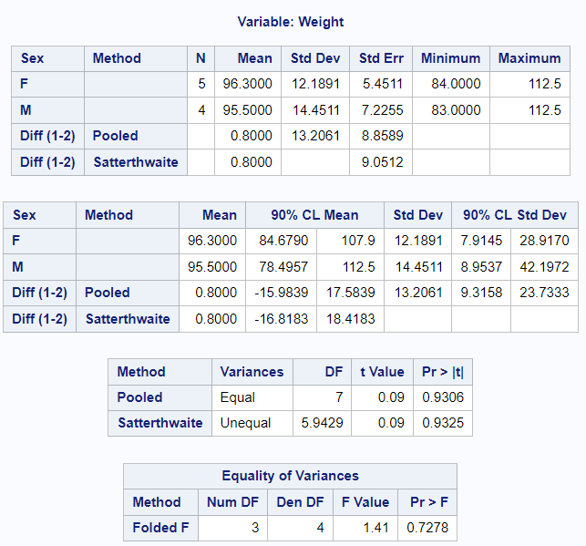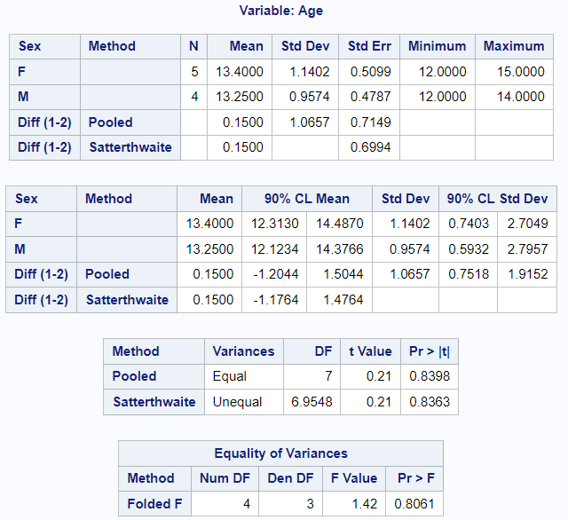
R Code and Output
proc_ttest(cls,  var = c("Height", "Weight", "Age"),  class = "Sex",  by = "region",  options = c("alpha" = 0.1)) | 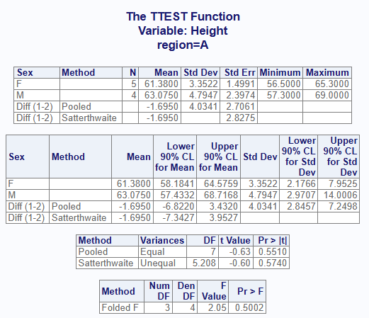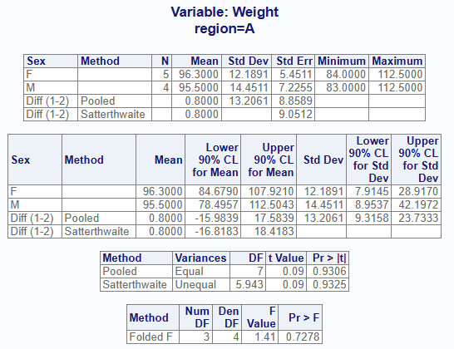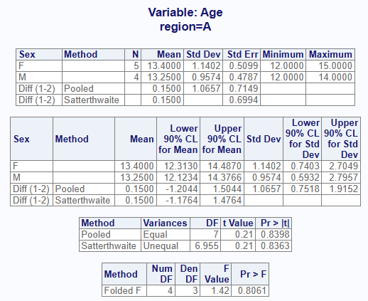
Comparison | Results
Perform T-Test on multiple unpaired variable with by. | Pass.

proc_ttest-009B
SAS Code and Output
proc ttest data=cls alpha=0.1;  class sex;  var Height Weight Age;  by region;  run; | 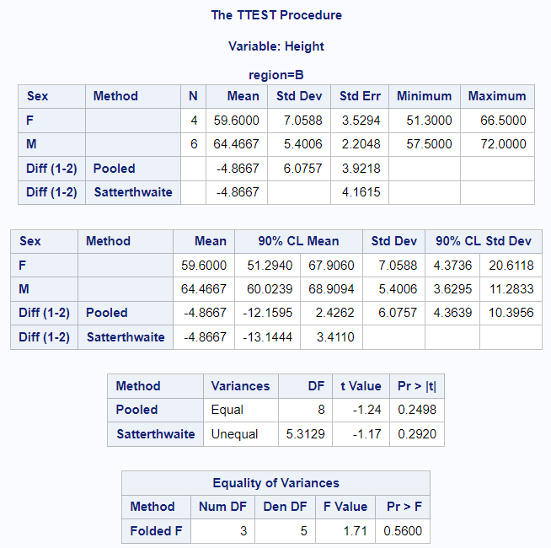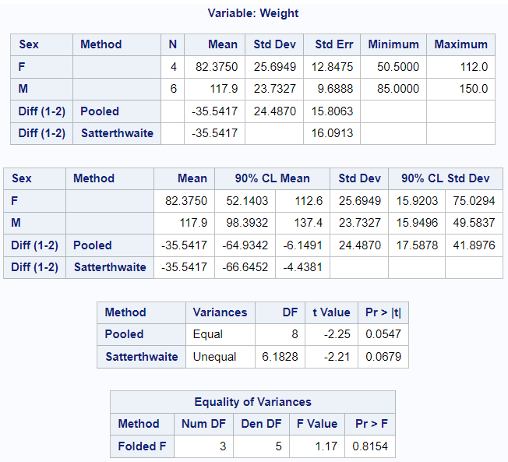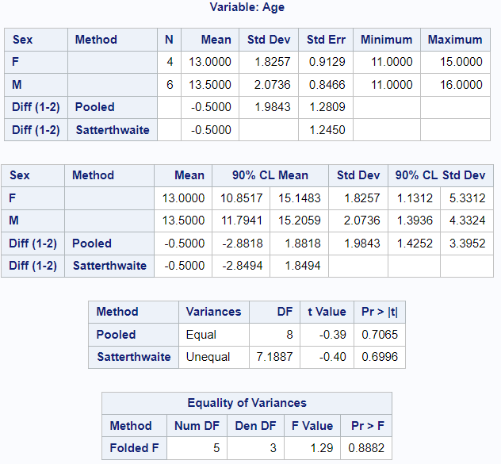
R Code and Output
proc_ttest(cls,  var = c("Height", "Weight", "Age")  class = "Sex",  by = "region",  options = c("alpha" = 0.1)) | 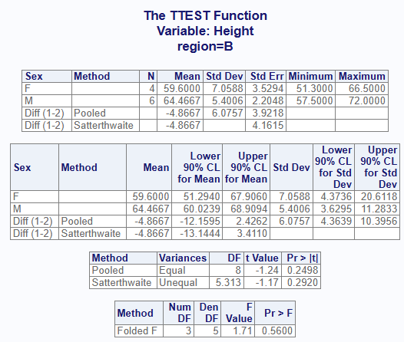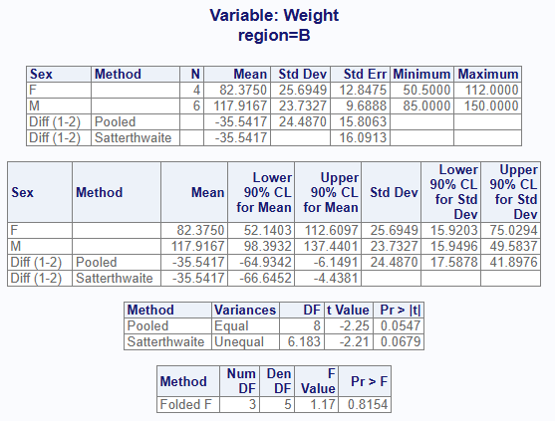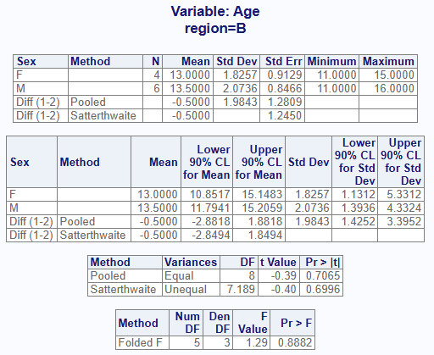
Comparison | Results
Perform T-Test on multiple unpaired variable with by. | Pass.

proc_ttest-010
SAS Code and Output
ods graphics on;  proc sort data = cls out = cls;  by Sex;  run;  proc ttest data=cls plots=all;  class sex;  var Height;  run;  ods graphics off; | 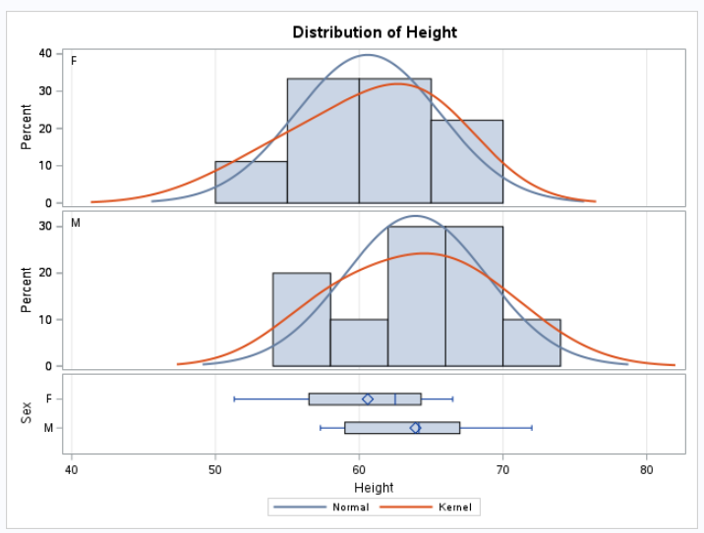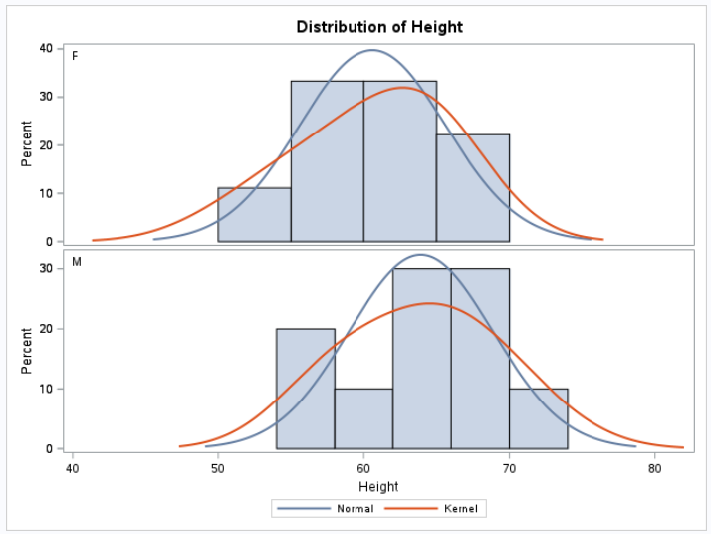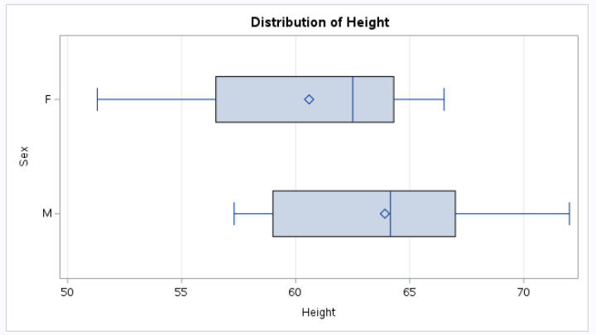  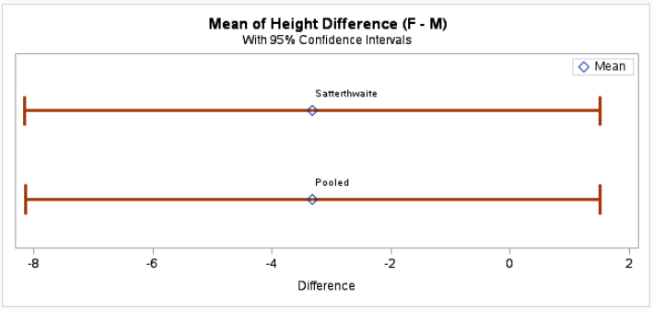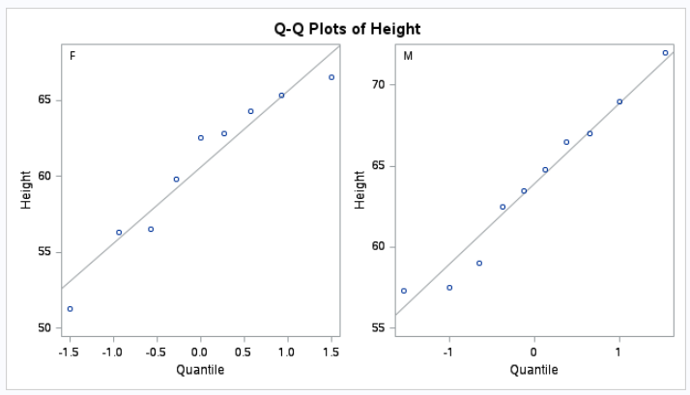
R Code and Output
proc_ttest(cls,  var = "Height",  class = "Sex",  plot = "all") | 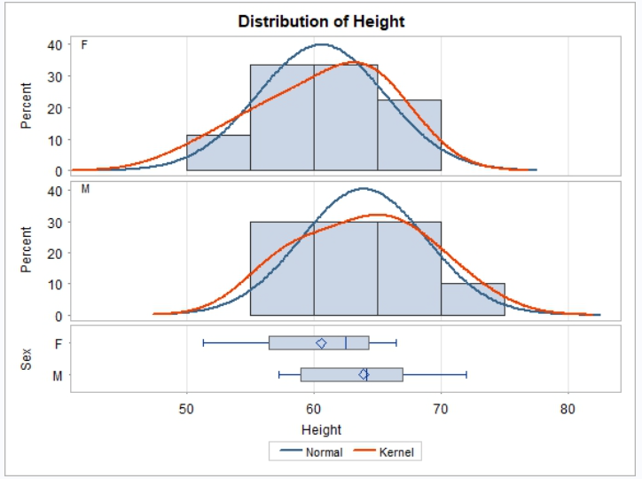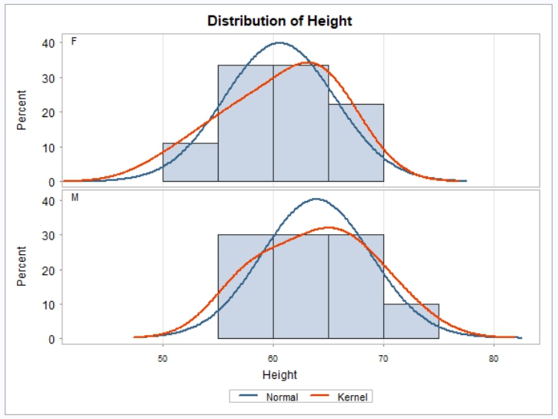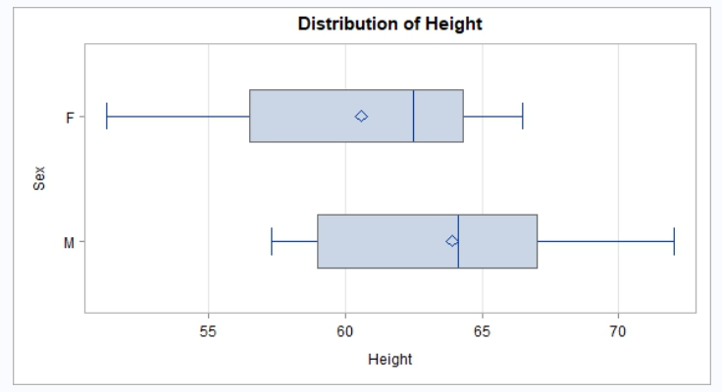  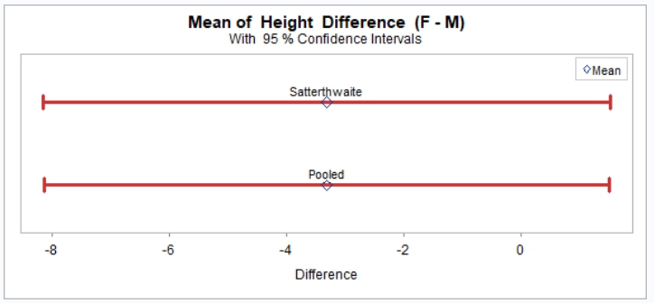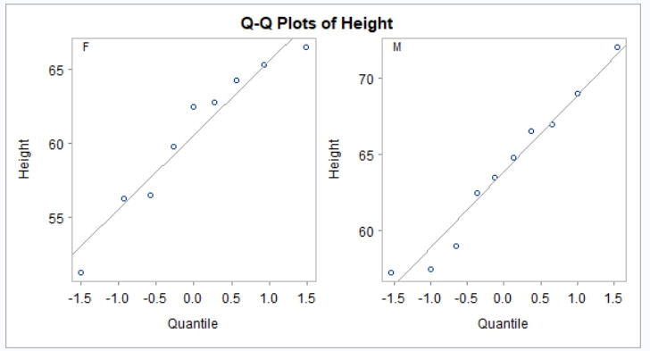
Comparison | Results
Two sample T-Test with all plots. | Pass.

proc_ttest-011
SAS Code and Output
ods graphics on;  proc ttest data = cls plots=all;  paired Height * Weight;  run;  ods graphics off; | 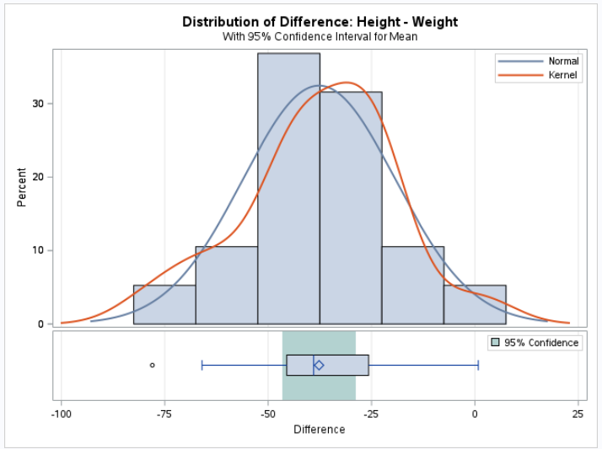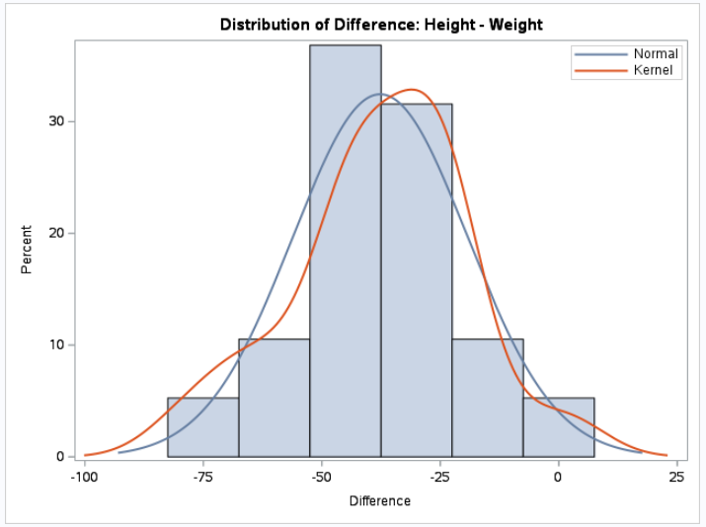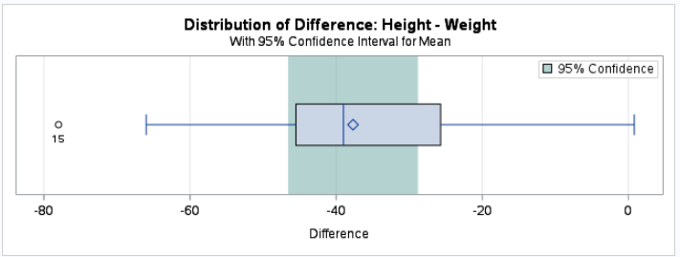  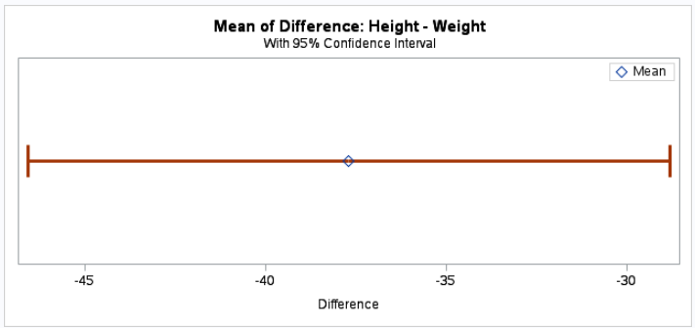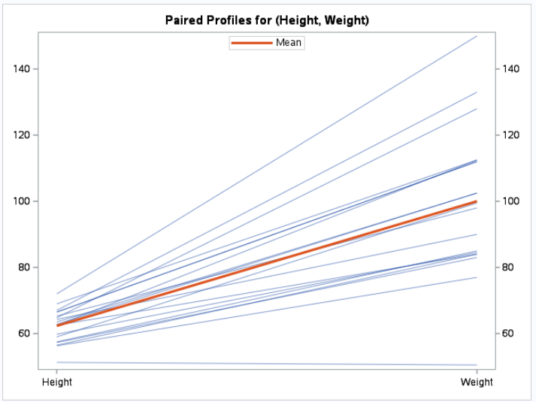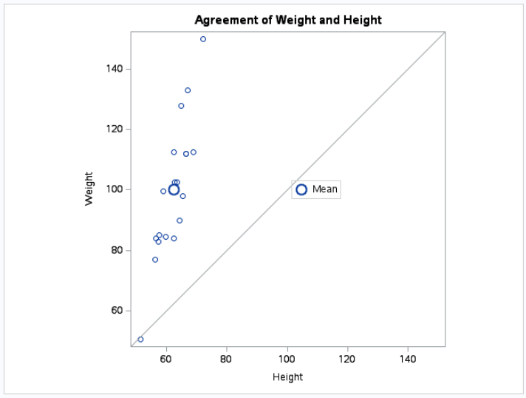  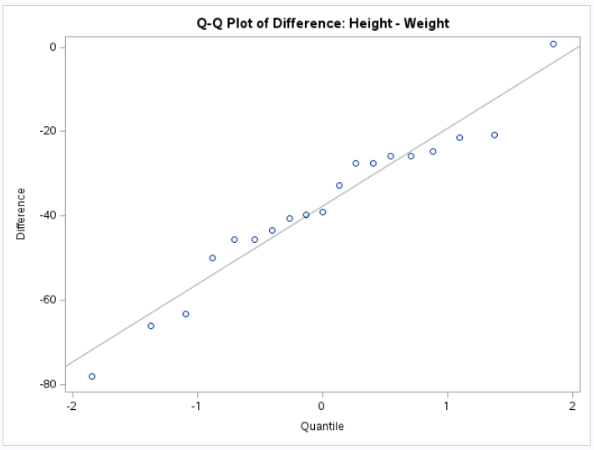

R Code and Output
proc_ttest(cls,  paired = "Height * Weight",  plot = "all") | 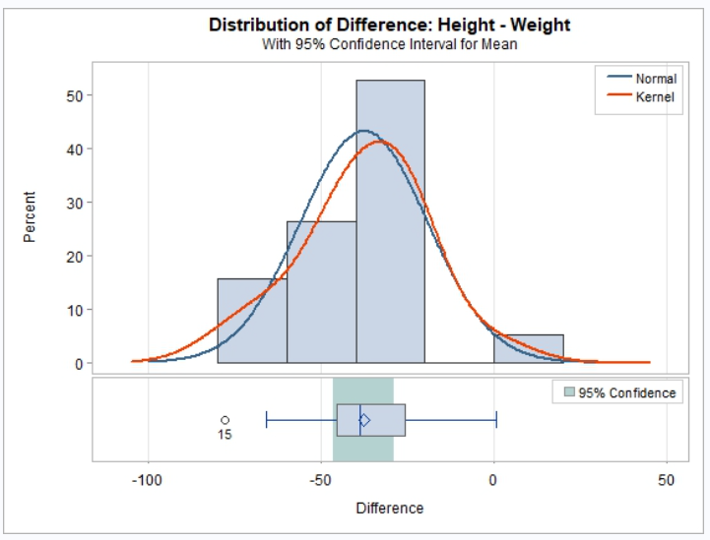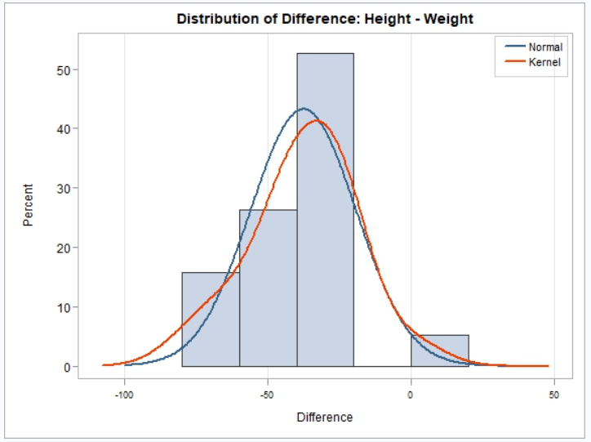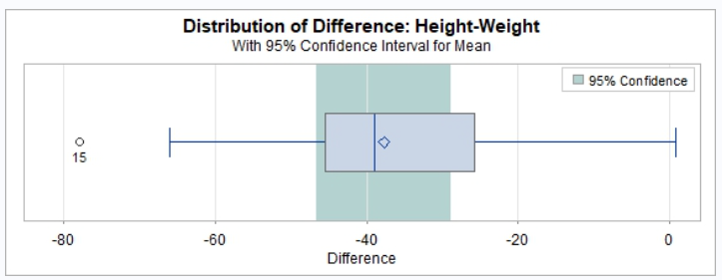  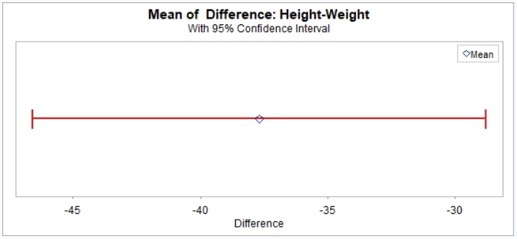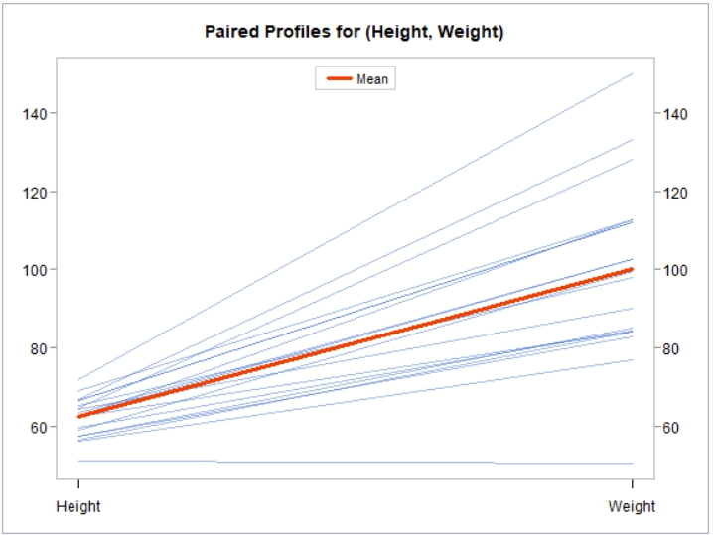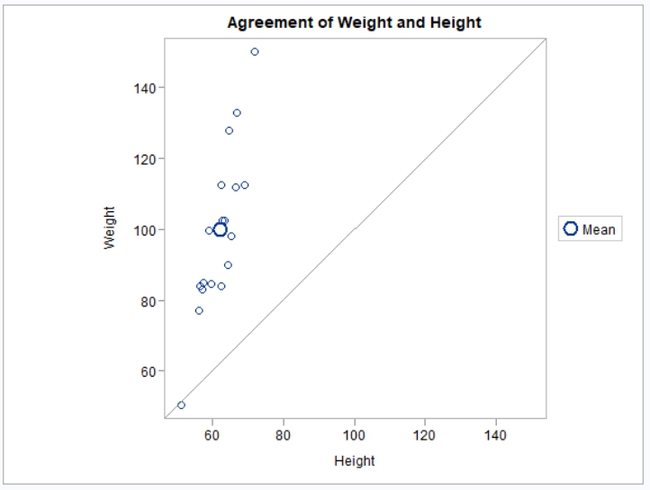  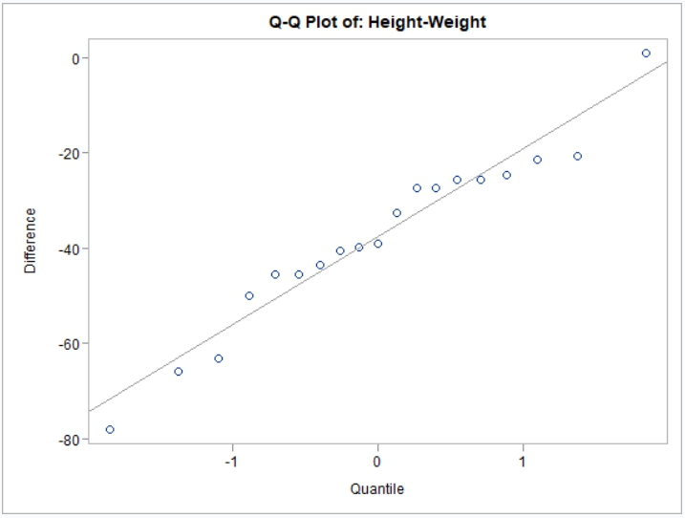
Comparison | Results
Paired T-Test with all plots. | Histogram bins will not match. Overall shape should be similar. Pass.

proc_ttest-012
SAS Code and Output
proc ttest data=cls  plots = all  sides = u;  var Height;  class Sex;  run; | 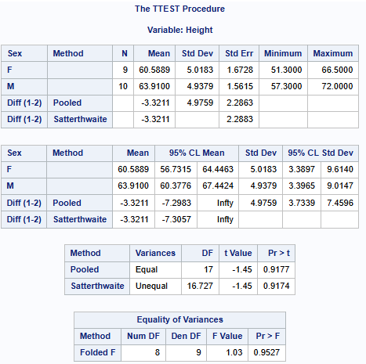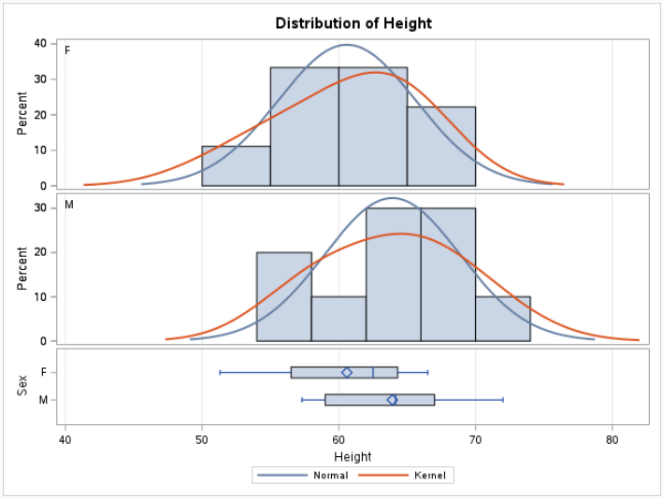  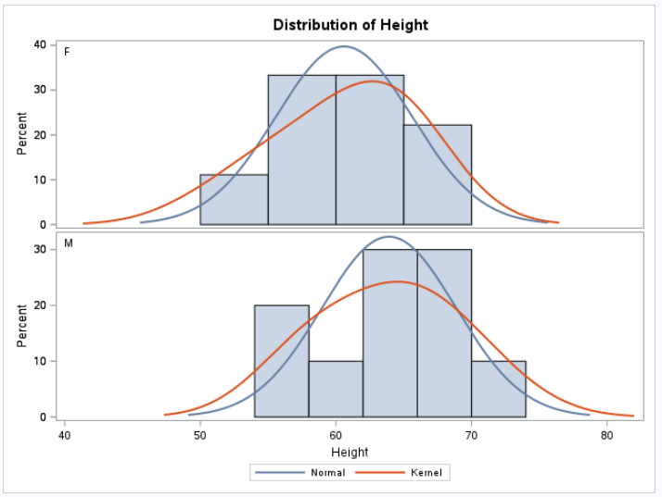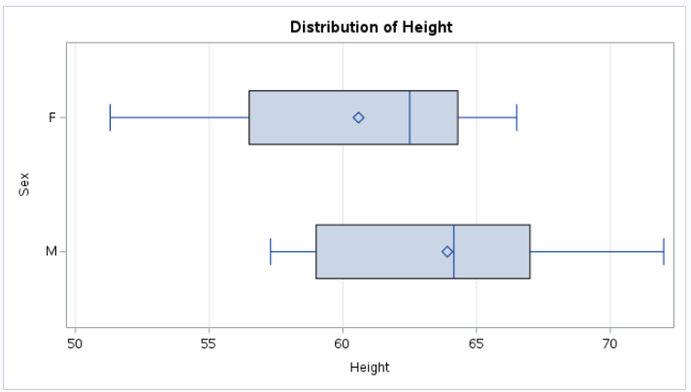  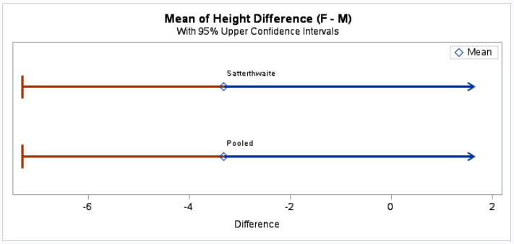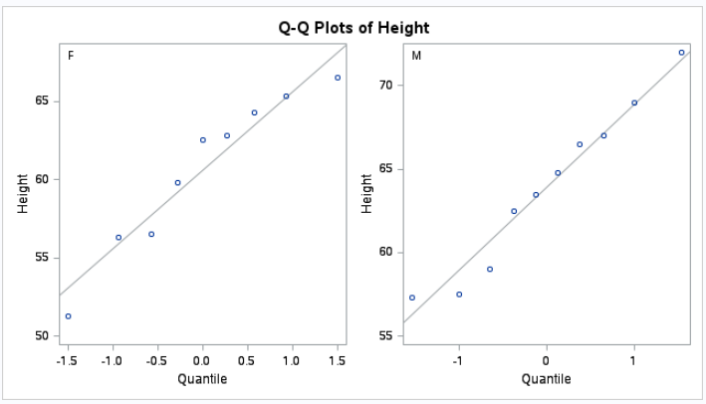

R Code and Output
proc_ttest(cls,  var = "Height",  class = "Sex",  options = c(sides = "U"),  plot = "all") | 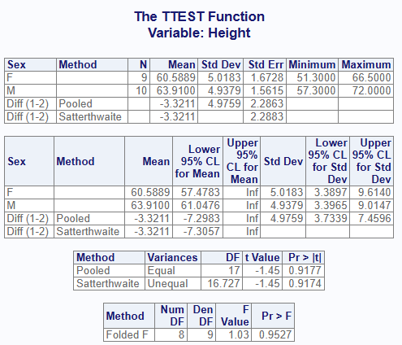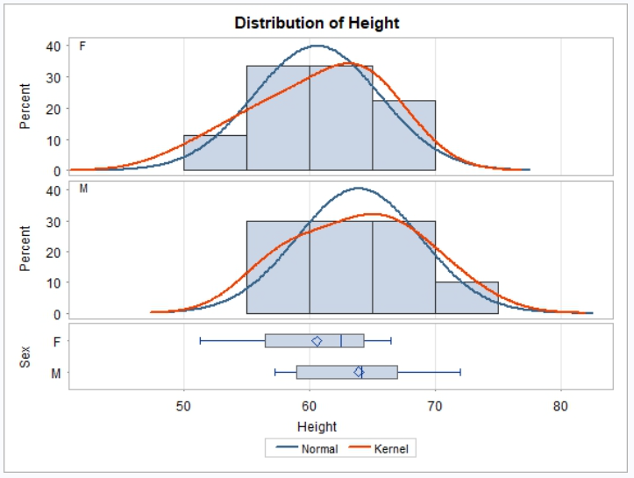  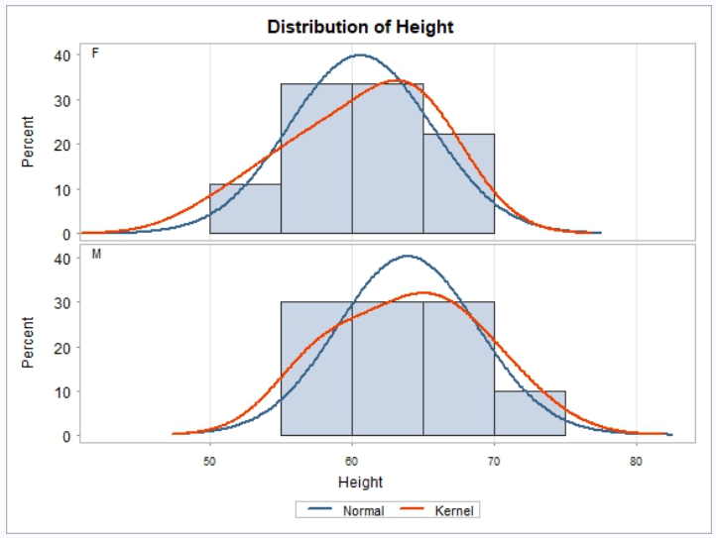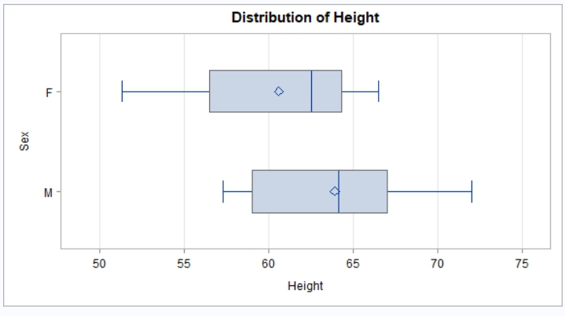  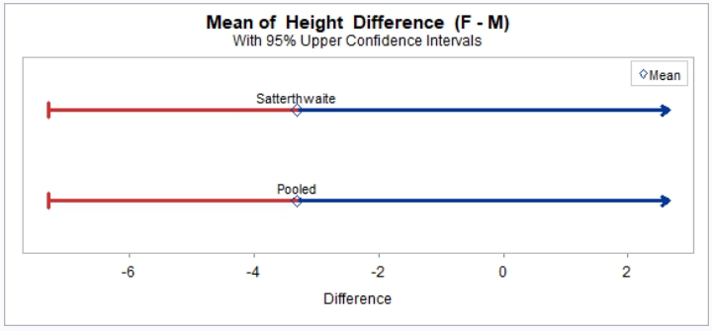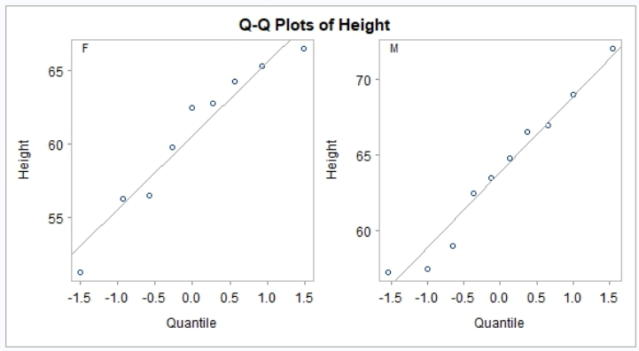
Comparison | Results
One-sided T-Test, upper, with plots. | Pass.

proc_ttest-013
SAS Code and Output
proc ttest data=sashelp.class  plots = all  sides = l;  var Height;  class Sex;  run; | 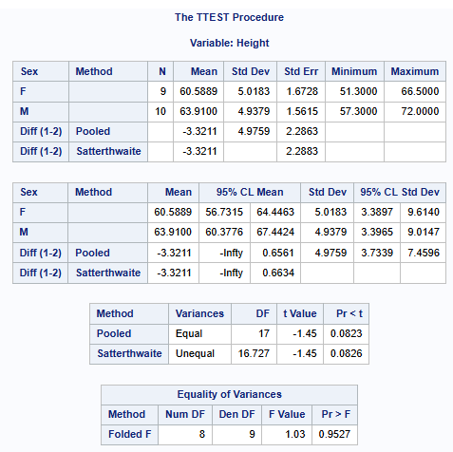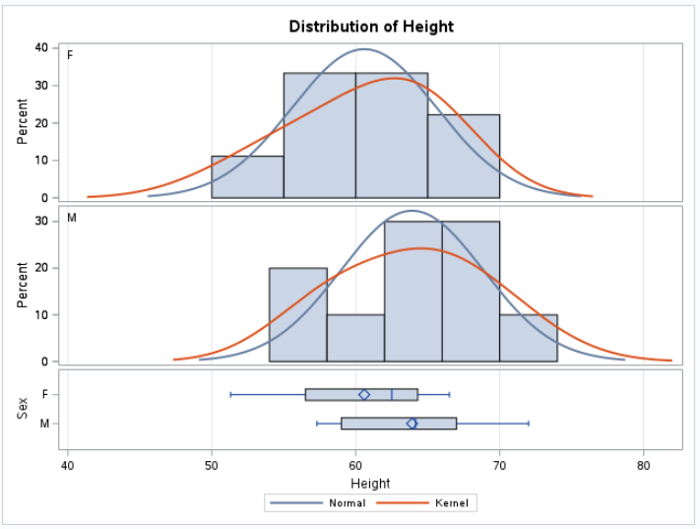  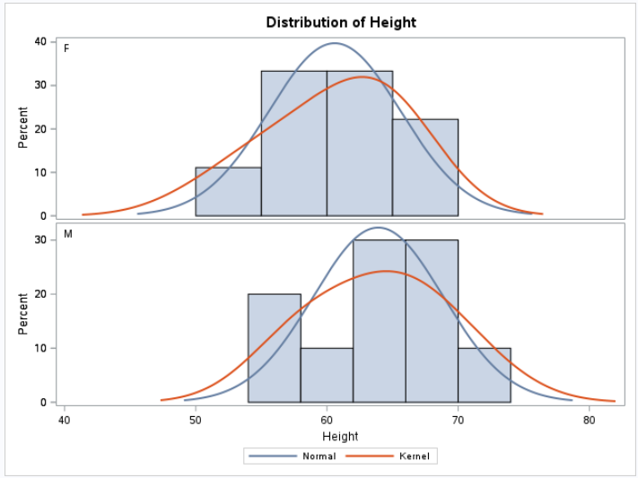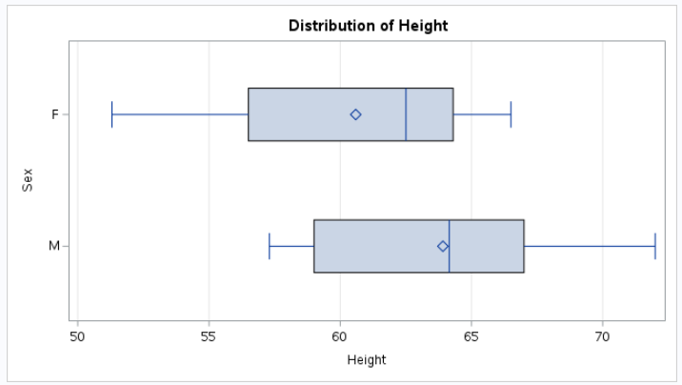  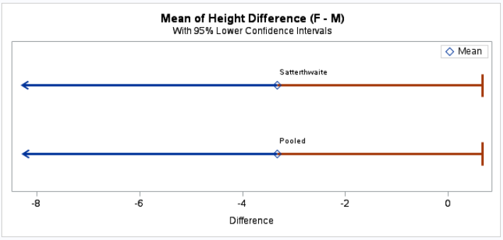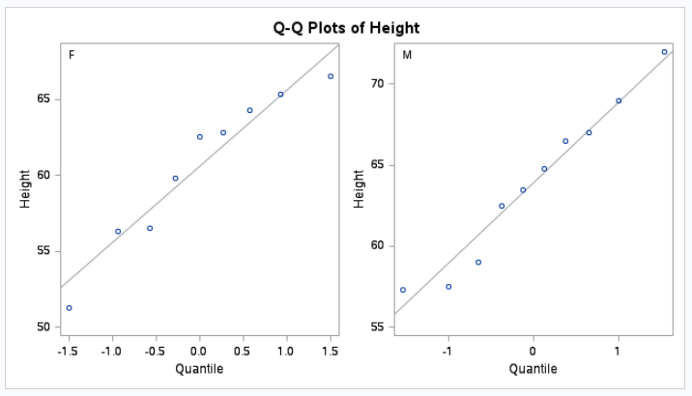

R Code and Output
proc_ttest(cls,  var = "Height",  class = "Sex",  options = c(sides = "L"),  plot = "all") | 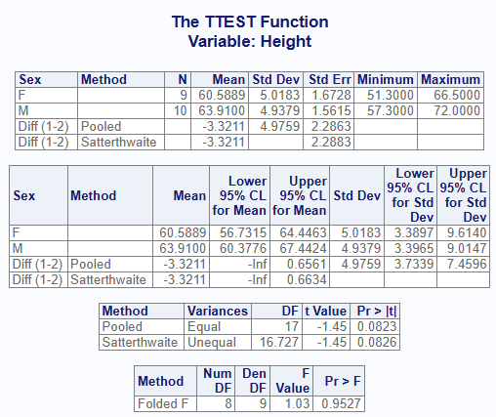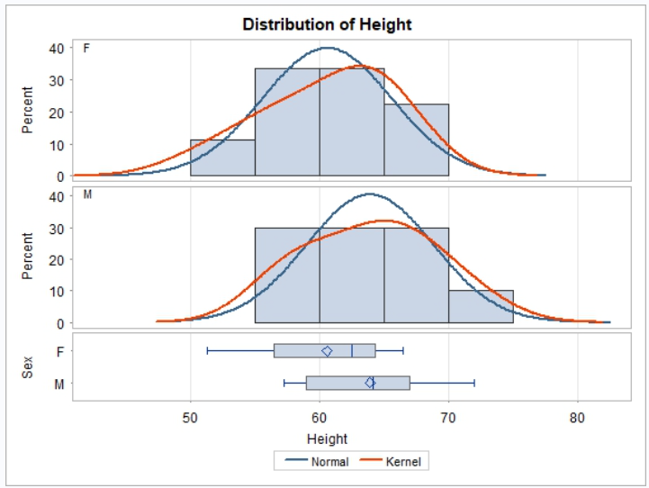  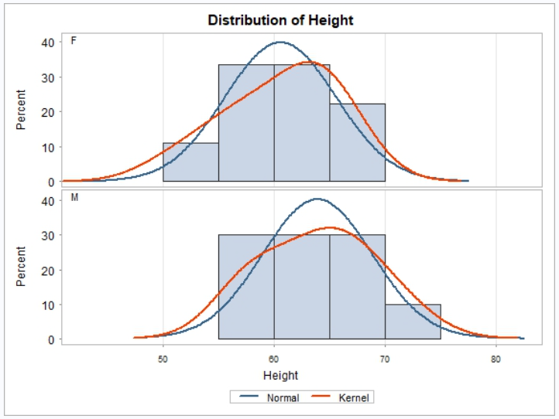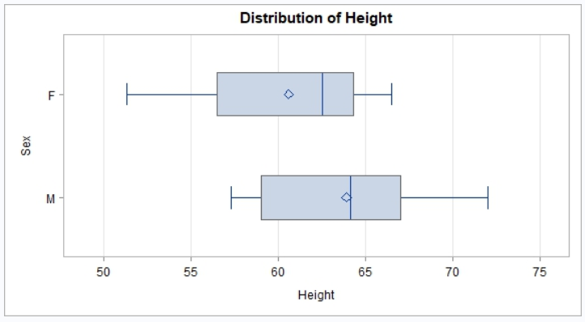  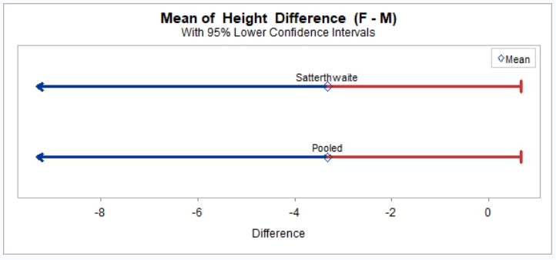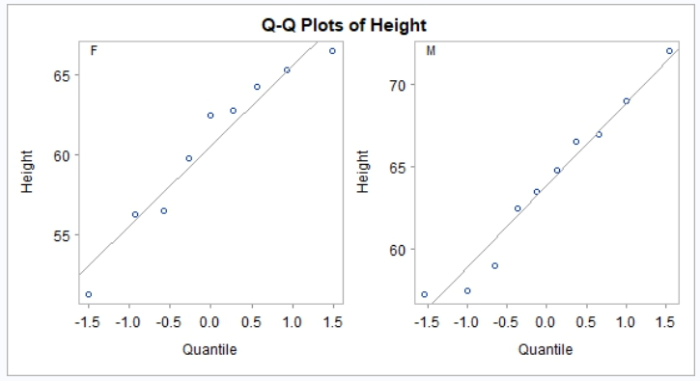
Comparison | Results
One-sided T-Test, lower, with plots. | Pass.

proc_ttest-014
SAS Code and Output
data school_scores;  input Group $ Score Frequency;  datalines;  Online 85 10  Online 90 25  Online 92 15  InPerson 88 12  InPerson 91 30  InPerson 95 18  ;  run;  proc ttest data=school_scores  plots = all;  class Group;  var Score;  freq Frequency;  run; | 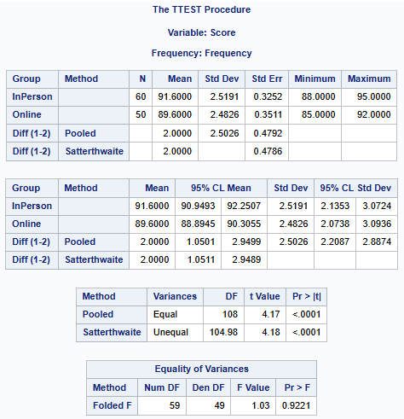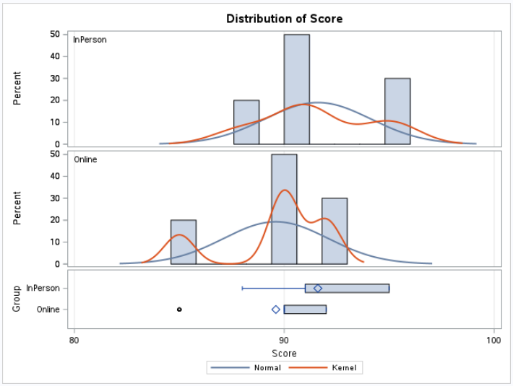  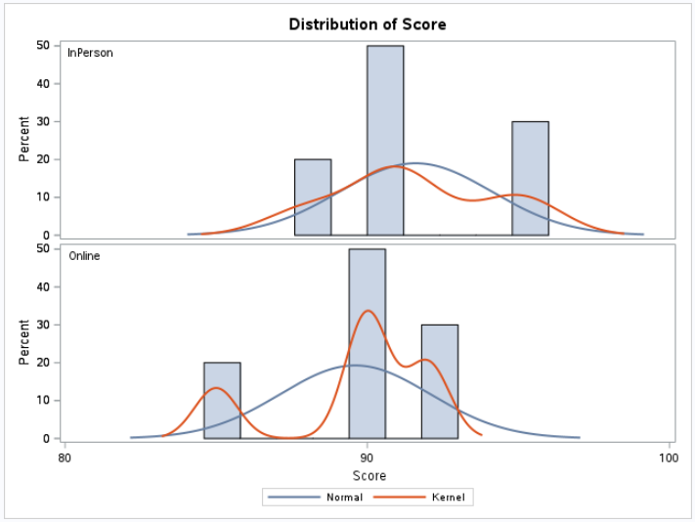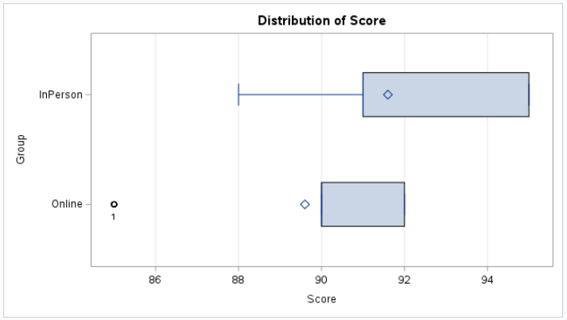  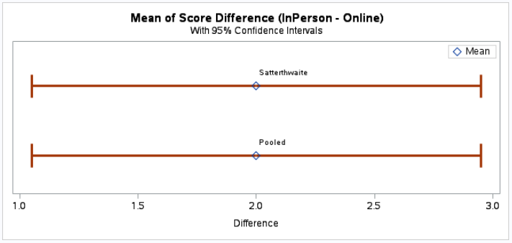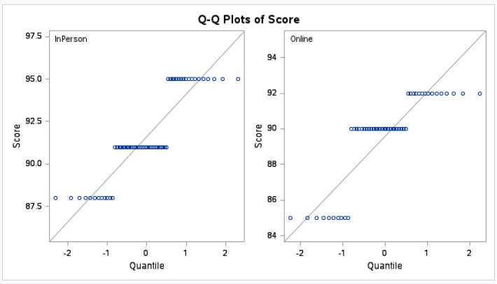
R Code and Output
scrs <- read.table(header = TRUE, text = '  Group Score Frequency  Online 85 10  Online 90 25  Online 92 15  InPerson 88 12  InPerson 91 30  InPerson 95 18  ')  proc_ttest(scrs,  var = "Score",  class = "Group",  freq = "Frequency",  plot = "all") | 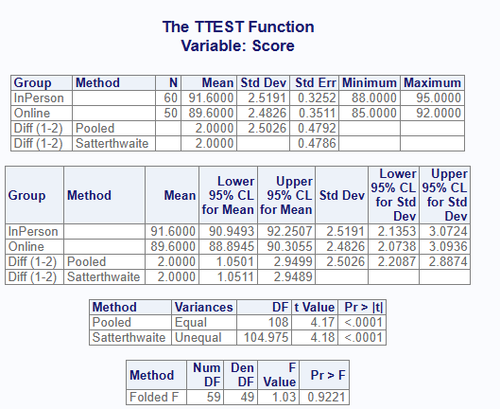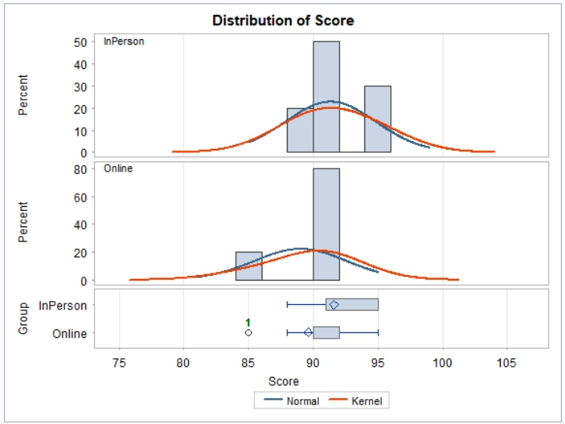  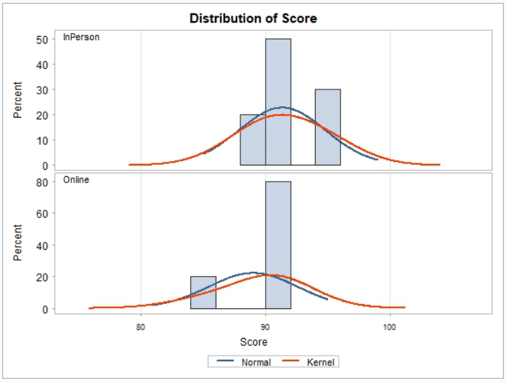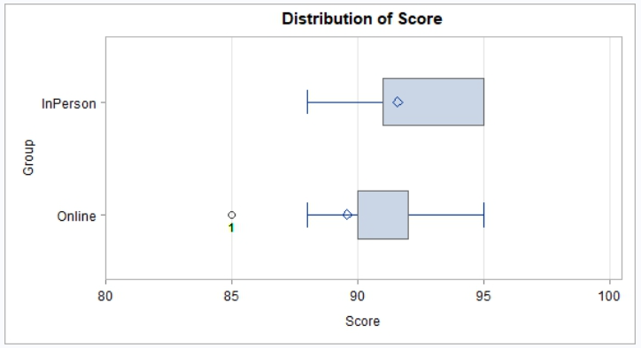  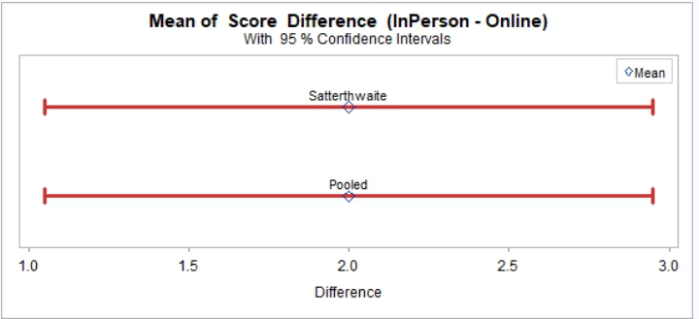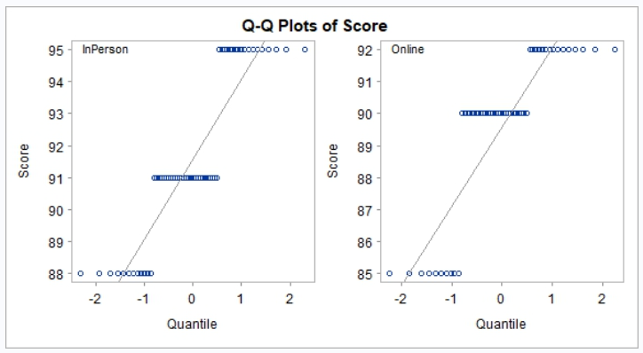
Comparison | Results
Two-sample T-test with freq parameter. | Pass.

proc_ttest-015
SAS Code and Output
data school_scores;  input Group $ Score Frequency;  datalines;  Online 85 10  Online 90 25  Online 92 15  InPerson 88 12  InPerson 91 30  InPerson 95 18  ;  run;  proc ttest data=school_scores  plots = all;  class Group;  var Score;  weight Frequency;  run; | 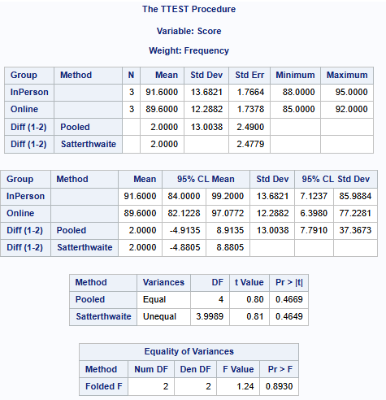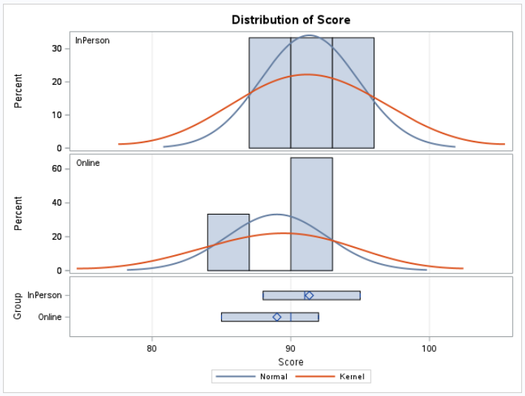  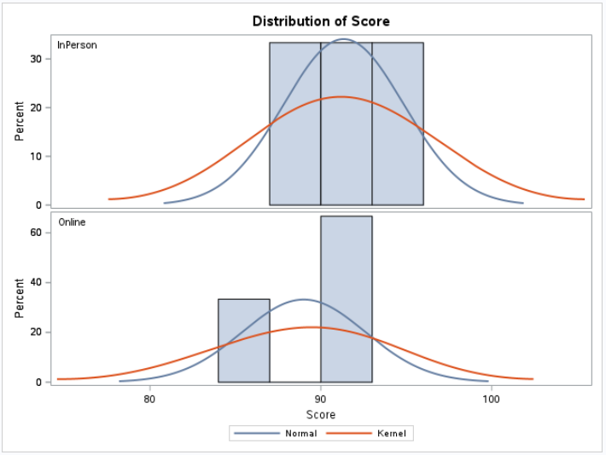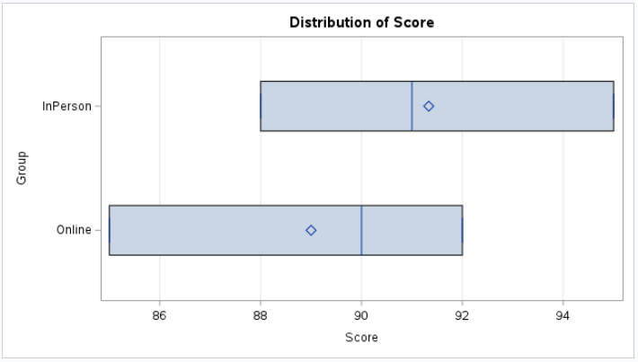  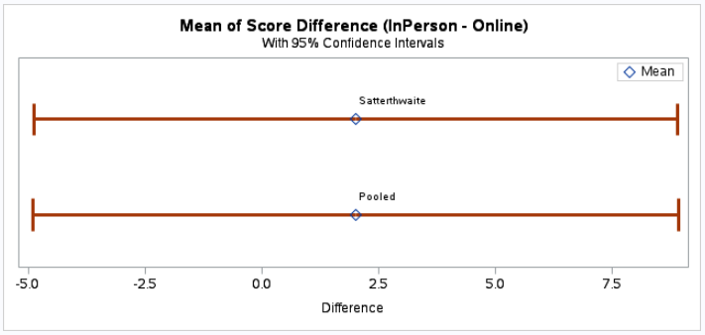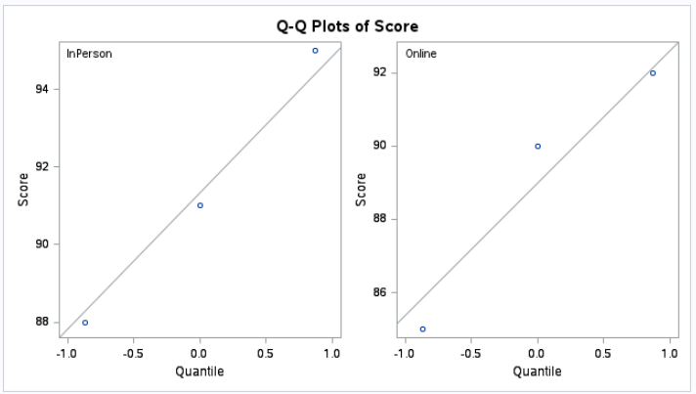

R Code and Output
scrs <- read.table(header = TRUE, text = '  Group Score Frequency  Online 85 10  Online 90 25  Online 92 15  InPerson 88 12  InPerson 91 30  InPerson 95 18  ')  proc_ttest(scrs,  var = "Score",  class = "Group",  weight = "Frequency",  plot = "all") | 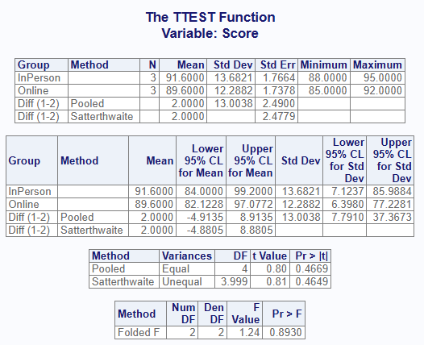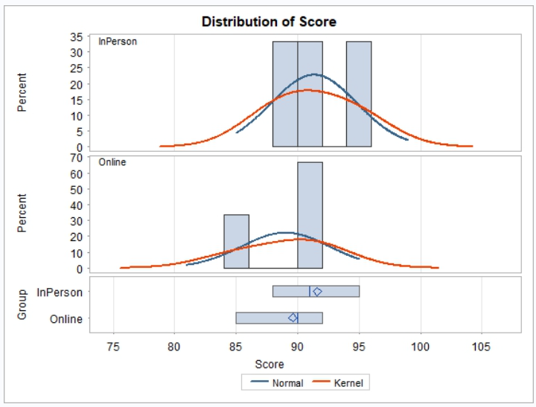  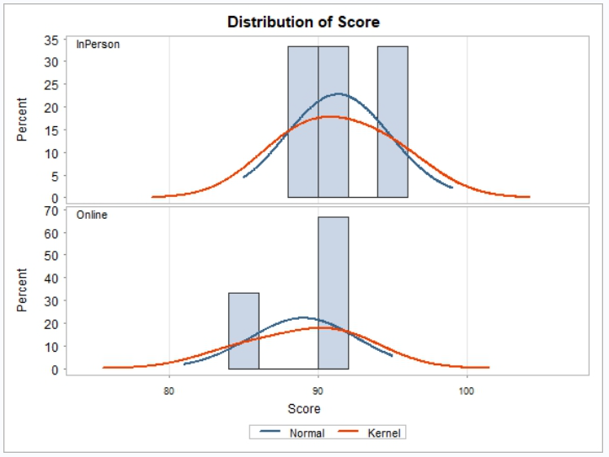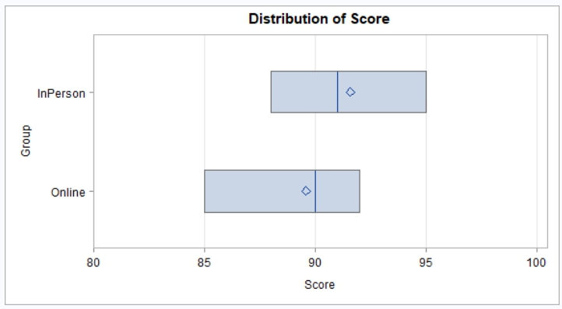  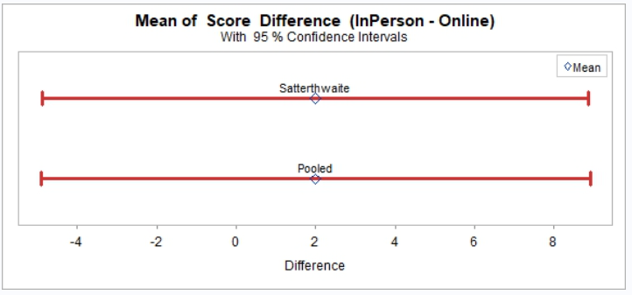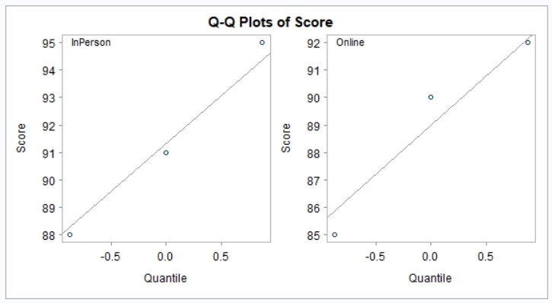
Comparison | Results
Two-sample T-test with weight parameter. | Pass.

Reg Data
SAS | R
data fitness;  input Age Weight Oxygen RunTime @@;  datalines;  44 89.47 44.609 11.37 40 75.07 45.313 10.07  44 85.84 54.297 8.65 42 68.15 59.571 8.17  38 89.02 49.874 9.22 47 77.45 44.811 11.63  40 75.98 45.681 11.95 43 81.19 49.091 10.85  44 81.42 39.442 13.08 38 81.87 60.055 8.63  44 73.03 50.541 10.13 45 87.66 37.388 14.03  45 66.45 44.754 11.12 47 79.15 47.273 10.60  54 83.12 51.855 10.33 49 81.42 49.156 8.95  51 69.63 40.836 10.95 51 77.91 46.672 10.00  48 91.63 46.774 10.25 49 73.37 50.388 10.08  57 73.37 39.407 12.63 54 79.38 46.080 11.17  52 76.32 45.441 9.63 50 70.87 54.625 8.92  51 67.25 45.118 11.08 54 91.63 39.203 12.88  51 73.71 45.790 10.47 57 59.08 50.545 9.93  49 76.32 48.673 9.40 48 61.24 47.920 11.50  52 82.78 47.467 10.50  ;  run; | fitness <- read.table(header = TRUE, text = '  Age Weight Oxygen RunTime  44 89.47 44.609 11.37  40 75.07 45.313 10.07  44 85.84 54.297 8.65  42 68.15 59.571 8.17  38 89.02 49.874 9.22  47 77.45 44.811 11.63  40 75.98 45.681 11.95  43 81.19 49.091 10.85  44 81.42 39.442 13.08  38 81.87 60.055 8.63  44 73.03 50.541 10.13  45 87.66 37.388 14.03  45 66.45 44.754 11.12  47 79.15 47.273 10.60  54 83.12 51.855 10.33  49 81.42 49.156 8.95  51 69.63 40.836 10.95  51 77.91 46.672 10.00  48 91.63 46.774 10.25  49 73.37 50.388 10.08  57 73.37 39.407 12.63  54 79.38 46.080 11.17  52 76.32 45.441 9.63  50 70.87 54.625 8.92  51 67.25 45.118 11.08  54 91.63 39.203 12.88  51 73.71 45.790 10.47  57 59.08 50.545 9.93  49 76.32 48.673 9.40  48 61.24 47.920 11.50  52 82.78 47.467 10.50')

proc_reg-001
SAS Code and Output
proc reg data = fitness;  model Oxygen = RunTime;  run; | 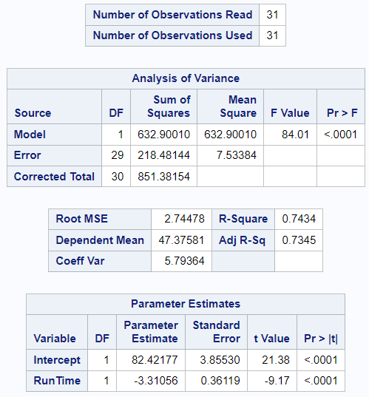
R Code and Output
proc_reg(fitness,  model = Oxygen ~ RunTime) | 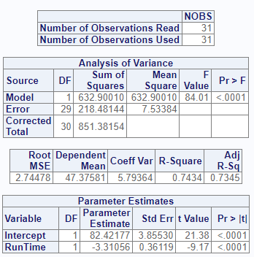
Comparison | Results
Perform basic Reg on single variable. | Pass.

proc_reg-002
SAS Code and Output
proc reg data = fitness;  model Oxygen = RunTime / clb;  run; | 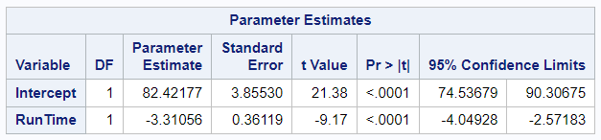
R Code and Output
proc_reg(fitness,  model = Oxygen ~ RunTime,  stats = clb) | 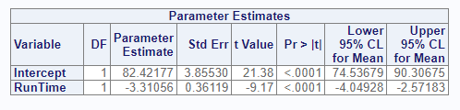
Comparison | Results
Perform basic Reg on single variable with clb option. | Pass.

proc_reg-003
SAS Code and Output
proc reg data = fitness;  model Oxygen = RunTime / hcc;  run; | 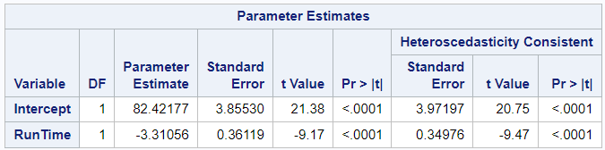
R Code and Output
proc_reg(fitness,  model = Oxygen ~ RunTime) | 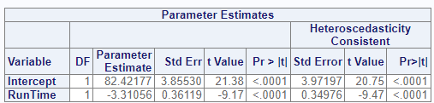
Comparison | Results
Perform basic Reg on single variable with hcc option. | Pass.

proc_reg-004
SAS Code and Output
proc reg data = fitness;  model Oxygen = RunTime / hcc hccmethod=3;  run; | 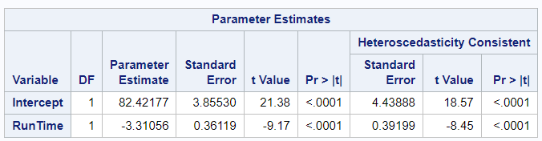
R Code and Output
proc_reg(fitness,  model = Oxygen ~ RunTime,  stats = v(hcc, hccmethod = 3)) | 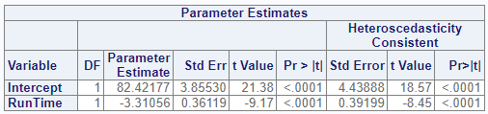
Comparison | Results
Perform basic Reg on single variable with hcc type 3. | Pass.

proc_reg-005
SAS Code and Output
proc reg data = fitness;  model Oxygen = RunTime / p;  run; | 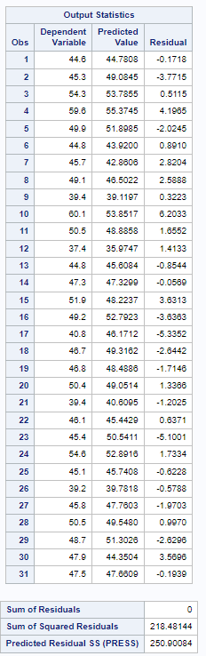
R Code and Output
proc_reg(fitness,  model = Oxygen ~ RunTime,  stats = p) | 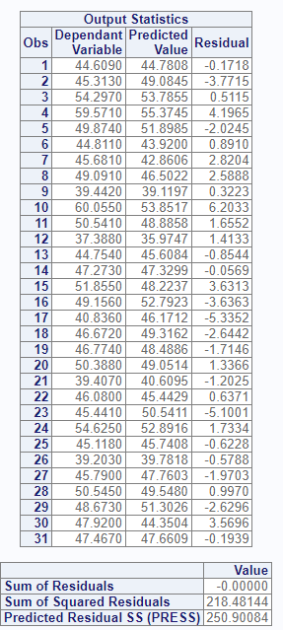
Comparison | Results
Perform basic Reg on single variable and p option | Pass. Decimal difference on dep variable OK.

proc_reg-006
SAS Code and Output
data fitness2;  set fitness;  if (Age < 50) then do;  AgeCat = "<50";  end;  else do;  AgeCat = ">=50";  end;  run;  proc sort data = fitness2 out = fitness2;  by AgeCat;  run;  proc reg data = fitness2;  model Oxygen = RunTime;  by AgeCat;  run; | 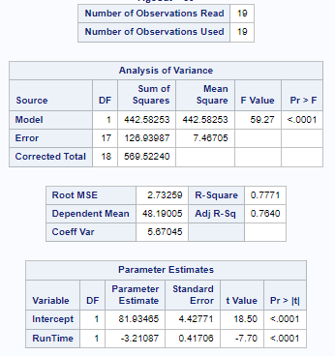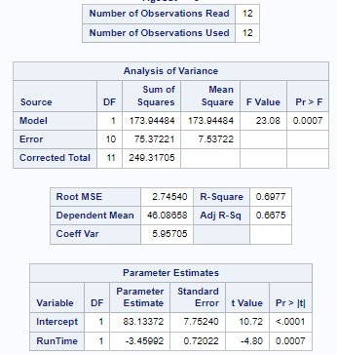
R Code and Output
fitness2 <- fitness  fitness2$AgeCat <- ifelse(fitness$Age < 50,  "<50", ">=50")  proc_reg(fitness2,  model = Oxygen ~ RunTime,  by = AgeCat) | 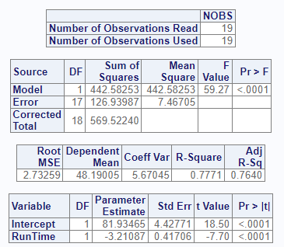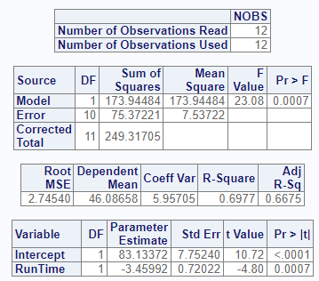
Comparison | Results
Perform basic Reg on single variable with by groups. | Pass.

proc_reg-007
SAS Code and Output
proc reg data = fitness;  model Oxygen = RunTime Age;  run; | 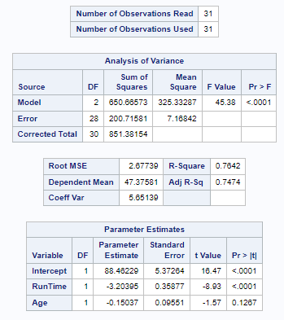
R Code and Output
proc_reg(fitness,  model = Oxygen ~ RunTime + Age) | 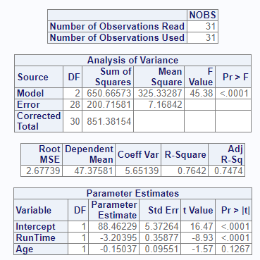
Comparison | Results
Perform basic Reg on single variable with two ind variables | Pass.

proc_reg-008
SAS Code and Output
proc reg data = fitness;  model Oxygen = RunTime Age Weight;  run; | 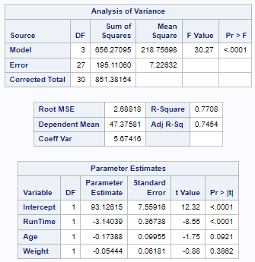
R Code and Output
proc_reg(fitness,  model = Oxygen ~ RunTime + Age + Weight ) | 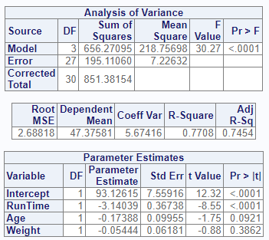
Comparison | Results
Perform basic Reg on single variable with three ind variables. | Pass.

proc_reg-009
SAS Code and Output
proc reg data = fitness plots = all;  model Oxygen = RunTime;  run; | 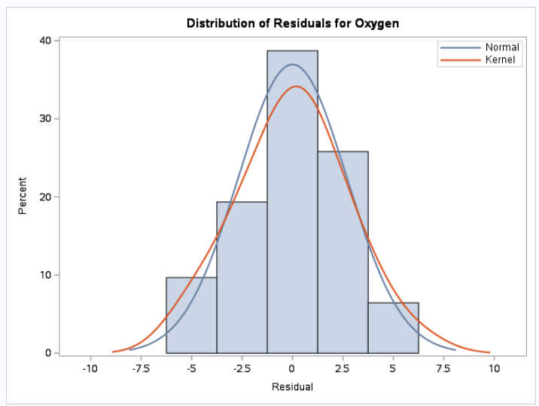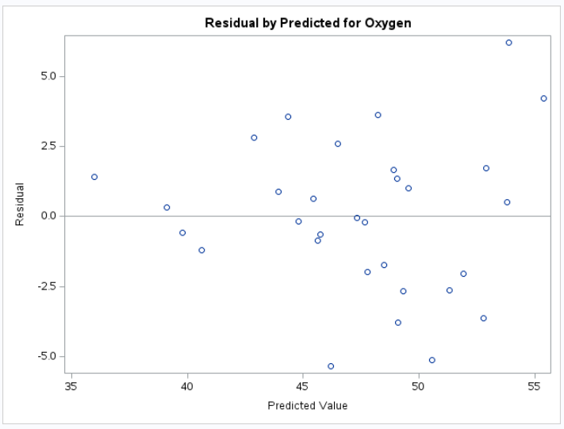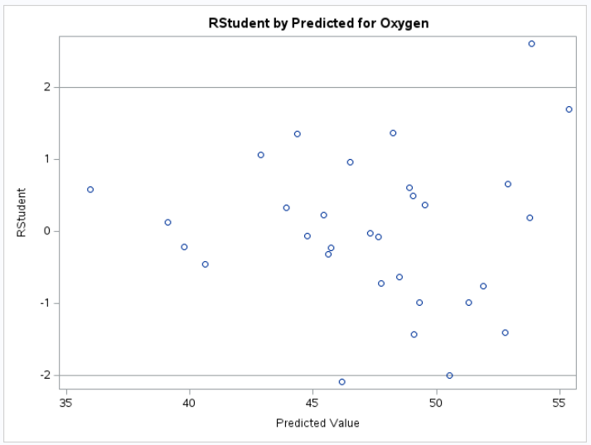  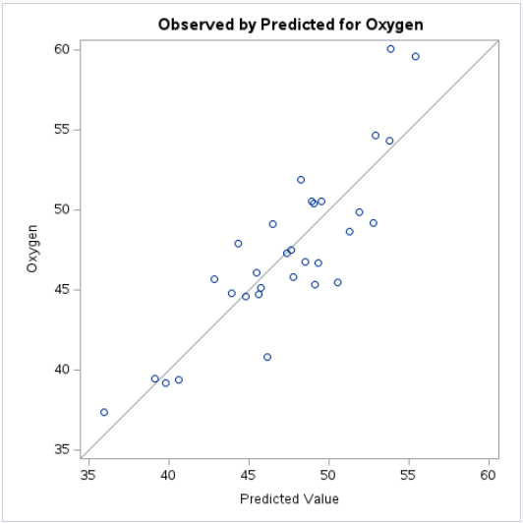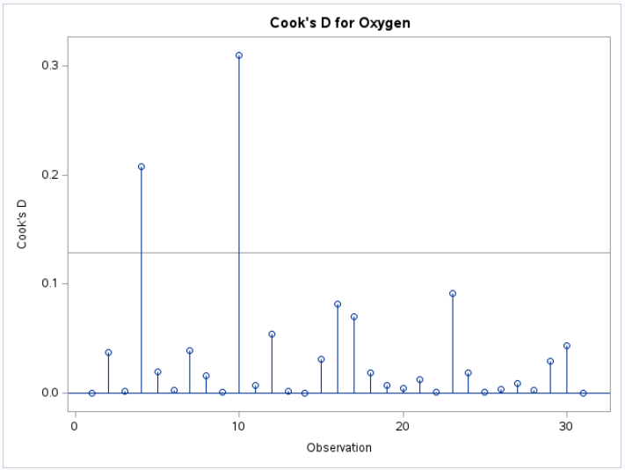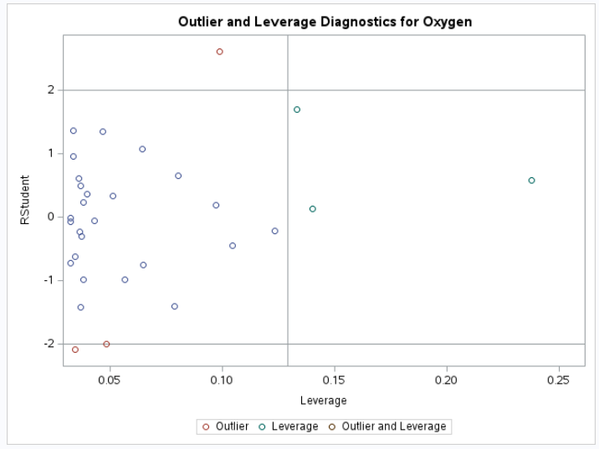  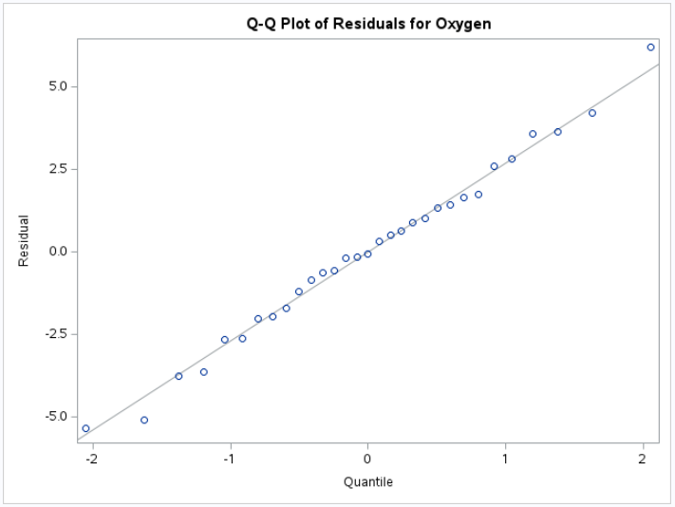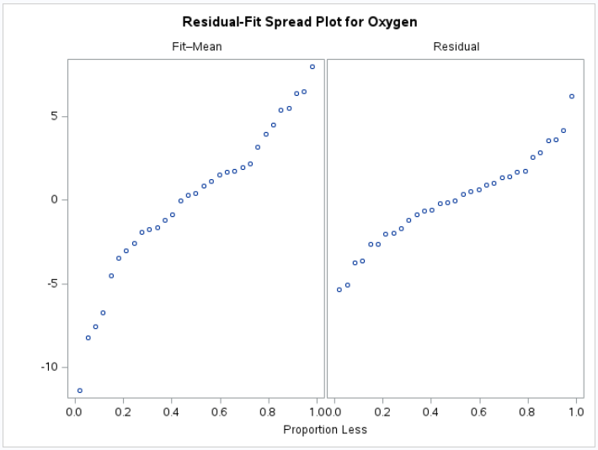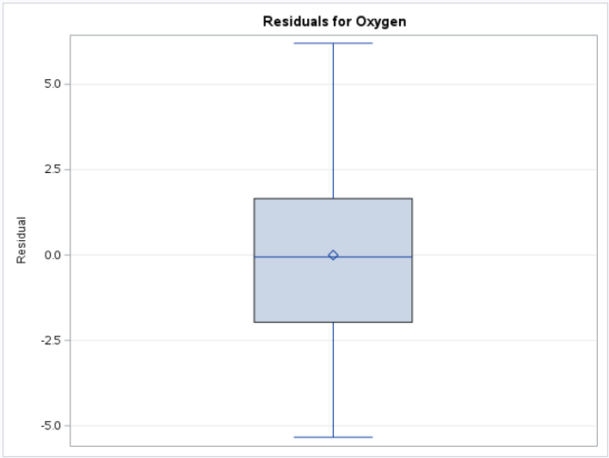  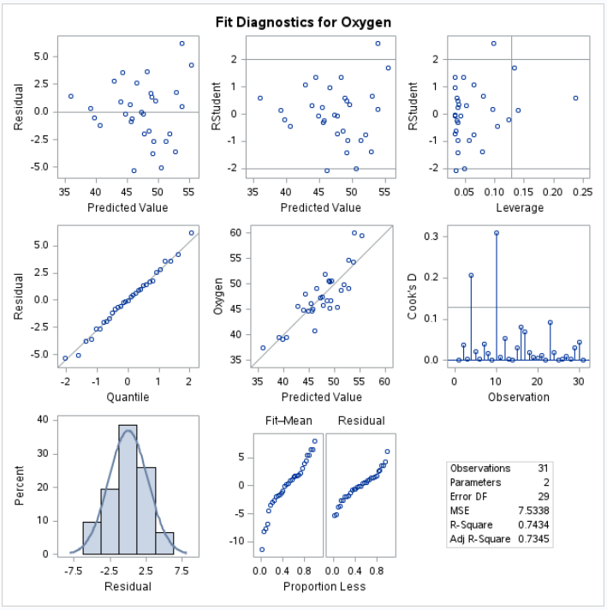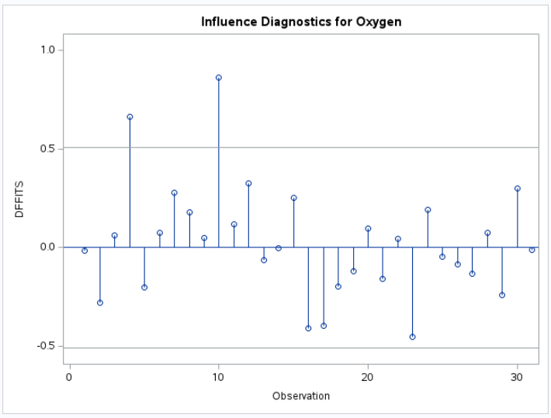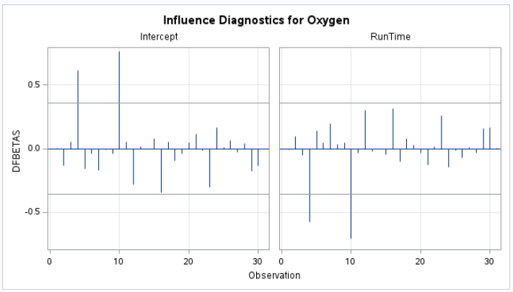  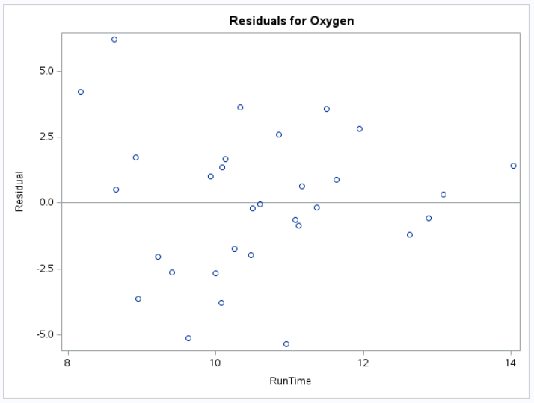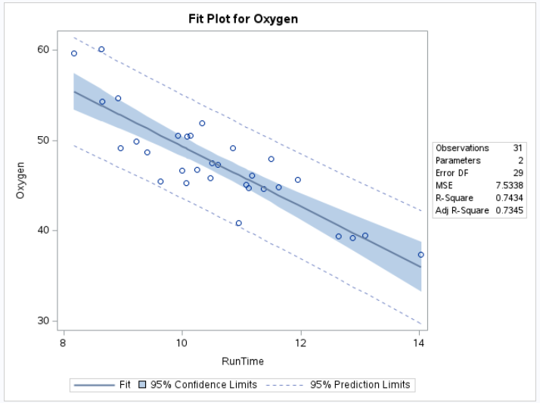
R Code and Output
proc_reg(fitness,  model = Oxygen ~ RunTime,  plots = "all") | 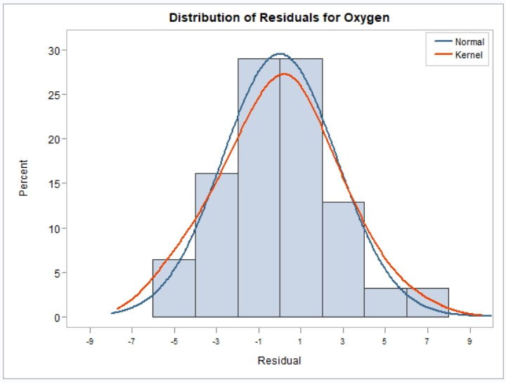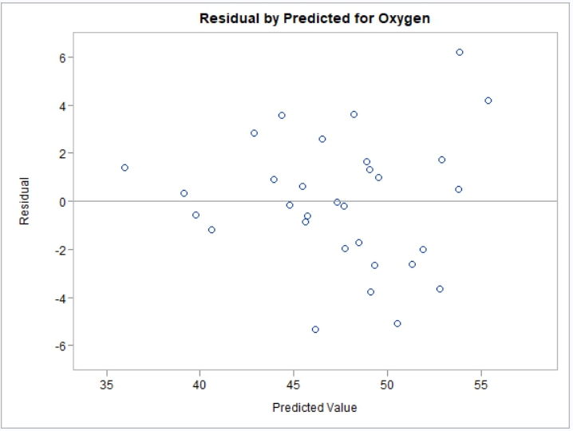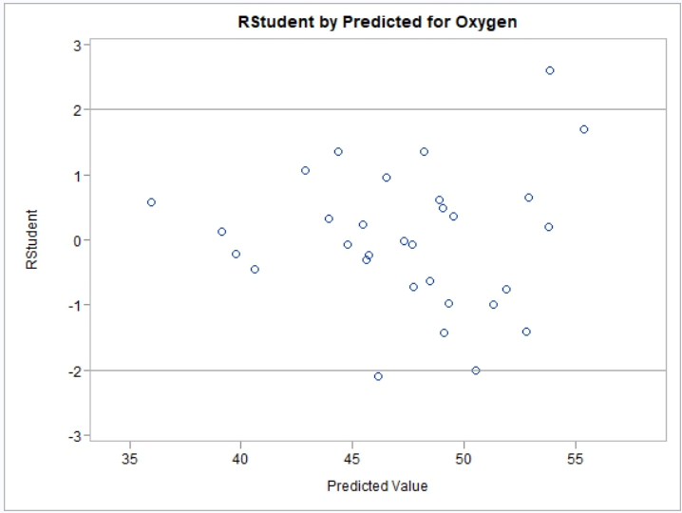  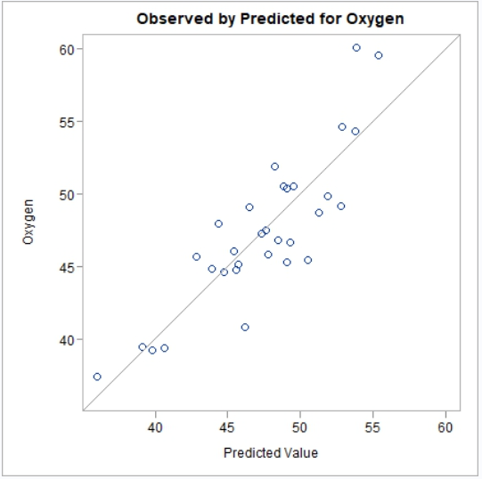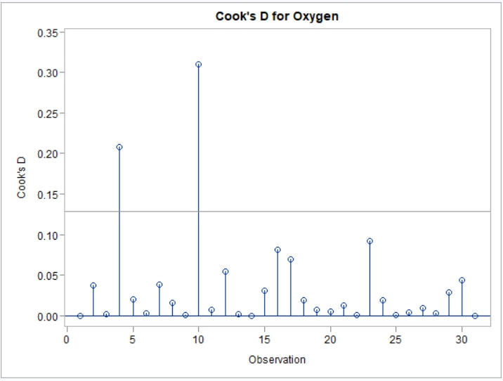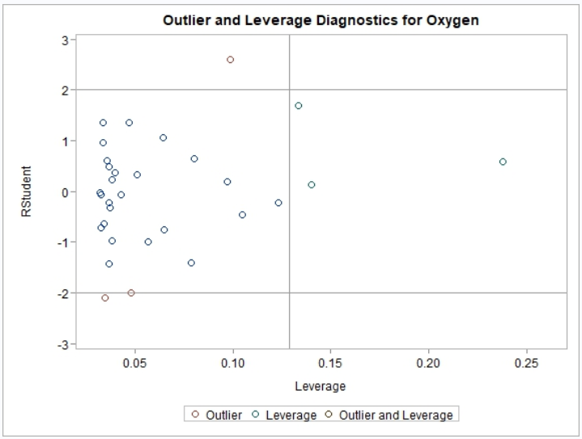  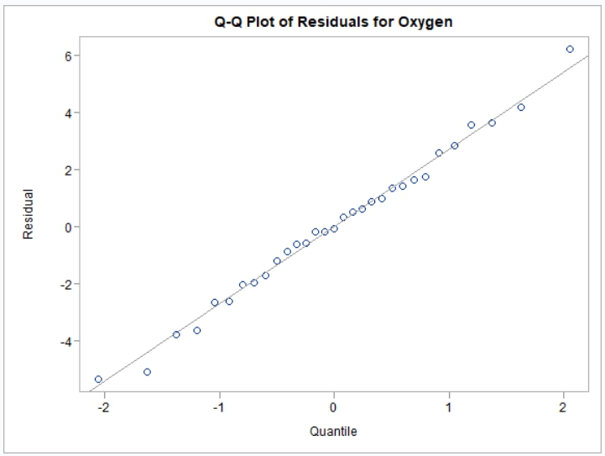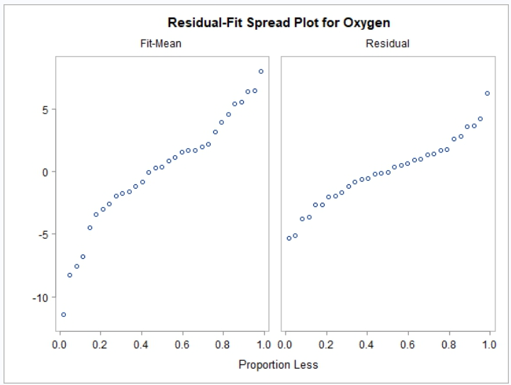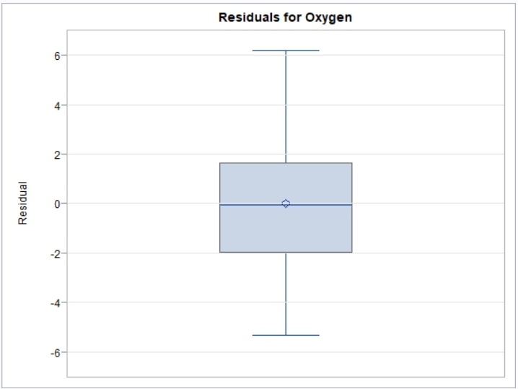  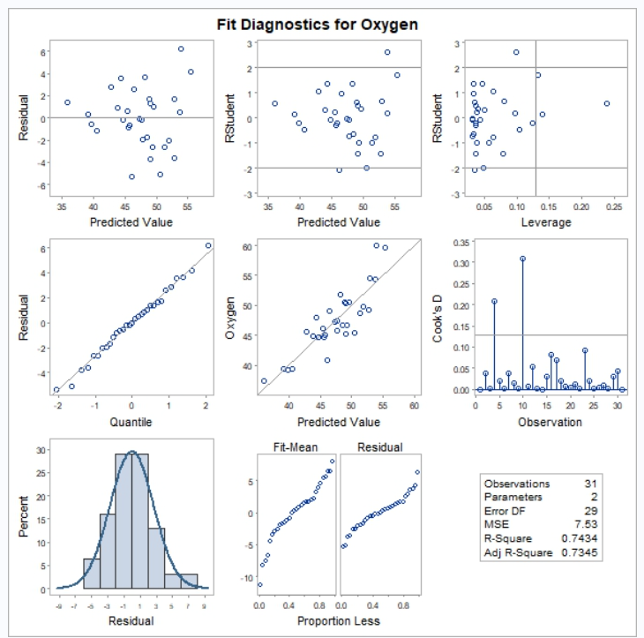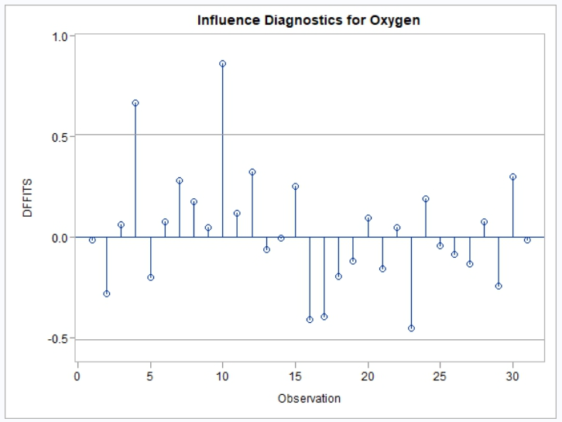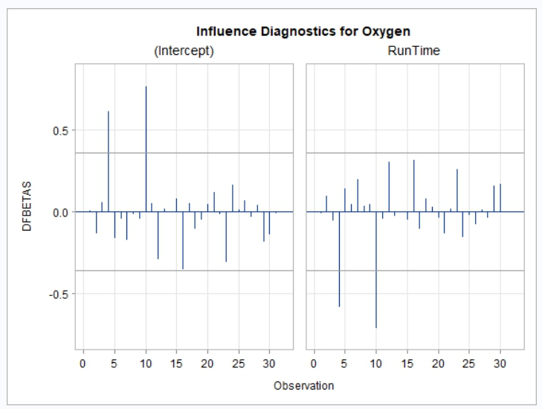  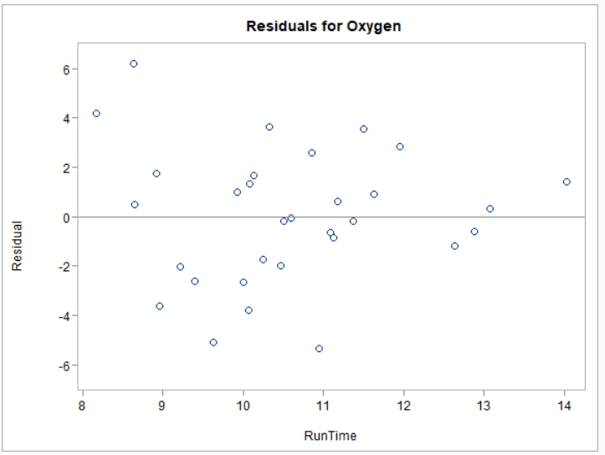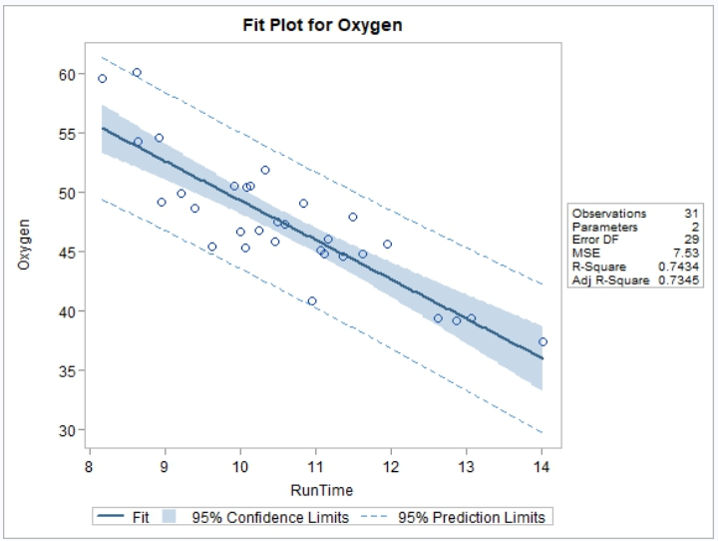
Comparison | Results
Perform proc reg with all plots. | Pass. Histogram bins won’t match. Everything else very close.

GLM Data
SAS | R
data fitness;  input Age Weight Oxygen RunTime @@;  datalines;  44 89.47 44.609 11.37 40 75.07 45.313 10.07  44 85.84 54.297 8.65 42 68.15 59.571 8.17  38 89.02 49.874 9.22 47 77.45 44.811 11.63  40 75.98 45.681 11.95 43 81.19 49.091 10.85  44 81.42 39.442 13.08 38 81.87 60.055 8.63  44 73.03 50.541 10.13 45 87.66 37.388 14.03  45 66.45 44.754 11.12 47 79.15 47.273 10.60  54 83.12 51.855 10.33 49 81.42 49.156 8.95  51 69.63 40.836 10.95 51 77.91 46.672 10.00  48 91.63 46.774 10.25 49 73.37 50.388 10.08  57 73.37 39.407 12.63 54 79.38 46.080 11.17  52 76.32 45.441 9.63 50 70.87 54.625 8.92  51 67.25 45.118 11.08 54 91.63 39.203 12.88  51 73.71 45.790 10.47 57 59.08 50.545 9.93  49 76.32 48.673 9.40 48 61.24 47.920 11.50  52 82.78 47.467 10.50  ;  run; | fitness <- read.table(header = TRUE, text = '  Age Weight Oxygen RunTime  44 89.47 44.609 11.37  40 75.07 45.313 10.07  44 85.84 54.297 8.65  42 68.15 59.571 8.17  38 89.02 49.874 9.22  47 77.45 44.811 11.63  40 75.98 45.681 11.95  43 81.19 49.091 10.85  44 81.42 39.442 13.08  38 81.87 60.055 8.63  44 73.03 50.541 10.13  45 87.66 37.388 14.03  45 66.45 44.754 11.12  47 79.15 47.273 10.60  54 83.12 51.855 10.33  49 81.42 49.156 8.95  51 69.63 40.836 10.95  51 77.91 46.672 10.00  48 91.63 46.774 10.25  49 73.37 50.388 10.08  57 73.37 39.407 12.63  54 79.38 46.080 11.17  52 76.32 45.441 9.63  50 70.87 54.625 8.92  51 67.25 45.118 11.08  54 91.63 39.203 12.88  51 73.71 45.790 10.47  57 59.08 50.545 9.93  49 76.32 48.673 9.40  48 61.24 47.920 11.50  52 82.78 47.467 10.50')

proc_glm-001
SAS Code and Output
proc glm data = fitness;  model Oxygen = RunTime;  run; | 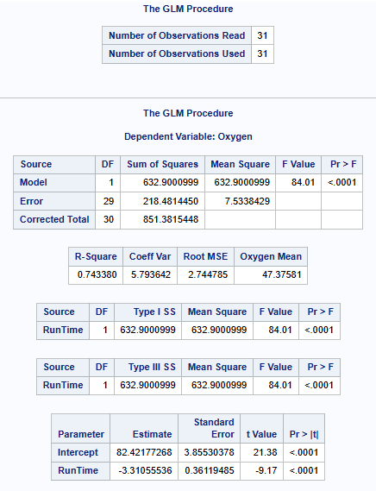
R Code and Output
proc_glm(fitness,  model = Oxygen ~ RunTime) | 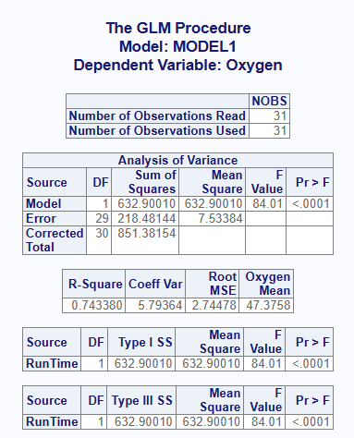
Comparison | Results
Perform basic GLM on single variable. | Fail. Parameter estimates table missing.

proc_glm-002
SAS Code and Output
proc reg data = fitness;
model Oxygen = RunTime / clb;
run;
R Code and Output
proc_reg(fitness,
model = Oxygen ~ RunTime,
stats = clb)
Comparison | Results
Perform basic Reg on single variable with clb option. | Pass.

proc_glm-003
SAS Code and Output
proc reg data = fitness;
model Oxygen = RunTime / hcc;
run;
R Code and Output
proc_reg(fitness,
model = Oxygen ~ RunTime)
Comparison | Results
Perform basic Reg on single variable with hcc option. | Pass.

proc_glm-004
SAS Code and Output
proc reg data = fitness;
model Oxygen = RunTime / hcc hccmethod=3;
run;
R Code and Output
proc_reg(fitness,
model = Oxygen ~ RunTime,
stats = v(hcc, hccmethod = 3))
Comparison | Results
Perform basic Reg on single variable with hcc type 3. | Pass.

proc_glm-005
SAS Code and Output
proc reg data = fitness;
model Oxygen = RunTime / p;
run;
R Code and Output
proc_reg(fitness,
model = Oxygen ~ RunTime,
stats = p)
Comparison | Results
Perform basic Reg on single variable and p option | Pass. Decimal difference on dep variable OK.

proc_glm-006
SAS Code and Output
data fitness2;
set fitness;
if (Age < 50) then do;
AgeCat = "<50";
end;
else do;
AgeCat = ">=50";
end;
run;

proc sort data = fitness2 out = fitness2;
by AgeCat;
run;

proc reg data = fitness2;
model Oxygen = RunTime;
by AgeCat;
run;
R Code and Output
fitness2 <- fitness
fitness2$AgeCat <- ifelse(fitness$Age < 50,
"<50", ">=50")

proc_reg(fitness2,
model = Oxygen ~ RunTime,
by = AgeCat)
Comparison | Results
Perform basic Reg on single variable with by groups. | Pass.

proc_glm-007
SAS Code and Output
proc reg data = fitness;
model Oxygen = RunTime Age;
run;
R Code and Output
proc_reg(fitness,
model = Oxygen ~ RunTime + Age)
Comparison | Results
Perform basic Reg on single variable with two ind variables | Pass.

proc_glm-008
SAS Code and Output
proc reg data = fitness;
model Oxygen = RunTime Age Weight;
run;
R Code and Output
proc_reg(fitness,
model = Oxygen ~ RunTime + Age + Weight )
Comparison | Results
Perform basic Reg on single variable with three ind variables. | Pass.

