Figure 1.0
MTCARS Miles per Cylinder Plot
Cylinders: 4
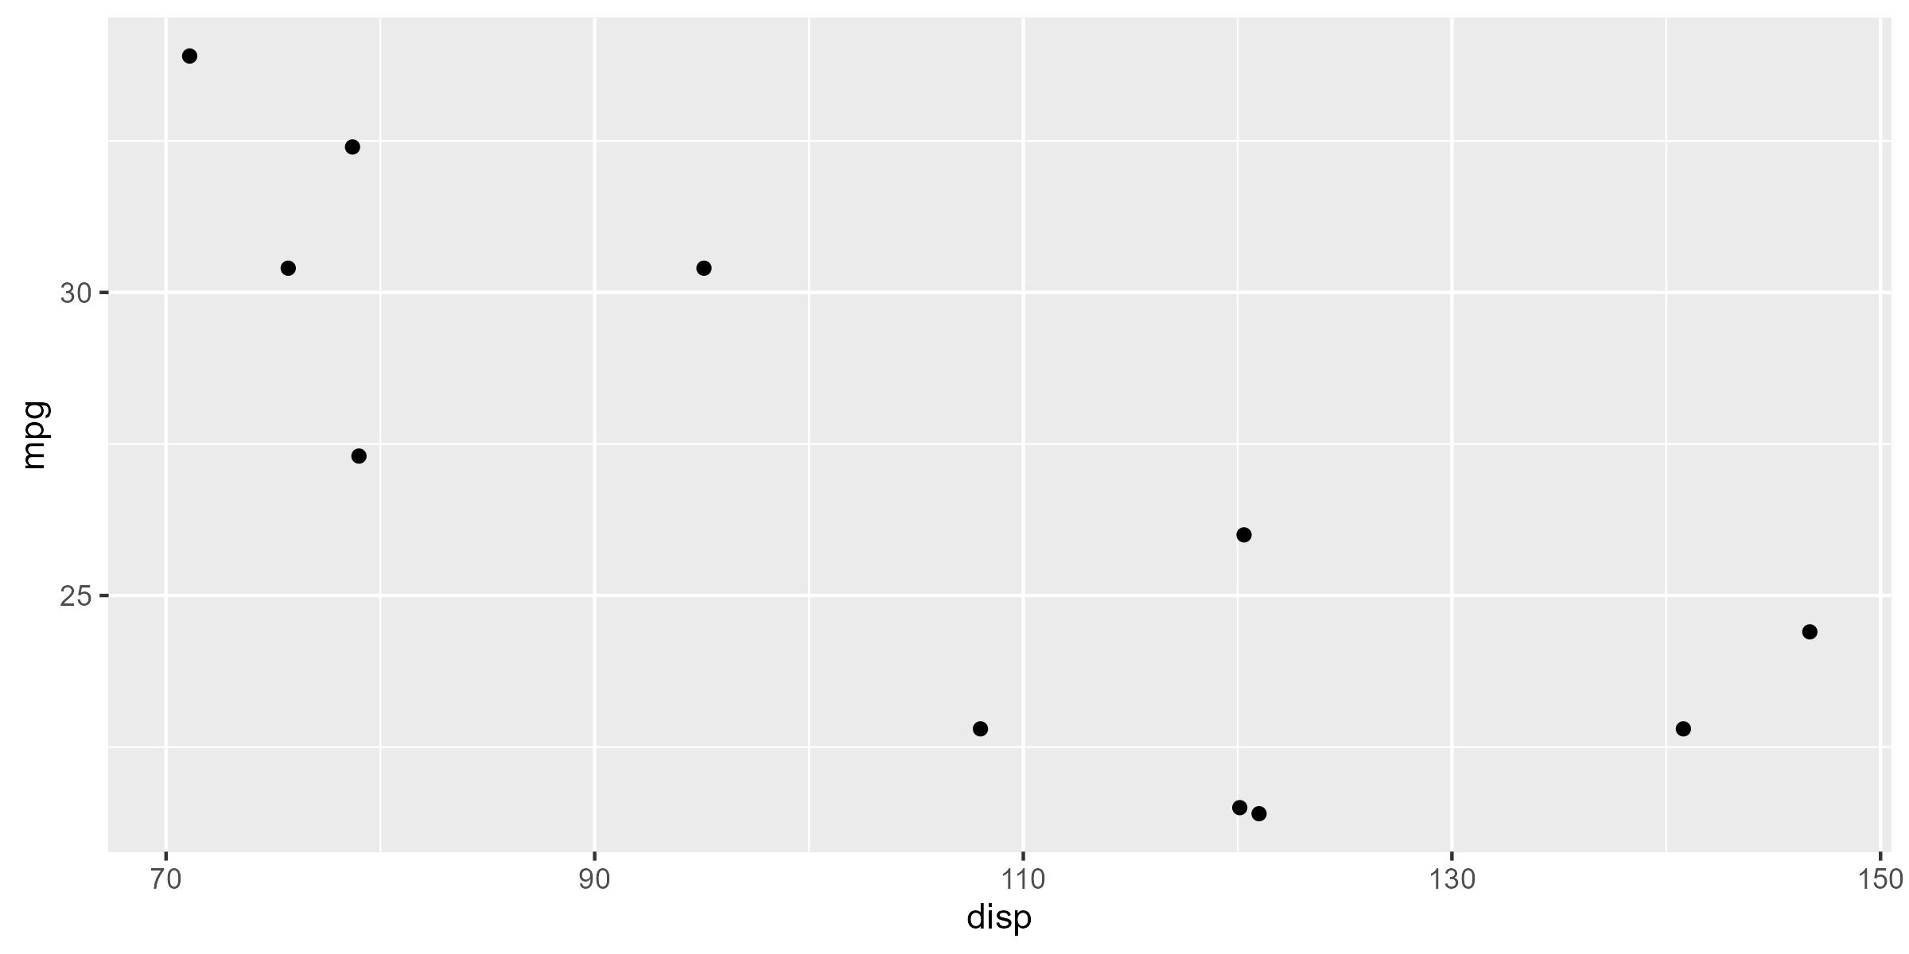
* Motor Trend, 1974

Figure 1.0
MTCARS Miles per Cylinder Plot
Cylinders: 6
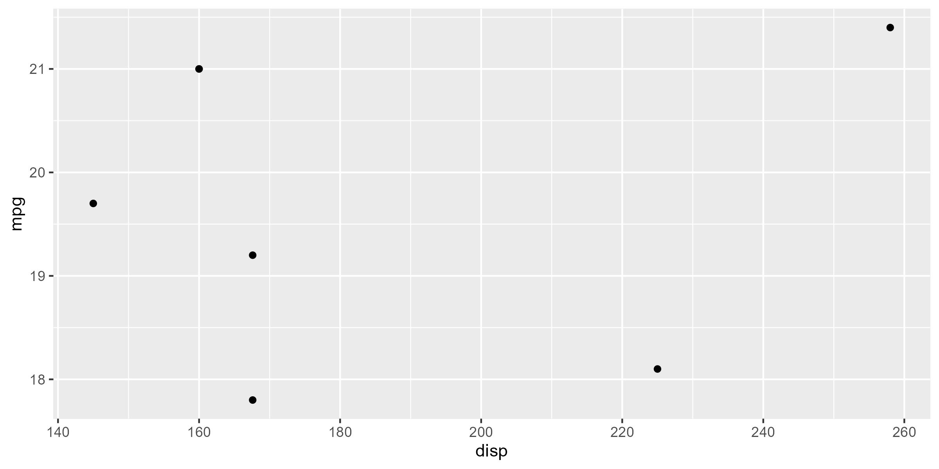
* Motor Trend, 1974

Figure 1.0
MTCARS Miles per Cylinder Plot
Cylinders: 8
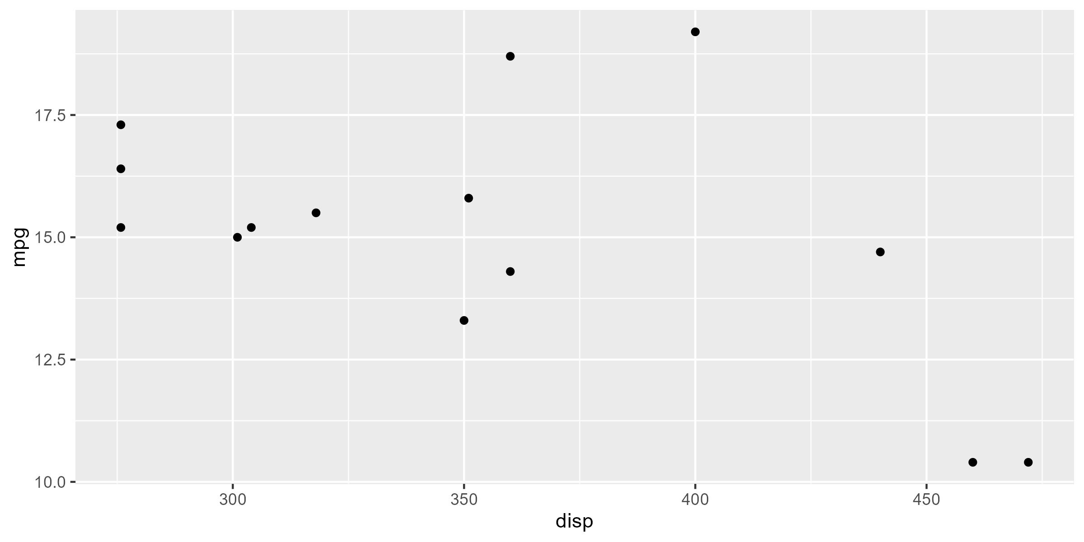
* Motor Trend, 1974

