Client Study: XYZ
Figure 1.0
MTCARS Miles per Cylinder Plot
mpg cyl disp hp drat wt qsec vs am gear carb
¯¯¯¯¯¯¯¯¯¯¯¯¯¯¯¯¯¯¯¯¯¯¯¯¯¯¯¯¯¯¯¯¯¯¯¯¯¯¯¯¯¯¯¯¯¯¯¯¯¯¯¯¯¯¯¯¯
21 6 160 110 3.9 2.62 16.46 0 1 4 4
21 6 160 110 3.9 2.875 17.02 0 1 4 4
22.8 4 108 93 3.85 2.32 18.61 1 1 4 1
21.4 6 258 110 3.08 3.215 19.44 1 0 3 1
18.7 8 360 175 3.15 3.44 17.02 0 0 3 2
18.1 6 225 105 2.76 3.46 20.22 1 0 3 1
14.3 8 360 245 3.21 3.57 15.84 0 0 3 4
24.4 4 146.7 62 3.69 3.19 20 1 0 4 2
22.8 4 140.8 95 3.92 3.15 22.9 1 0 4 2
19.2 6 167.6 123 3.92 3.44 18.3 1 0 4 4
* Motor Trend, 1974
Time Confidential Page 1 of 2
Client Study: XYZ
Figure 1.0
MTCARS Miles per Cylinder Plot
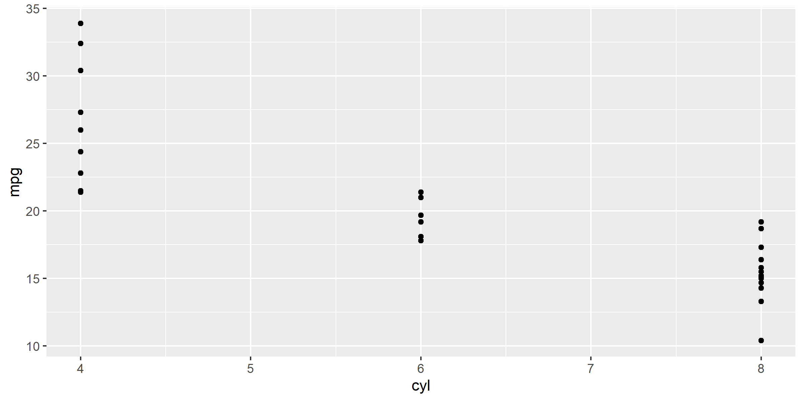
* Motor Trend, 1974
Time Confidential Page 2 of 2

