Client Study: XYZ
Figure 1.0
MTCARS Miles per Cylinder Plot
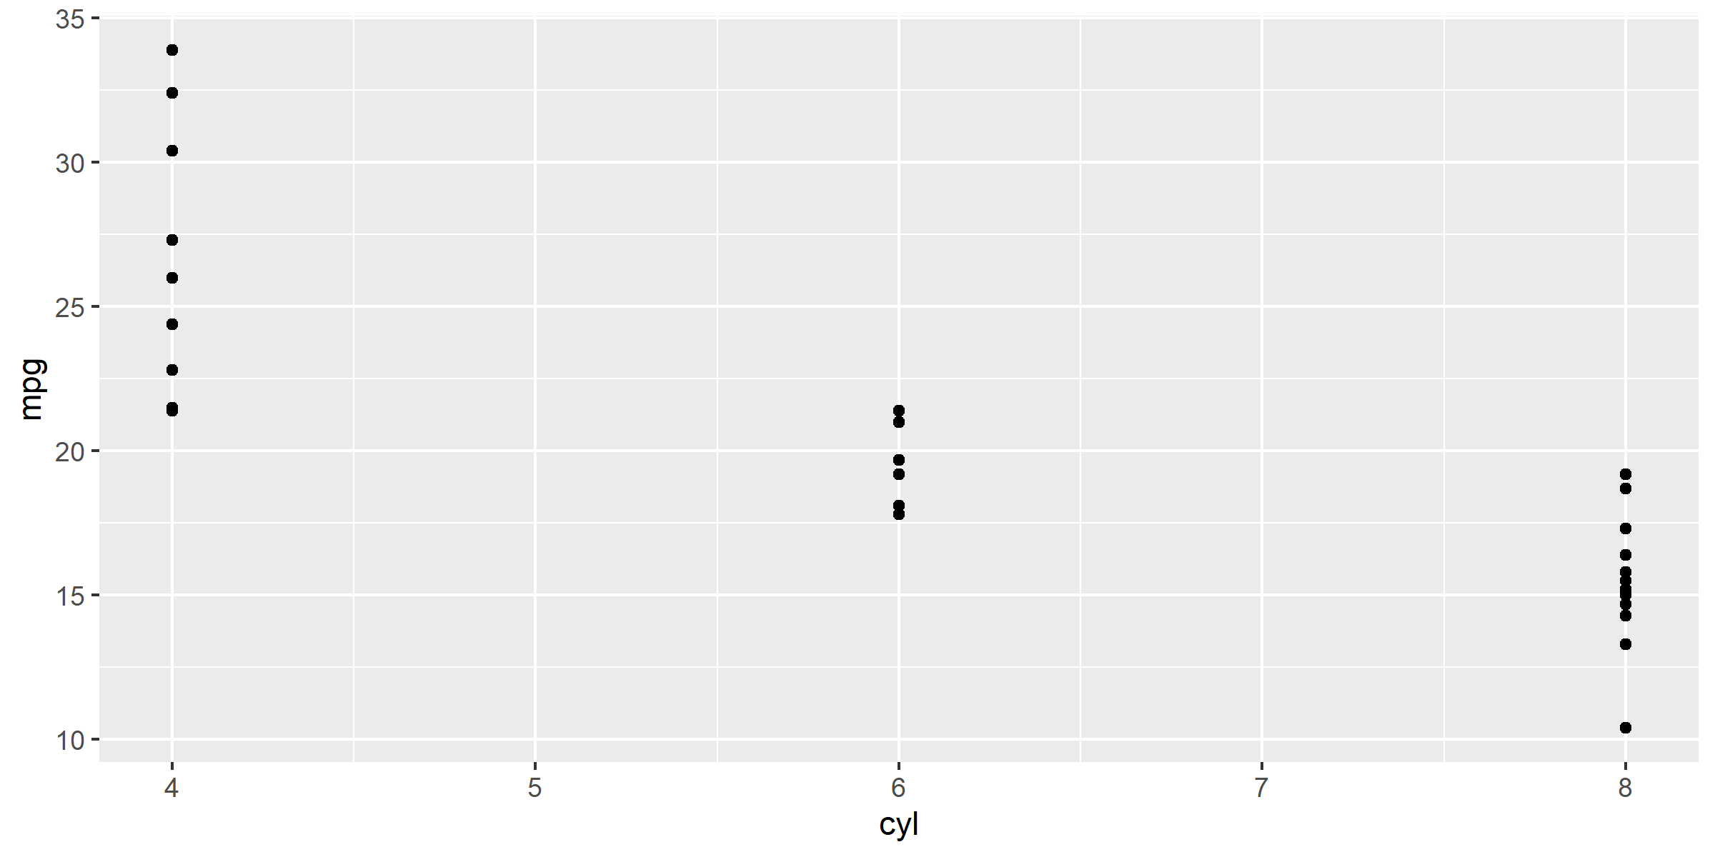
mpg cyl disp hp drat wt qsec vs am gear carb
¯¯¯¯¯¯¯¯¯¯¯¯¯¯¯¯¯¯¯¯¯¯¯¯¯¯¯¯¯¯¯¯¯¯¯¯¯¯¯¯¯¯¯¯¯¯¯¯¯¯¯¯¯¯¯
21 6 160 110 3.9 2.62 16.46 0 1 4 4
21 6 160 110 3.9 2.875 17.02 0 1 4 4
22.8 4 108 93 3.85 2.32 18.61 1 1 4 1
* Motor Trend, 1974
Time Confidential Page 1 of 1

