Client Study: XYZ
Figure 1.0
MTCARS Miles per Cylinder Plot
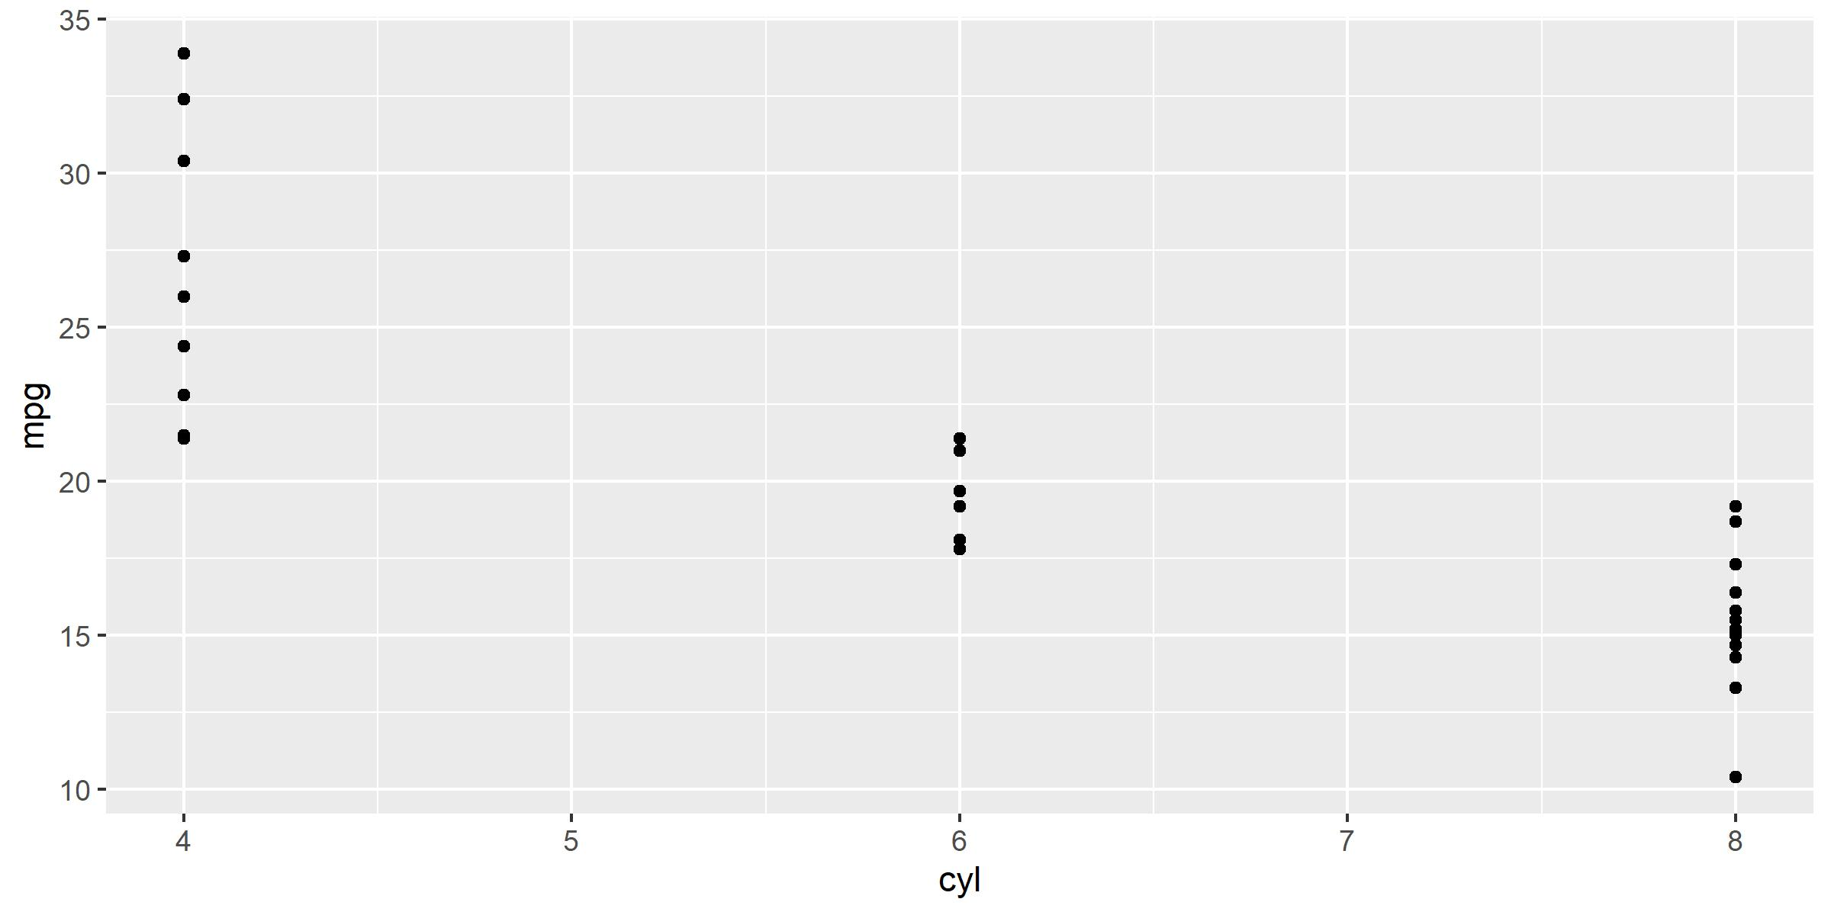
* Motor Trend, 1974
Time Confidential Page 1 of 1

