TASCA 01.01

# Nivell 1

## Exercici 1

SHOW DATABASES; -- Un cop executats els scripts adjunts, ens mostra que la base de dades existeix

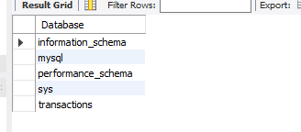

SELECT * FROM transactions.company; -- Ens mostra la taula "company"

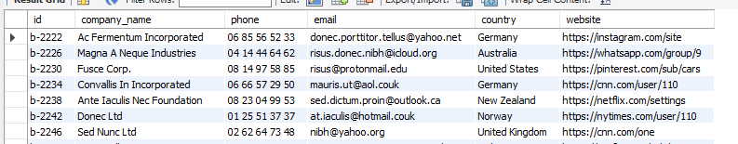

SELECT * FROM transactions.transaction; -- Ens mostra la taula "transaction"

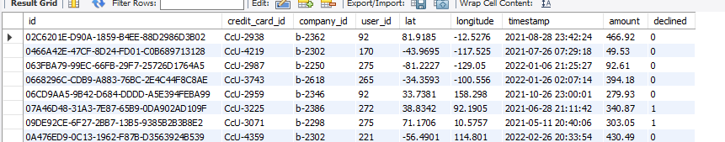

Mostra el diagrama de la base de dades.

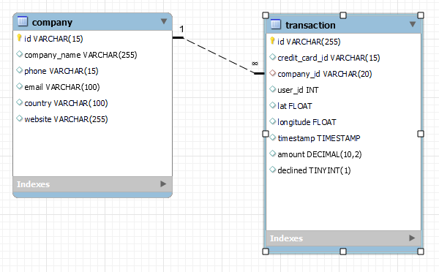

## Exercici 2

SELECT company_name, email, country FROM transactions.company ORDER BY company_name;

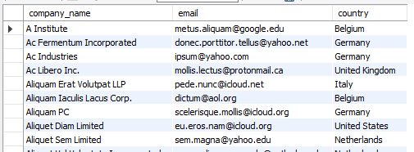

## Exercici 3

SELECT DISTINCT country FROM transactions.company

INNER JOIN transactions.transaction

ON company.id = transaction.company_id;

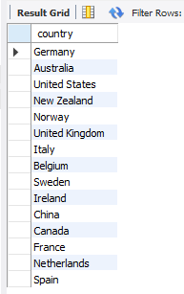

## Exercici 4

SELECT COUNT (DISTINCT country) AS num_countries FROM transactions.company

INNER JOIN transactions.transaction

ON company.id = transaction.company_id;



## Exercici 5

SELECT country, company_name FROM transactions.company WHERE id = "b-2354";



## Exercici 6

SELECT AVG(transaction.amount) AS avg_comp_amount, company.company_name

FROM transactions.transaction

INNER JOIN transactions.company

ON transaction.company_id = company.id

GROUP BY company_id ORDER BY avg_comp_amount DESC LIMIT 1;



# Nivell 2

## Exercici 1

SELECT id, COUNT(id) FROM transactions.company

GROUP BY id

HAVING COUNT(id) > 1;

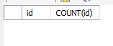

No dona cap resultat.

-- Per comprovar, ordeno les identificacions

SELECT id FROM transactions.company

ORDER BY id;

-- També puc comptar les id

SELECT COUNT(id) FROM transactions.company

ORDER BY id;

-- I veure si és diferent del resulta amb dictinct

SELECT DISTINCT COUNT(id) FROM transactions.company

ORDER BY id;

-- Per tant, no, no hi ha identificadors duplicats.

## Exercici 2

SELECT timestamp, SUM(amount) AS sum_amount FROM transactions.transaction

GROUP BY timestamp

ORDER BY sum_amount DESC LIMIT 5;

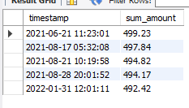

## Exercici 3

SELECT timestamp, SUM(amount) AS sum_amount FROM transactions.transaction

GROUP BY timestamp

ORDER BY sum_amount ASC LIMIT 5;

-- Es pot treure l’ASC, ja que és el valor per defecte

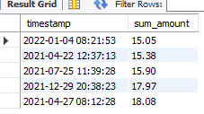

## Exercici 4

SELECT AVG(transaction.amount) AS avg_country_amount, company.country

FROM transactions.transaction

INNER JOIN transactions.company

ON transaction.company_id = company.id

GROUP BY country ORDER BY avg_country_amount DESC;

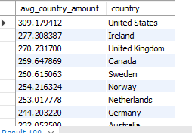

# Nivell 3

## Exercici 1

SELECT company.company_name, company.phone, company.country, SUM(transaction.amount) AS total_amount

FROM transactions.company

INNER JOIN transactions.transaction

ON company.id = transaction.company_id

WHERE amount BETWEEN 100 AND 200

GROUP BY company_id

ORDER BY total_amount DESC;

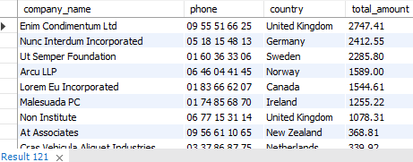

## Exercici 2

SELECT DISTINCT company.company_name FROM transactions.company

INNER JOIN transactions.transaction

ON company.id = transaction.company_id

WHERE transaction.timestamp LIKE "2022-03-16%"

OR transaction.timestamp LIKE "2022-02-28%"

OR transaction.timestamp LIKE "2022-02-13%"

ORDER BY company_name;

