AFIS
Debasish Bose 
Electronics & Instrumentation Engineering, EI-7
AFIS Documentation

Automatic Fingerprint Identification System

By

Minutiae Analysis & Neural Network Matching

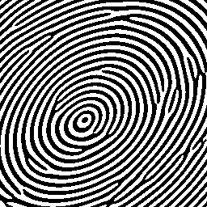

Debasish Bose
USIC, UNIVERSITY Of Kalyani
West Bengal
India

Mr Debasish Bose
University Science Instrumentation Centre
University Of Kalyani,
Kalyani , Nadia
West Bengal
India

Dr. P Basu
Head of USIC
University Of Kalyani
Kalyani , Nadia
West Bengal
India

Sir,

In accordance with the requirements of the Bachelor of Technology degree in the division of Electronics & Instrumentation Engineering , I hereby submit for your consideration my final year project entitled:

Automatic Fingerprint Identification System
By
Minutiae Analysis & Neural Network Matching.

Yours sincerely,
Debasish Bose



Amongst the main innovation prospects within so called Information Society, and in the framework of future communication systems, we find database-access integral services, e-commerce and communication systems, together with modern telemetry, being all of them the result of global services derived from last generation of Mobile Telephony and Internet. Some features stand out from such future services: security (guaranteeing user's privacy while in operation) and realistic Human Computer Interface (HCI).To deal with security problems, the use of Biometric-based Technology (specifically through face, fingerprint & speech) is proposed, as those technologies have now reached a high degree of maturity such as to allow successful application of secure authentication. My project is a Automatic Fingerprint Identification System(AFIS) where minutiae matching is done by sophisticated learning technique in Neural Network(NN).Although system is PC-based, I can easily port it as an embedded one by designing in embedded VC++ instead of current VC++6 platform.
In short every FP image must go through some image processing steps like: Image Enhancement, Foreground/Background Segmentation, Ridge Extraction/Binarization, Thinning, and Minutiae Extraction. Uniqueness in fingerprint is actually the uniqueness of extracted minutiae which are primarily of two type end point (EP) and bifurcation point (BP). In EP ridge ends abruptly and in BP ridge forks into two branch ridges. By ignoring false minutiae ~80 minutiae can be extracted from a well-processed FP. Each minutiae classifier must contain x-y coordinate & slope (θ). Extracting two arrays (one for EP and one for BP) from each FP, I use those processed data to train a NN. Other than 1:1 comparison, 1: N comparison can be done with a fast-access FP database. Every step in identification can add cumulative error to next so some rectification must be done at each step. For example there can be several types of false minutiae as in figure 2.So false minutiae detection & elimination algorithm must be robust. Otherwise minutiae matching will give poor result. Another important thing is the intelligent detection of ROI which is the area where actual ridges & furrows of FP lies or local variance in normal and tangent direction of a ridge exceeds a Particular value. ROI is important for deletion of corner noise or text on FP

Many researchers have shown interest in theoretical aspects of fingerprint analysis, enhancement and matching. But in the current project Visual C++6 implementation is given equal emphasis. The system has a nice GUI based VC++6 project associated with it. Many modern biometrics systems including fingerprint analysis are mainly VLSI/ASIC based and thus very expensive. In comparison this PC based prototype is not expensive at all. In addition to this the system can be extended to take the advantage of controlling any relevant hardware seeking biometric protection by sending Boolean answer (match/no-match) to COM-LPT port. Neural Network (ART) is used to develop the matching module to make the identification/verification process more robust and biometrically secure



This is the final-year project report of Batchelor of Technology in Electronics and Instrumentation Engineering [EIT] at the University Science Instrumentation Centre, University Of Kalyani during the session 2002-2003. We would like to give special thanks to our project guide-team comprising of Mr. Susanta Biswas, Mr. Partha Pratim Sarkar, and Mrs. Debashree Sarkar for their constructive criticism & advice. They have pointed out most of my critical errors that was supposed to hinder natural progress of my project. Without their valuable guidance and various methodologies suggested by them, my project wouldn’t be a successful one.

Special Thanks goes to KODAK company for providing the “Imaging For Windows” toolkit which eases the task of interfacing a TWAIN-compatible scanner to my AFIS module , Microsoft Corporation for the excellent IDE Visual C++6 , MathWorks Inc. for the one & only MATLAB,NIST for testing-time fingerprints and www.citeseer.nj.nec.com for quality research papers of computer science at no cost.





Over the last 10 - 15 years organizations and corporations have increasingly been
distributing access to information throughout their organization. Sometimes
even involving a third party.
When having made information so available, it is necessary to secure access to the information to authorized personnel only. A person’s claimed identity has to be verified. So far, authorized access has been based on PINs, passwords etc. The problem is that this is not always the most convenient and secures way to log on to a system. The principal drawbacks are security issues (passwords can be, and often are, given away to colleagues, can be snatched by non-authorized persons etc.), convenience issues (e.g. password has to be changed, extra time to enter a password, forgetting a PIN) etc. As an alternative to the use of PINs and passwords, biometric information can be used to verify the identity of an individual by his or her characteristics. The human fingerprint is unique and can therefore successfully be used in a biometric verification system. Normally fingerprints are utilized in Identification and Verification. Identification is just to answer the question WHO AM I? On the other hand Verification is to answer the question AM I WHO I CLAIM I AM? Verification is most suitable to Banking Security; Physical Access Control systems. Fingerprint verification module embedded in a digital signal processor (DSP) is particularly interesting in wireless technologies such as in the 3G phones. Since cellular phones already have a built in DSP it is possible that in a near future we will be using our fingerprint to log on to our cellular phones, making transactions etc. see Figure 1.1.

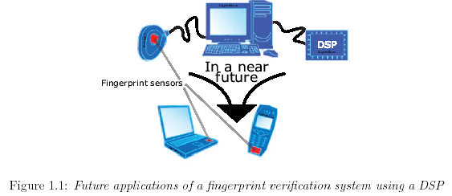



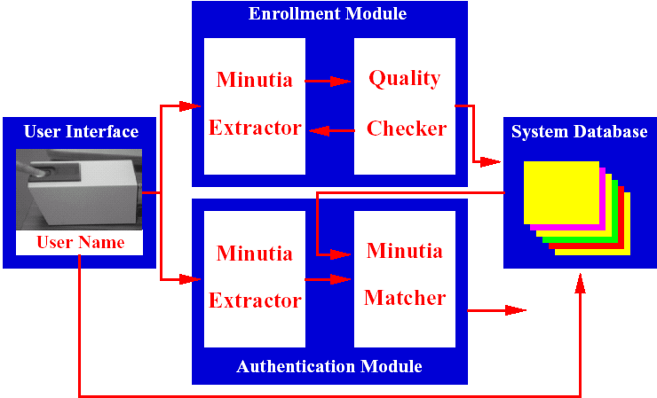

 Basically a LiveScanTM based fingerprint scanner. Many biometrics companies (Precise Biometrics, BioKey etc) supply such scanner and they are mostly USB based.

 Means “Minute Details”; Latin word. It is the general term to describe unique/discriminatory features of a fingerprint.NIST has standardized nine such minutiae classes between which two are most popular – Endpoint & Bifurcation.

 A fast access fingerprint database. Searching in such a database is mostly hashing-based.NIST is the largest & oldest of such databases. Its specialty is that researchers can download fingerprint from it and it is interfaced with internet although physically it remains inside of a huge database server-farm.



The use of biometric information such as fingerprints instead of PINs and passwords can indeed heighten security. It does however also present several problems. All verification/identification systems require that the data the user will input to the system already exists in the system. There needs to be something to compare the password or PIN code against to verify that the user is legitimate. Since fingerprints are being discussed here, this information stored for comparison is called a template of the fingerprint. When a new user is created, a template of his or her fingerprint is made. Each time the user tries to log on, the system compares the new fingerprint impression with the template. However, since a fingerprint is an image and no impression of a fingerprint is exactly like one of the previous ones, the user might turn the finger slightly or put the finger a bit higher on the sensor or press the finger down harder, it is not as simple to do the comparison as when passwords are used. To verify a user by comparing
the two images with each other is not an option. It demands that the entire image is stored in the template which requires a lot of memory, but above all; no acquired images are exactly the same so it wouldn’t work. The real problem is to extract what is interesting in the image and to compress it so that the template doesn’t allocate too much memory. Further, those interesting characteristics must be of kinds that are possible to extract regardless of small differences in different impressions. One should also bear in mind that a finger changes with time and temporary cuts etc. shouldn’t keep a user out. A reasonable assumption to make is that the user wants access to the system and therefore it is safe to assume that the user will make an effort to submit a good fingerprint. Because of this it is acceptable to presume a cooperative user and to set some limitations to the system due to this presumption. One limitation is that the rotation of the fingerprint can not be too large and another that the system only works for whole fingerprints and not partial prints. Reasonable demands on the system are that it should be able to successfully process whole prints that are not rotated more than §15±. Another demand is that the application does not take too long to process a fingerprint before passing or failing the user. Naturally the user will loose his, or her, patience if the application takes too long to deliver the results. However since the template generation process only is done once, or at least seldom, it is reasonable to allow it to take somewhat longer time. Template generation requirements of a user to submit several fingerprints during template generation are therefore acceptable.



The goal of the project was to design a Fingerprint Verification/Identification
System with the use of a fingerprint sensor / normal flatbed scanner The system should be developed for verification purposes but also have an identification feature. Since the applications for the system are thought to be cellular phones and laptops, i.e. things with few if not only one user, the user shouldn’t have to give the system his or her username
which is classic for a verification system. Instead the system should be able to presume that the person trying to log on is one of a handful of legitimate users and identify the user as one of them. Hence the identification feature. In general the system should be able to decode a fingerprint, compare it to the given users of the system and if a match is found accept the user and otherwise decline. The system should also provide means to add and remove users. It should be able to perform this with acceptable speed.



Many different methods to extract the relevant and unique information from fingerprints
have been developed. The original fingerprint image is often of poor quality and many of the methods also deal with image enhancement [1],[2].There are also filters designed to remove noise from the print and thus enhance the image [4]. When extracting the unique features in a fingerprint some methods skeletonize the image [7] before identifying characteristic points, i.e. special features in the print. Other methods find the interesting points by treating the image as a vector field and examining the divergence of the field to find the interesting features of the print [5]. When comparing fingerprints there also exist different methods. Some break the image or the Fourier transform of the image down into different areas and count the number of interesting points in each area and then compare the quantity [1],[2]. Other computes the directional image of the grayscale image in small blocks and compares those [2].Some employs Artificial Intelligence/Neural Network training methodology to find a match.



A deeper investigation of the theory regarding the different steps in a verification/
Identification system is found in section two. The section also contains a thorough description of the chosen algorithm/steps. The implementation of the algorithm is described in section three. Section four supplies information about the testing of the algorithm and the achieved results. The conclusions drawn and suggestions for future work are found in section five. Appendix A contains a User manual for the developed system.





The process of fingerprint verification/identification can be divided into several steps. In brief a fingerprint impression is acquired from the fingerprint sensor. The fingerprint is then compared with a database of a few certified users. If a match is found the user is granted access (Figure 2.1).

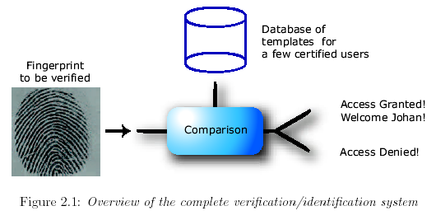

The system is roughly broken down into image enhancement, feature extraction, template generation and the actual Neural Network-based verification/identification step. The fingerprint impressions are acquired from a fingerprint sensor often resulting in an image of poor quality thus making image enhancement necessary. The image enhancement step consists of three major sub processes which are thoroughly described in Section 2.1 below. An overview of the image enhancement step is visualized in Figure 2.2.

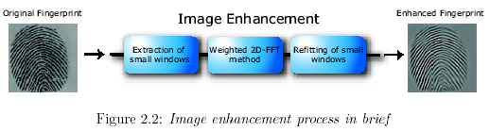

The subsequent feature extraction step is highly dependent of the quality of the image. The task of the feature extraction process is to extract distinct (and hopefully unique) characteristics from the fingerprints and thus reducing the amount of information that has to be compared. The process is concisely depicted in Figure 2.3 below and a detailed description of it can be found in Section 2.2.
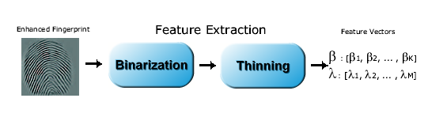

In order to successfully determine whether a specific fingerprint has access or not a good template to compare with is of the essence. A template is made from a few representative impressions from the same finger. The process is sketched in Figure 2.4 below and described in Section 2.3.
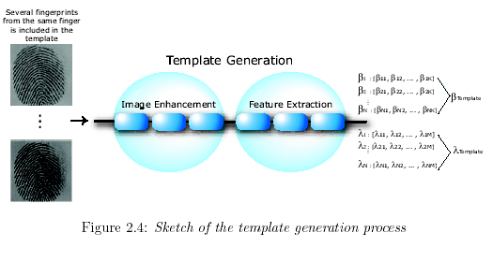

Combining all above processes (Along with some hidden processing like ROI detection, Orientation field calculation) of template generation the complete flowchart of a typical AFIS can be given as



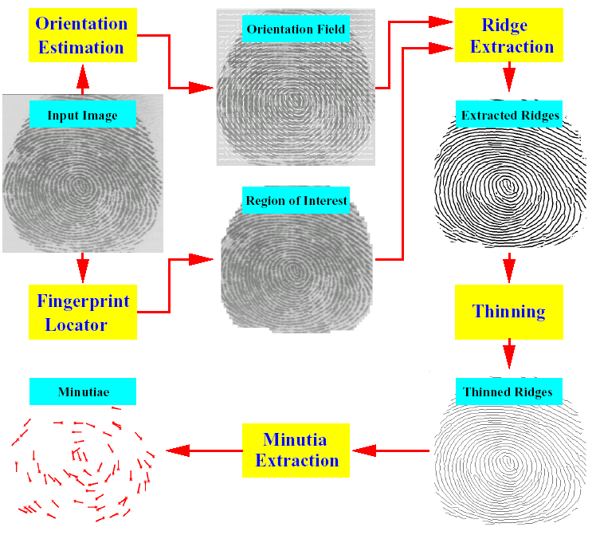




In all applications involving image acquisition, followed by processing of images, successful pre-processing is of the essence. Every sensor has its own characteristics, but in general the quality of the acquired fingerprint image is rather poor. This is partly due to non-uniform contact between the finger and the sensor surface, which causes breaks in ridges and bridges between them. Overall grayscale intensity variations, poor contrast and noisy background are also frequently encountered issues. Furthermore, age and profession, and other environmental differences, additionally affect the quality of a person’s fingerprint. For example, elderly people usually lack well-defined ridges and valleys, thus yielding a poor quality image from the sensor. Another problem to be considered is the oil and dirt that is left behind on the sensor surface from previous fingerprints, further degrading print quality. All these problems must be dealt with before
feature extraction and recognition or verification can be successfully performed.
For the purposes of this project the main objective concerning the image enhancement is to fill ”holes” and to increase the contrast in the, many times pretty rough, grayscale fingerprint image from the sensor. That is, making the non-continuous ridges and valleys of the fingerprint continuous, extract the highly interesting foreground from the noisy and irrelevant background and preserve valid minutiae. Most importantly: Doing all this without producing any false minutiae such as bifurcations, terminations and so forth.



Before going any further, one has to understand the significance of 2D digital convolution
In signal & system convolution is defined as

∞
x(t) * y(t) = ∫x(k)y(t-k)dk
- ∞
But image is 2-Dimentional & discrete image so definition changes to following

∞ ∞
x’[ x , y] = ∑ ∑ x[ i , j ].f[ x-i , y-j ]
- ∞ - ∞
But there is a problem. Images are finite sampled signals of the form I = f(x, y).So we have modified our definition of convolution

x’[ x , y] = ∑ ∑ x[ i , j ].f[ x-i , y-j ]
w w

Where W is called a window or sliding window. At each point [i, j] of the image a window of size W*W is drawn around it.f[x-i, y-j] is basically a swing through the filter (Digital) kernel. Finite digital convolution can be best understood by following Sum of the Products (SOP) representation

-86
68
62
66
120
33
37
62
65
61
-1
0
1

-1

0
1

-1

0
1

Image upon which convolution operator is applied
68
62
66
120
33
37
62
65
61
(-1x68) + (0x62) + (1x66) + (-1x120) + (0x33) + (1x37) + (-1x62) + (0x65) + (1x61) = -86

[ 68 , 62 … this values represents pixel values of a 8 bit gray-scale image having 256(0…255) different gray levels ]
Sliding window of size 3#3
Filtered image

: 

Implementation for such operations is now explained with VC++ source code. For such filter operations I designed a class hierarchy maintaining OOP (Object Oriented Programming) law. At the top of hierarchy contains a Virtual class CUserDefinedFilter
Three classes are subsequently are derived from it depending on the kernel size of the filters: C3By3Filter (3#3 Kernel), C5By5Filter (5#5 Kernel), C7By7Filter (7#7 Kernel).

CUserDefinedFilter
C3By3Filter
C5By5Filter
C7By7Filter
//////////////////////////////////////////////////////////////////////////////////
// Image.h: Prototype of Filter classes

class CImage;
class CUserDefinedFilter
{
//pure virtual(abstract)class::no implementation now !
public:
virtual COLORREF Filter(CImage* image,UINT m, UINT n) =0;

};

Class C3By3Filter : public CUserDefinedFilter
{
public:
C3By3Filter();
float m_kernel[3][3];
int m_iDivision;
int m_iBias;

// it must override Filter(...)
virtual COLORREF Filter(CImage* image,UINT m,UINT n);
};

class C5By5Filter : public CUserDefinedFilter
{
public:
C5By5Filter();
float m_kernel[5][5];
int m_iDivision;
int m_iBias;

// it must override Filter(...)
virtual COLORREF Filter(CImage* image,UINT m,UINT n);
};

class C7By7Filter : public CUserDefinedFilter
{
public:
C7By7Filter();
float m_kernel[7][7];
int m_iDivision;
int m_iBias;

// it must override Filter(...)
virtual COLORREF Filter(CImage* image,UINT m,UINT n);
};

CImage is the master encapsulation for all fingerprint data. At user-defined filter no implementation of Filter operation is made; Just interface is provided. Depending on Kernel size in derived classes Filter function is overrided to implement the specific operation.That is classic OOP.

//////////////////////////////////////////////////////////////////////////////////
// Image.cpp: Implementation of Filter classes

C3By3Filter::C3By3Filter()
{

for(int i=0;i<3;i++)
for(int j=0;j<3;j++)
m_kernel[i][j]=0.0;

/* from here each 3 * 3 filter will be initialized by following matrix to do nothing with the image :-

| 0 0 0 |
H = | 0 1 0 |
| 0 0 0 |

*/
m_kernel[1][1]=1.0;
m_iDivision=1;
m_iBias=0;

}

COLORREF C3By3Filter::Filter(CImage* image,UINT m,UINT n)
{
/* input image = u[m][n] : output image = v[m][n]
3 3
calculates v[m][n] = Sigma Sigma ( h[k][l] * u[m - k][n - l] )
k=1 l=1
v[m][n]'s color !

*/
float R,G,B;
pixel pix;
int circumference = 2;
int radius = 1;
int x,y;

for(int k = 0; k <= circumference; k++)
{
for(int l = 0; l <= circumference; k++)
{
x = m + k - radius;
y = n + l - radius;

if (image->GetPixel(x,y,&pix))
{
R += m_kernel[k][l] * pix.r;
G += m_kernel[k][l] * pix.g;
B += m_kernel[k][l] * pix.b;
}
}
}

ASSERT(m_iDivision != 0);

// be aware of greater than 255 !
R = min(R/m_iDivision + m_iBias,255);
G = min(G/m_iDivision + m_iBias,255);
B = min(B/m_iDivision + m_iBias,255);

// be aware of less than 0 !
R = max(R,0);
G = max(G,0);
B = max(B,0);

return RGB((BYTE)R,(BYTE)G,(BYTE)B);

}

C5By5Filter::C5By5Filter()
{
for(int i = 0; i < 5; i++)
for(int j = 0; j < 5; j++)
m_kernel[i][j]=0.0;

/* from here each 5 * 5 filter will be initialized by following matrix
to do nothing with the image :-

| 0 0 0 0 0|
H = | 0 0 0 0 0|
| 0 0 1 0 0|
| 0 0 0 0 0|
| 0 0 0 0 0|
*/
m_kernel[2][2]=1.0;
m_iDivision=1;
m_iBias=0;

}

COLORREF C5By5Filter::Filter(CImage* image,UINT m,UINT n)
{

/* input image = u[m][n] : output image = v[m][n]
5 5
calculates v[m][n] = Sigma Sigma ( h[k][l] * u[m - k][n - l] )
k=1 l=1
v[m][n]'s color !

*/
float R,G,B;
pixel pix;
int circumference = 4;
int radius = 2;
int x,y;

for(int k = 0; k <= circumference; k++)
{
for(int l = 0; l <= circumference; k++)
{
x = m + k - radius;
y = n + l - radius;

if (image->GetPixel(x,y,&pix))
{
R += m_kernel[k][l] * pix.r;
G += m_kernel[k][l] * pix.g;
B += m_kernel[k][l] * pix.b;
}
}
}

ASSERT(m_iDivision != 0);

// be aware of > 255 !
R = min(R/m_iDivision + m_iBias,255);
G = min(G/m_iDivision + m_iBias,255);
B = min(B/m_iDivision + m_iBias,255);

// be aware of < 0 !
R = max(R,0);
G = max(G,0);
B = max(B,0);

return RGB((BYTE)R,(BYTE)G,(BYTE)B);

}

C7By7Filter::C7By7Filter()
{
for(int i = 0; i < 7; i++)
for(int j = 0; j < 7; j++)
m_kernel[i][j]=0.0;

/* from here each 7 * 7 filter will be initialized by following matrix to do nothing with the image :-

| 0 0 0 0 0 0 0|
H = | 0 0 0 0 0 0 0|
| 0 0 0 0 0 0 0|
| 0 0 0 1 0 0 0|
| 0 0 0 0 0 0 0|
| 0 0 0 0 0 0 0|
| 0 0 0 0 0 0 0|
*/
m_kernel[3][3]=1.0;
m_iDivision=1;
m_iBias=0;

}

COLORREF C7By7Filter::Filter(CImage* image,UINT m,UINT n)
{
/* input image = u[m][n] : output image = v[m][n]
7 7
Calculates v[m][n] = Sigma Sigma ( h[k][l] * u[m - k][n - l] )
k=1 l=1
v[m][n]'s color ! */

float R,G,B;
pixel pix;
int circumference = 6;
int radius = 3;
int x,y;

for(int k = 0; k <= circumference; k++)
{
for(int l = 0; l <= circumference; k++)
{
x = m + k - radius;
y = n + l - radius;

if (image->GetPixel(x,y,&pix))
{
R += m_kernel[k][l] * pix.r;
G += m_kernel[k][l] * pix.g;
B += m_kernel[k][l] * pix.b;
}
}
}

ASSERT(m_iDivision != 0);

// be aware of greater than 255 !
R = min(R/m_iDivision + m_iBias,255);
G = min(G/m_iDivision + m_iBias,255);
B = min(B/m_iDivision + m_iBias,255);

// be aware of less than 0 !
R = max(R,0);
G = max(G,0);
B = max(B,0);

return RGB((BYTE)R,(BYTE)G,(BYTE)B);

}

Now it’s time to show how these filter classes & their implementation is linked to the CImage class.For this a function called UserDefinedFilter (Polymorphic Interface) is defined as a private method of CImage.Code of the function is provided as detail as possible but there may be some undiscussed references of the mother class CImage. Those references will be covered when architechture of CImage will be discussed.

bool CImage::UserDefinedFilter(CUserDefinedFilter* filter,CString szFilterName)
{
// Setup and Call Progress Dialog
CProgressDlg pdlg(szFilterName);
pdlg.Create();
UINT pixels = (unsigned int)(m_height * m_width * 0.01); // 1% //of total pixels
UINT pixelsProcessed = 0;
bool canceled = false;
UINT m, n;
COLORREF cr;

for (m = 0; m < m_height; m++)
{
if (pdlg.CheckCancelButton())
if(AfxMessageBox("Are you sure you want to Cancel?", MB_YESNO)==IDYES)
{
canceled = true;
break;
}

for (n = 0; n < m_width; n++)
{
//runtime polymorphism
cr = filter->Filter(this,m,n);
m_processed[m][n] = cr;

pixelsProcessed++;
if (pixelsProcessed % pixels == 0)
pdlg.StepIt();
}
}

pdlg.DestroyWindow();
return !canceled;
}

For now it will be enough to know that m_processed (Data member of CImage) is an image-matrix where the resulting image is stored after any image processing operation defined by CImage clas.m_height and m_width (Data member of CImage) are hight and width of the fingerprint bitmap loaded into the CImage class. CProgressDlg is Dialog class in VC++ used to display a modal progress bar during image processing showing on how many pixels the present point operation is already being applied.Details about CProgressDlg will be discussed later. szFilterName parameter is used as a caption of the progress bar dialog box.COLORREF is a Windows strcture used in RGB style color format.

Using this filter framework one can easily implement sophisticated image processing filters used to enhance the quality of fingerprint.Just declare the filters depending on what neighbourhood operation(3#3 : 5#5 : 7#7) is required.Then just plug the filter-specific masks into the m_kernel data-member.Normally m_iDivision and m_iBias are kept at their default values (1 and 0 respectively). For example 2D-Gaussain filter(Used extensively in fingerprint enhancement)can be implemente as follows :-

m_kernel[5][5] = {

{ 2.0/115 , 4.0/115 , 5.0/115 , 4.0/115 , 2.0/115 },

{ 4.0/115 , 9.0/115 , 12.0/115 , 9.0/115 , 4.0/115 },

{ 5.0/115 , 12.0/115 , 15.0/115 , 12.0/115 , 5.0/115 },

{ 4.0/115 , 9.0/115 , 12.0/115 , 9.0/115 , 4.0/115 },

{ 2.0/115 , 4.0/115 , 5.0/115 , 4.0/115 , 2.0/115 }

};

These digital masks are result of numerical calculation of classical Gaussiabn distribution given by.Such discrete masks are calculated by ANDO (2000) :

f(x,y) = (1/2π σ²)exp(-(x² + y²)/2σ²)

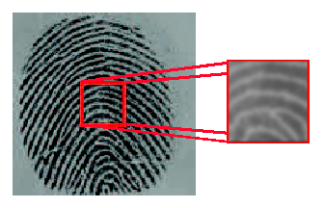
For example a Gaussian-smoothed fingerprint can be given as below. Other than Gaussian filter several other 2D digital filters are implemented.Some of them are Laplacian filter , Sobel edge-detecting filter , Roberts operator , Isotropic operator , Prewitt operator , Kirsch operator , Pyramidal filter , Cone filter etc.
Other than low pass filtering by classical smoothing filter Normalization is another image enhancing operation described next



The grayscale intensities are normalized to a constant mean and variance to remove the effects of sensor noise and grayscale variations due to finger pressure differences. Let I(x,y) denote the grayscale value at pixel (x, y), M and V , the estimated mean and variance of grayscale values in a prefixed window, respectively, and N(x,y), the normalized grayscale value at pixel (x , y). For all the pixels the window, the normalized image is defined as:
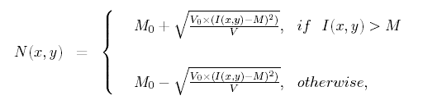

where M₀ and V₀ are the desired mean and variance values, respectively. Normalization is
a pixel-wise operation and does not change the clarity of the ridge and valley structures.
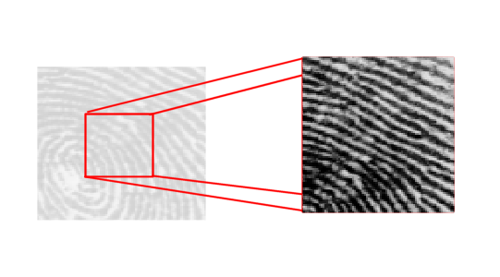

Here is the implementation of Normalisation.Desired mean and desired variance are both assumed to be 100.

//////////////////////////////////////////////////////////////////////////////////
// Image.h:CImage class

class CImage : public CBitmap
{

//Other stuff...

protected:
bool Normalize(float DesiredMean=100,float DesiredVariance=100);

}

//////////////////////////////////////////////////////////////////////////////////
// Image.cpp : Normalization

bool CImage::Normalize(float DesiredMean,float DesiredVariance)
{

// Setup and Call Progress Dialog
CProgressDlg pdlg;
pdlg.Create();
UINT pixels = (unsigned int)(m_height * m_width * 0.01); // 1% of //total pixels
UINT pixelsProcessed = 0;
bool canceled = false;

int i,j,k,l,x,y;
BYTE value,intensity;
float sum1 = 0,sum2 = 0;
float Mean,Variance;
float result;

pdlg.SetDialogCaption("Calculating Mean & Variances...");

for (i = 0; i < (int)m_height; i++)
{
if (pdlg.CheckCancelButton())
if(AfxMessageBox("Are you sure you want to Cancel?", MB_YESNO)==IDYES)
{
canceled = true;
break;
}

for (j = 0; j < (int)m_width; j++)
{

intensity = m_img[i][j].intensity();
sum1 += intensity;
sum2 += sqr(intensity);

pixelsProcessed++;
if (pixelsProcessed % pixels == 0)
pdlg.StepIt();

}
}

// estimated mean & variance
Mean = (sum1/pixelsProcessed);
Variance =((sum2/pixelsProcessed) - (Mean * Mean));

pdlg.SetPos(0);
pdlg.SetDialogCaption("Fixing To Desired Mean & Variance...");

for (i = 0; i < (int)m_height; i++)
{
if (pdlg.CheckCancelButton())
if(AfxMessageBox("Are you sure you want to Cancel?", MB_YESNO)==IDYES)
{
canceled = true;
break;
}

for (j = 0; j < (int)m_width; j++)
{

intensity = m_img[i][j].intensity();
if (intensity > Mean)
{
result = DesiredMean + sqrt((sqr(intensity - Mean) * DesiredVariance)/Variance);
}
else
{
result = DesiredMean - sqrt((sqr(intensity - Mean) * DesiredVariance)/Variance);
}

m_processed[i][j].color(result);

pixelsProcessed++;
if (pixelsProcessed % pixels == 0)
pdlg.StepIt();
}
}

pdlg.DestroyWindow();

return !canceled;

}



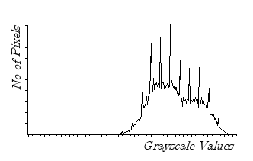
Equalization is technique by which the histogram of the fingerprint is made smooth:means the variation of No of Pixels with Pixel Values is made uniform.Histogram is basically a frequency distribution of pixels and variable is pixel value – grayscale value.A typical histogram is shown at left.Equalization is generally used in fingerprint preprocessing steps because it can brilliantly enhance the ridge-furrow’s intensity while keeping the background intensity suppressed.A demo histogram function can be give as below : ( Image is 8-bit )

long* CImage::Histogram(imagematrix img)
{

int i, j,b;
BYTE val;
long count;
long* h=(long*)new long[256];

for(b = 0; b < 256; b++)
{
count=0;
for (i = 0; i < (int)m_height; i++)
{
for (j = 0; j < (int)m_width; j++)
{
val = img[i][j].Gray();
if (val==b)
count++;
}

}

h[b]=count;

}

return h;

}



bool CImage::Equalize()
{
// Setup and Call Progress Dialog
CProgressDlg pdlg("Equalizing...");
pdlg.Create();
UINT pixels = (unsigned int)(m_height * m_width * 0.01); // 1%
//of total pixels
UINT pixelsProcessed = 0;
bool canceled = false;
const BYTE MAXGREY=255;

UINT i, j,k;
BYTE x,value;
long *h=Histogram(m_img);
long cumulative;
int dummy;

for (i = 0; i < m_height; i++)
{
if (pdlg.CheckCancelButton())
if(AfxMessageBox("Are you sure you want to Cancel?", MB_YESNO)==IDYES)
{
canceled = true;
break;
}

for (j = 0; j < m_width; j++)
{
x = m_img[i][j].Gray();
cumulative=0;

for(k = 0; k < x; k++)
{
cumulative+=h[k];
}

dummy=ROUND(((MAXGREY * cumulative)/(m_height * m_width))-1);

if (dummy < 0)
value=0;
else
value=dummy;

m_processed[i][j].color(value);

pixelsProcessed++;
if (pixelsProcessed % pixels == 0)
pdlg.StepIt();
}
}
pdlg.DestroyWindow();
return !canceled;
}


Binarization is a method of transforming greyscale image pixels into either black or white pixels by selecting a threshold. The process can be fulfilled using a multitude of techniques.Binarization is relatively easy to achieve compared with other image processing techniques.In this process the fingerprint image I:(x,y) → [0 ,255] is converted to B:(x ,y) → {0 ,1},where the value 0 corresponds to valleys and 1 to ridges.One way of accomplishing this is to select a global threshold T and converting the image I(x,y) to a binary image as

1, I(x,y) > T

B(x,y) =

0, I(x,y) < T

Although T can be a function of spatial co-ordinates : T = T(x,y) , usually it is kept globally constant and hence sometimes this type of thresholding technique is called Global Thresholding Method.



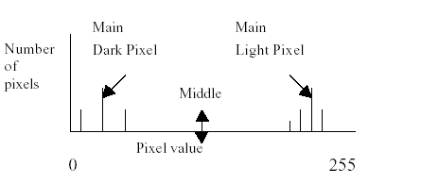
The first technique considered focused on finding the global threshold. The main black and white pixel values of each image is determined. (see figure below) The pixel range in between these pixel values is used to separate the black and white colours. Global binarization involves the formulation of a histogram consisting of the number of pixels versus the pixel value. The two major peaks will be found, assumed to be the most commonly used dark pixel and the most common light pixel.The middle rage pixel will then be used to
discriminate between black and white pixels for binarization. Complications may arise if there is more than one main pixel value or the contrast of the image is poor.
This thresholding scheme is crude and fails whenever image has more than two distinct peaks.Due to this some automatic thresholding tevhnique is necessary. Ridler and Calvard's automatic thresholding is just the answer.This technique is not commonly used to binarize a fingerprint as far as reviewed papers(more than 33) are concerned.
- Calculate the mean brightness T
- Calculate Tb,mean of all the pixels below brightness T
- Calculate Tu,mean of all the pixels above brightness T
- Calculate Tnew = 0.5*(Tb + tu)
- Goto step-(1) if Tnew ≠ T

Tnew is automatically calculated global threshold used to binarize the fingerprint.



Cosider a square block of sufficient size. Now calculate the mean for each block . If intensity of a pixel in that block is higher than mean just calculated for that block ,set the pixel black otherwise set it white in the resulting binary matrix.Implementation of both type of binarization is given in single function.



class CImage:public CBitmap
{

//other stuff...

protected:
bool Binarize(bool adaptive=false,UINT block = 20);
//...
};

If adaptive parameter is false function does automatic thresholding-based binarization,otherwise adaptive binarization is done

bool CImage::Binarize(bool adaptive,UINT block)
{

//allocate the binary image matrix...
m_binaryimage=CreateBinaryMatrix(m_height,m_width);

//Setup and Call Progress Dialog
CProgressDlg pdlg;
pdlg.Create();
bool canceled = false;

// Binarization

UINT i,j,k,l;
BYTE mean;

if (adaptive==false)
{

long sum = 0;
pdlg.SetDialogCaption("Calculating Mean...");
UINT pixels = (unsigned int)(m_height * m_width * 0.01); // 1% //of total pixels
UINT pixelsProcessed = 0;

// Mean Calculation
for (i = 0; i < m_height; i++)
{
if (pdlg.CheckCancelButton())
if(AfxMessageBox("Are you sure you want to Cancel?", MB_YESNO)==IDYES)
{
canceled = true;
break;
}

for (j = 0; j < m_width; j++)
{

sum += m_img[i][j].intensity();

pixelsProcessed++;
if (pixelsProcessed % pixels == 0)
pdlg.StepIt();
}
}

mean = (sum / ((int)(m_height * m_width)));

///////////////// Algorithm /////////////////////////////////
// Desc : Ridler and Calvard's automatic thresholding...
/////////////////////////////////////////////////////////////

pdlg.SetPos(0);
pdlg.SetDialogCaption("Applying Histogram-based Thresholding...");

long* h = Histogram(m_img);
BYTE T,Tnew = mean,Tb,To;
long sumTb1,sumTb2;
long sumTo1,sumTo2;

do
{
//assign last one
T = Tnew;

sumTb1 = 0;
sumTb2 = 0;

//mean of all the pixels below brightness T
for(k = 0; k < T; k++)
{
sumTb1 += (k * h[k]);
sumTb2 += (h[k]);
}

// bug fix..
if (sumTb2 == 0)
Tb = T;
else
Tb = (sumTb1/sumTb2);

sumTo1 = 0;
sumTo2 = 0;

//mean of all the pixels above brightness T
for(k = T; k < MAXINTENSITY; k++)
{
sumTo1 += (k * h[k]);
sumTo2 += (h[k]);
}

//bug fix..
if (sumTo2 == 0)
To = T;
else
To = (sumTo1/sumTo2);

// calculate new T
Tnew = ( Tb + To )/2;

}while(Tnew != T);

pdlg.SetPos(0);
pdlg.SetDialogCaption("Binarizing...");

for (i = 0; i < m_height; i++)
{
if (pdlg.CheckCancelButton())
if(AfxMessageBox("Are you sure you want to Cancel?", MB_YESNO)==IDYES)
{
canceled = true;
break;
}

for (j = 0; j < m_width; j++)
{
//thresholding...
if (m_img[i][j].intensity() < Tnew)
{
//object/foreground pixels(BLACK)
m_binaryimage[i][j]=0x01;

}
else
{
//background pixels(WHITE)
m_binaryimage[i][j]=0x00;

}

pixelsProcessed++;
if (pixelsProcessed % pixels == 0)
pdlg.StepIt();
}

}

}
else
{
//do adaptive thresholding.

pdlg.SetDialogCaption("Applying Adaptive Thresholding...");
UINT blocks = ((m_height * m_width)/(block * block)) * 0.01; // 1% of total blocks
UINT blocksProcessed = 0;
long sum;

for(i = 0;; i += block)
{
if (i+block > m_height)
break;

if (pdlg.CheckCancelButton())
if(AfxMessageBox("Are you sure you want to Cancel?", MB_YESNO)==IDYES)
{
canceled = true;
break;
}

for(j = 0;; j += block)
{
if (j+block > m_width)
break;

sum = 0;
for(k = i; k <= (i+block-1); k++)
{
for(l = j; l <= (j+block-1); l++)
{
sum += m_img[k][l].intensity();
}
}

mean = (BYTE)(sum/(block * block));

// now again go through that block to set ON/OFF
for(k = i; k <= (i+block-1); k++)
{
for(l = j; l <= (j+block-1); l++)
{

if (m_img[k][l].intensity() < mean)
{
// paint as black
m_binaryimage[k][l] = 0x01;

}
else
{
// paint as white
m_binaryimage[k][l] = 0x00;

}

}
}

blocksProcessed++;
if (blocksProcessed % blocks == 0)
pdlg.StepIt();

} //end for j

} //end for i

}

pdlg.DestroyWindow();

if (canceled == true)
return false;
else
return DrawBinaryImage(m_binaryimage,0,m_height-1,0,m_width-1);
}

DrawBinaryImage is simple member function of CImage which takes a binary image matrix , draw the pixel black if binary image matrix is TRUE and white if it is FALSE.Binarization can be done by other methods such as Median Filtering etc.Here is a sample of binarization :
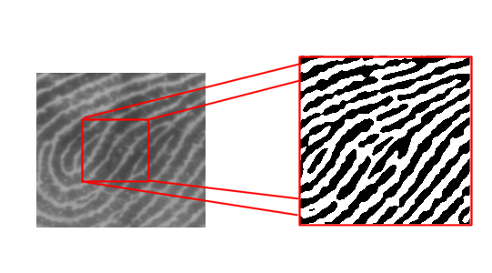
 



The aim of thinning is to reduce the fingerprint to lines one pixel wide.Thinning is a morphological operation performed on binary images.This is achieved by successive deletions of pixels from different sides of each image.(north, south, east, west) Each of the four sides are eroded away according to some set template. Eventually, the image being thinned will no longer possess any points which match the deletion templates. This
remaining image will be the thinned representation of the original image.Other than template searching technique there is Zhang-Suen thinning algorithm which is very efficient skeletonizing algorithm.Although both will be described , the later is adopted in this project.



Table 1 shows a thinning method involving the overlaying of the eight matrices onto the
image. If the image template matches, the middle pixel is removed. The two north images are processed, then the other compass points are overlaid. Once all eight matrices have been sampled on the entire image, the process is repeated on the newly formed image. Processing only stops when no more points can be deleted.

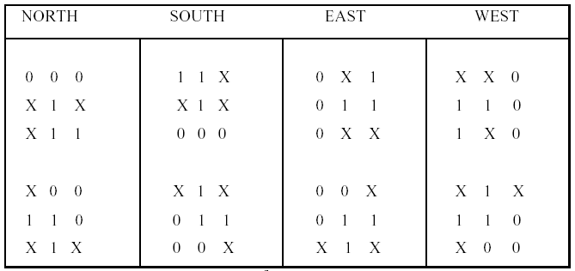

Four point thinning algorithms are also available, these algorithms have only one template for each position. The resulting thinned image isn’t as refined as the eight matrices algorithms because it places fewer criterions on the image. The result usually possesses more spur points.In the next section Zhang-Suen algorithm will be discussed.



Pseudo-steps of the algorithm will not be given.As the C++ code is self-explanatory only implementation is given :

bool CImage::Thinning()
{
// if binarization is yet to be done --
if (m_binaryimage == NULL)
{
// thinning demands that image must be binarized first...
bool bResult=true;
int iResponse=AfxMessageBox("Binarization is necessary before thinning.If you want adaptive binarization\nthen press Yes or If you want histogram-based binarization press No",MB_YESNOCANCEL|MB_ICONINFORMATION);

switch(iResponse)
{
case IDYES:
bResult = Binarize(true); //adaptive
break;
case IDNO:
bResult = Binarize(); //histogram-based
break;
case IDCANCEL: //no binarization
return false;
break;
}

//binarization is stopped,so thinning must be stopped.
if (bResult == false)
return false;
}

// allocate & initialize m_thinmap
m_thinmap=CreateBinaryMatrix(m_height,m_width);
CopyBinaryMatrix(m_thinmap,m_binaryimage);

// Setup and Call Progress Dialog
CProgressDlg pdlg("Thinning The Binarized Image...");
pdlg.Create();
UINT pixels = (unsigned int)(m_height * m_width * 0.01); // 1% of total pixels
UINT pixelsProcessed = 0;
bool canceled = false;

// The Zhang-Suen thinning algorithm
UINT i,j;
BYTE nsum,tsum,tsumP2,tsumP4;
bool changed = true;

while(changed == true)
{
/*

Note: by inspecting each location such p1 we end up examining pixels from a
5 by 5 neighborhood.so, i = [2, m_height-3] and j = [2, m_width-3]

P3 | P2 | P9
P4 | P1 | P8
P5 | P6 | P7

*/
changed = false;

for (i = 2; i <= (m_height-3); i++)
{
if (pdlg.CheckCancelButton())
if(AfxMessageBox("Are you sure you want to Cancel?", MB_YESNO)==IDYES)
{
canceled = true;
break;
}

for (j = 2; j <= (m_width-3); j++)
{
nsum = NeighborhoodSum(m_thinmap,i,j);
tsum = TransitionSum(m_thinmap,i,j);
tsumP2 = TransitionSum(m_thinmap,i-1,j);
tsumP4 = TransitionSum(m_thinmap,i,j-1);

if (m_thinmap[i][j] == 0x01) //is pixel is on ?
{
if ((nsum >= 2) && (nsum <= 6))
{
if (tsum == 2)
{
if ((And248(m_thinmap,i,j) == 0) || (tsumP2 != 2))
{
if ((And246(m_thinmap,i,j) == 0) || (tsumP4 != 2))
{
//delete it :: white
m_thinmap[i][j]=0x00;
changed = true;

}
else
{
// keep it :: black
m_thinmap[i][j]=0x01;

}
}
else
{
// keep it :: black
m_thinmap[i][j]=0x01;

}
}
else
{
// keep it :: black
m_thinmap[i][j]=0x01;

}

}

}

pixelsProcessed++;
if (pixelsProcessed % pixels == 0)
pdlg.StepIt();

}

}

// loop through until no further changes occur in the image
}

pdlg.DestroyWindow();

if (canceled == true)
return false;
// actually plot the pixels of m_thinmap :: draw from binary image
return DrawBinaryImage(m_thinmap,2,m_height-3,2,m_width-3);

}

Four helping functions in thinning algorithm are NeighborhoodSum , TransitionSum , And248 , And246.Before going to give away their C++ implementation , a word about Connectivity Number is necessary.Low level features(minutiaes) are identified by their CN and this fact is brought in light by S.Kasaei, M.Deriche & B.Boashash from Signal Processing Research Centre(SPRC),QUT, Brisbane Q 4001 , Australia.

BYTE CImage::And248(binarymatrix img, UINT x, UINT y)
{

return(img[x-1][y] * img[x][y-1] * img[x][y+1]);

}

BYTE CImage::And246(binarymatrix img, UINT x, UINT y)
{

return(img[x-1][y] * img[x][y-1] * img[x+1][y]);

}

BYTE CImage::NeighborhoodSum(binarymatrix img, UINT x, UINT y)
{

//did we have crossed our boundary !
if (x >= 1 && x <=(m_height-2) && y >= 1 && y<=(m_width-2))
{

BYTE sum = 0;

/*
from here on following neighborhood convension will be customery . Note :: And248 & And268 are named by this convension

P3 | P2 | P9
P4 | P1 | P8
P5 | P6 | P7

*/

sum += img[x-1][y];
sum += img[x-1][y-1];
sum += img[x][y-1];
sum += img[x+1][y-1];
sum += img[x+1][y];
sum += img[x+1][y+1];
sum += img[x][y+1];
sum += img[x-1][y+1];

return sum;
}

}

BYTE CImage::TransitionSum(binarymatrix img, UINT x, UINT y)
{

// TransitionSum = 2 * CN
// CN or Connectivity Number will be discussed shortly
BYTE sum = 0;

sum += (BYTE)fabs(img[x][y-1] - img[x+1][y-1]);
sum += (BYTE)fabs(img[x+1][y-1] - img[x+1][y]);
sum += (BYTE)fabs(img[x+1][y] - img[x+1][y+1]);
sum += (BYTE)fabs(img[x+1][y+1] - img[x][y+1]);
sum += (BYTE)fabs(img[x][y+1] - img[x-1][y+1]);
sum += (BYTE)fabs(img[x-1][y+1] - img[x-1][y]);
sum += (BYTE)fabs(img[x-1][y] - img[x-1][y-1]);
sum += (BYTE)fabs(img[x-1][y-1] - img[x][y-1]);

return sum;

}

Skeletonizing the already binarized image can employ many headaches to the identification/recognition process.First of all if the Region Of Interest(ROI) of original grayscale image is not identified properly many spurious minutiae can appear in the thinned fingerprint.Moreover many spurious minutiae can be generated in previous image processing steps such as binarization.Many real minutiae(s) can disappear as a bad effect of the faulty image processing steps.A sample of thinned fingerprint is shown below.Before actual minutiae detection can take place spurious minutiae should be removed.It’s categorized as one of the major post-processing steps.

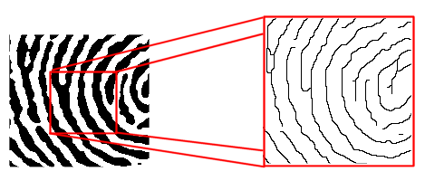



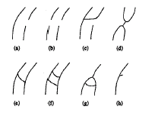
Various types of spurious minutiae can appear as a nasty by-product of fingerprint thinning or skeletonizing.Some of them are given at left.So rigorous post-processing are necessary to wipe out those alse minutiae.Some heuroistic strategies can help us ; such as if one starts from an EP(End Point) or BP(Bifurcation Point) and traces through the corresponding ridges(1 for EP , 3 for BP) no other minutiae should appear less than 25 pixel(say.) distant from the starting point.”25 pixel” is an ad hoc length.In fact one can suitably adjust the cut-off length as required.One can specify the minutiae density because on fingerprint number of minutiae per unit area cannot be too large.If minutiae density crosses a prefixed limit one can replace all the suspicious minutiae(s) by a single minutiae centred at the middle of minutiae cluster.Other strategies are available too. Foe details one may consult the paper – Fingerprint Feature Extraction Using Block-Direction On Reconstructed Images by S. Kasaei , M. Deriche , B. Boashash


Before giving any clue about finding singular points in fingerprint, it is very important to know about “Minutiae” – means “Minute Details”.Generally all the features of a well-captured fingerprint has two major classification – High Level Feature & Low Level Feature.Categorization tree for fingerprint feature can be described as :
Fingerprint Feature
High Level
Low Level
Core
Delta
End Point
Bifurcation Point



Core & Delta points are important features but not as important as minutiae.They are helpful in rotationally aligning a fingerprint with another and fingerprint classification such as left loop , right loop , arch , tented arch , whorl.Such Core-Delta based classification helps to reduce the time-complexity of a fingerprint database searching.If a fingerprint is priori identified as belonging to “arch” category , only the “arch” type of fingerprints in the database is searched for a possible match.

The proposed method can only be performed on thinned images. It is known as crossing number or connectivity number. The technique uses a sample window, 3 pixels by 3 pixels wide to detect key features such as endpoints and bifurcation.The formula for the detection of key point is :
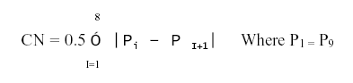
P3 | P2 | P9
P4 | P1 | P8
P5 | P6 | P7
This is applied to matrix with above P_{i} convention(neighbourhood convention).Following table will be helpful to find out singular points (minutiaes) depending on Connectivity Number(CN)

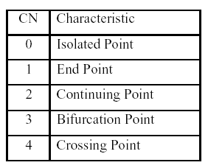

S.Kasaei, M.Deriche & B.Boashash found that this method, combined with a ridge direction algorithm is satisfactory. X.Sun & Z.Ai uses the same methods as S.Kasaei et al with the addition of a similarity measure which compares the number of minutiae in the test print and the identified prints.

Let’s give the much-awaited c++ implementation of minutiae detection.

// Image.h
class CImage:public CBitmap
{

// Other Stuff . . .

private:
bool IsBifurcation(binarymatrix img,UINT x,UINT y);
bool IsEnd(binarymatrix img,UINT x,UINT y);
bool IsSingle(binarymatrix img,UINT x,UINT y);
bool ExtractMinutiae();

// Other private functions…

};

// Image.cpp
bool CImage::IsBifurcation(binarymatrix img, UINT x, UINT y)
{

// No meaning of minutiae at boundary
if (x == 0 || x == m_width-1 || y == 0 || y == m_height-1)
return false;
else
return (TransitionSum(img,x,y) == 6)?true:false;
}

bool CImage::IsEnd(binarymatrix img,UINT x,UINT y)
{
// No meaning of minutiae at boundary
if (x == 0 || x == m_width-1 || y == 0 || y == m_height-1)
return false;
else
return (TransitionSum(img,x,y) == 2)?true:false;
}

bool CImage::IsSingle(binarymatrix img,UINT x,UINT y)
{
return (NeighborhoodSum(img,x,y) == 0)?true:false;
}

These are helper functions.To build up the minutiae list again OOP’s(Object Oriented Programming) was sought.A class hierarchy was designed and given below :

class CMinutiae
{
public:
CMinutiae();
virtual ~CMinutiae();

//public data members
CPoint pt;
float theta;
};

class CEndPoint : public CMinutiae
{
public:
CEndPoint();
virtual ~CEndPoint();

//specific to CEndPoint - 1
int iNeighbours;
};

class CBifurcationPoint : public CMinutiae
{
public:
CBifurcationPoint();
virtual ~CBifurcationPoint();

//specific to CBifurcationPoint - 3
int iNeighbours;
};

For actual list we have following prototype in image.cpp. CArray is an dynamic array supported by VC++/MFC library.

//Image.h
typedef CArray<CEndPoint*,CEndPoint*> END_LIST;
typedef CArray<CBifurcationPoint*,CBifurcationPoint*> BRANCH_LIST;

class CImage : public CBitmap
{
// Other stuff...

private:
END_LIST m_endlist;
BRANCH_LIST m_branchlist;

};

//Image.cpp
bool CImage::ExtractMinutiae()
{
//Thinning is necessary for this step
if (m_thinmap == NULL)
{
// minutiae extraction demands that image must be thinned first
bool bResult=true;
int iResponse=AfxMessageBox("Thinning is necessary before minutiae extraction.Do you want to continue?",MB_YESNO|MB_ICONINFORMATION);

switch(iResponse)
{
case IDYES:
bResult = Thinning(); //Thinning
break;
case IDNO:
return false; //no thinning
break;
}

//thinning is stopped so minutiae extraction must be stopped.
if (bResult == false)
return false;
}

//make m_processed a copy of original m_img to draw on
CopyImageMatrix(m_processed,m_img);

//set list sizes
m_endlist.SetSize(100);
m_branchlist.SetSize(100);

// Setup and Call Progress Dialog
CProgressDlg pdlg("Extracting Minutiae Lists...");
pdlg.Create();
UINT pixels = (unsigned int)(m_height * m_width * 0.01); //1%
//of total pixels
UINT pixelsProcessed = 0;
bool canceled = false;
UINT i,j,k;
CEndPoint EP;
CBifurcationPoint BP;

for(i = 3; i <= (m_height-4); i++)
{
if (pdlg.CheckCancelButton())
if(AfxMessageBox("Are you sure you want to Cancel?", MB_YESNO)==IDYES)
{
canceled = true;
break;
}
for(j = 3; j <= (m_width-4); j++)
{
if (m_thinmap[i][j] == 0x01)
{
if (IsEnd(m_thinmap,i,j))
{
// Yes, an end-point
EP.pt = CPoint(i,j);
EP.theta = Orientation[i][j];

DrawCircleOnTop(m_processed,CPoint(i,j),5,RGB(255,0,0));
m_endlist.Add(&EP);
}

if (IsBifurcation(m_thinmap,i,j))
{
// Yes, a bifurcation point
BP.pt = CPoint(i,j);
BP.theta = Orientation[i][j];

DrawCircleOnTop(m_processed,CPoint(i,j),5,RGB(0,255,0));
m_branchlist.Add(&BP);
}

}
pixelsProcessed++;
if (pixelsProcessed % pixels == 0)
pdlg.StepIt();
}
}

pdlg.DestroyWindow();
return !canceled;

}

It’s time to raise the curtain from the CImage class :

class CImage : public CBitmap
{
//Other stuff…
private:
BYTE* m_buf; //formatted buffer
imagematrix m_original; //original image matrix
imagematrix m_img; //input image
imagematrix m_processed; //output image
binarymatrix m_binaryimage; //binary image
float** m_orientation; //local orientation of
//fingerprint
binarymatrix m_regionmask; //holds ROI of FP
binarymatrix m_thinmap; //thinned binary image
BYTE** m_undobuf; //array of undo buffer
UINT m_width; //image width
UINT m_height; //image height
UINT m_widthDW; //scanline width with
//DWORD padding

CString m_filename; //full path name of image
operationtype m_type; //operation type
int m_undolevel; //how deep UNDO is
// supported ?

};

enum operationtype
{
UNDO,
NEGATIVE,
GRAYINT,
HISTOGRAMBINARIZE,
ADAPTIVEBINARIZE,
FPSEGMENTATION,
EQUALIZE,
EDGEDETECTION,
CONV,
BLUR,
NORMALIZE,
ORIENTATION,
DRAWCIRCLE,
DRAWLINE,
THINNING,
EXTRACT,
CORE,
MARKROI
};
#define UNDEFINED -1
#define ROUND(x) (int)((x)+(0.5))
#define sqr(x) ((x)*(x))
#define MAXUNDO 20
#define PI 3.1428
#define MAXINTENSITY 255
#define MIN(x,y) (((x) < (y))?(x):(y))
typedef pixel* imagerow;
typedef pixel** imagematrix;
typedef BYTE** binarymatrix;
typedef bool** boolmatrix;


class pixel
{
public:
void operator=(pixel& p);
void operator=(hsvpixel& hsv);
void operator=(COLORREF& crColor);
bool operator>(pixel& p);
bool operator>(BYTE x);
bool operator<(pixel& p);
bool operator<(BYTE x);

void color(BYTE R, BYTE G, BYTE B);
void color(BYTE X);
void color(float R, float G, float B);
void color(float X);
void color(COLORREF cr);

BYTE intensity();
void lighten(UINT i);
void darken(UINT i);
BYTE Gray();
bool IsGray();

BYTE r;
BYTE g;
BYTE b;

};
class hsvpixel
{
public:
void operator= (hsvpixel& hsv);
void operator= (pixel& p);

double h; // hue [0,360]
double s; // saturation [0,1]
double v; //brightness [0,1]

};

The minutiae extraction result is brilliant.As told before many spurious minutiae can appear as result of random thinning , no or little post-processing steps etc.Several clever technique like ridge tracing or minutiae density based cut-off can bring down the spurious minutiae number at a level where they can be ignored.

Branch Point



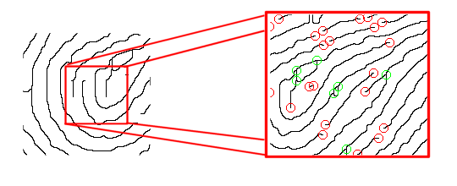



The directional image is usually used to derive the average direction of a small segment
of the image. The image is divided into 4 sub-directions. If required the image could be
sorted into a larger number of bins for greater segmentation. The technique is used on the unprocessed greyscale images. The darker pixels result in a greater number in the corresponding sub-direction. A test area 16 pixels wide was selected. The actual test area depends on the dimensions of the entire image. The area should include at least 1 ridge (dark area) and 1 valley.
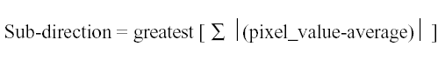
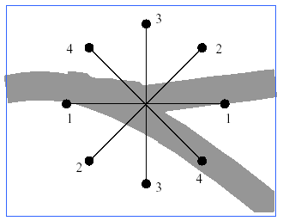
The technique gives similar results to the dominant ridge direction equation (DRD) .None of the articles reviewed use this method to classify the direction of the bifurcations.Unlike the end points branch points are not unidirectional .So local orientation of a grayscale image must be measured long before of binarization , skeletonizing.Initially the fingerprint is smoothed by a low-pass filter like Gaussian filter.Then applying any gradient operator local gradients of the image must be determined.SOBEL operator is one of the most popular gradient operators and very efficient.After calculating Gx and Gy least square technique is used to build the local orientation map of the fingerprint.At the left the new method shows all the possible sub-directions of a typical bifurcation point.In this technique direction of an arbitrary branch point varies between 1-4.

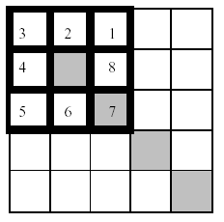
The technique for the classification of endpoint directions is easier to implement. The pixel next to the endpoint determines the direction. Unlike the bifurcation direction, endpoint directions are unidirectional. In this instance the direction equates to 7.If this step is done properly one must able to extract
NIST –specified minutiae information from a fingerprint and store it to a simpe database like :

X | Y | Minutiae Type | Direction:  (1-8) for EP  (1-4) for BP
67 | 98 | EP | 7
123 | 34 | BP | 3

This type of database can be a simple text file formatted as above.




Edge detection will be employed to remove false minutiae resulting from boundaries
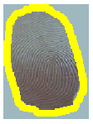
where the fingerprint has stopped coming into contact with the paper or scanner. The Canny method is able to locate edges by observing the local maxima of the gradient. This gradient is calculated using the derivative of a Gaussian filtered image. Two thresholds are used by this method, one detects strong edges whilst the other detects weak (less pronounced) edges. The weak edges are only included in the output if they are
linked to the strong edges. The Canny method isn’t susceptible to noise and is able to detect ‘true’ weak edges better than many other edge filtering methods studied.This method was not encountered in any articles which were reviewed. Many of the reviewed articles found the edges, then focused on a rectangular region situated within these edge boundaries.Thick yellow border locate the global edge of a finger imprint.It’s variation of Region Of Interest (ROI) estimation to eliminate the corner noise,unwanted text etc.



The excess bifurcations and endpoints associated with noise must be removed to

maintain accuracy levels. A proximity guideline will be used to decide if minutiae should be removed. In the case of spur removal, every bifurcation will be selected. If any endpoints are within the specified pixel radius then all points, including the centre bifurcation, will be deleted. In the case of bifurcations, every bifurcation within the pixel radius of another bifurcation will be deleted. The same principle applies to endpoints.If too many minutiae become deleted, tougher constraints will be imposed. The approach is unique to this project.The perimeter surrounding the minutiae will decide if it and other minutiae falling within will be deleted.One can make the provision for minutiae radius to be adjustable to make the noise removal process flexible.


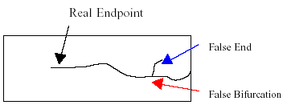
Spur removal helps to remove bifurcations and ends caused by thinning. If these points were not removed, they would result in false endpoints and false bifurcations. A compromise between spur removal must be met. Although it will remove some noise from the thinned image, it will also move endpoints from their ‘real’ locations. This illustrates the dependency of filtering on the quality of the image.
A quality image will require few or no spur removal cycles.


Fingerprint matching can be done in a plenty of ways.For example one can employ simple point matching algorithm if minutiae alignment is not a problem.But if alignment is necessary matching an already existing fingerprint with a new one is not easy.Here comes the technique of Neural Network(NN) which involves none of these complex steps such as “minutiae alignment”.Before actual NN algorithm is employed, a little introduction to NN is necessary.

The human visual system behaves like an adaptive system.Let’s consider how it’s respond
to the stimulus pattern at left.This figure is called Kanizsa square[1976].What we see in the picture ?.Technically four circles and one-quarter of each circle are symmetrically cut out.What about illusory boundaries ? We recognize a bright square.We should not see it ,because it is simply not there.This illusory square is called Kanizsa square which exists only in our brain.The real-time interaction of millions of competing and cooperating neurons produces Kanizsa square illusion.Brain is high-speed , distributed , nonlinear , massively parallel pre-attentive processing.Intelligent beings like humans does a thing called “Adaptive Model-free Estimation”.Adaptive means it tries to adapt a scenario depending on input stimulus.
A function f, denoted f:X → Y maps a input domain X to an output range Y.For every element x in X the function uniquely assigns the element y in Y such that y = f(x).Science and Engineering paint the universe as functions.If some input/output pairs are available we can estimate/design a function from those I/O pairs.The technique is called best-fitting and very popular among statisticians.But such function-estimation is static in the sense that if a new I/O pair appears one has to estimate the function from the scrach.Function itself does not have the ability to “adapt” to all I/O pairs including new ones.Humans , animals , other living beings also estimate functions.Here I/O pair is called stimulus/response pair.Their estimation is not static because they can generalize the functional mapping.
Let’s consider a set of known stimulus/response pair vector <x,y>.Stimulus x belongs to S:stimulus space = set of all possible stimuli for the specific problem at hand.Response vector y belongs response space R.Now if a unknown stimulus vector x’ ≈ x is presented to the system then system should respond with a response vector y’ ≈ y where y is related to x by y = f(x).One astonishing fact about model-free biological adaptive estimators such human brain is that it can “learn”.Learning means synaptic value changes in brains.Learning simply means parameter change.Parameter may be numerical floating point weights in a typical inner-product sum OR average neurotransmitter release rates at synaptic junctions.Neural networks can learn patterns,minutiae sets,problem-specific functions or probability distributions to recognize future patterns,minutise sets etc. Here in ART (Adaptive Resonance Theory) will be utilised to train the NN-matching module with test fingerprints.ART will be discussed next.

 

ART stands for Adaptive Resonance Theory , a method of doing pattern recognition and learning using architectures in which the architecture can be described by a set of differential equations and where, when a pattern match occurs, the system ``resonates". ART models are thought to be similar in many ways to how the brain operates. The ART models have been developed mainly by Grossberg and Carpenter and there are two main versions of ART models that have been produced. ART I uses input patterns that consist of only 0s and 1s while the newer ART II can handle analog patterns. Here we will only look at ART I. Whereas the models can, and usually are, described in terms of solving a set of differential equations the weights used in the network converge to well defined values that can be easily described by simple formulas, therefore, instead of describing ART I precisely in terms of differential equations we will just use the simple formulas. A complete description of ART I can be found in [Grossberg 1988a] (chapter 6) A simple description of ART I and related algorithms can be found in [Moore 1989]. A description of ART II can be found in [Carpenter 1987a]
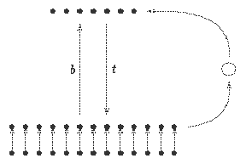
R Layer

C Layer

I Layer

The I Layer holds the unknown patterns.Comparisons between stored pattern and input pattern are done in mid C Layer.The bottom-up weights b , activates nodes in the recognition layer R.Each R_{i} stands for different prototype pattern and these patterns are stored in top-down weights t.When a comparison is made in C layer reset control decides whether R_{i} class is good enough match for present pattern or not.If it is enough process halts otherwise more comparisons are made until all prototype pattern classes are exhausted.
The function of the ART I architecture is to look at patterns and either categorize them as belonging to a group of patterns it already knows about or to take a novel pattern and create a new category for it, thus it is another method of clustering data. The most important parts of the architecture are shown in the above figure.Each node in the R (for recognition) layer represents a different category that ART can put patterns in. In operation, a pattern is placed on the I (for input) layer and then immediately copied onto the C (for comparison) layer. Between the R and C layers there are weighted connections designed to activate the units in the R layer. We will call the matrix of these bottom-up weights, b. Each of the R layer units are activated by the input pattern in the typical fashion:

R_{j}=∑b_{ij}C_{i}
i
The units on the R layer compete with each other to become the winning unit. If the winning unit is labeled J, then R_{J} becomes 1 while all the other R layer units are set to 0. Unit J represents a tentative choice as to the category that the input pattern belongs to and now this choice will be compared with the input pattern in more detail.
To make the comparison between the candidate category represented by the unit R_{J} and the actual input pattern a comparison is made in the C layer. There is an additional set of weighted connections that go from the R layer to the C layer and we will call the matrix of these top-down weights, t. All these weights will be 0 or 1 and they represent the prototype pattern associated with a category. The R_{J} unit will send activation down its connections to the C layer. Units on the C layer will combine the pattern coming from R_{J} with the pattern coming from the I layer and will form a new pattern in the C layer. If the pattern formed in C has enough 1 bits in common with the pattern coming from the I layer the input pattern will be accepted as an instance of the category represented by R_{J}. In particular, if the number of 1 bits in C divided by the number of 1 bits in I is greater than a user chosen parameter, r, the vigilance parameter, then the match is acceptable and the system is said to resonate. When the resonance occurs the top-down and bottom-up weights are modified and the algorithm ends.
However, if the pattern sent down by R_{J} is not close enough then the reset control becomes active and it strongly inhibits R_{J} so that it will not become active again during the current search process. Now the pattern I will be copied into C, C will activate a different node in R. This R node will send a pattern down to C and, again, if the pattern coming down from the winning R node is close enough to the pattern coming up from I then the pattern matches. If the match is not close enough the current active R node is strongly inhibited, another R node is selected, etc. If the input pattern does not match any existing node then an unused node will become activated and match the input by default

This simple pattern classifier will explain - why ART is used as fingerprint matching module

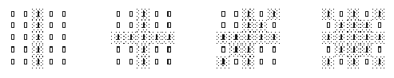


The initial bottom-up weights, b_{ij}, start out with the values

b_{ij} = | L
b_{ij} = | L - 1 + M

where M = 25 and a satisfactory value for L will be 1.05. This makes each b_{ij} = approximately 0.042. The initial top-down weights, t_{ij}, all start out as 1. The vigilance parameter r will be 0.7.
When the first pattern is input all the R nodes will light up to 0.21. The nodes compete as to which one gets selected as the winner and let us assume node 1 wins. Its pattern, the set of weights from R₁ to each C_{i}, is initially composed of all 1s. Now every location in C that is receiving a 1 from above and a 1 from below becomes 1 while all the other C nodes become 0. Five out of 5 of the 1s from the input pattern are matched, this is greater than 0.7, so resonance occurs and weights in the network are adjusted. The bottom-up weights are changed to :

b_{i1}= | LC_{i}
b_{i1}= | L - 1 + |C|

where |C | means the number of 1 bits in C. Therefore, every non-zero weight b_{i1} becomes approximately 0.21. The top-down weights become :
t_{1i} = C_{i}
making each t_{Ji} either 1 or 0, an exact copy of the C (and in this case, the I) pattern. When the second pattern is input node 1 lights up to 1.039604 while the remaining nodes are all approximately 0.38 so node 1 is the winner. Node 1's pattern together with the input from I produce a pattern with only five 1 bits in C. 5/9 is less than 0.7, so node 1 is strongly inhibited by the reset control. Node 2 is selected as the next candidate. It matches 9 out of 9, resonance occurs and the weights are updated as before.
When the third pattern is input R₂ has a value of 1.044199 so it is checked first. There are 9 out of 13 matches, a ratio of 0.69 that is less than 0.7, so the search continues. Next node 1 is selected, its value is 1.039604, but only 5 out of 13 matches occur. Finally, node R₃ is selected, resonance occurs and the weights are updated.
When the fourth pattern is input, node R₃ lights up, there are 13 out of 17 matches, a ratio of 0.76, so the fourth pattern is classified as being in category 3.
If the value for r during the training process had been 0.8 a fourth category would have been created while if the value for r had been 0.2 only one category would have been created. Notice, then, that a low vigilance parameter produces a coarse grouping of patterns and a high vigilance parameter produces a fine degree of discrimination.
In general it may take a number of training passes for a network to learn all the patterns. Any given training pattern may be coded first in one category and later, in another pass, in another category. Once the categories have stabilized any member of the training set will be placed in the correct category on the first try.
At the feature extraction section we have extracted two arrays – one for end points(EP) and other for bifurcation points(BP). The data thus obtained from image processing module are used to train a classical ART-1 network as described just before.One problem faced : ART-1 was designed to handle binary type of patterns while ART-2 was designed for analog data but ART-2 and it’s formulation is much more complex than that of ART-1.So ART-1 is employed.
BP1
X₁ , Y₁ , θ₁
BP2
X₂ , Y₂ , θ₂
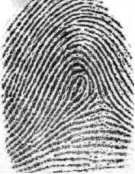
EP1
X₁ , Y₁, θ₁
EP2
X₂ , Y₂, θ₂
Raw Fingerprint
Bifurcation point array

End point array



The similarity measure between a template and a fingerprint or between two fingerprints should be flexible as necessary.In classical fingerprint matching match probability is given by:

M =√((Nm*Nm)/(N1*N2))

where N1 and N2 are the number of bifurcations in fingerprint 1 and 2 respectively. Nm is the maximum number of matches acquired when the print was compared to all prints in the database set.Here in ART-based matching one can adjust the degree of discrimination between two fingerprint by adjusting the vigilance parameter(rho).





Implementation of the feature enhancement and extraction techniques gave superb results.
The final, commercial product would involve scanned images. The results have been analysed and presented in this paper on a typical inked fingerprint. This non-ideal, inked images help to illustrate the effectiveness of the enhancements and potential worse case problems.
It is interesting to note that the majority of the images processed by the articles reviewed are of a higher quality. Many are close to the ideal conditions for the feature enhancements described in this paper.



Unfortunately the global threshold technique proved too troublesome in determining appropriate thresholding levels. The resulting images obtained contained large faded and large dark areas. Some globally binarized images were of an adequate standard, however
the technique wasn’t robust enough to be implemented into the system.That’s why neces-

Black Pixels Low Contrast White Pixels
( Ridge ) ( Valley )

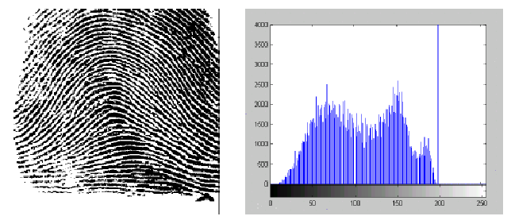

-sity of an automatic global thresholding scheme (like Ridler and Calvard) was felt and it served the purpose brilliantly.None of the reviewed papers has utilised this type of automatic global thresholding technique of binarization.
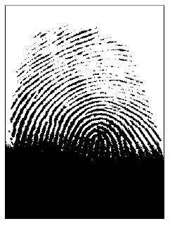
Previous figure shows one of the few cases in which the global threshold approach has worked properly. There is still some smudging present in on the left side which will result in false minutiae during the feature extraction.Reason is crystal clear from histogram : The contrast between the ridges and valleys in the greyscale image isn’t large enough for the selection of an adequate threshold.

Figure at left shows the result of a globally threshold
fingerprint image. The image is practically unworkable, with the bottom area beyond repair and
the top half containing many breaks in the ridge lines.



This project has achieved all of the aims set at the commencement of the project. The design method has been proven to work effectively. Several shortcomings and areas of potential improvement have been foreshadowed throughout this document including:



It is not viable for the current design to be implemented as a security system. Although the feature extraction isn’t very good with poor quality images, it works exceptionally well for its intended use on scanned prints. Results obtained are similar to that obtained from the reviewed articles.The choice of image acquisition method is the most important factor in attaining good results with the designed program. The LiveScanTM based scanner with good lighting contrast should meet these requirements. The best matching accuracy arose when the fingerprints are scaled and tuned properly, with high contrast and no smudging.The noise reduction methods function within acceptable levels. They do not have to be improved in any way. Problems can still occur from noisy images, minutiae features, and small ridge segments. Enough noise is filtered out for the proper operation of the system.
The main problem of the matching algorithm was false matches. (As oppose to no match)
The results obtained are quite promising.



It is appropriate to conclude this paper with a brief summary of the future directions this
work could take.

The program could be used to perform matches on other images. For instance, character recognition could be performed. The only requirement is that the letters have enough
contrast and possess a large enough spacing between minutia. The system would perform
extremely well with large printed images.

The final task is to apply the program to a real world task.Such an embedded system can easily be developed in WindowsCE.Net-eMbedded VC++ platform.As the project is developed in Windows-VC++6 platform, porting it to embedded windows(eMbedded VC++ supports MFC) will not be very painful.Also Windows CE supports many embedded processors.So developing for Windows CE means developing for these diverse processors architechture.

The current matching algorithm isn’t very accurate with low quality images, however it could be integrated with other recognition systems such as face recognition. The resulting combination would be a formidable security system.



[1] G.A.Baxes, Digital Image Processing: Principles and Applications, John Wiley
& Sons, Inc., New York, NY, 1994.

[2] B.D.Costello, C.A.Gunawardena and Y.M.Nadiadi, “Automated Coincident
Sequencing for Fingerprint Verification”, The institute of engineers, 1994.

[3] K.Fan, D.Chen, M.Wen, “Skeletonization of Binary Images With Nonuniform
Width Via Block Decomposition and Contour Vector Matching”, Pattern
Recognition, Vol 31, No 7, 1988, 823-838.

[4] C.A.Gunawardena & V.K.Sagar, “Fingerprint Verification using Coincident
Sequencing and Thinning”, IECON ’91: 17th Annual International Conference on
Industrial Electronics, Vol 3, September 1993, 1917-1922.

[5] K.Karu & A.K.Jain, “Fingerprint Classification”, Pattern Recognition, Vol 29,
1996,389-404.

[6] S.Kasaei, M.Deriche, B.Boashash, “Fingerprint Feature Enhancement Using
Block-Direction on Reconstructed Images”, International Conference on
Information, Communications and Signal Processing ’97, September 1997, 721-
725.

[7] R.Klette and P.Zamperoni, Handbook of Image Processing Operators, John
Wiley & Sons, New York, NY, 1995.

[8] W.K.Lee & J.H.Chung, “Automatic Real-time Identification of Fingerprint
Images Using Wavelets and Gradient of Gaussian.”, Journal of Circuits, Systems,
and Computers, Vol 7, No. 5, 1997,433,440.

[9] N.Rather, S.Chen and A.K.Jain, “Adaptive Flow Orientation-Based Feature
Extraction in Fingerprint Images”, Pattern Recognition, Vol 28, 1995,1652-1672.

[10] A.Rosenfeld and A.C.Kak, Digital Picture Processing: Second Edition, Academic
Press, New York, NY, 1982.

[11] J.C.Russ, The Image Processing Handbook, CRC Press, USA, 1992.

[12] X.Sun & Z.Ai, “Automatic Feature Extraction and Recognition of Fingerprint
Images”, Proceedings of ICSP’ 1996, 1086-1089.

[13] Anil Jain, Lin Hong, Sharath Pankanti and Ruud Bolle, “An Identity Authentication System Using Fingerprints”.

[14] A. Jain, S. Prabhakar and L. Hong(1999): A Multichannel Approach to Fingerprint Classification.IEEE Trans. On Pattern Analysis and Machine Intelligence 21(4): 348-359.

[15] Meltem Ballan and F. Ayhan Sakarya: A Fingerprint Classification Technique Using Directional Images, Yildiz Technical University, Electronics and Comm. Eng. Dept., 80750 Istanbul, Turkey




The proposed graphical user interface is quite intuitive and user friendly. Help files will answer any queries which the users may have.Irrespective of Windows version system has a XP look.System is not a mere collection of MATLAB files.Instead it’s a full-blown software written entirely in VC++(Strength under the hood).

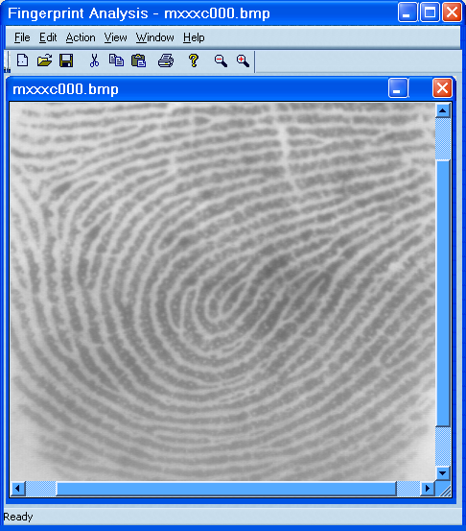
Toolbar Zoom+
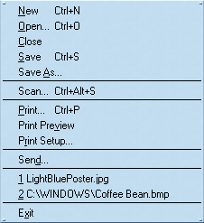
are visible

Scan from TWAIN scanner

Mail the fingerprint

MRU files

StatusBar

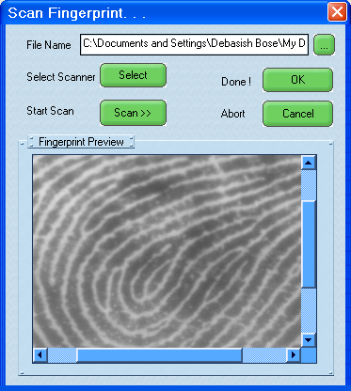
                         
Select a filename where
scanner will dump

Select the scanner if more than one scanner installed

Start scanning

Preview fingerprint
Scanner interface Dialog

User data to be stored in database

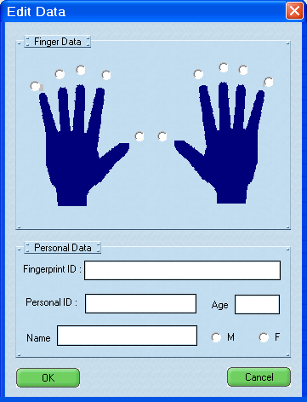

Which hand/finger ?

Personal information block

Database 

All sorts of image processing functions and all menuitems are self-explanetory.

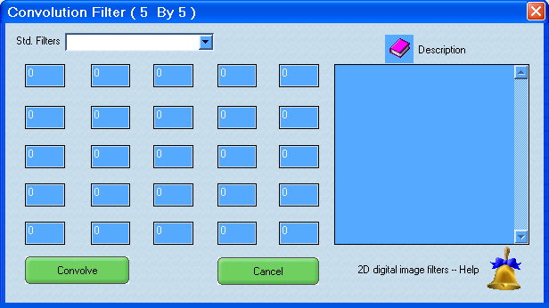

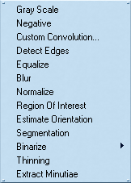
 

Both type of Binarization
Digital filter masks

