ft_db

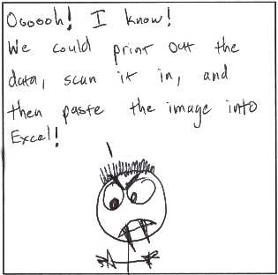

1. Structure 3

2. Data serialization and storing 4

3. Querying the database 5

4. Possible improvements 5

# 1. Structure

Tab n

[cell 1]-[cell 2]-[cell 3]-[cell n]

Tab 2

[cell 1]-[cell 2]-[cell 3]-[cell n]

Tab 1

[cell 1]-[cell 2]-[cell 3]-[cell n]

DB General structure

DB

Database structure:

Char *name – database name

t_tab *tabs – table array for access and store all tables in current database

unsigned int size – current number of tables in database

Table structure:

t_cell *cells – cell array for given table

char *name – table name

unsigned int – current number of cells in the given table

Cell structure:

Char *name – cell’s name

Void *data – data that is stored in the given cell

Things to improve: relations between tables.

# 2. Data serialization and storing

Research what could be done beyond memcpy’ing whole structures and writing in binary files.

Investigate available encryption solutions for data protection.

# 3. Querying the database

Implement creating/editing/deleting for cells, tabs and dbs.

Implement simple SELECT from single or multiple tabs.

# 4. Possible improvements

Research the possibility for memory management. For example, load into memory only tables that was queried or recently created/edited.

Possibility to save and store views (results from SELECT operation).