The Formation of New Rebel Groups

David Bowden

June 28, 2017

# The Formation of New Rebel Groups

This chapter builds on the individual-level findings from Chapter ?? to explain one aggregate manifestation of repression --- the formation of entirely new rebel groups. Specifically, I am interested in cases where entirely new rebel groups join ongoing civil wars. By new I simply mean a group that has not previously participated in violence. Pre-existing non-violent organizations such as religious organizations or political parties could constitute a new rebel group so long as they have not used violence previously, as would entirely new organizations that form during a conflict. I distinguish this sort of group formation from the splintering of existing organizations, as I expect the causal processes to be somewhat different. While splintering is driven by individuals who have already resorted to violence deciding to reorganize, group formation has the additional requirement of mobilizing previously non-violent individuals. To the best of my knowledge, no existing study directly addresses this question.

I expect that repression should increase the probability that a new rebel group will enter an ongoing conflict. As previously peaceful individuals experience violence, the relative cost for them to join a rebellion decreases. These individuals will not necessarily be inclined to join an existing rebel group, however. If an individual has been repressed, existing groups have in some sense failed to protect them. Furthermore, repression should tend to induce greater levels of ethnic identification. Repression is often targeting on the basis of ethnicity, increasing the salience of such identities. Ethnic identification may also have instrumental value in attracting support from outside co-ethnic states, and repression may give these outside states both motive and political cover for supporting new rebel groups. Thus, there should be a relationship between repression and the emergence of new rebel groups.

*Hypothesis 3: The probability that a new rebel group will form should increase with the level of repression in the country*

If ethnic polarization is the mechanism behind rebel group formation, the ethnic diversity of a country should provide an important scope condition. It would be unlikely for repression to induce ethnic identification in a very homogeneous society, for instance. In such cases a different social cleavage might be activated, or repression might not sow division among dissidents at all. I thus expect a positive interaction between repression and ethnic diversity, with repression increasing the probability of new rebel groups at higher levels of diversity, while being less effective at low levels of diversity.

*Hypothesis 4: There should be a positive interaction between repression and ethnic diversity*

My theory suggests that individuals form new rebel groups largely because repression begins to polarize society on the dimension of ethnic identity. This argument has a testable implication regarding the new rebel groups that emerge --- they should be likelier than pre-existing groups to draw their support from a single ethnic group.

*Hypothesis 5: Rebel groups that join ongoing conflicts should be more likely than others to draw their support from a single ethnic group*

## Research Design

To test the preceding hypotheses I use a dataset of country war-years derived from the Uppsala Conflict Data Program and Peace Research Institute Oslo's Dyadic Dataset, version 4-2016 (Harbom, Melander, and Wallensteen 2008; Melander, Pettersson, and Themnér 2016). This dataset includes one observation for every government-rebel group dyad for each year in which it produced at least 25 fatalities. I exclude all interstate conflicts from the data, and include all civil wars, anti-colonial wars, and internationalized civil wars. The remaining rebel dyads are grouped into conflicts, with all rebels seeking to overthrown the central government considered to be part of the same conflict, and separatist movements grouped together if they are pursuing independence for the same territory. Thus conflicts can contain multiple rebel groups, and countries can contain multiple conflicts. I then aggregate this data to the conflict-year, as my outcome of interest is whether a new rebel group joined the fighting in a given year. This results in a dataset of 2,048 observations, covering the period 1946--2015. The advantage of using conflict-years rather than aggregating to country-years is that I am able to examine the effects of several covariates measured at the conflict level, including conflict intensity and the type of issue at stake. The use of conflict-years does create a methodological challenge, however, as many of my covariates are measured at the country level. To combat this I cluster the standard errors by country. Additionally, aggregating the data to the country-year does not substantially change the results.

### Dependent Variables

#### Entry of New Rebel Groups

My primary dependent variable in this study is the entry of new rebel groups to an ongoing conflict. To qualify, a rebel group must meet two criteria. First, it cannot have previously participated in political violence. To determine this I use rebel origins data I collected (described in the Chapter 2 Appendix), and exclude groups that originated as portions of different rebel groups --- splinter organizations and alliances. This leaves rebel groups that emerged out of non-violent organizations such as political organizations, as well as militarized, but not political organizations such as local defense militias. Second, the group must join an ongoing conflict. I define a conflict as ongoing if it has produced at least 25 fatalities in at least one of the past three years. If three consecutive years of peace occur, I consider the next round of fighting to be a new conflict episode, and any new rebel groups that appear in the first year of an episode are considered to have initiated that conflict rather than joined it.

Of the 503 rebel groups that appear in my data, 83 fit the definition. As some of these entered the same conflict in the same year, 73 of 2045[1] (5.6%) of conflict-years are coded as having a new rebel group.

#### Rebel Group Ethnicity

*H5* predicts that because the formation of new rebel groups is driven by a broader reorganization of society along ethnic lines, these newly-formed rebel groups should be likelier than others to draw their support from a single ethnic group. To test this I use the ACD2EPR 2014 dataset (Wucherpfennig et al. 2011; Vogt et al. 2015), which links rebel groups from the Uppsala Armed Conflict Data v.4-2014 (Melander, Pettersson, and Themnér 2016) to ethnic groups from the Ethnic Power Relations (EPR-Core 2014) (Cederman, Wimmer, and Min 2010; Vogt et al. 2015). This dataset identifies three forms of linkages between ethnic groups and rebel groups. First, a rebel group can claim to operate exclusively on behalf of a particular ethnic group. The dataset does allow for the possibility that a group could make such claims for multiple ethnic groups, as was the case for several of the South Sudanese separatist groups. Second, the data records all of the ethnic groups from which a rebel group recruits a significant number of soldiers. Finally, the data codes whether at least 50% of the members of an ethnic group support a rebel group. I collapse these measures into a single count of the number of ethnic groups to which a rebel group is tied. I then categorize rebel groups as "mono-ethnic," "multi-ethnic," or "non-ethnic," if they have no such ties. The distribution of cases across these categories is reported in Table 1.

Table 1 Rebel Groups by Ethnic Affiliation

|  |  |  |
| --- | --- | --- |
| Non-Ethnic | Mono-Ethnic | Multi-Ethnic |
| 97 | 309 | 47 |

### Independent Variables

#### Human Rights

To measure repression I use the same country-level measure employed in Chapter ??, the Latent Human Protection scores, version 2 (Fariss 2014; Schnakenberg and Fariss 2014). The motivation for this data project is the fact that human rights measures are typically based on media reports, creating the possibility that both the depth of coverage and standards against which human rights practices are evaluated might vary across space and time. To solve this, the dataset uses thirteen data sources including U.S. State Department and Human Rights Watch reports and most major scholarly datasets in a Bayesian measurement model. This produces an estimate for each country-year based on a mix of the data for that particular year and the average score for that country and year. While this creates a human rights measure that is comparable across contexts, one disadvantage is that the units are not inherently meaningful, only providing a basis for comparison across observations.

The measure ranges from roughly -3.1 (most repressive) to 4.7 (most respectful of human rights). The average score across the full sample of post-World War II country-years is 0.29, while in my sample of countries experiencing civil war the mean is -1.24, with a range from -3.11 to 1.51. Thus, the sample includes the full range of repressive states, while unsurprisingly lacking any states with especially strong human rights practices. For reference, recent country-years with scores around 1.5 including Hungary in 2011, and France in 2007. In other words, these are typically cases in which citizens are generally safe from physical harm, but some minorities such as Muslims in France experience political and economic discrimination. Russia in recent years falls in the middle of the spectrum, with scores around 1.0. Examples of cases towards the more repressive end of the spectrum include Saddam Hussein's Iraq, which had a score averaging around -2.5, and Sudan, which had scores around -3.0 during the genocide in Darfur.

The raw Latent Human Protection Scores tend to be relatively static over time. Yet, my theory suggests that it is changes in human rights practices, in the direction of being more repressive, that should change dissident behavior. To ensure that I am capturing these pheonemena, I use the year-over-year change in human protection score. While the average conflict-year sees very little change from the preceding year (the mean change is -0.01), 110 cases experience a negative change of at least 0.25, and in one case the score decreased by 2.52 in a single year. I lag the measure by one year, meaning that I am ultimately using the change in human rights practices at time *t* to predict the formation of new rebel groups at time *t+1*.

#### Ethnic Diversity

*H4* suggests that ethnic diversity should place a scope condition on my theory, with the formation of new groups being less likely at very high and low levels of ethnic diversity. I first test for the effect of ethnic diversity individually by including the raw and squared ethnolinguistic fractionalization as predictors. This tests for a curvilinear relationship, allowing for the effect of the variable to differ at moderate and extreme values. The data come from Fearon and Laitin (2003), and can be interpreted as the probability that two individuals drawn at random will be able to communicate. In addition to testing whether ethnic diversity affects the probability of new group formation on its own, I also test whether it alters the performance of the human rights measure, by interacting the latter with both the raw and squared ethnolinguistic fractionalization measures.

#### New Rebel Group Entry

*H5* predicts that the rebel groups that form during ongoing conflicts should be more likely than others to be tied to a single ethnic group. Thus the new rebel group entry variable becomes an independent variable in this analysis, predicting the ethnic composition of rebel groups.

### Control Variables

I control for several factors that might confound my results. To account for the possibility that human rights scores are simply a function of conflict intensity, rather than discriminatory intent, I include the maximum conflict intensity value from the UCDP Dyadic data. The measure is binary, with a value of 1 indicating that the dyad produced between 25 and 999 fatalities in a given year, and a value of 2 indicating that the dyad produced 1,000 or more fatalities. This measure is moderately correlated with the human rights score (Pearson's r = -0.30). The exact measure of fatalities available for the post-1989 period is even less correlated (Pearson's r = -0.25). Thus, human rights practices are for the most part measuring something distinct from conflict intensity.

Conflicts that already have multiple rebel groups may have some unobserved quality that makes them more likely to have fragmented rebel movements. For example, there might be a history of personal animosity between rebel elites (see Christia 2012). To capture such effects, I include a binary indicator of whether a conflict had multiple rebel groups in the previous year.

Two standard controls from past conflict studies are also likely to be relevant. One potential mechanism that might produce increased numbers of rebel groups in a conflict is the movement of groups from a neighboring civil war into a new conflict. To control for this possibility I construct an indicator for the presence of a civil war in a state that is contiguous by land using the UCDP Dyadic data and the Correlates of War Direct Contiguity data, version 3.2 (Stinnett et al. 2002). As secessionist movements are often (though not always) tied to a specific ethnic group, my hypothesized theoretical mechanism should be less likely to apply in such conflicts. Thus, I include a binary indicator of whether a conflict is secessionist as opposed to being fought over control of the central government.

I also control for several country-level factors. Conceivably, the number of rebel groups in a country might simply be a function of the country's size. I thus include a measure of the countries area in logged square kilometers from the World Bank (The World Bank 2015), and logged population and logged GDP per capita from Gleditsch (2002). The characteristics of a country's terrain might also matter, with mountainous areas both creating more opportunities for rebellion, and more challenges in coordinating rebel activities across space. To control for this affect I include Fearon and Laitin's (2003) measure of the percentage of a country's terrain that is mountainous. As democratic competition might provide another incentive for ethnic identification (Eifert, Miguel, and Posner 2010), I include the country's Polity IV regime score (Marshall, Gurr, and Jaggers 2016). The international context could conceivably play an important role in rebel group formation, for instance by shaping the availability of external support. I thus include a binary indicator of whether a country-year occurred during or after the Cold War.

Finally, the presence of natural resources may influence the functioning of my theoretical mechanism. My theory assumes that rebel elites desire the support of dissident constituents. If rebel groups are able to procure sufficient funds and war materiel through the sale of natural resources, however, they might care little about civilians (see Weinstein 2007). I thus include a count of the number of locations in a country containing 'lootable' natural resources, meaning those which can be extracted with relatively unsophisticated operations. The resources included in the measure are oil (Lujala, Rød, and Thieme 2007), diamonds (Gilmore et al. 2005; Lujala, Gleditsch, and Gilmore 2005), gold (Balestri 2012), gems (Lujala 2008), and drugs (Buhaug and Lujala 2005).

### Statistical Model

As the dependent variable in this study is a binary measure of whether a new rebel group entered a conflict in a given year, I use a logistic regression model. For robustness, I examine several variants of the model. These include a model with fixed effects for country and year, and a rare-events correction to account for the fact that group formation occurs in only a small portion of my cases. I also cluster the standard errors by country, as many of my variables are measured at the country-level, creating the possibility that errors could be correlated across different conflicts in the same country. I also estimate models (not reported) with the country-year as the unit of analysis. None of these changes substantially alters the results for my variables of interest.

## Results

### Group Formation Results

The logistic regression results are reported in Table 1. Model 1 includes only the change in human rights measure, Model 2 adds a battery of controls, Model 3 includes an interaction effect between human rights and ethnolinguistic fractionalization, and Model 4 replaces the (mostly) static country-level variables with fixed effects for conflict and year.

In the three models without interaction terms the Change in Human Rights variable performs as I expect. It is consistently negatively related to the probability of new rebel group formation. The relationship is statistically significant at the 99% level in all three models. The substantive effect is large, with a one-unit (which equates to roughly 1.5 standard deviations) decrease in human rights practices being associated with a roughly 400% increase in the odds of new rebel group formation. While the predicted probability of a new rebel group emerging is quite low when the change in human rights practices is zero (around 0.03, see Figure 1), at the largest decreases (a change of -2.5 in one year) the probability of a new rebel group emerging is 0.72. The effect size is similar across models. With these results I am able to reject the null hypothesis of no relationship between repression and the formation of new rebel groups, consistent with my expectation in *Hypothesis 4*.

Model 3 provides a test of the interaction proposed in *H5*. Whereas I expect an interaction effect between the human rights measure and ethnolinguistic fractionalization, the two coefficents testing this (there are two as I expect the effect of ethnolinguistic fractionalization to be curvilinear) are not statistically significant. Ethnic diversity does not seem to matter on its own, either, as there is no evidence of a curvilinear effect, nor of a linear effect (not reported). I am thus unable to reject the null hypothesis of no relationship between ethnic diversity and the probability of new rebel groups forming. It is unclear whether this means my hypothesized mechanism of increased ethnic salience operates even at extreme levels of diversity, or if other mechanisms might operate in those cases. The analysis later in this chapter sheds light on that question.

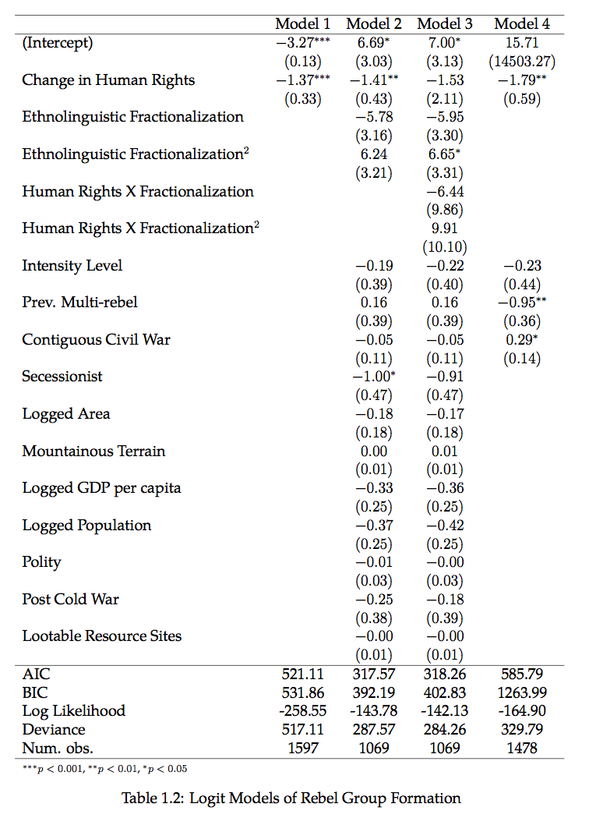

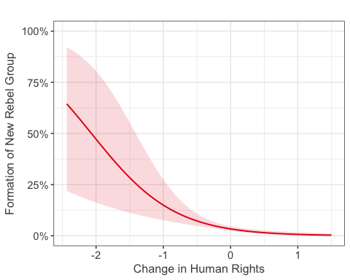

Figure 1 Predicted Probability of New Rebel Group Formation (Based on Model 2)

Only a few control variables are significant, likely reflecting the fact that rebel group formation is a rare and time-varying outcome, while many of the predictors are largely static. New rebel groups are less likely in secessionist conflicts. As these conflicts are often fought by an ethnically homogeneous movement, this result is consistent with my overarching belief that the formation of new groups is about fighting on behalf of previously underrepresented ethnic groups. The 'Previously Multi-Rebel' measure is negatively related the probability of further groups joining, though only in the fixed effects model. This result perhaps suggests that rather than portending further fragmentation of the rebel movement, the presence of multiple rebel groups might signal that a conflict has become saturated with factions, and further additions are unlikely. Contiguous civil wars have a significant positive relationship, suggesting that some new rebel groups might be transnational in character. Again, however, the result is only significant in the fixed effects model.

These results are robust to a number of manipulations. The raw Latent Human Protection Score also consistently predicts the formation of new groups, though the substantive effect is slightly smaller than that of the differenced measure I employ. As mentioned, the results are similar when the data are aggregated into conflict years rather than treating separatist movements as distinct conflicts. I also include attributes of the largest rebel group active in the previous year, such as its size, degree of centralization, and whether it received foreign support. None change the performance of my human rights measure.

I do not perform any sort of causal identification in this analysis. I have examined several measures of oil production as potential instruments for repression, but none came close to the conventional standard for a strong instrument.[2] Matching is not an ideal choice here, as it requires a binary treatment, and my human rights measure is continuous. I cannot rule out the possibility that my results actually reflect the government's ability to anticipate new rebellions. Given that a rebel group must produce 25 fatalities in a calendar year before it enters the data, it is possible for an organization to exist, and for the government to be aware of it, in the years prior to it being coded as a new group in my data. However, I am skeptical that the temporal structure of such a process would be consistent enough to produce the results I report here --- it is unlikely that the increase in repression would consistent occur one year before the rebel group produces 25 fatalities, rather two or three years prior.

Ultimately, these results provide strong support for *H4*, as changes in human rights are robustly related to the formation of new rebel groups. I do not find support that ethnic diversity is related to this outcome, as I predicted in *H5*. Yet, this hypothesis is intended to establish scope conditions. The lack of support could then be an indication that my theory applies more broadly than I expected.

### Group Composition Results

*H6* predicts that the groups which join ongoing conflicts should be more likely than others to draw their support from a single ethnic group. This proposition is tested in Table ??. These analyses use the rebel group as the unit of analysis, with the ethnic composition of the group being the dependent variable. In Model 5 the dependent variable is monoethnic composition, in Model 6 it is multiethnic composition, and in Model 7 it is nonethnic composition, meaning the group has no discernible ties to a politically-relevant ethnic group. I include two group-level covariates from the Non-State Actor Dataset (Cunningham, Gleditsch, and Salehyan 2009): binary indicators of whether the group was active in a previous conflict, and whether it is a transnational organization.

Consistent with *H6*, I find that rebel groups that join ongoing conflicts are nearly twice as likely as others to be monoethnic. The relationship is statistically significant at the 95% level. Joining status is not related to multiethnic or nonethnic composition. Secessionist groups are also more likely than others to be monoethnic, while being significantly less likely to be multiethnic or

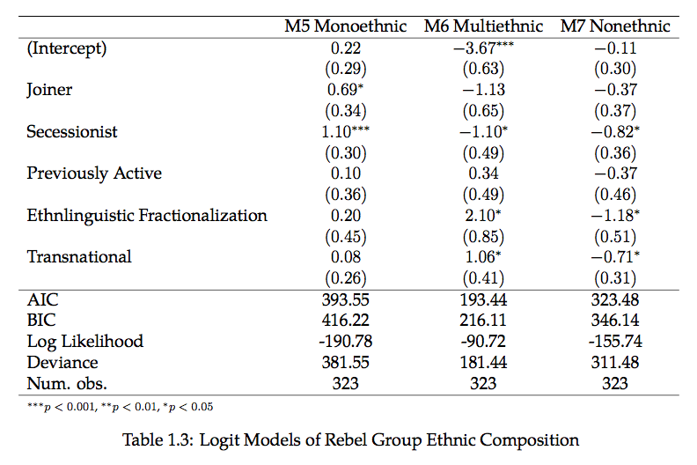

nonethnic. Unsurprisingly, the level of ethnolinguistic fractionalization in a country is positively related to the probability that rebel groups there will be multiethnic, and negatively related to their likelihood of being nonethnic. Finally transnational groups are more likely than others to be multiethnic, and less likely to lack an ethnic affiliation.

This analysis provides support both for *Hypothesis 6*, and for my broader theoretical framework. I expect that the entry of new rebel groups to ongoing conflicts is the manifestation of increased mobilization around ethnic identity. The fact that rebel groups of this kind are significantly more likely than others to draw their support from a single ethnic group provides strong evidence for this argument. Future work should delve deeper into group attributes, looking not only at recruitment and claims of representation, but also the platform that rebel groups adopt. I would expect that joining groups would tend to place greater emphasis on ethnic grievances than others.

## Burma Case Study

To provide a more detailed examination of the processes leading to the formation of new rebel groups, I conduct a qualitative case study of Burma.[3] Burma is in many respects among the most ethnically-polarized societies in the world, as it has 11 separatist movements. I argue that some of these movements have followed a pattern of rebel organization that tracks closely with my theory. One advantage of choosing this case is that potentially confounding factors such as the presence of natural resources and support from outside states varies substantially across separatist movements, while holding many other factors constant including government attributes and colonial history. Burma is also home to several rebel groups that do not conform perfectly to my theoretical framework, providing an opportunity to refine my explanation and identify scope conditions.

Figure 2 Administrative Districts of Burma. Source: Aotearoa.

Figure 2 Administrative Districts of Burma. Source: Aotearoa.

As a whole, Burma is an ethnically diverse society, though ethnic minorities tend to be concentrated on the largely mountainous periphery of the country, while ethnic Burmans predominate in the central lowlands (Steinberg 2010). In the pre-colonial era these ethnic identities were relatively fluid, both in terms of their content and their membership (South 2008). British colonial rule from 1885--1948 led ethnic categories to become both more calcified and more salient, as they practiced direct rule over the ethnic Burmans in the lowlands, while delegating significant autonomy to the ethnic minorities of the mountainous regions (South 2008). Furthermore, administrative practices such as frequent censuses required individuals to declare their ethnicity (Charney 2009), and most positions in the colonial bureaucracy and security forces were given to minorities, as the majority Burmans were viewed as a greater threat to colonial rule (Steinberg 2010). Japan occupied Burma through much of World War II, further entrenching ethnic divisions as the Burman majority collaborated with the Japanese, while many ethnic minorities including the Karen and Kachin supported the Allies (Steinberg 2010).

Late in the war the most prominent faction of pro-Japanese Burmans, led by Aung San, switched sides to support Allied efforts to liberate the country. Most of the politically-active population of Burma, including most ethnic minorities, joined together to form the Anti-Fascist People's Freedom League (AFPFL). The organization remained mostly cohesive for several years after the war in pursuit of independence (Charney 2009). As soon as Aung San succeeded in negotiating a peaceful conferral of independence from the British in January 1947, however, ethnic tensions re-emerged. The Panglong Agreement the following month established the boundaries of the new Burmese state, placing the minority-dominated Frontier Areas under Burman control. As several of the minority groups, including the Karen, had received tacit promises from the British that they would receive independence as separate states, turmoil ensued (Steinberg 2010). Almost immediately upon gaining independence in 1948, Burma faced two civil wars --- a secessionist campaign led by the Karen National Union, and a bid to overthrow the central government by the Red Flag faction of the Communist Party of Burma.

### The Arakanese Buddhist Rebels

The Arakan state is located in Western Burma, along its border with Bangladesh. Today the district is more commonly known as Rakhine state (or Rakhaing in Figure 2), and is notable for being the location of the humanitarian crisis centering around the forced migration of the Rohingya people. In this case study I will relax the assumption that different issues of contention constitute entirely separate conflicts. While the country ultimately saw separatist movements associated with 11 different territories, the dissident elites who led these movements were mostly united within the AFPFL prior to independence. In some cases rebels from different separatist regions collaborated, even while pursuing different goals (Smith 1999). Furthermore, in some cases smaller ethnic groups initially participated in the movements of larger ethnicities, before launching their own rebellion. For example the Karenni originally participated in the separatist movement of their relatives the Karen, before later launching their own rebellion (Uppsala Conflict Data Program 2016). In some cases, then, it might be more accurate to view the new separatist movements in Burma as having joined a larger ongoing conflict, rather than initiating an entirely new one. Under this conception, even the first Arakan separatist groups, the Arakan People's Liberation Party (APLP) and the Mujahid Party, would be considered as joining an ongoing conflict in 1948. Even when applying the coding rules of the quantitative analysis and treating these groups as initiating a new conflict, two other Buddhist groups clearly qualifier as new groups --- the Arakan National Liberation Party (ANLP) in 1964, and the Arakan Liberation Party in 1977.

While Arakan is considered an ethnicity largely because it has a long history as a unified polity, its residents are divided along religious lines. Indeed, even in its earliest days (beginning in 1948) the secessionist movement there was divided into a Muslim faction (the Mujahid Party) and a Buddhist one (the APLP) (Fredholm 1993). This illustrates an important limitation of my theoretical and empirical approach. I focus on ethnicity as I expect that it will be the most salient social cleavage in most countries, because its importance in the context of civil war has been well-established (see Cederman, Wimmer, and Min 2010), and because ethnicity is more easily measured than most other dimensions of identity. Clearly, however, other cleavages can take priority in some cases, and can sub-divide ethnicity as is the case in Arakan. Thus, even though both factions of Arakan residents share a common purpose of securing independence from Burma, they adopt the potentially counterproductive arrangement of being organized into separate rebel groups on the basis of religion.

Ultimately, however, I view the Arakan separatist movement as largely consistent with my theory. While I expect that repression will ultimately lead ethnic groups to produce cohesive rebel groups organized around their identity, and this stops short of occurring in Arakan due to religious divisions, the reasons why Arakanese organize as they do are largely consistent with my theory. I expect that individuals will turn to ethnicity in the face of repression because 1) repression is often targeted on the basis of ethnicity, increasing the salience of such groupings, and 2) ethnicity often provides a useful basis for defense from repression, as ethnic groups often have militias, and may be able to attract support from co-ethnic outside states.

While Burma was nominally democratic from independence in 1948 until a military coup in 1962, the quality of human rights in the country was low. The Latent Human Protection Score for the country was around -1.47 during this period, making it a relatively repressive regime as the global average over the period was 0.03. For comparison, the score changed little after what is generally considered to be a very repressive military regime took power. Thus, at the dawn of the Arakan independence movement the Burmese government employed a level of repression that I would expect to provoke increases in the number of individuals resorting to violence, and to levels of ethnic identification. But whereas I suspect that repression is generally targeted disproportionately at certain ethnic groups, in Arakan the targeting was more specific, with Muslims being disproportionately targeted relative to Buddhists. In fact, the government renamed the state "Rakhine," a name that previously referred only to the Buddhist subset, to emphasize their stance against the Muslim minority known as the Rohingyas (Fredholm 1993). The Burmese government has maintained a military deployment to the region through much of the conflict, and while it has applied significant repression to both religions, it has been especially brutal toward the Rohingya, ultimately seeking to force the minority to migrate into Bangladesh (Steinberg 2010). Thus, the underlying logic of my theory would imply that as repression is applied with respect to both ethnicity and religion, both dimensions of identity should be salient.

Once deciding to rebel, it would not be a foregone conclusion that an Arakense dissident would choose to form a new rebel group. The Communist Party of Burma had a strong following in Arakan; joining the Red Flag faction, or later the Communist Party of Arakan, might have been a viable option for many. The Karen National Union was also active prior to any significant military mobilization in Arakan. It is not obvious, *a priori*, why the various separatists would not band together, as individually none could pose a serious threat to the Burmese government. Indeed, most of the separatist movements agreed to ceasefires in the 1990's and 2000's without winning any concessions, or coming at all close to military victory. Later in the conflict there were in fact attempts to build multi-ethnic alliances (Smith 1999). Initially, however, dissidents generally choose to organize on the basis of ethnicity, in some cases further subdivided by religion. Geographic isolation surely played some role in the lack of coordination across regions, but in several cases separatists operated outside of their own secessionist territory, and Communist forces frequently traveled between different separatist regions (Smith 1999). Furthermore, the Arakanese and Karen separatists had been unified under the banner of the AFLFP just a few months prior, meaning that at least at the elite level, they had communication channels and a history of interaction. As Staniland (2014) notes, social groups with these sorts of ties are often able to build national rebel groups. The fact that this did not occur suggests that ethnicity was an important factor in preventing the consolidation of dissent.

After accounting for the religious cleavage, the organization of Arakanese rebels is consistent with my expectations. Buddhists and Muslims generally consolidated into a single rebel group each. Interestingly, the specific organizations changed over time, with one group being defeated and another taking its place. For example, when the Arakan conflict began in 1948, Buddhists were represented by the Arakan People's Liberation Party. The APLP was defeated in the late 1950's. Surviving members joined with new recruits to form the Arakan National Liberation Party a few years later. The ANLP too was defeated, only to be later replaced by the Arakan Liberation Party. Thus while three new Buddhist organizations joined the ongoing conflict in Arakan, they seemingly replaced one another, and represented the same underlying constituency. This suggests that dissidents only form new organizations if there is not already a group representing their particular set of identities. Furthermore, it suggests that there is a persistent demand for rebel groups to provide representation. If an existing rebel group is defeated, the potential support of dissident constituents provides an incentive for entrepreneurs to create a replacement.

Other elements of the Arakan case are broadly consistent with my theory, while also suggesting nuance. Most of the ethnic minorities faced significant repression starting almost immediately after World War II, as the central government sought to create a unified Burmese state. The Arakanese groups that joined later in the conflict seem to fit my prediction that repression reduces the disincentive to participate in violence, though accounts from individual rebels are virtually non-existent. It should be noted, however, that the initial Arakense rebellion, the APLP, was comprised largely of individuals who had fought the Japanese in World War II (Charney 2009). While the core logic of the theory likely applies to these individuals --- the brutal Japanese occupation reduced the relative cost of fighting --- I fail to account for the fact that conflicts often cluster in space and time, meaning that the most recent wave of repression will not always be the only violent experience shaping dissident preferences. The Arakanese also ulimately formed new rebel groups around the identities that formed the basis for repression, as I expect. Yet the logic of forming a new group does not seem to follow the logic I propose. Whereas I expect that new groups to constitute a rejection of existing rebel groups in response to their lack of representation for some ethnic groups and inability to protect civilians, in Arakan the decision was mutual and collaborative. The Karen National Union was uninterested in recruiting Arakense dissidents, but did support the movement and aided in the establishment of several of the rebel groups there (Smith 1999).

### Discussion

The Arakan case suggests some refinements for my theory, but in most ways is consistent with its logic. As I predict, the emergence of rebellion in Arakan followed a period of political and physical repression, though the residual effects of World War II likely played a role in producing a pool of individuals wiling to fight. I also sexpect that repression will lead individuals to identify more strongly with their ethnic group. In Arakan state this prediction is not inaccurate, but is underspecified. The fundamental groups to which Arakanese turned was a subdivision of their ethnicity that combines ethnic identity with religion. While I focus on ethnicity for reasons of clarity and data availability, Arakan shows that a full understanding of any particular case requires knowledge of the social cleavages there. Identities such as religion can crosscut ethnicity, and in some cases might even take priority over it. Indeed a split between Muslims and Christians led to conflict in the ethnically-homogeneous South Sudan almost immediately upon its independence. A question raised by this analysis is how rebel elites are sometimes able to overcome such divisions and produce a movement that coheres around a broader identity. The Iraqi Kurdish population, for example, contains Muslims, Christians, and adherents to a number of smaller religions such as Zoroastrianism. While at times the Kurds have divided along these lines, they've tended to come together in the face of conflict (McLauchlin and Pearlman 2012). Future work should explore why the Kurds have been able to accomplish this, while the Arakanese have not.

## Conclusion

I have argued that repression should increase the probability that new rebel groups will join ongoing civil wars. This is so because repression reduces the relative risk of fighting for previously non-violent individuals, creating a pool of individuals willing to join the conflict. Yet because repression also tends to enhance the salience of ethnic identities, due to the fact such identities often form the basis for targeting and emphasizing such identities is often a good strategy for procuring foreign support, these new fighters are not always interested in joining existing groups. Rather, they should form new rebel groups that provide explicit representation to their ethnic group.

Consistent with my expectations in *H4*, I find that decreases in human rights practices are associated with a substantial increase in the probability that a new rebel group will join the conflict in the following year. A change of -1 in the Latent Human Protection Score for a country, roughly the difference between France and Russia in recent years, triples the probability that a new group will emerge. I do not find support for *H5*, which predicted that ethnic diversity would limit the scope in which the repression mechanism should apply. I do find support for *H6*, which tests the implication that new rebel groups emerging through this process should be more likely than others to draw support from a single ethnic group. Rebel groups that join ongoing conflicts are nearly twice as likely as others to have ties to only a single ethnic group.

These results suggest that the government plays a surprisingly large role in shaping rebel movement structure. Existing work on rebel structure tends to focus on the social (Staniland 2014) or economic (Weinstein 2007) context from which rebels emerge, and studies that do consider the role of the government have often found that repression increases cohesion among target groups (Simmel 1955), though the effect may be contingent on internal group dynamics (McLauchlin and Pearlman 2012). The findings also contribute to the school of thought which suggests that ethnic diversity is not inherently dangerous (Fearon and Laitin 1996), with ethnic conflict instead being contingent on the treatment of ethnic groups (Cederman, Wimmer, and Min 2010). Similarly, these results suggest that policymakers could limit the emergence of ethnic polarization during conflicts by ensuring the protection of civilian populations.

# References

Angrist, Joshua D., and Jorn-Steffen Pischke. 2009. *Mostly Harmless Econometrics: An Empiricists Companion*. Princeton, NJ: Princeton University Press.

Balestri, Sara. 2012. “Gold and Civil Conflict Intensity: evidence from a spatially disaggregated analysis.” *Peace Economics, Peace Science and Public Policy* 18 (3): 1–17. doi:[10.1515/peps-2012-0012](https://doi.org/10.1515/peps-2012-0012).

Buhaug, Halvard, and Päivi Lujala. 2005. “Accounting for scale: Measuring geography in quantitative studies of civil war.” *Political Geography* 24 (4): 399–418. doi:[10.1016/j.polgeo.2005.01.006](https://doi.org/10.1016/j.polgeo.2005.01.006).

Cederman, Lars-Erik, Andreas Wimmer, and Brian Min. 2010. “Why do ethnic groups rebel?: New data and analysis.” *World Politics* 62 (1): 87–98.

Charney, Michael W. 2009. *A history of modern Burma*. Cambridge: Cambridge University Press.

Christia, Fotini. 2012. *Alliance Formation in Civil Wars*. Cambridge: Cambridge University Press.

Cunningham, David E., Kristian Skrede Gleditsch, and Idean Salehyan. 2009. “It Takes Two: A Dyadic Analysis of Civil War Duration and Outcome.” *Journal of Conflict Resolution* 53 (4): 570–97.

Eifert, Benn, Edward Miguel, and Daniel N. Posner. 2010. “Political competition and ethnic identification in Africa.” *American Journal of Political Science* 54 (2): 494–510.

Fariss, Christopher J. 2014. “Respect for Human Rights has Improved Over Time: Modeling the Changing Standard of Accountability.” *American Political Science Review* 108 (2): 297–318.

Fearon, James D., and David D. Laitin. 1996. “Explaining Interethnic Cooperation.” *American Political Science Review* 90 (4): 715–35.

———. 2003. “Ethnicity, Insurgency, and Civil War.” *American Political Science Review* 97 (1): 75–90.

Fredholm, Michael. 1993. *Burma: Ethnicity and Insurgency*. London: Praeger.

Gilmore, Elisabeth, Nils Petter Gleditsch, Päivi Lujala, and Jan Ketil Rød. 2005. “Conflict Diamonds: A New Dataset.” *Conflict Management and Peace Science* 22 (3). Taylor & Francis Group: 257–72.

Gleditsch, Kristian Skrede. 2002. “Expanded trade and GDP data.” *Journal of Conflict Resolution* 46 (5): 712–24.

Harbom, Lotta, Erik Melander, and Peter Wallensteen. 2008. “Dyadic Dimensions of Armed Conflict, 1946—2007.” *Journal of Peace Research* 45 (5): 697–710.

Lujala, Päivi. 2008. “Deadly Combat over Natural Resources: Gems, Petroleum, Drugs, and the Severity of Armed Civil Conflict.” *Journal of Conflict Resolution* 53 (1): 50–71. doi:[10.1177/0022002708327644](https://doi.org/10.1177/0022002708327644).

Lujala, Päivi, Nils Petter Gleditsch, and Elisabeth Gilmore. 2005. “A Diamond Curse?: Civil War and a Lootable Resource.” *Journal of Conflict Resolution* 49 (4): 538–62.

Lujala, Päivi, Jan Ketil Rød, and Nadja Thieme. 2007. “Fighting over Oil: Introducing a New Dataset.” *Conflict Management and Peace Science*, August. Taylor & Francis Group.

Marshall, Monty G., Ted Robert Gurr, and Keith Jaggers. 2016. “Polity IV Project Dataset Users’ Manual, v.2015.” *Polity IV Project*, 1–86.

McLauchlin, T., and W. Pearlman. 2012. “Out-Group Conflict, In-Group Unity?: Exploring the Effect of Repression on Intramovement Cooperation.” *Journal of Conflict Resolution* 56: 41–66. doi:[10.1177/0022002711429707](https://doi.org/10.1177/0022002711429707).

Melander, Erik, Therése Pettersson, and Lotta Themnér. 2016. “Organized violence, 1989–2015.” *Journal of Peace Research* 53 (5): 727–42.

Schnakenberg, Keith E., and Christopher J. Fariss. 2014. “Dynamic Patterns of Human Rights Practices.” *Political Science Research and Methods* 2 (1): 1–31.

Simmel, Georg. 1955. *Conflict and the Web of Group-Affiliations*. New York: Free Press.

Smith, Martin. 1999. *Burma: Insurgency and the Politics of Ethnicity*. London: Zed Books Ltd.

South, Ashley. 2008. *Ethnic Politics in Burma : States of Conflict*. New York: Routledge.

Staniland, Paul. 2014. *Networks of Rebellion: Explaining Insurgent Cohesion and Collapse*. Ithaca, NY: Cornell University Press.

Steinberg, David I. 2010. *Burma/Myanmar: What Everyone Needs to Know*. New York: Oxford University Press.

Stinnett, Douglas M., Jaroslav Tir, Paul F. Diehl, Philip Schafer, and Charles Gochman. 2002. “The Correlates of War (Cow) Project Direct Contiguity Data, Version 3.0.” *Conflict Management and Peace Science* 19 (2): 59–67.

The World Bank. 2015. “World Development Indicators.” Washington D.C.: The World Bank.

Uppsala Conflict Data Program. 2016. “UCDP Conflict Encylopedia.” <http://ucdp.uu.se/?id=1>.

Vogt, Manuel, Nils-Christian Bormann, Seraina Ruegger, Lars-Erik Cederman, Philipp Hunziker, and Luc Girardin. 2015. “Integrating Data on Ethnicity, Geography, and Conflict: The Ethnic Power Relations Data Set Family.” *Journal of Conflict Resolution* 59 (7): 1327–42.

Weinstein, Jeremy M. 2007. *Inside Rebellion*. Cambridge: Cambridge University Press.

Wucherpfennig, Julian, Nils W. Metternich, Lars-Erik Cederman, and Kristian Skrede Gleditsch. 2011. “Ethnicity, the State, and the Duration of Civil War.” *World Politics* 64 (1): 79–115.

1. Some observations are left-censored, meaning I am unable to determine whether there was conflict during the previous three years as it would predate the beginning of the dataset.
2. An instrument is considered strong if the first-stage F-statistic is at least 10 (Angrist and Pischke 2009). The scores for the oil measures were generally around 4.5.
3. The country's military regime began using the name "Myanmar" in 1989, but most dissidents and the U.S. government continue to use "Burma."