The Realignment of Rebel Groups

David Bowden

June 30, 2017

Having explored the formation of new rebel groups in the previous chapter, I turn now to the other major process affecting the number of rebel groups in a conflict --- the realignment of existing rebel factions. There are two ways in which rebels can realign. First, subsets of existing groups can break away to form splinter organizations. For example, Hezbollah split from the Amal movement during the Lebanese Civil War to form a more radical organization. I define a splinter organization as an independent rebel group, signified by having an identifiable name and leadership that are not shared with any other rebel group, that was previously subsumed within another rebel organization. Thus, entirely new rebel groups are excluded, even if they constitute a subset of a larger non-violent organization. Splinter organizations generally emerge during ongoing conflicts, though sometimes they are formed during periods of peace to initiate a new wave of fighting, as the Real Irish Republican Army did (Stedman 1997).

Second, previously independent rebel organizations can form alliances. Here I focus on alliances with meaningful integration of command structures, defining an alliance as an organization with a distinct name that merges a substantial amount of the decision-making for two or more previously independent rebel groups. This might occur if one group absorbs another, or two groups create a formal umbrella organization to coordinate their activities. An example of the latter case is the Syrian Defense Forces, under which the Kurdish People's Protection Units (YPG) have joined with several Arab rebel groups to coordinate their campaign against the Islamic State. Note that this definition excludes cooperation that falls short of formal integration. Such behavior is difficult to measure systematically, though multiple forthcoming data collections should facilitate research on the topic in the future.

I expect these process to be closely related as part of a broader process of realignment around ethnic identity. Repression should make civilians more likely to identify with their ethnic group. While I do not necessarily expect this effect to extend directly to rebels --- almost by definition, they experience violence --- I do expect that there will generally be a strong connection between rebels and civilians dissidents. Except for a few cases with exceptionally large endowments of natural resources or foreign support, rebels depend on dissident civilians for recruits, shelter, and material resources. As civilians often have the ability to defect to the side of a rival rebel group or the government, rebels have an incentive to represent the interests and identities of these constituents. Furthermore, ethnic identification can be an effective means of securing support from foreign co-ethnic states, and such appeals might be especially likely to succeed during periods of repression. Thus, rebels should tend to identify more strongly with their ethnic group following episodes of repression.

This dynamic should lead rebels to reorganize on the basis of ethnicity. In some cases rebel leaders may be able to reorient their group to emphasize ethnicity more strongly (see Christia 2012). Often, however, it will be difficult for them to do so credibly. For example, if a rebel had previously maintained a multi-ethnic coalition of support, it would be difficult for them to emphasize a particular ethnic identity. In such cases, entrepreneurial members of the group may see opportunities to form a new splinter organization that "outbids" the original rebel group with a more credible, extreme appeal to ethnic identity (see Horowitz 1985). As doing so could potentially win the support of a large number of dissident civilians, and leading a rebel group is likely to bring private benefits such as resource revenues, this should often be an enticing opportunity. As I expect this cycle of ethnic outbidding to be especially likely in the wake of repression, I expect that the level of repression should predict the likelihood that new splinter organizations will form.

*Hypothesis 6: The probability that rebels groups splinter should increase with the level of repression in a country*

I argue that splintering often reflects a process of reorganization around ethnic identity. The ability of this process to produce new rebel groups should depend, however, on the pre-existing configuration. A rebel group that is already composed primarily of members of a single ethnicity may be able to adapt to increased ethnic identification, though they may still fragment as a result of outbidding appeals. Nevertheless, groups that draw their support from multiple ethnic groups should be much more vulnerable to fragmentation as the result of increased ethnic identification.

*Hypothesis 7: Multi-ethnic rebel groups should be at greater risk of splintering than monoethnic ones*

My theory also suggests a testable implication regarding the characteristics of the splinters groups that emerge. If splintering is motivated by a desire to form rebel groups that more clearly represent a particular ethnic group, the rebel groups that emerge from this process should be likelier than others to draw their support from a single ethnic group.

*Hypothesis 8: Splinter organizations should be more likely than others to draw their support from a single ethnic group*

While this process of realignment around ethnic identities should lead to the fragmentation of some groups, in other cases it might create opportunities for aggregation. One disadvantage of splintering is that it will generally result in a weaker organization than members had previously, as it will have only a subset of the parent group's members at its disposal. As a crucial function of alliances is the aggregation of capabilities, forming new alliances is a potential solution to this problem. Alliances may also have the benefit of managing potential conflict between their members (Gibler 1996), ensuring that resources are directed toward fighting the government rather than other rebel groups. Finally, outside states often attempt to maximize the impact of their support by channeling it to a coalition of rebels, rather than a series of smaller, independent groups. Interventions of this sort might be especially likely in the wake of a humanitarian crisis.

As is the case with splintering, my theory offers predictions regarding not only when new alliances should emerge, but also what their ethnic composition should be. I expect that the ethnic polarization sparked by repression should lead rebels to leave multi-ethnic coalitions, but also to form new alliances with co-ethnic factions.

*Hypothesis 9: The probability that new, mono-ethnic alliances will form should increase with the level of repression*

Conversely, the emergence of multi-ethnic alliances should be less likely when this dynamic is at work.

*Hypothesis 10: The probability that new, multi-ethnic alliances will form should decrease with the level of repression*

## Research Design

While I believe them to be the result of closely related theoretical processes, the splintering of individual rebel organizations and the formation of alliances between separate organizations require distinct research designs. I first explain my choice of designs for studying splintering.

### Splintering

The first phenomenon I explain in this chapter is splintering. As the explanatory factors in *H7* and *H8* are group attributes, the unit of analysis in this portion of the study is the rebel group-year. I seek to explain not simply which conflict years produce splinter organizations, but also which rebel groups within those conflict years. I draw my sample of cases from the UCDP Dyadic Dataset, version 4-2016 (Melander, Pettersson, and Themnér 2016), which includes an observation for every non-state actor in every year in which it was involved in conflict with the government producing at least 25 fatalities. After collapsing observations for rebel groups that appear in multiple conflicts in a single year, I am left with a dataset of 2,656 rebel group years covering the period 1946--2015.

#### Dependent Variables

**Splintering**

The first dependent variable in this portion of the analysis is the splintering of existing rebel groups. I use my own data on rebel group origins to identify splinter groups.[1] A group is coded as a splinter organization if most of its leadership were previously members of another rebel group. I follow the UCDP coding decisions for distinguishing cases where a new group has emerged from simple name changes. Essentially, a group is considered new if its leadership, organizational structure, or membership differs substantially from previous existing organizations. When two groups disagree about which is the original organization and which is the splinter, the larger group is considered the original.

113 of the 506 rebel groups in my data are splinter organizations. As there are four cases in which a rebel group produced two splinter organizations in the same year, the number of years in which a new splinter organization emerged is 109. However, a large portion of these are coterminous with dissolution of the original organization. Typically in these cases the main organization will agree to a peace deal, and a radical faction will form a splinter organization to continue fighting. While this is an interesting and consequential phenomenon, it has already received a substantial amount of attention from scholars (e.g. Stedman 1997). Furthermore, I am interested in processes that increase or decrease the number of rebel groups in a conflict. Replacing a large, moderate organization with a more radical splinter has important implications for the probability of peace and the tactics likely to be deployed. Ultimately, however, it does not alter the number of rebel groups competing simultaneously. I thus consider these cases to be beyond the scope of this dissertation, and exclude them from my analyses. This leaves a total of 25 cases in which a splinter and parent organization were active simultaneously. This variable is coded as 1 in the group-year in which a parent organization loses a splinter faction (i.e. I examine the groups that splinter).

**Rebel Group Ethnicity**

*H8* predicts that splinter organizations should be more likely than others to draw support from a single ethnic group. As I did for the similar hypothesis in Chapter ??, I use the the ACD2EPR 2014 dataset (Wucherpfennig et al. 2011; Vogt et al. 2015) to determine this. The data measures three categories of ties between rebel and ethnic groups --- explicit claims of representation, recruiting, and support from at least half the ethnic group. I collapse these forms to code a trichotomous measure indicating whether a rebel group is multi-ethnic, mono-ethnic, or non-ethnic, meaning it has no observable links to any ethnic group.

#### Independent Variables

**Human Rights**

I again use the Latent Human Protection scores, version 2 (Fariss 2014; Schnakenberg and Fariss 2014) to measure repression. As I do in Chapter ??, I combat the fact that the measure is mostly static with a slight positive trend over time by using the change over the previous. In this measure, a negative score indicates that a country has become more repressive, while a positive score means that human rights have improved. In this sample the mean change is just 0.01, but there are numerous large change in both directions.

**Multi-ethnic Group**

To test *H7* I use the measure of rebel group ethnicity that serves as a dependent variable later in the chapter. In this case I collapse the measure into a dichotomous indicator with rebel groups that draw support from multiple ethnic groups coded as 1, and all others coded as zero. There are relatively few multi-ethnic groups in the data, with the attribute occurring in 334 of 2393 valid group-year observations.

**Splinter Organization**

The test of *H8* uses the splinter variable from my rebel origins data as an explanatory factor. The coding rules are described above. 113 out of 503 rebel groups are splinter organizations.

#### Control Variables

I include many of the country-level covariates from Chapter ?? in the splintering analyses as controls. These include ethnolinguistic fractionalization (Fearon and Laitin 2003), Polity IV score (Marshall, Gurr, and Jaggers 2016), land area (The World Bank 2015), population (Gleditsch 2002), GDP per capita (Gleditsch 2002), and a count of lootable resource sites (Lujala, Rød, and Thieme 2007; Gilmore et al. 2005; Lujala, Gleditsch, and Gilmore 2005; Balestri 2012; Lujala 2008; Buhaug and Lujala 2005). Refer to the previous chapter for detailed descriptions.

Additionally I include several rebel group-level controls from Cunningham, Gleditsch, and Salehyan (2009). These include a binary indicators of whether the rebel group is stronger than the government, whether the group has a presence in multiple states, whether the group has a political wing, whether the group controls territory, whether the group has centralized control, and whether it receives external support. Each of these measures is a snapshot, measured for each group at only one point in time.

#### Modeling Strategies

To test *H6* and *H7* I use a Cox proportional hazard survival model. This is a useful modeling framework in this case because the probability that a rebel group will splinter is in part a function of time. In a standard logistic regression analysis with the rebel group as the unit of analysis, the duration of time the group was active is such a strong predictor of splintering that it typically nullifies the significance of all other variables. Survival models address this by treating splintering as a function of time, expressed as the probability that a rebel group will survive a given number of years without splintering. Independent variables explain deviations from this baseline survival curve. The Cox model is likely to be the proper choice of survival models in this case, as survival times for rebel groups are heavily right-skewed, and the Cox model does not assume survival times form any particular distribution (i.e. it is non-parametric).

The exact specification of the dependent variable in this analysis is the number of years between a rebel group's first appearance in the data and the first time it generates a splinter organization. I remove a rebel group from the study once it has splintered for the first time. This results in the exclusion of three instances of splintering from rebel groups that had splintered previously. As many of my covariates are measured at the country level and there are often multiple rebel groups per country, I cluster the standard errors by country.

To test *H8* I use a simple logistic regression with the rebel group as the unit of analysis. The mono-ethnic indicator is the dependent variable, and the indicator of whether the group is a splinter organization is the main predictor.

### Alliance Formation

The research design for the two alliance formation hypotheses (*H9* and *H10*) closely resembles the group formation analysis from Chapter ??. The unit of analysis is the conflict-year. While I control for the number of rebel groups, I do not exclude observations that have only one rebel group. There are several cases where a new rebel group enters a conflict and joins an alliance in the same calendar year.

#### Dependent Variable

The dependent variables for the two hypotheses are the formation of two different types of alliances --- mono-ethnic and multi-ethnic. I use my data on rebel origins to determine when a new alliance has formed. I code an alliance as any group whose members are drawn from at least two distinct previously active rebel groups. These alliances constitute a substantial enough integration of command that they replace their constituent groups in the data. In many cases, however, the alliance splinters and the members groups re-enter the data. I combine the alliance measure with the ethnic composition variable to code two dependent variables --- the formation of new multi-ethnic alliances, and of new mono-ethnic ones. Alliances involving this degree of integration are rare. New mono-ethnic alliances form in 29 of 2014 conflict-years, while there are only 13 years in which a new multi-ethnic alliance emerged.

#### Independent Variable

I use same measure of human rights as in the preceding analyses. I again use the lagged change in the Latent Human Protection Score (Fariss 2014; Schnakenberg and Fariss 2014). The mean change in this data is -0.01, with a range from -2.51 to 1.50.

#### Control Variables

I include two conflict-level controls: a binary indicator of whether the conflict produced 1,000 or more fatalities in a year, and a binary indicator of whether multiple rebel groups participated in the conflict in a year. Both measures come from the UCDP Dyadic Data (Melander, Pettersson, and Themnér 2016). Additionally I control for several country-level factors, including ethnolinguistic fractionalization and the percentage of terrain that is mountainous (Fearon and Laitin 2003), population and GDP per capita (Gleditsch 2002), the Polity IV score (Marshall, Gurr, and Jaggers 2016), and an indicator of whether there was a civil war in a neighboring country.

#### Modeling Strategy

As both dependent variables are binary but rare, I use a logistic regression with a rare events correction (King and Zeng 2001). As there are sometimes multiple conflicts in a country-year, I cluster the standard errors by country.

## Splintering Results

Results of the splintering analysis are reported in Table 1. I fit five Cox proportional hazard models with different batteries of covariates. Model 1 includes only the two independent variables used to test my hypotheses --- the lagged change in human rights, and an indicator of whether the rebel group is multi-ethnic. In Model 2 I add several country-level control variables. Model 3 combines the change in human rights with a set of rebel group-level controls.

The coefficients of a Cox model represent the effect of a variable on the hazard of failure (splintering in this case). A positive coefficient indicates that the risk of splintering increases with the level of that variable, while a negative coefficients signifies a reduced risk. Consistent with *H6* I find that the change in human rights is negatively related to the hazard of splintering. As human rights improve the risk that a rebel group will splinter decreases; as a country becomes more repressive, the risk of splintering increases. However, the effect is only statistically significant in Models 1 and 4, and even then only at the 90% level. The effect size is large, with a one-unit increase in human rights being associated with a 70% reduction in the likelihood of splintering in Model 1, and a 74% reduction in Model 4. The relationship is not significant in Model 2, though it is not clear

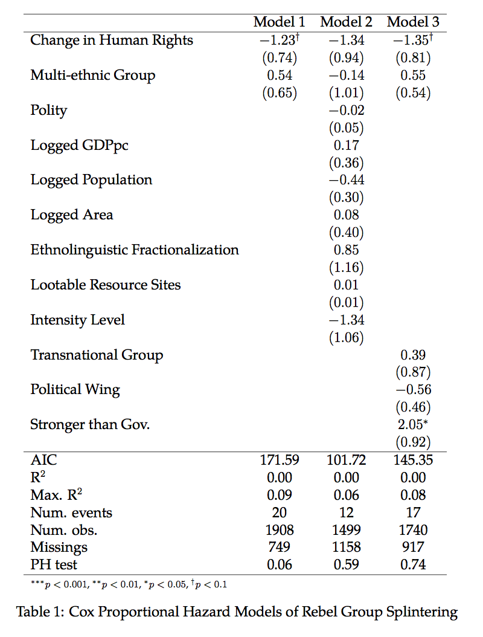

whether the relationship is confounded by the country-level covariates, or the change is the result of missing data on those variables.

The findings are thus mostly consistent with *H6*, though not as robust as most of the analyses in the preceding chapters. Several cases from the data clearly fit my theoretical framework. The Karenni ethnic group of Burma are close relatives of the Karen, and fought as members of the Karen National Union (KNU) for the first several years of Burmese independence. In 1957, however, the Karenni left the KNU to form their own rebel group, the Karenni National Progressive Party (KNPP). This case illustrates that splintering does not always lead to hostile relations between the formerly united groups, however, as the KNU strongly supported the KNPP's desire to pursue a separate Karenni state (Fredholm 1993). The Free Aceh Movement splintered from Darul Islam in Indonesia to pursue independence for the Acehnese people, rather than the Darul Islam's goals of an Islamic State in Indonesia. A review of the cases also suggests a possible explanation for the lack of robustness --- communist rebel groups are highly prone to fragmentation, and account for a large portion of the splinter organizations.

I find no support for *H7*, as the multi-ethnic variable never approaches statistical significance. As I discuss in the study of the Shan State independence movement later in this chapter, it is seemingly common for ethnically homogeneous groups to splinter. Only one control variable is significant --- the indicator of whether a rebel group is stronger than the government in Model 3. Being stronger than the government increases the risk of splintering by a factor of seven. This suggests that splintering has a strong strategic element. When rebels are weak and cannot afford any loss in capability, they hang together. When victory appears likely, however, they act on their internal differences, perhaps with an eye toward post-war bargaining.

In summary the results of this analysis are largely consistent with my broader theory, though not robust to the inclusion of country-level controls. I interpret the results as suggesting that ethnic polarization is a common pathway to splintering. It is not, however, the only pathway. Communist rebellions are prone to splintering along doctrinal lines, and splinter organizations often emerge late in conflicts to continue the fighting after the original organization ceases its activities.

### Splinter Group Ethnicity

*H8* predicts that splinter organizations should be more likely than others to draw their support from a single ethnic group. If splintering is fundamentally about reorganization along ethnic lines, it stands to reason that the leaders of splinter organizations should take only co-ethnics with them. I test this proposition in Table 2. I do not find support for *H8*, as splinter organizations are not likely than others (alliances and originating rebel groups constitute the baseline) to be ethnically-homogeneous. Splinter organizations also do not significantly differ in their probability of being multi-ethnic. I do find that splinter organizations are less likely less likely than others to have no ties to any ethnic group, with the effect being significant at the 95% level. This suggests that support from ethnic constituents might be an important factor in facilitating splintering. Factions that lack such support may be more likely to remain in the original rebel group, as they have less assurance of being able to acquire enough resources to be a viable independent group.

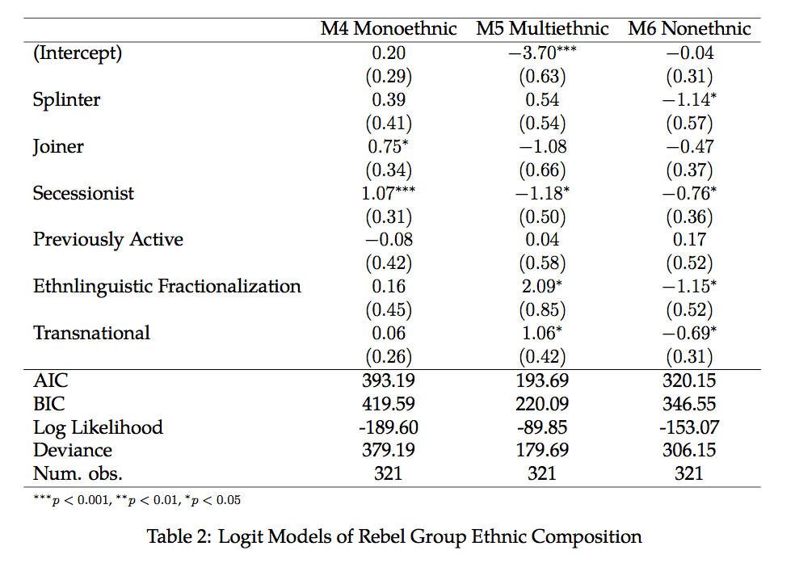

## Alliance Formation Results

The alliance formation results are reported in Table 3. Model 1 uses mono-ethnic alliances as the dependent variable, while Model 2 focuses on multi-ethnic alliances and Model 3 combines all alliances. In *H9* I predict that the probability of new ethnically homogeneous alliance will be greater following increases in repression. Consistent with this prediction, the "Change in Human Rights" variable has a strong negative relationship with the probability of new rebel group formation. A one-unit decrease in human rights (again, roughly the difference between France and Russia in recent years) more than triples the odds of a new rebel group forming. In the years following the largest declines in human rights practices (-2.5), the probability of a new mono-ethnic alliance is 0.21 (see Figure 1). When the change is zero or positive, the probability of such an alliance is around 0.01. This relationship is statistically significant at the 90% level. Given that the sample size is not especially small (n=1209), an $α$ of 0.1 might be considered overly permissive. However, no other variable is significant at even the 90% level, suggesting that even after applying the rare events correction the model has limited statistical power. Thus, I contend that it is reasonable to interpret relationships at this significance level, and reject the null hypothesis of no relationship between repression and the emergence of mono-ethnic rebel groups.

In Model 2 I do not find support for *H10*, as the relationship between "Change in Human Rights" and the probability of new multi-ethnic alliances does not approach statistical significance. While repression does not seem to deter this type of alliance as I expected,

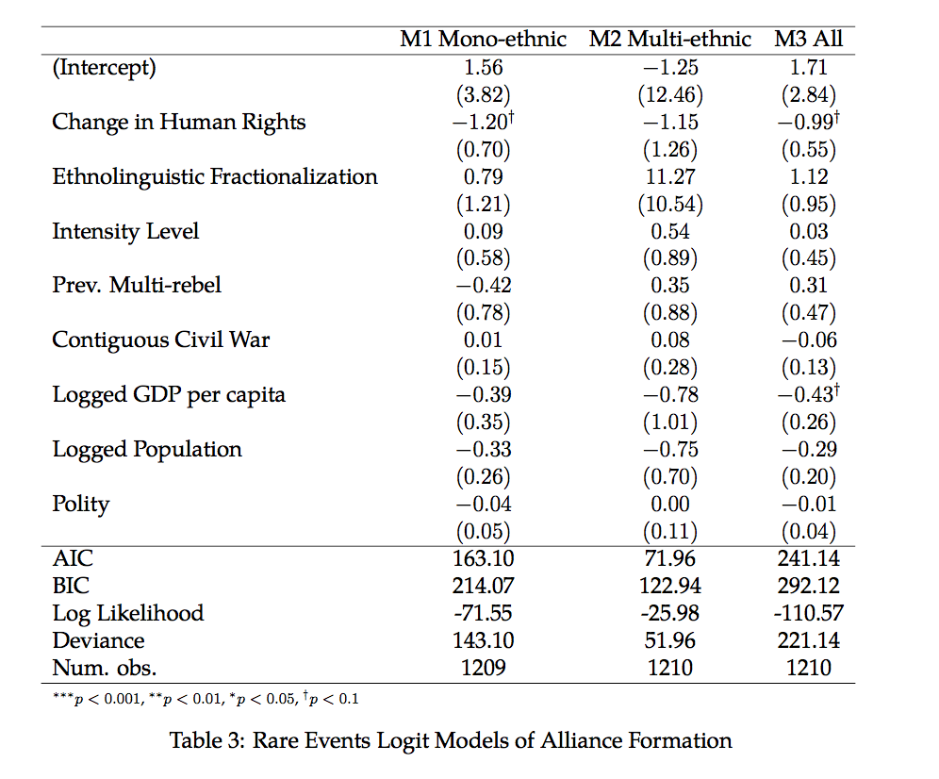

neither does it make them more likely. Thus while I find that repression is associated with a general increase in the probability of new alliances, the relationship seems to be driven by ethnically-homogeneous coalitions. The effect of repression seems to be specific to this type of alliance, rather than producing a general increase in the propensity to form coalitions.

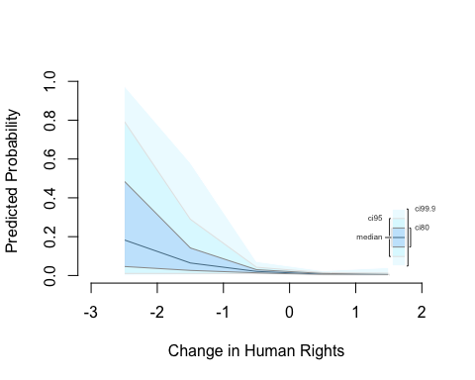

Figure 1 Predicted Probability of Mono-ethnic Alliance (Model 1)

The only statistically significant control variable in any of the three models is logged GDP per capita in Model 3. The relationship is negative, indicating that alliances are less common in wealthier countries. One possible explanation is that the variable is acting as a proxy for the intensity or spread of the conflict, capturing an attribute distinct from the binary measure of whether the conflict produced 1,000 fatalities. In cases such as Afghanistan where most of the country is consumed by war, the economy is likely to suffer. In cases where the fighting is more localized, such as Ukraine in recent years, there will not necessarily be a significant economic decline at the country level. The former situation might be more likely to have a plethora of rebel groups available to form alliances.

The findings in this section are broadly consistent with my theoretical framework. Increased repression is associated with higher probabilities of the formation of ethnically homogeneous alliances, which supports my expectation that repression triggers a cycle of realignment around ethnic identity. One case that is consistent with this story is the Uganda National Liberation Front. Uganda is among the most ethnically diverse societies on earth, with an ethnolinguistic fractionalization score indicating that there is nearly a 90% chance that two randomly selected individuals will be from different ethnic groups. A number of small rebel groups formed there in 1978 with the goal of overthrowing Idi Amin, to which the government responded with a substantial increase in repression (a change of -0.5 in the Latent Human Protection Scores). In early 1979, with help from the Tanzanian government, several ethnically Lango rebel groups responded by a forming an alliance, the Uganda National Liberation Front. A month later they successfully overthrew Amin. While numerous small rebel groups were active during this time (Lewis 2016), only the bloc of Lango groups was able to successfully form an alliance.

## The Shan Secessionist Movement

The Shan State secessionist movement in Burma includes cases that support both the splintering and alliance formation aspects of the analysis. Yet it has also seen many instances of splintering that my theory would not predict, suggesting additional variables for consideration. Shan State is a large, mountainous area in eastern Burma, bordering Thailand on the south, Laos on the east, and China on the north. The Shan people and language are both closely related to the Thai, and in pursuit of its historical rivalry with Burma the Thai government has frequently supported Shan rebellions to form a sort of buffer zone between the two countries (Steinberg 2010). Adding to the international character of the region are the facts that it has long been one of the world's most productive areas for opium cultivation, and that it was used as refuge by Kuomintang (KMT) forces fleeing China in the 1950's and 1960's (Cowell 2005). Shan State initially faced less repression than most other areas of the country, as it had been granted the right to secede in the Burmese Constitution (Silverstein 1958).

The initial formation of rebellion in Shan State is largely consistent with the process of group formation I discuss in Chapter ??, although there was not an ongoing conflict in the region. Following their defeat in the Chinese Civil War in 1950, a contingent of KMT soldiers fled into Shan in search of refuge. During the same period, the Communist Party of Burma and separatists from the Kachin region frequently used the area as a base of operations (Smith 1999). In hopes of defeating the Communists and Kachin, and expelling the KMT, the Burmese army sent a large troop deployment to the region in the late 1950's. These forces were undisciplined, however, and frequently committed abuses against the local population. These abuses induced a greater level of Shan nationalism as a basis for opposition to the occupation (Fredholm 1993, Ch. 8). The process of increased ethnic identification in this case is largely consistent with my theoretical argument. Shan elites, especially the leaders of student organizations, began developing and advocating for a distinctly Shan identity in the mid-1950's. Repression by the Burmese army significantly enhanced the efficacy of these appeals, leading large portions of the Shan to embrace ethnic nationalism (Fredholm 1993, 156--157). In 1958 this nationalism culminated in the formation of the first Shan rebel group, the Young Brave Warriors.

Shortly after the fighting began, the Young Brave Warriors splintered. A large portion of the group's membership joined the new Shan State Independence Army (SSIA). One factor in this move appears to be the fact that the SSIA was more explicitly nationalist than its predecessor (Brown 1988; Fredholm 1993, 156). While I expect ethnically-homogeneous groups such as the Young Brave Warriors to be more cohesive than multi-ethnic coalitions, these groups are still vulnerable to outbidding appeals. The Young Brave Warriors-SSIA split is consistent with my general argument that repression induces greater levels of ethnic identification, which in turn leads rebels to reorganize. It also suggests an explanation for my finding of no relationship between the ethnic composition of a rebel group and its risk of splintering --- even ethnically-homogeneous groups are at risk of splintering through an outbidding dynamic. Thus it may be the case that the null finding is the result not of multi-ethnic groups being cohesive, but rather of mono-ethnic groups being similarly fragile.

The Shan secessionist movement has also seen the creation of several alliances. Almost immediately upon splitting from the Young Brave Warriors, the students who from the SSIA welcomed a group of defectors from the Burmese Army (Fredholm 1993, 156). In 1964, the SSIA participated in a much larger merger with the Kokang Force and the Shan National United Front, forming the Shan State Army (SSA) (Lintner 1984). While the Kokang are often considered a separate ethnic group from the Shan, in my data they are coded as having no ties to an ethnic group. With the other two members being Shan, the SSA is coded as an instance of a new mono-ethnic alliance. Collectively, the various Shan organizations totaled no more than 8,000 members (Fredholm 1993, 158). Thus aggregating and coordinating capabilities was likely an important motive for the group leaders. The timing of the merger is also consistent with my theory. Burma's democratic regime fell to a military coup in 1962, two years prior to the formation of the SSA. While the Latent Human Protection Scores do not detect a sharp change perhaps due to a dearth of data sources in that period, the tactics used by the new military regime toward the various separatists were generally harsher than those of the previous regime (Charney 2009).

While the early years of the Shan independence movement provide strong support for my theory, the amount of subsequent splintering observed there surpasses what I would expect in an ethnically-homogenous movement. My data show that four distinct splinter organizations have appeared in the Shan conflict, and there were a number of other splinter organizations that did not produce enough fatalities to be included in the data (see Fredholm 1993). This contrasts with the Arakanese Buddhist movement discussed in Chapter ??, which never produced a splinter organization. Shan and Arakan are similar on many dimensions. Each is a mountainous region on the country's border, each is pursuing independence for a defined territory that largely maps to historical boundaries, and each is fighting the same Burmese government. That leaves two key differences. First, the Arakan separatist movement had its roots in the efforts to defeat the Japanese occupation during World War II, meaning that most of the dissident elites in the region were at one time members of the same political organization (the Anti-Fascist People's Freedom League [AFPFL]). These dissidents then launched a secessionist campaign almost simultaneously with Burmese independence. By contrast, elites in Shan state had been negotiating a peaceful path to independence during British rule, and were granted the right to pursue autonomy in the Burmese constitution (Charney 2009). Only after it became clear that the Burmese government would not allow a peaceful move toward independence in a timely fashion did the Shan rebel. As this occurred more than ten years after Burmese independence, the Shan dissident elite mostly lacked an existing social network. Staniland (2014) views pre-war social networks as the key to subsequent cohesion. Organizations that have strong ties both between elites and rank-and-file, and between different horizontally equal units should tend to avoid splintering, while others should be plagued by it. It is not clear, however, that the AFPFL meets this criteria. Steinberg (2010) describes it as a loose collection of political organizations and strong men unified only by their opposition to foreign occupation and left-of-center political views.

The second key difference between Shan and Arakan is the robust drug trade in the former. A major reason why the KMT selected Shan State as a base of operations was the opportunity to reap profits from the opium trade (Cowell 2005). After the KMT was forced out of the region, Shan rebels largely filled this role. The emergence of at least one of the splinter organizations in the conflict is clearly related to the drug trade. The Shan United Revolutionary Army split from the SSA to focus on controlling drug production, rather than political goals. While I include a measure of lootable resources in my quantitative analyses which is not significant, the Shan case suggests that under certain conditions resources can provoke splintering.

## Conclusion

In this chapter I test whether my theory extends to the realignment of existing rebels. As they often depend heavily on them for material, rebels should respond to the increased ethnic identification of dissident civilians in the wake of repression. Repression should be associated with increased instances of both splintering and alliance formations, as rebels reorganize around ethnic identity.

Due in part to the rarity of both categories of events, the statistical results in this chapter are not as robust as in previous chapters. Still, the findings are consistent with the theory that repression triggers a cycle of reorganization around ethnic identity among rebels. I find that repression substantially increases the probability that existing rebel groups will splinter, as I predict in *H6*. Contrary to my expectation in *H7*, however, multi-ethnic groups are not more prone to this phenomenon than others. I also do not find support for *H8*, which predicts that splinter organizations should be likelier than others to draw support from a single ethnic group. A qualitative analysis of the Shan separatist movement in Burma suggests that my proposed mechanism does occur. However, it appears that there are other pathways to splintering that my current set of control variables do not capture. The results in my analysis of alliance formation are somewhat more favorable to my theory. Consistent with *H9*, I find that repression is associated with an increased probability of new mono-ethnic alliances. While I do not find the hypothesized negative relationship between repression and multi-ethnic alliances (*H10*), the relationship is null, suggesting that the two categories of alliances do emerge from different processes.

These results suggest that repression can trigger a realignment of existing rebel organizations around ethnic identity, though the robustness of the results is limited by the fact that both splintering and alliance formation are rare outcomes, and several other pathways to these outcomes appear to exist. Still, my proposed causal chain in this portion of the theory is rather long, with rebels responding to the way in which civilians respond to repression. To find significant results at all is perhaps surprising. Especially counterintuitive is the fact that both splintering and certain types of alliance formation are both related to repression. This suggests that repression does not necessarily alter the aggregate number of rebel groups in a conflict, but does reconfigure them. This contrasts with existing conceptions of rebel movement structure, which tend to view conflicts as trending consistently toward greater fragmentation or greater integration of rebels, but not both simultaneously (e.g. Kalyvas 2006; McLauchlin and Pearlman 2012).

# References

Balestri, Sara. 2012. “Gold and Civil Conflict Intensity: evidence from a spatially disaggregated analysis.” *Peace Economics, Peace Science and Public Policy* 18 (3): 1–17. doi:[10.1515/peps-2012-0012](https://doi.org/10.1515/peps-2012-0012).

Brown, David. 1988. “From Peripheral Communities to Ethnic Nations: Separatism in Southeast Asia.” *Pacific Affairs* 61 (1). Pacific Affairs, University of British Columbia: 51. doi:[10.2307/2758072](https://doi.org/10.2307/2758072).

Buhaug, Halvard, and Päivi Lujala. 2005. “Accounting for scale: Measuring geography in quantitative studies of civil war.” *Political Geography* 24 (4): 399–418. doi:[10.1016/j.polgeo.2005.01.006](https://doi.org/10.1016/j.polgeo.2005.01.006).

Charney, Michael W. 2009. *A history of modern Burma*. Cambridge: Cambridge University Press.

Christia, Fotini. 2012. *Alliance Formation in Civil Wars*. Cambridge: Cambridge University Press.

Cowell, Adrian. 2005. “Opium Anarchy in the Shan State of Burm.” In *Trouble in the Triangle: Opium and Conflict in Burma*, edited by Martin Jensen, Tom Kramer, and Pietje Vervest, 1–22. Chiang Mai, Thailand: Silkworm Books.

Cunningham, David E., Kristian Skrede Gleditsch, and Idean Salehyan. 2009. “It Takes Two: A Dyadic Analysis of Civil War Duration and Outcome.” *Journal of Conflict Resolution* 53 (4): 570–97.

Fariss, Christopher J. 2014. “Respect for Human Rights has Improved Over Time: Modeling the Changing Standard of Accountability.” *American Political Science Review* 108 (2): 297–318.

Fearon, James D., and David D. Laitin. 2003. “Ethnicity, Insurgency, and Civil War.” *American Political Science Review* 97 (1): 75–90.

Fredholm, Michael. 1993. *Burma: Ethnicity and Insurgency*. London: Praeger.

Gibler, Douglas M. 1996. “Alliances That Never Balance: The Territorial Settlement Treaty.” *Conflict Management and Peace Science* 15 (1): 75–97.

Gilmore, Elisabeth, Nils Petter Gleditsch, Päivi Lujala, and Jan Ketil Rød. 2005. “Conflict Diamonds: A New Dataset.” *Conflict Management and Peace Science* 22 (3). Taylor & Francis Group: 257–72.

Gleditsch, Kristian Skrede. 2002. “Expanded trade and GDP data.” *Journal of Conflict Resolution* 46 (5): 712–24.

Horowitz, Donald L. 1985. *Ethnic Groups in Conflict*. Berkeley, CA: University of California Press.

Kalyvas, Stathis N. 2006. *The Logic of Violence in Civil War*. Cambridge: Cambridge University Press.

King, Gary, and Langche Zeng. 2001. “Logistic Regression in Rare Events Data.” *Political Analysis* 9 (2): 137–63.

Lewis, Janet I. 2016. “How Does Ethnic Rebellion Start ?” *Comparative Political Studies*, forthcoming.

Lintner, Bertil. 1984. “The Shans and the Shan State of Burma.” *Contemporary Southeast Asia* 5 (4): 403–50.

Lujala, Päivi. 2008. “Deadly Combat over Natural Resources: Gems, Petroleum, Drugs, and the Severity of Armed Civil Conflict.” *Journal of Conflict Resolution* 53 (1): 50–71. doi:[10.1177/0022002708327644](https://doi.org/10.1177/0022002708327644).

Lujala, Päivi, Nils Petter Gleditsch, and Elisabeth Gilmore. 2005. “A Diamond Curse?: Civil War and a Lootable Resource.” *Journal of Conflict Resolution* 49 (4): 538–62.

Lujala, Päivi, Jan Ketil Rød, and Nadja Thieme. 2007. “Fighting over Oil: Introducing a New Dataset.” *Conflict Management and Peace Science*, August. Taylor & Francis Group.

Marshall, Monty G., Ted Robert Gurr, and Keith Jaggers. 2016. “Polity IV Project Dataset Users’ Manual, v.2015.” *Polity IV Project*, 1–86.

McLauchlin, T., and W. Pearlman. 2012. “Out-Group Conflict, In-Group Unity?: Exploring the Effect of Repression on Intramovement Cooperation.” *Journal of Conflict Resolution* 56: 41–66. doi:[10.1177/0022002711429707](https://doi.org/10.1177/0022002711429707).

Melander, Erik, Therése Pettersson, and Lotta Themnér. 2016. “Organized violence, 1989–2015.” *Journal of Peace Research* 53 (5): 727–42.

Schnakenberg, Keith E., and Christopher J. Fariss. 2014. “Dynamic Patterns of Human Rights Practices.” *Political Science Research and Methods* 2 (1): 1–31.

Silverstein, Josef. 1958. “Politics in the Shan State: The Question of Secession from the Union of Burma.” *Source: The Journal of Asian Studies* 18 (1): 43–57.

Smith, Martin. 1999. *Burma: Insurgency and the Politics of Ethnicity*. London: Zed Books Ltd.

Staniland, Paul. 2014. *Networks of Rebellion: Explaining Insurgent Cohesion and Collapse*. Ithaca, NY: Cornell University Press.

Stedman, Stephen John. 1997. “Spoiler Problems in Peace Processes.” *International Security* 22 (2): 5.

Steinberg, David I. 2010. *Burma/Myanmar: What Everyone Needs to Know*. New York: Oxford University Press.

The World Bank. 2015. “World Development Indicators.” Washington D.C.: The World Bank.

Uppsala Conflict Data Program. 2015. “UCDP Actor Dataset 2.2-2015.” Uppsala University.

Vogt, Manuel, Nils-Christian Bormann, Seraina Ruegger, Lars-Erik Cederman, Philipp Hunziker, and Luc Girardin. 2015. “Integrating Data on Ethnicity, Geography, and Conflict: The Ethnic Power Relations Data Set Family.” *Journal of Conflict Resolution* 59 (7): 1327–42.

Wucherpfennig, Julian, Nils W. Metternich, Lars-Erik Cederman, and Kristian Skrede Gleditsch. 2011. “Ethnicity, the State, and the Duration of Civil War.” *World Politics* 64 (1): 79–115.

1. The UCDP Actor data (Uppsala Conflict Data Program 2015) does identify splinter groups, but uses very conservative coding rules that exclude many clear examples of splinter.