AFE-N2N

Portfolio Analysis


Prepared by AFE-N2N Client Service Group
Prepared for Jane Jones
Report Generated on: 2024-10-03
Analysis as of: 2024-10-03

Table of contents

Table of contents 2
Executive Summary 4
Performance Analysis 5
Market Risk 8
Liquidity Risk 9
Concentration Risk 10
Correlation risk 12
Tail Risk 13
Related Notification Announcement Notice: 14

Executive Summary

This report helps you better understand the risks within your portfolios held at AFE-N2N and at other financial institutions which you may have shared with us. This report presents portfolio characteristics, as well as estimates of portfolio volatility and stress test results. The report estimates volatility by analyzing the positions in your portfolio. Commonly, the higher the volatility, the riskier is the security or portfolio. Stress testing is available to illustrate how your portfolio might react under a certain market scenario or set of events.
The purpose of the Suitability Benchmark is to assist you in understanding the risk in your portfolio referenced in this report against your stated risk profile. The Suitability Benchmark may be different than the one used to compare your portfolio performance.
The Report allows you to review and compare the results of the Risk Analysis of your Current Portfolio against a Suitability Benchmark, and hypothetical Alternate Portfolio, if depicted, of positions that you may or may not own, or may not own in the same quantities. The Alternate Portfolio, if depicted in this report, including the asset allocation and particular securities in the Alternate Portfolio, are hypothetical illustrations only.
AFE-N2N is not recommending that you adopt the hypothetical Alternate Portfolio shown in this Report or any of its components. Rather, we are presenting it so that you have a basis for comparison when you consider the risk characteristics of your current holdings. After discussing with you the analyses in this Report, and your ability and willingness to take risk, your Financial Advisor can work with you to construct a portfolio that meets your needs.
The Hypothetical Results Illustrated in this Report for Your Current Portfolio and/or Alternate Portfolio are not and should NOT be construed as a guarantee of future performance. The factor models used to generate these results may contain errors or faulty assumptions.
Please refer to the Important Disclosures and Glossary at the end of this Report for additional information, including a description of the assumptions and methodologies used throughout and definitions of key terminology.

Performance Analysis
Asset Allocation
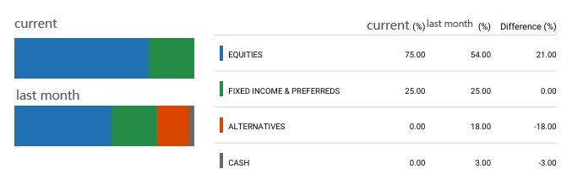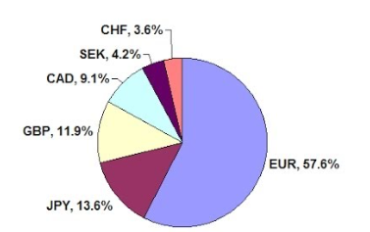

Holding
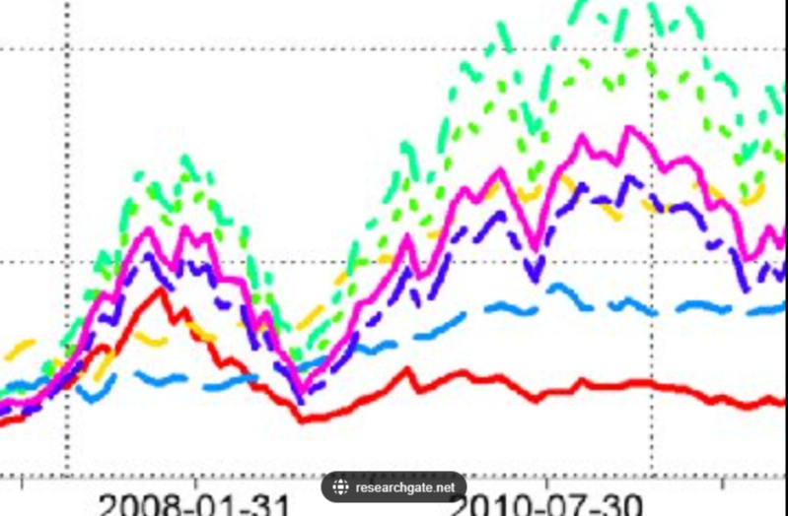

 | Percentage (current) | Contribution (1 Mo) | Maximum Drawdown (1 mo) | Volatility (1 Mo)
Portfolio | 100% | 100%
Tencent | 20% | 110%
CAD | 70% | -5%
10-year US Treasure | 10% | -5%

 | Percentage (3 mo) | Contribution (3 Mo) | Maximum Drawdown (3 mo) | Volatility (3 Mo)
Portfolio | 100% | 100%
Tencent | 20% | 110%
CAD | 70% | -5%
10-year US Treasure | 10% | -5%

 | Percentage (6 mo) | Contribution (6 Mo) | Maximum Drawdown (6 mo) | Volatility (6 Mo)
Portfolio | 100% | 100%
Tencent | 20% | 110%
10-year US Treasure | 10% | -5%

Market Risk

 | VaR(value at risk) | Standard Deviation | Risk Contribution | cVaR (alpha=0.5)
Portfolio
Tencent
10-year US Teasury

Portfolio Last 5 each year hypothetical performance simulated Global historical Scenarios:
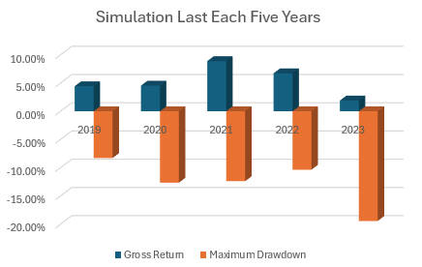

Liquidity Risk

 | ADTV | Holding | Holding/ADTV
Tencent | 19,912,536 | 2000 | 0.010%
10-year US Teasury

Concentration Risk
Equity Allocation by Sector
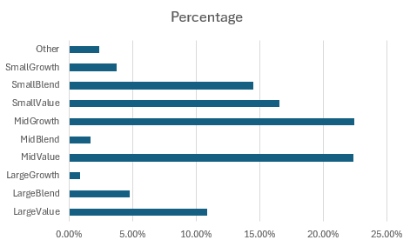
Equity Allocation by Categories
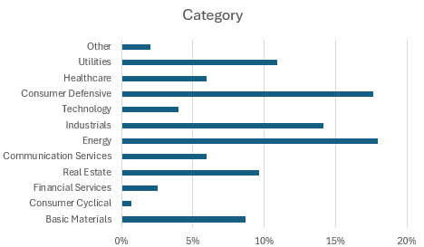

Fixed Income Allocation by Credit Quality
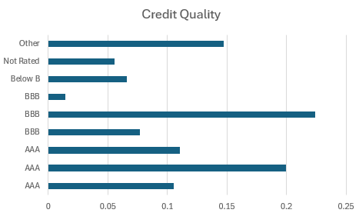
Dear Client, Your holding contains certain sectors taking up more than 20%. Mid growth and mid value sectors 22% and 21.7%. You should pay more attention to these sectors.

Correlation and tail risk
Linear Correlation:
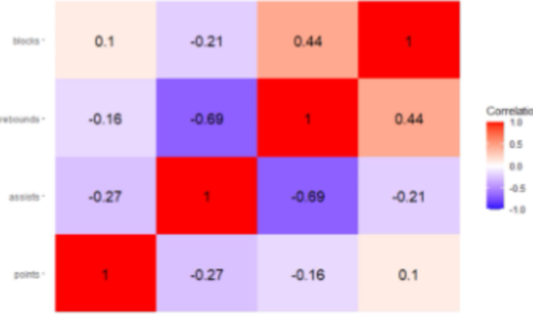

Tencent and Meituan in your portfolio are highly related (over 0.8 in Spearman correlation). You should pay more attention to this pair of investments.
We analyzed historical data on your investments to identify extreme losses and fitted an EVT model to predict potential future tail risks. Your holding Tencent and Meituan may drop sharply due to high tail risk. You may consider reduce exposure on these stocks.
(High concentration investment poses several disadvantages, including increased risk due to greater volatility and exposure to company-specific events. It lacks diversification, leading to higher unsystematic risk, and can reduce flexibility in capturing broader market opportunities. Such portfolios may face liquidity issues, making it difficult to sell large positions quickly. Additionally, investors might develop emotional biases towards their holdings, affecting decision-making. Balancing concentration with diversification is essential to mitigate these risks effectively.)
(Extreme Value Theory helps us understand the behavior of extreme events in financial markets. It focuses on the tails of the distribution, where rare but impactful losses occur.)

Related Notification Announcement Notice:

