elibrary
© 2000 – 2004 David Bracewell

Table of Contents

1. QuickStart 1
2. Configuring Options 2
2.1 General Settings 2
2.2 HTML Settings 3
2.3 Reader Settings 4
3 Searching for Books 5
4. How Do I???? 5
4.1 Change my server 5
4.2 Download a book list 5
4.3 Download a book 5
4.4 Print a book 6
4.5 Import books 6
5. Troubleshooting 6

1. QuickStart
The steps in getting eLibrary up and running are...
    - Install
    - Setup server
    - Download the book list

To install eLibrary simply run the Setup.exe and follow the instructions. After you install eLibrary you should find a shortcut to the application in your start menu under programs -> eLibrary. Startup eLibrary and then click on the view menu and then on options. Consult section 2. Configuring Options for information on server settings. After setting up the server click on the File menu and then on Download Book List. Depending on your connection this can take a couple of minutes. After the book list loads you are ready to download books!!

2. Configuring Options

2.1 General Settings

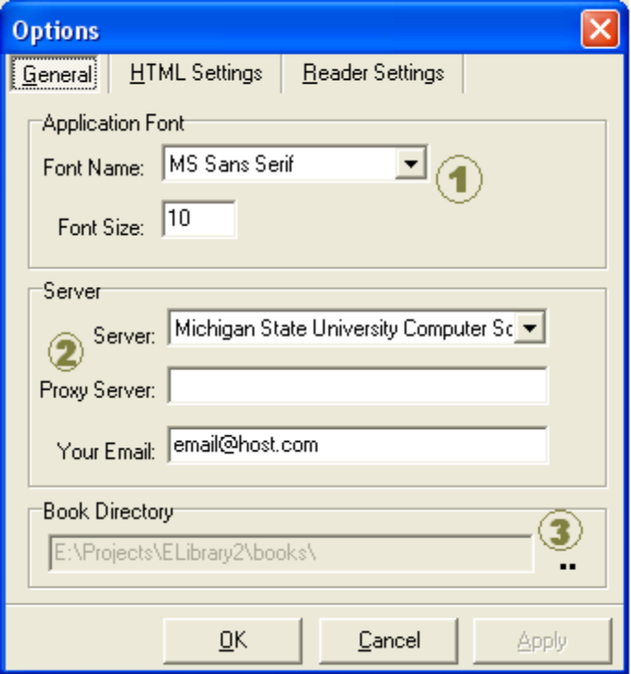
- Application Font Settings - This is the font and size of font for the different lists (book list, search list, My Library list) in eLibrary
- Server Settings
  - Server – The server you want to connect to for downloading books and book lists
  - Proxy Server – If you use a proxy server put it here otherwise leave it blank.
  - Your Email – Most anonyomous FTP sites ask that you use your email address as a password. However it is not needed.
- Book Directory – This is the folder that your downloaded books will be stored in. (You may want to create a My Books folder under My Documents for this)

2.2 HTML Settings

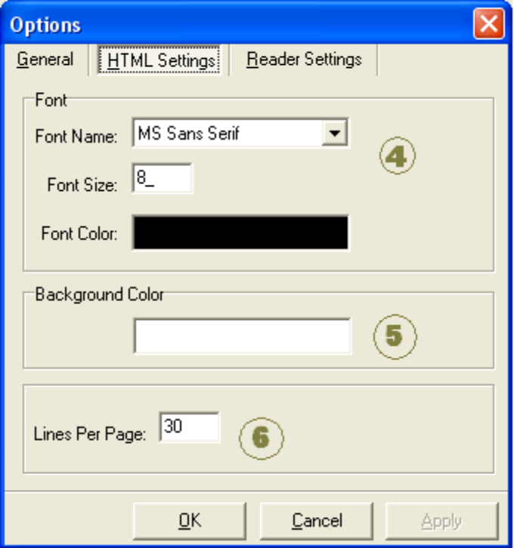
- HTML Font Settings - This box contains settings for font name, size, and color for when you export a book to a html file.
- Background Color – This is the background color of the created html pages.
- Lines Per Page – The number of lines of text to have per page.

2.3 Reader Settings

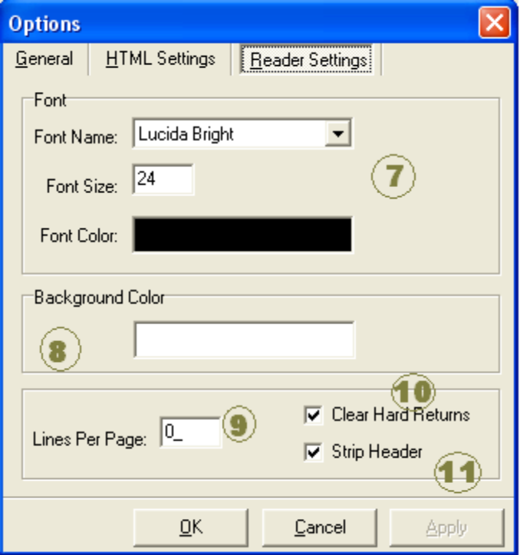
- Reader Font Settings - This box contains settings for font name, size, and color for the built in book reader
- Background Color – This is the background color of the built in book reader.
- Lines Per Page – The number of lines of text to have per page. If this number is set to 0 then the program will determine the best lines per page for full screen viewing and open all books in full screen mode.
- Clear Hard Returns – This attempts to make the paragraphs easier to read.
- Strip Header – Every Gutenberg book has a header at the beginning of it. If this option is checked the header will be stripped and displayed and then you can read the book. Otherwise, it will remain as a part of the book.

3 Searching for Books

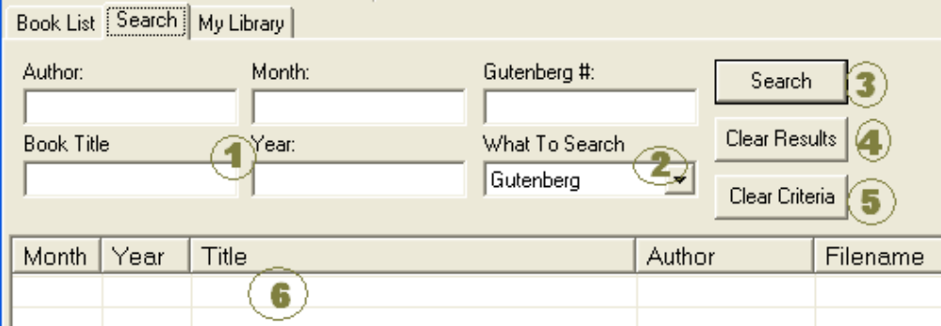
- You can search by Author, Book Title, Month, Year, and Gutenberg Number. The search is not case sensitive.
- In the What to Search drop down you can choose to search Gutenberg (the book list you downloaded) or your My Library.
- Search – Performs the search.
- Clear Results – Clears any previous search results.
- Clear Criteria – Clears any of the search information you entered
- Search Results – This list shows the result of your search. Depending on if you searched Gutenberg or My Library you can do different tasks with the books.

4. How Do I????

4.1 Change my server
Click on the View menu then on options. The server settings are under the general tab use the drop down box to change the server.

4.2 Download a book list
With the book list or search tab selected you can do one of the following...
    - Click on the File menu and then click on Download Book List
    - Use the keyboard shortcut Ctrl + D

4.3 Download a book
With the search or My Library tab selected and the book you want to download selected you can...
    - Double click on the book
    - Right click and choose download book
    - Click on the File menu and then click on Download Book
    - Use the keyboard shortcut Ctrl+B

4.4 Print a book
Select the My Library tab and then select the book you wish to print. Then click on the My Library menu and choose print.

4.5 Import books
To import Gutenberg books simply copy them to your book directory specified in the options and restart eLibrary.
4.6 Adding Servers
In the folder you installed eLibrary into there is a text file called servers.txt. This file has the following format..

# of servers
1st Server name
1st Server address
1st Server path to Gutenberg

You can edit this file in notepad or any other text editor. To add a server change the first line of the file to that number + 1. For example, if it had a 5 (meaning currently there are 5 servers) replace it with a 6. Then at the end of the file add your server. Make sure you add all 3 rows (name, address, path). You can find new servers on Project Gutenberg's website http://www.promo.net/pg/ under FTP Sites.

5. Troubleshooting
Q: I am unable to download a book list or any books what can I do?
A: Be sure to try all the servers that are listed. If you are unable to connect to any server then try again later or read section 4.5 Adding Servers. The author of this software is not in charge of any of the servers that mirror the Gutenberg archive.

Q: When I try to open book xxx I get an error message.
A: If this happens go to the options and uncheck Strip Headings.

