For getting data from jsp pages we have 4 options:

1)httpServletRequest

2)@Requestparam

3)@PathVariable

4)@modelAttribute

@RequestParam

This annotation is used to annotate request handler method arguments. Sometimes you get the parameters in the request URL, mostly in GET requests. In that case, along with the @RequestMapping annotation, you can use the @RequestParam annotation to retrieve the URL parameter and map it to the method argument. The @RequestParam annotation is used to bind request parameters to a method parameter in your controller.

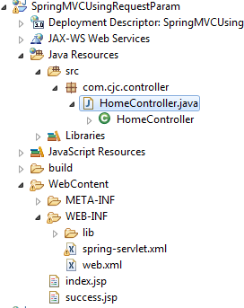

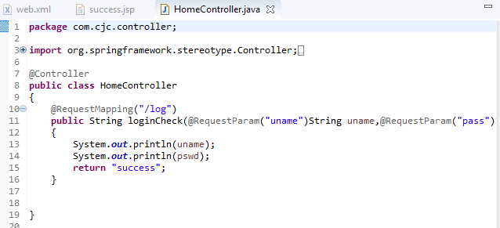

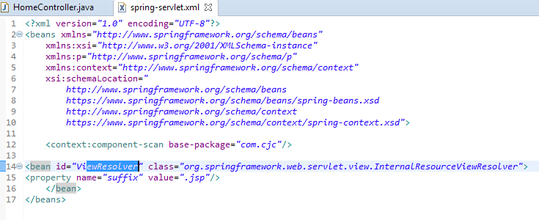

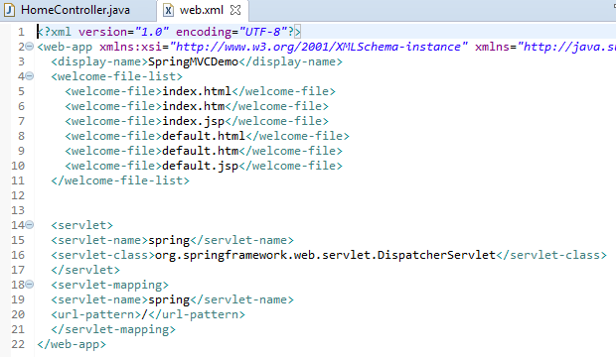

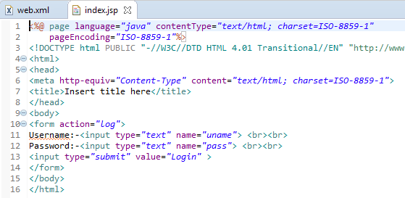

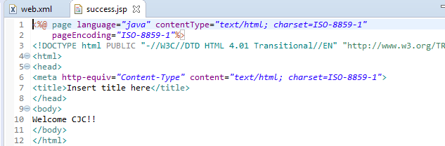

OutPut:

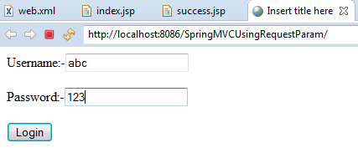

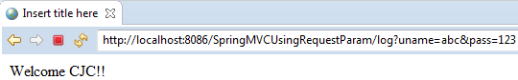

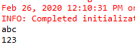

@PathVariable

This annotation is used to annotate request handler method arguments. The @RequestMapping annotation can be used to handle dynamic changes in the URI where a certain URI value acts as a parameter. You can specify this parameter using a regular expression. The @PathVariable annotation can be used to declare this parameter.

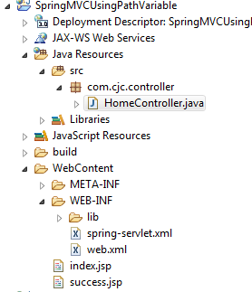

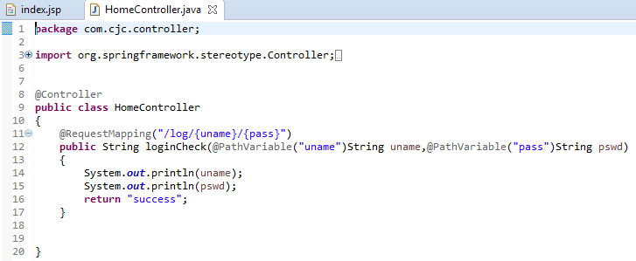



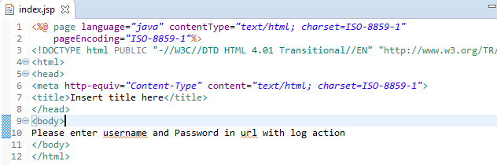



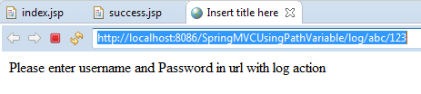



@modelAttribute:

When used as a method argument, it indicates the argument should be retrieved from the model. When not present, it should be first instantiated and then added to the model and once present in the model, the arguments fields should be populated from all request parameters that have matching names.

 The annotation works only if the class is a Controller class (i.e. annotated with @Controller).

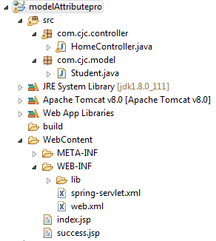

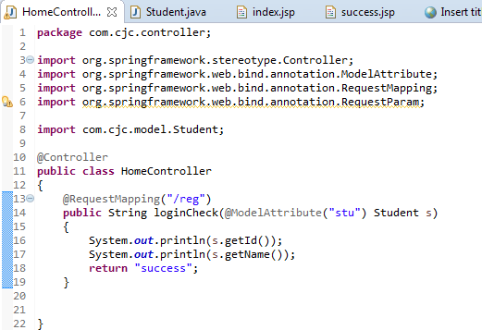

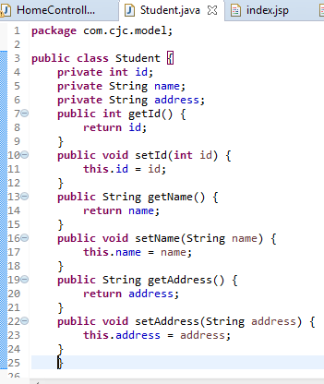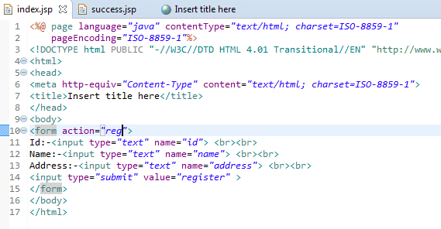

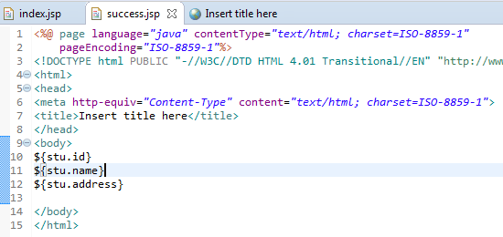





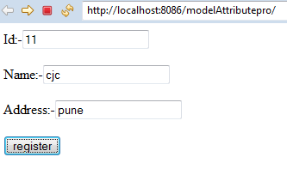

After register data will go to controller and also to success page

