**Summary Statistics**

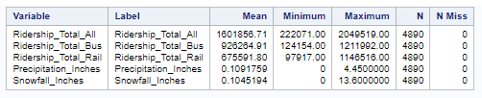

**Histogram for Ridership_Total_Bus Variable**

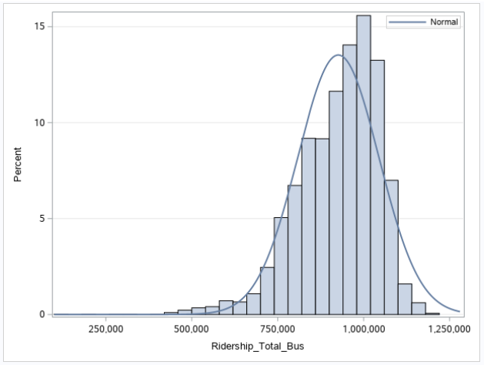

**Histogram for Ridership_Total_Rail Variable**

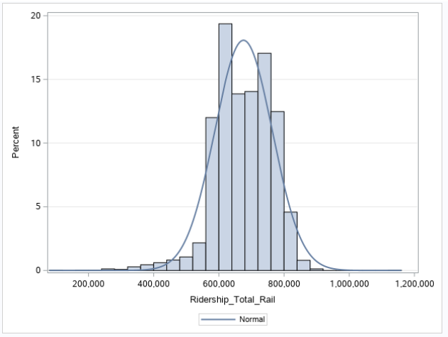

**Histogram for Precipitation_Inches Variable**

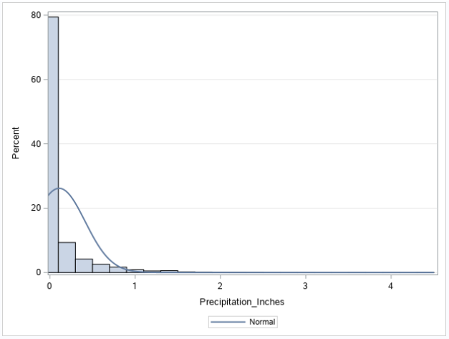

**Histogram for Snowfall_Inches Variable**

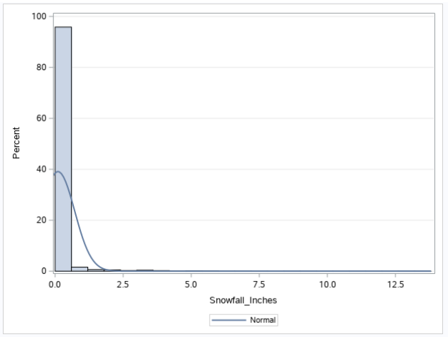

**RQ1: Scatter Plot of Correlation between Precipitation_Inches and Ridership_Total_All**

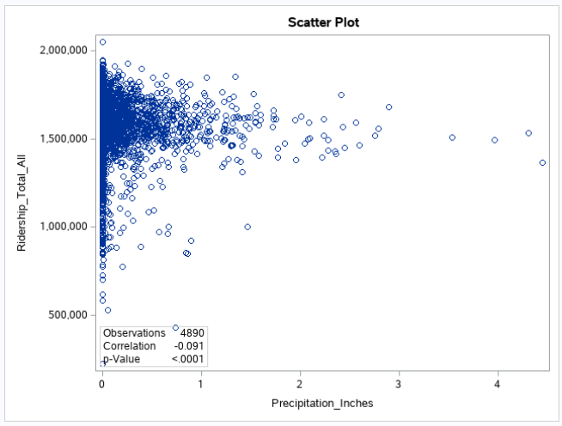

**RQ2: Scatter Plot of Correlation between Precipitation_Inches and Ridership_Total_Bus**

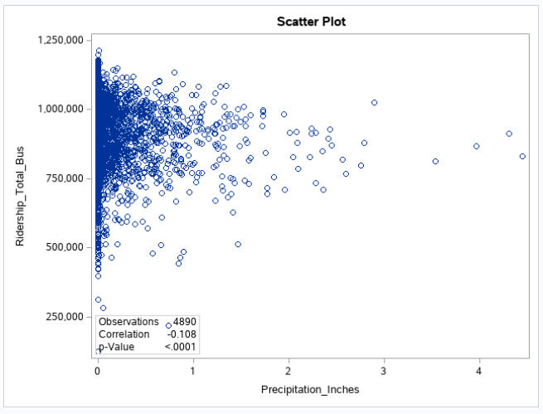

**RQ3: Scatter Plot of Correlation between Precipitation_Inches and Ridership_Total_Rail**

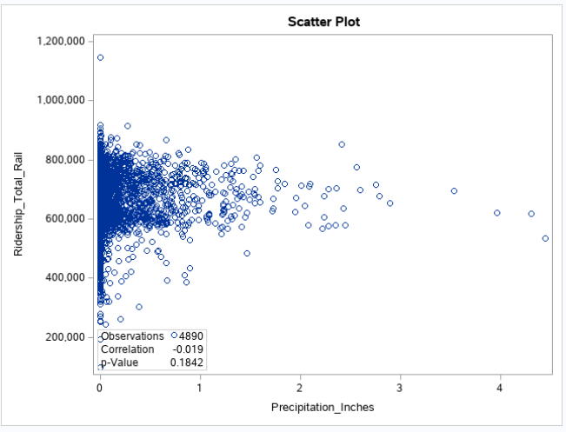

**RQ4: Scatter Plot of Correlation between Snowfall_Inches and Ridership_Total_All**

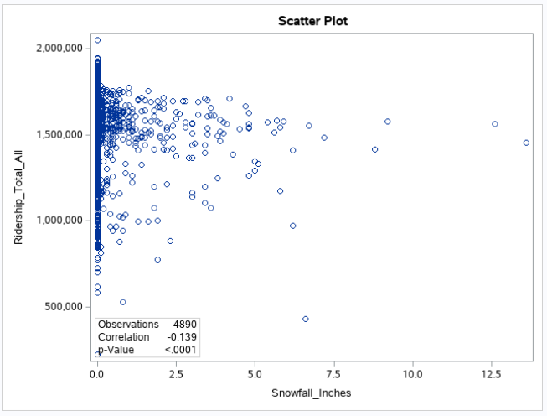

**RQ5: Scatter Plot of Correlation between Snowfall_Inches and Ridership_Total_Bus**

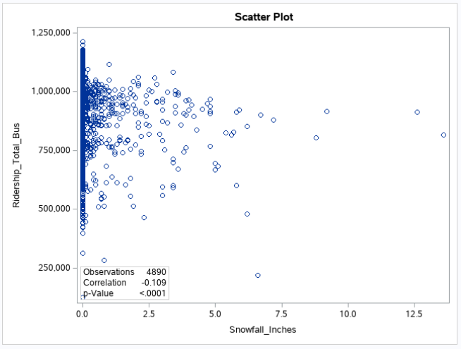

**RQ6: Scatter Plot of Correlation between Snowfall_Inches and Ridership_Total_Rail**

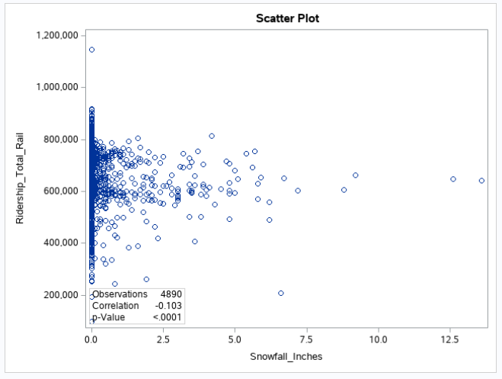

### end of outputs ###