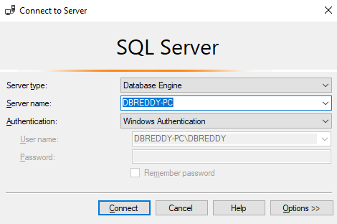

select * from sys.databases;

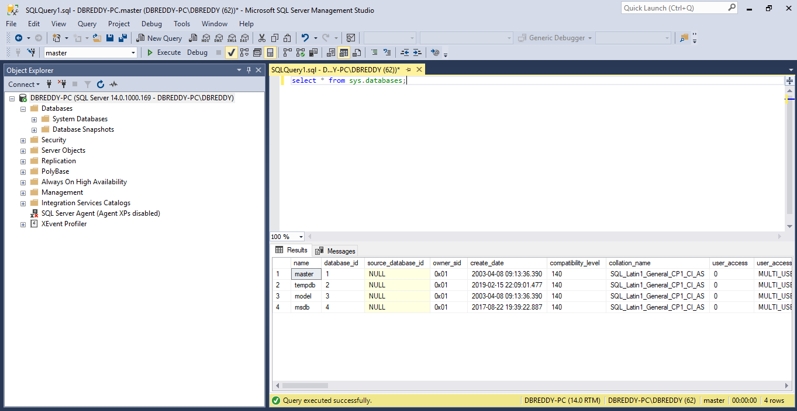

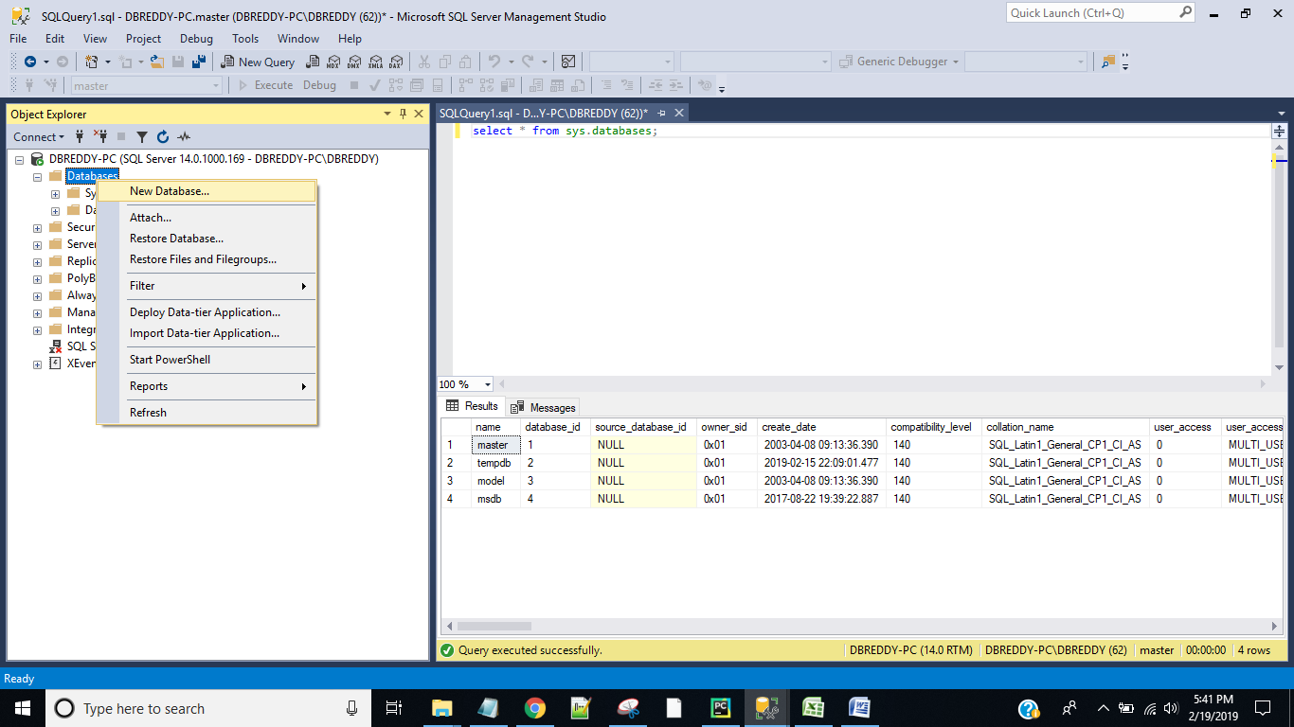

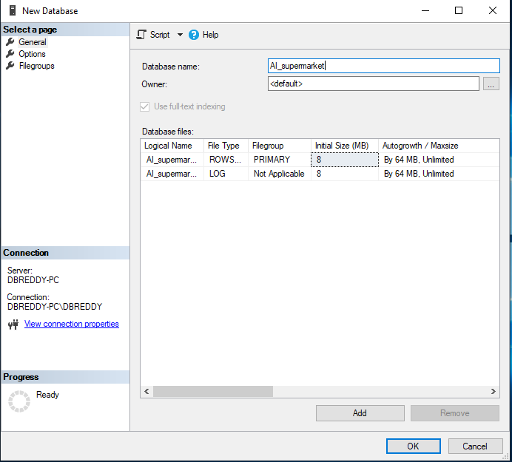

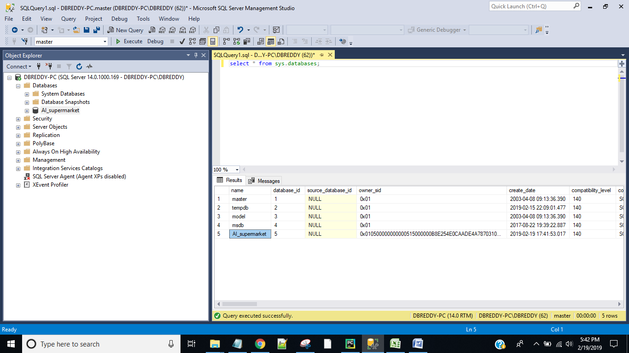

select * from sys.databases WHERE name NOT IN ('master', 'tempdb', 'model', 'msdb');

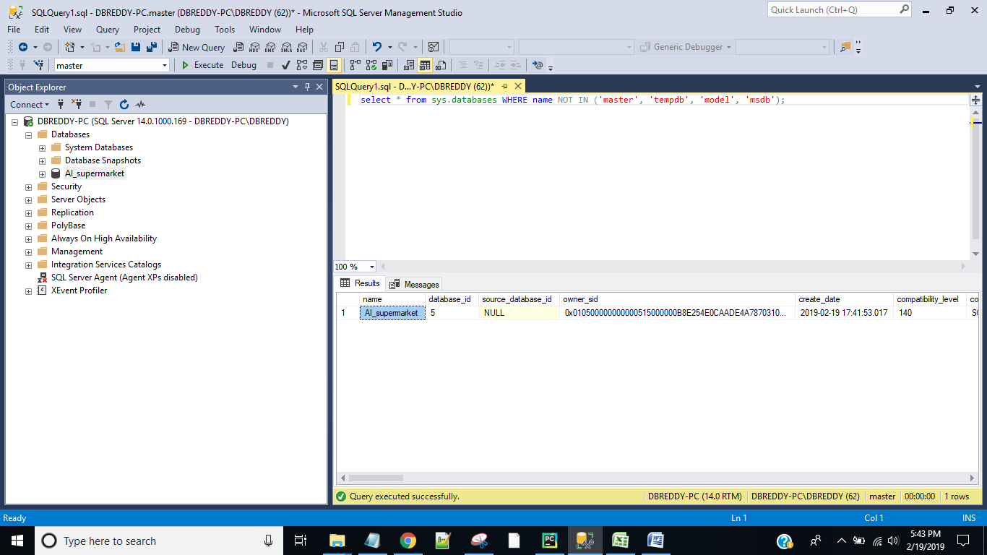

use AI_supermarket;

SELECT * FROM sys.Tables;

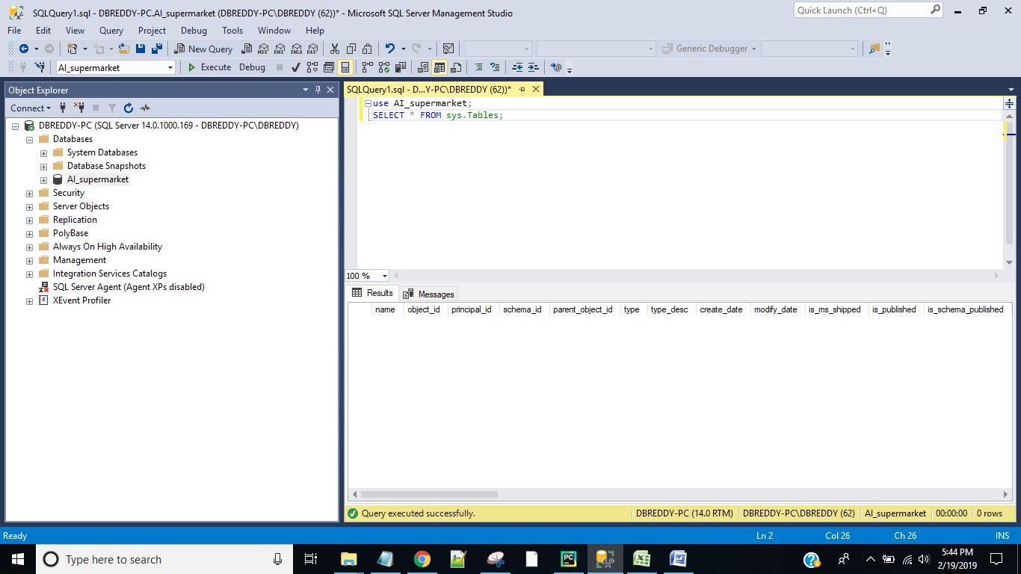

CREATE TABLE dbo.sales_daily

(sale_category_id int PRIMARY KEY NOT NULL,

vegetables_fruits_kgs int NOT NULL,

home_kitchen_items int NOT NULL,

breakfast_dairy_units int NOT NULL,

beverages_units int NOT NULL,

personal_care_items int NOT NULL,

grocery_staples_units int NULL,

baby_kids_items int NOT NULL,

furnishing_homeneeds_units int NOT NULL);

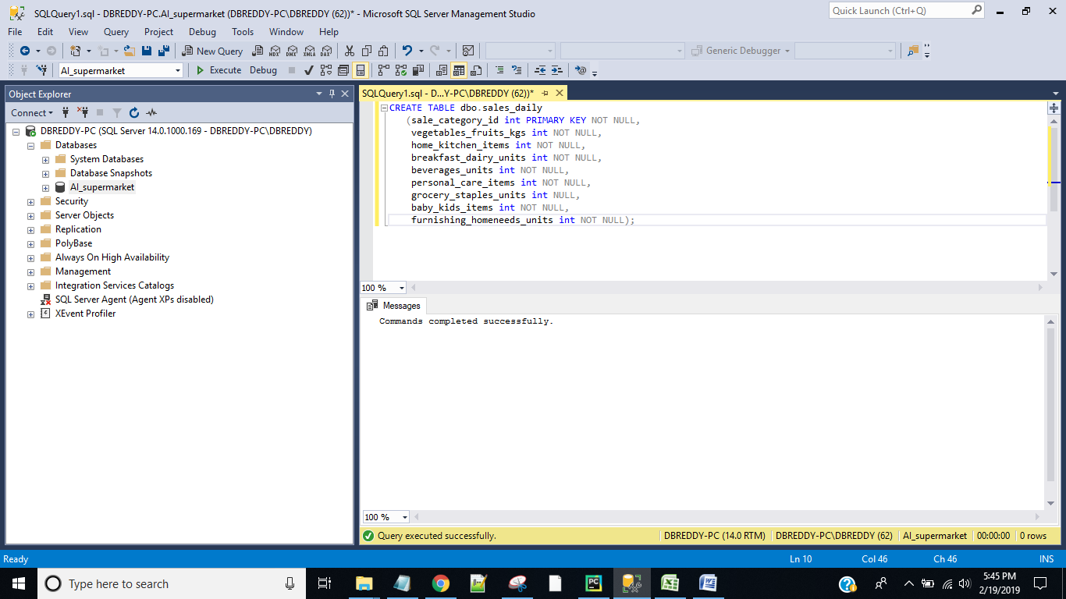

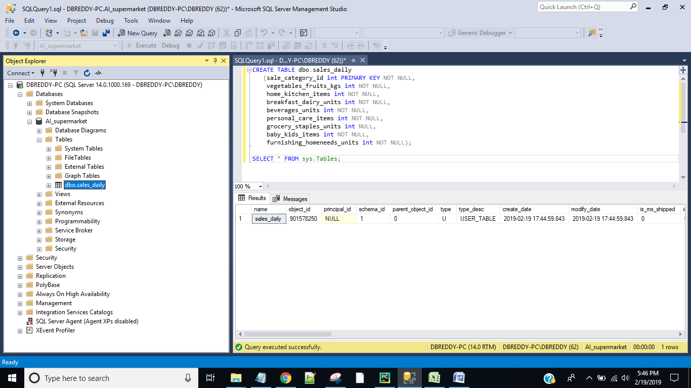

INSERT dbo.sales_daily(sale_category_id, vegetables_fruits_kgs, home_kitchen_items, breakfast_dairy_units, beverages_units, personal_care_items, grocery_staples_units, baby_kids_items, furnishing_homeneeds_units)

VALUES (20190219, 25, 30, 45, 65, 34, 21, 47, 32) ,(20180219, 205, 320, 445, 615, 324, 211, 427, 312),(20170219, 295, 370, 465, 655, 344, 221, 477, 323);

