**Splunk and AppDynamics: Better Together**

With applications front-and-center of many enterprises’ digital transformation, thousands of Splunk customers around the globe use Splunk to collect, index and analyze their machine data so they can prevent application failures and troubleshoot problems quickly when they occur. Many of those same Splunk customers are also using AppDynamics to provide in-depth code-level visibility into applications. Combined, Splunk integrated with AppDynamics provides a COMPLETE view of how your applications are performing and enables you to [take a platform approach to application management.](https://www.splunk.com/en_us/solutions/solution-areas/it-operations-management/the-new-it.html)

**Overview**

The Splunk App and Add-on for AppDynamics uses AppDynamic’s REST APIs to gather data from the applications you are monitoring. This data can then be combined with all your other machine data in Splunk (wire data, log data, server data, and other infrastructure sources) to provide a complete picture of your applications’ performance.

Install the Add-on, supply your AppDynamics collector details and an authorization token and you will have access to metrics for your web applications, mobile applications, business transactions and health rule violations right inside of Splunk. Install the App to access a comprehensive set of visualization within Splunk. This application provides a set of dashboards and takes advantage of Splunk’s built-in machine learning algorithms to predict future values of metrics providing the ability to forecast potential problems BEFORE they occur. APM is a great source of data for your IT Troubleshooting and Monitoring needs and this application will enable you to easily correlate your AppDynamcis data with all other data sources ingested in Splunk.

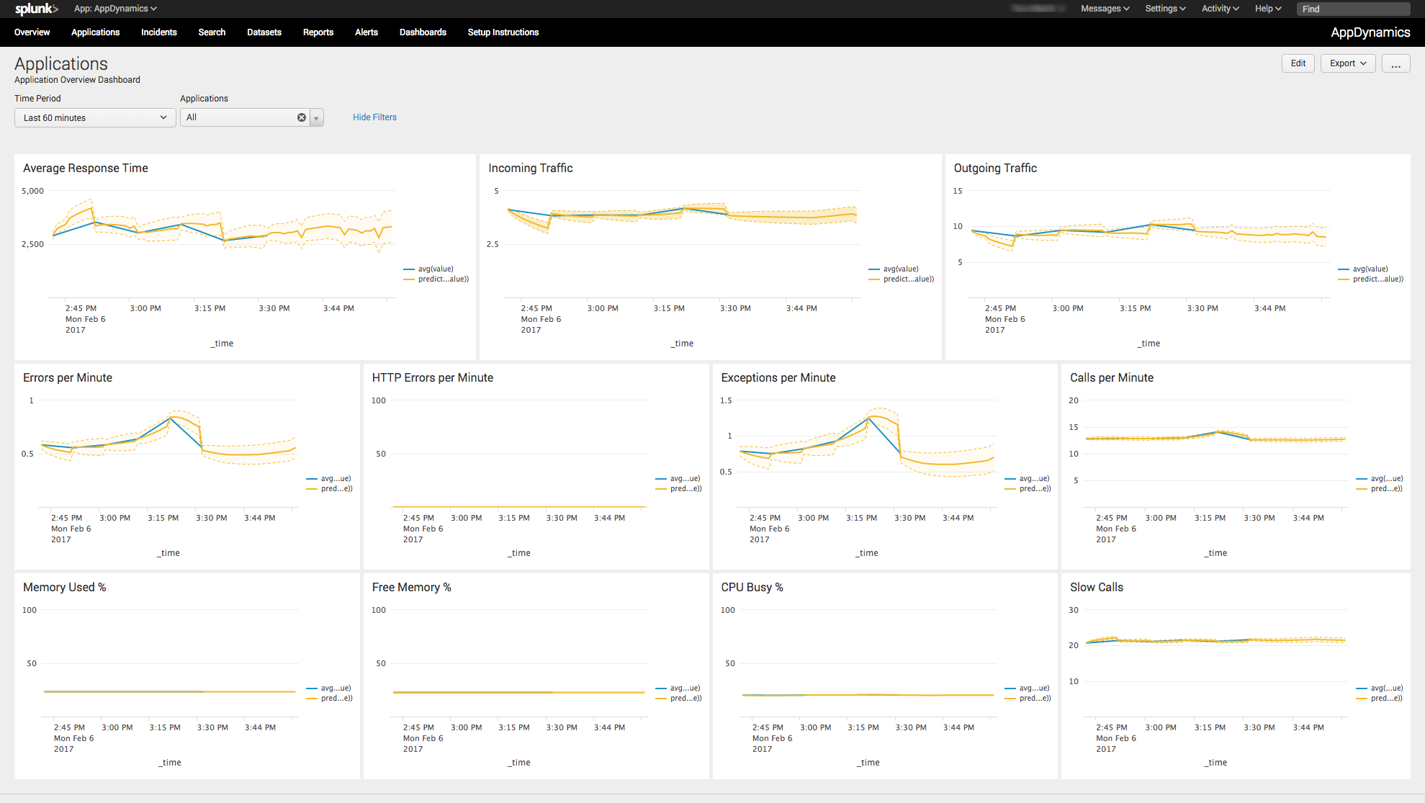

**What you will need**

* Splunk Add-on for AppDynamics
* Splunk App for AppDynamics
* AppDynamics Collector URL and Port
* AppDynamics User ID, Password and Account Name

**Installation**

The installation consists on 2 steps; installing the Splunk Add-on for AppDynamics and the Splunk App for AppDynamics. The Add-on is responsible for executing the rest calls and collecting the data from AppDynamics. The App provides the dashboards and saved searches.

To install navigate to Apps 🡪 Manage Apps and select the “Install app from File” button. Specify the location of the file you downloaded and install. Repeat this process for both the App as well as the Add-On.

**Configuration**

The Splunk Add-on for AppDynamics contains two separate input types:

* AppDynamics Summary
* AppDynamics Single API Call

In most cases, you will only need to use the AppDynamics Summary input. For each AppDynamics Collector that you have, you will enter you’re the host and port of that collector and an authorization token comprised of a base64 encoded has of your userid, password and account name (typically “cusotmer1” for most on-premise Appdynamics installations). The Input will gather performance data for your applications, business transaction, infrastructure and health rule violations.

To begin click the “Configure New Input” button and select “AppDynamics Summary”.

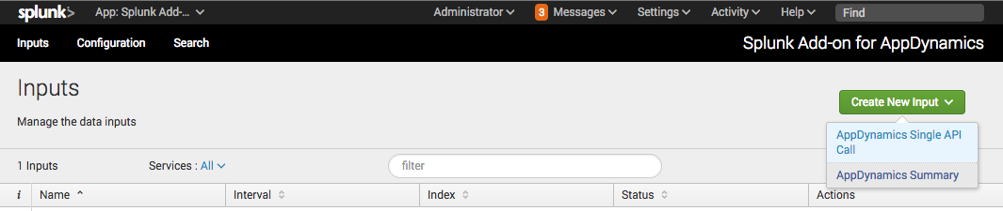

Enter your details as follows:

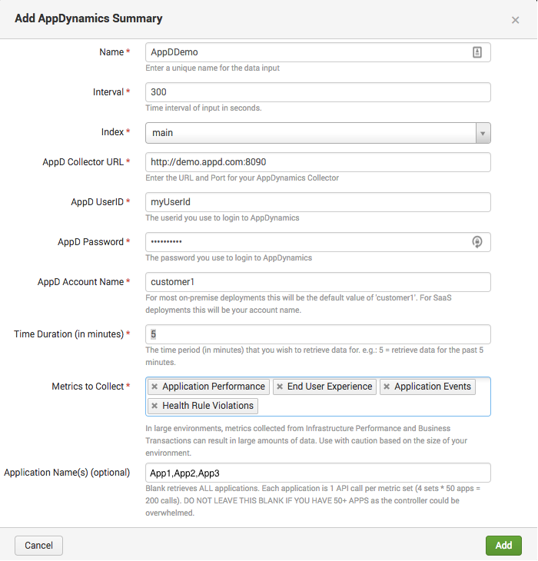

Now visit the Splunk App for AppDynamics and see your AppDynamics data!  Or you can now start searching using sourcetype="appdynamics_summary" 

**Note:** For more details on the Authorization Token please see the AppDynamics documentation here: <https://docs.appdynamics.com/display/PRO42/AppDynamics+APIs>

**Additional Inputs: AppDynamics Single API Call**

In some cases you may not want all of the Summary data for a given account or you may additional metrics from AppDynamics. In these cases you can use the AppDynamics Single API Call input type.

Use the AppDynamics Metric Browser to find the specific metric(s) you would like to collect. While in the Metric Browser, right click and copy the “Full Path” to the metric you want. You will copy this path into the AppDynamics Single API Call input screen as you setup your input.

Click the “Configure New Input” button and select “AppDynamics Single API Call” and follow the prompts.

Here’s an example of setting up a Single API Call:

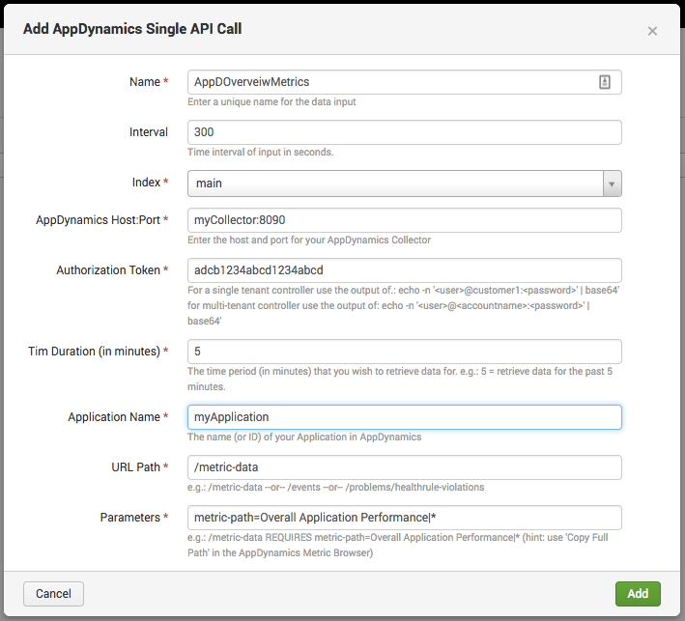

Now start searching using sourcetype="appdynamics_single_api_call”