6.1 Coding

Question 1:
We had you define the acceleration due to gravity as a field in a structure that you had to pass as an input argument to several functions. Instead, we could have had you type the value for the constant, 3.72 m/s2, directly in those functions. Do you believe there is an advantage to how we had you do it? Explain. Would you have done it differently? Explain why or why not.

I think there is an advantage to defining gravity as a field instead of directly typing 3.72 m/s² into each function. Most importantly, it centralizes the value in one place to make it easier to change the value. For example, if we wanted to change the plant would not have to find every place in the code to change gravity individually. It also makes it easier to reuse the value because we can simply call it from the function instead of initializing the value each time we type code. This helps ensure there are no accidental differences in the value of gravity between different code files. Ultimately, I would have done the same thing because it makes the code consistent and easier to modify.

Question 2:
What happens if you try to call F_gravity using a terrain slope of 115 degrees? Is this desirable behavior? Explain why you think this.

When F_gravity is called using a terrain slope of 115 degrees, it raises an exception stating that the terrain angle must be between -75 and 75 degrees. This can be seen in the picture below. This is for the best as an angle outside of this range would be unrealistic for a rover. For example, -115 degrees would essentially represent a cliff and 115 degrees would essentially represent a wall. In either situation, the rover realistically would not be able to move across that terrain.

6.2 Motor and Speed Reducer Behavior

Question 3:
What is the maximum power output by a single rover motor? At what motor shaft speed does this occur? Provide graphs or other data to support your answer.

The maximum power output by a single motor is approximately 161.5 W which occurs at the motor shaft speed of 1.90 rad/s. The graphs below demonstrate the maximum power output versus the motor shaft speed in rad/s.
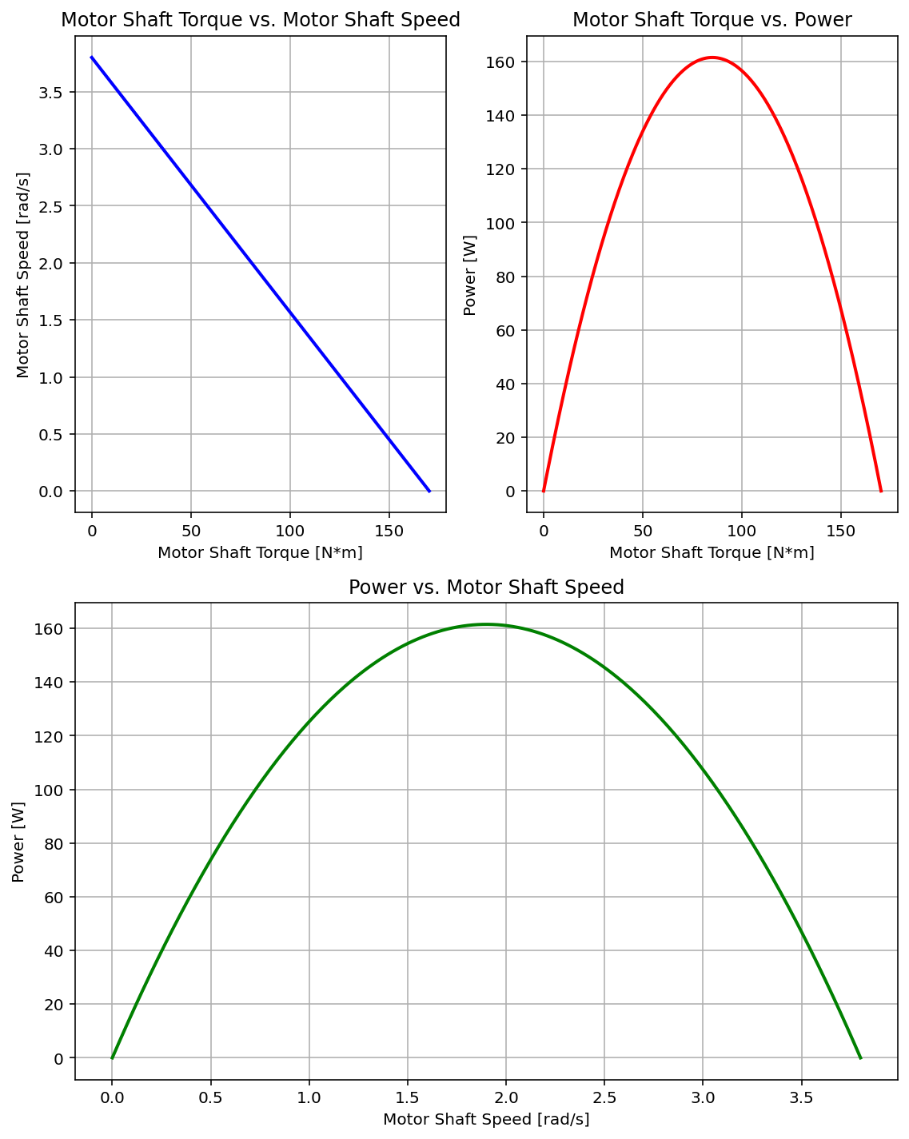
Question 4:
What impact does the speed reducer have on the power output of the drive system? Again, provide any graphs or supporting data.

The speed reducer does not directly change the power output of the drive system. Instead, it increases torque while decreasing rotational speed, thus indirectly affecting power output. Since power is calculated as P=tau*omega, the power output depends on the combination of torque and speed. As shown in the graphs below, the maximum power is about 160 W near the middle of the operating range. This is when there is a balance of torque and speed. At extremes of speed and torque, the power decreases because either the torque or speed approaches zero.
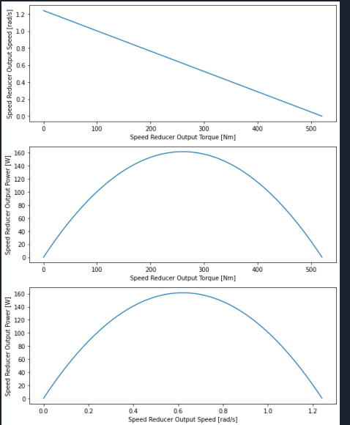
6.3 Rover Behavior

Question 5:
Examine the graph you generated using analysis_terrain_slope.py. (Provide the graph in your response for reference.) Explain the trend you observe. Does it make sense physically? Why or why not? Please be precise. For example, if the graph appears linear or non-linear, can you explain why it should be the way you observed? Refer back to the rover model and how slope impacts rover behavior.

The graph below demonstrates the maximum attainable rover speed versus the terrain slope. Logically, increasing terrain slope puts more resistance into the rover and therefore it requires more force to move up the slope. The graph demonstrates a near linear relationship as the terrain angle alpha increases from -15 to 35, the rover has to overcome resistance moving up the slope. The graph accurately portrays the speed lost to the slope. The dc motors must supply higher torque output to overcome the increasing resistance so that trade off results in a decrease in speed as angle alpha increases. Translation speed is proportional to motor speed so a higher slope forces the rover to travel lower.
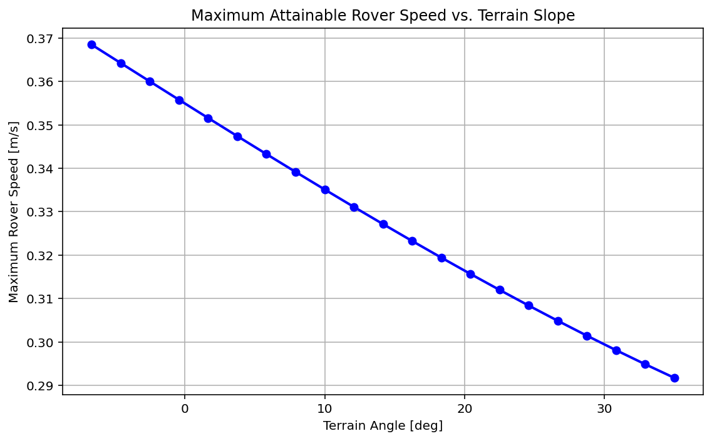

Question 6:
Examine the graph you generated using analysis_rolling_resistance.py. (Provide the graph in your response for reference.) Explain the trend you observe. Does it make sense physically? Why or why not? Please be precise. For example, if the graph appears linear or non-linear, can you explain why it should be the way you observed? Refer back to the rover model and how the coefficient of rolling resistance impacts rover behavior.

The graph below shows the maximum attainable rover speed versus the rolling resistance coefficient stored in variable Crr. The graph demonstrates that in ideal conditions when rolling resistance is zero, the attainable rover speed is maximum. The graph is predictable in its trend, unless there are other non-conservative forces, it displays a linear relationship between the speed and the rolling resistance coefficient. The higher the Crr value, the greater loss of energy the rover experiences due to the increased resistance of the ground. The motor to overcome this resistance increases torque output, and due to the linearity of the motor speed-torque curve, the more torque forces the lower the speed reducing the maximum attainable motor speed.

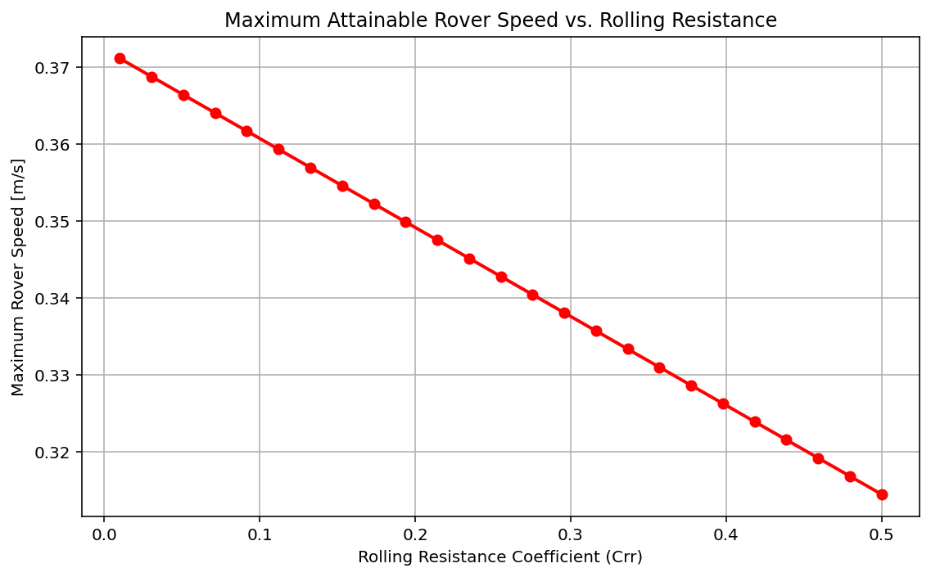
Question 7:
Examine the surface plot you generated using analysis_combined_terrain.py. (Provide the graph in your response for reference.) What does this graph tell you about the physical conditions under which it is appropriate to operate the rover? Based on what you observe, which factor, terrain slope or coefficient of rolling resistance, is the dominant consideration in how fast the rover can travel? Please explain your reasoning.

The graph below shows that as terrain slope and rolling resistance increases the maximum velocity of the rover decreases. Therefore, lower slopes and lower rolling resistance are better conditions for operating the rover at higher speeds. Terrain slope appears to be the dominant factor because changing the slope causes a larger change in maximum velocity as proven by the larger gradient. One important thing is that the blank region at low rolling resistance and negative slopes does not mean the velocity is zero. Instead, a maximum velocity is never reached because the rover continues to accelerate downhill meaning the rootfinder can never find the value. Thus velocity in those conditions is dependent on how long it travels under those conditions.

