**2022-05-28**

|  |  |
| --- | --- |
| What is this experiment for? | Steel Plate 01 |

# **Checklist**

Position Tiles

Turn Vacuum off

Put measurement cap on

Turn Kamera light off

Measure tiles

Put cap off

Turn Vacuum on

**Glue:**

|  |  |  |  |
| --- | --- | --- | --- |
| Start Time: |  |  |  |
|  | Measurements / Parameters to test | Stopwatch time | Comments |
| Glue Temperature: | 60°C |  |  |
| Weight Glue: | 10,002g | Waage springt 0,005g |
| Weight Hardener: | 0,749g | **Start Stopwatch** |  |
| Glue Temperature: | 30°C | 2:10min |  |
| Degas Pictures taken after X min: | 1 min, 5 min, 8min, 10 min, 12min, 13min | 15:30min | Kleines Haar auf der Platte gefunden zwischen 7 und 17, mit Druckluft und Pinzette (nicht die Platten berührt) versucht, kein Erfolg. Ende, da zu viele kleine Blasen |
| Glue Temperature: | 23°C | 17:00min |  |
| Filling Syringe |  | 19:30min |  |
| Testing Dispenser |  | 20:17min dispenser in cnc 25:15 | Zuviel Klebstoff eingefüllt, Dispenser lässt sich nicht zusammen setzen |
| Leveling Procedure |  | 28:00 |  |
| Start Triplet 1 | Phi / v / h / = | 28:40 start platte |  |
| End Triplet 1 |  | 00 |  |
| Start Triplet 2 | Phi / v / h / = | 00 |  |
| End Triplet 2 |  | 00 |  |
| Start Triplet 3 | Phi / v / h / = | 00 |  |
| End Triplet 3 |  | Ende 45:00 |  |
| Turn Vacuum off |  | Start messung 1 48:00 |  |
| Put measurement cap on | Now waiting 1h 15min for measurement | Starting 40 reps measurement |  |
| Start measurement (Repetion: x24) |  | 00 |  |
|  |

## Results

Ref: prev day vac – novac

|  |  |
| --- | --- |
|  |  |

Ref: same day vac – novac

|  |  |
| --- | --- |
|  |  |

|  |  |
| --- | --- |
|  |  |

Curing with vac ref:

|  |
| --- |
|  |
|  |

|  |  |
| --- | --- |
|  |  |

Curing with novac ref:

|  |
| --- |
|  |
|  |

|  |  |  |
| --- | --- | --- |
|  |  |  |

## Microscope data:

Front:

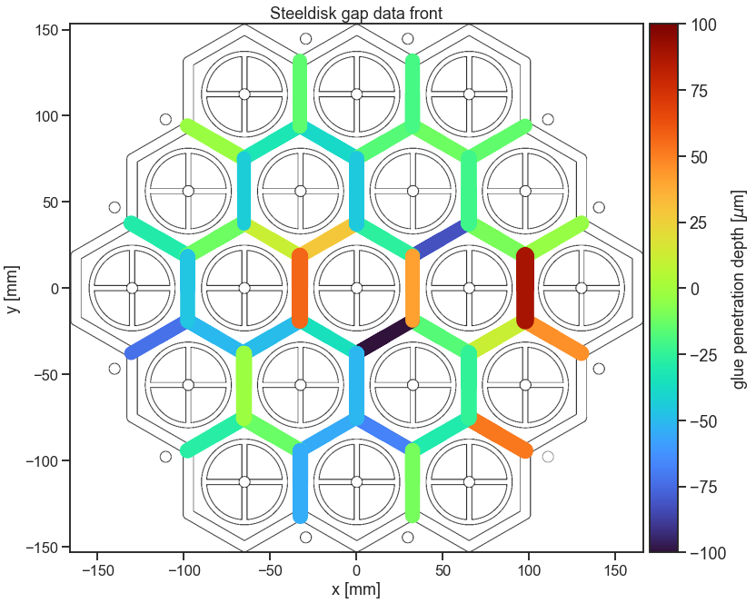

|  |  |  |
| --- | --- | --- |
|  |  |  |

Horizontal

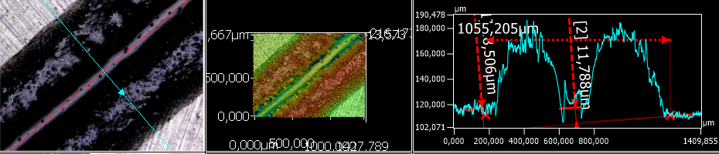

Back:

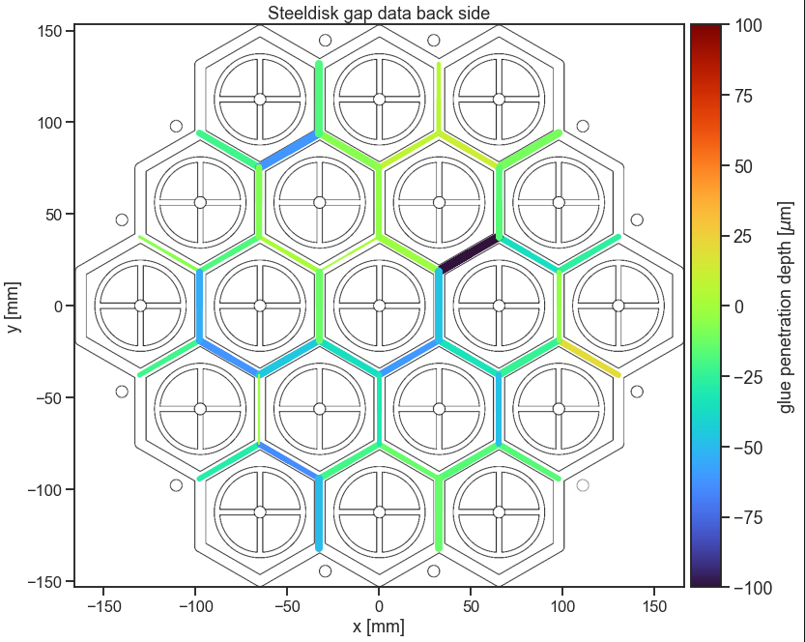

|  |  |  |
| --- | --- | --- |
|  |  |  |

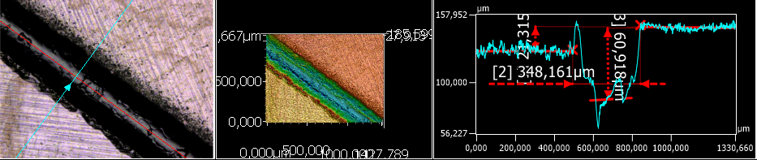

Horizontal

Vertex front:

Not useful cause

|  |  |
| --- | --- |
|  |  |

Vertex Front:

Not useful cause only hill to valley measurement was possible, not valley to disk

Vertex

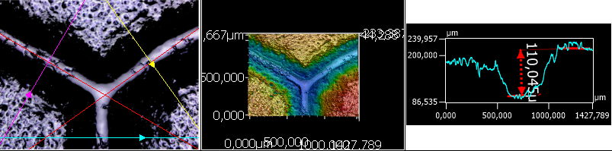

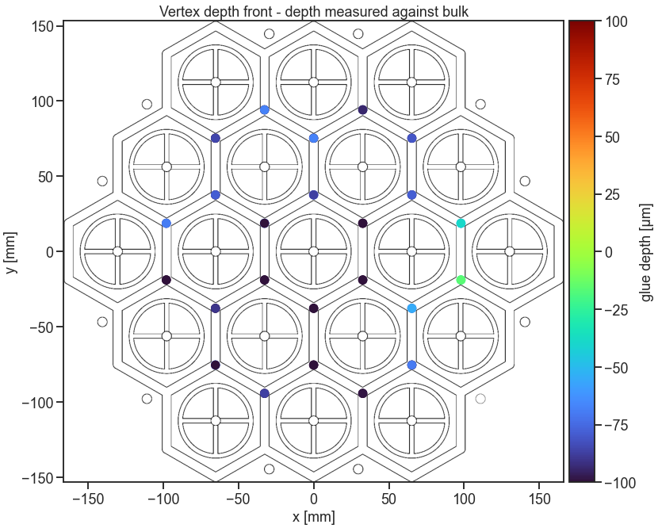

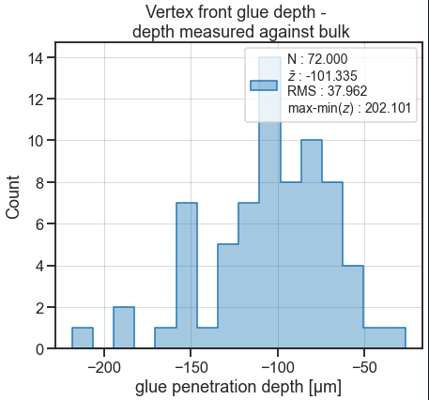

Vertex back:

Vertex

