Types of aircraft

The space shuttle：

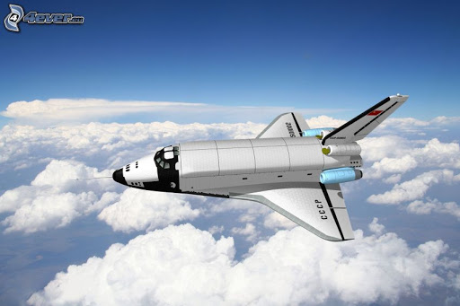

It's a reusable vehicle to and from low Earth orbit to the ground

The spaceship：

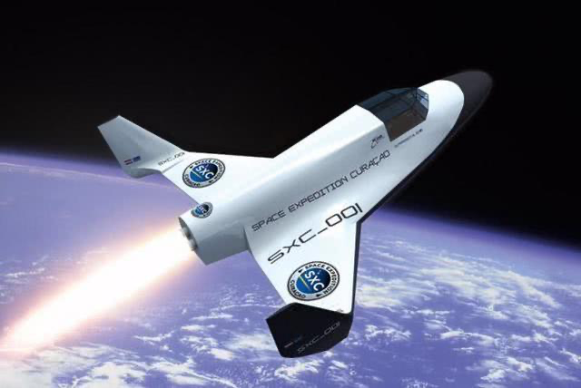

It is a kind of transport astronauts, goods to space and safe return to the spacecraft

The rocket：

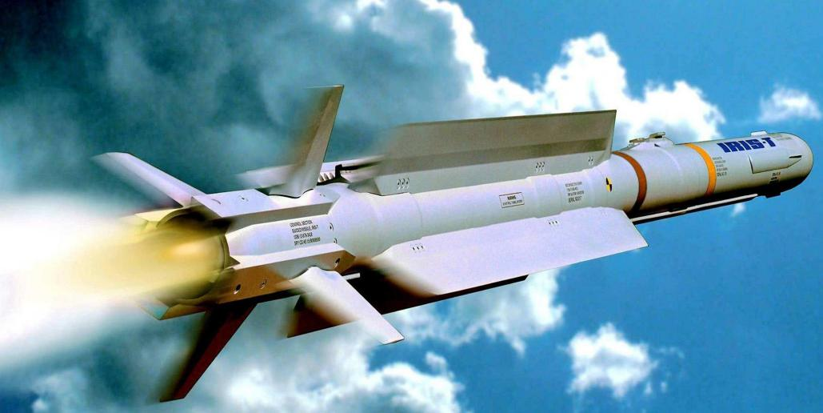[IMG_256](https://www.baidu.com/link?url=Xh_s8AlCPCASu2f0FWnAiZ90ut-uU0AZrK4Y5n8OF7NzwlWP712rbnKve9HE60LPkeAklHbbUlhd3pgCP-RJluEMK2HPh_126mWYdRl-QpJrgOHcURlpM1rc5R7KUKzEXF_guu76H7FlrnqdFQrZ4pl_TaJINbH9XbshxB66AuuCfo0LL9Te7-V3qgrVhWxatFuMFNA0Eh0C2kwac6c3lIAj1VGUUM--_feaeaYevJU16m7iwsE4GAdYvM2FHkzYwldUWjyu3ZoAXEfhCnzJfOmpKdRlLHbQsVrDYtQm3MB1yiTTkUHz55a3mRJ137R_QiKpvEnjhnFB_LYknACEohGHMQAojTnClgkYaH6U5qg3jDDErNLFmgfmCxGPCLlr_lAC8h0hRBiHnxnyynJ_ZG7LpBatzsZl4Hn1wFMat3pt0eoiHaiZ94KHaAiFk8J3fjiDTF22PmeE0ATnM9BgTQdPcZuKUkXCtMjAfvZEGVfuhy5r6ZuURxEIIJl5TX9vavlQwRt9zsZuUnSNcDXha2ank8o-V1En_NUM-jKdU9Uy62M71uFuc14gg2kReWzA-KemUIhvDFKe4KAOcj3zo2oL0irCmHCFYsBpwtcuz3bq22ceETT8ZPBd1MSsz5-v&wd=&eqid=87debb14001dec8e0000000560ab9c56&click_t=1621859419857&s_info=1097_732)

It is the rocket engine jet working fluid produced by the reaction force to advance the aircraft, is to achieve space flight vehicle.

Military aircraft：

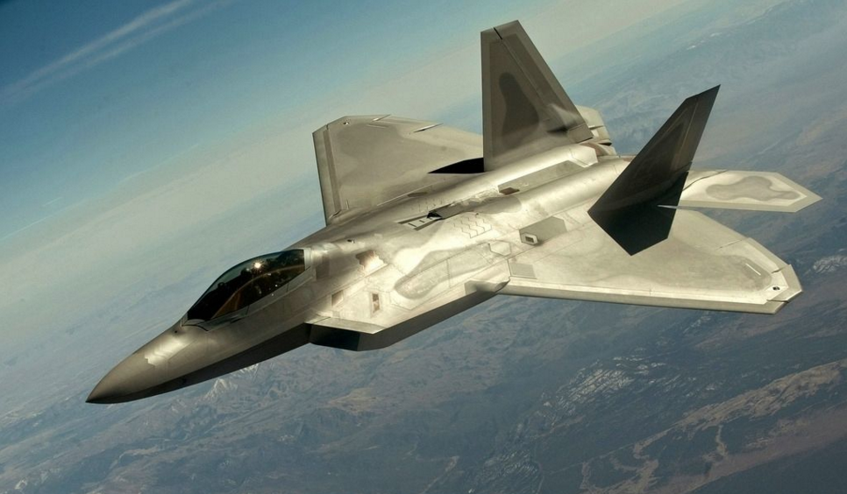

It is used to destroy enemy aircraft and other aerial attack weapons in the air.

Civil aircraft：

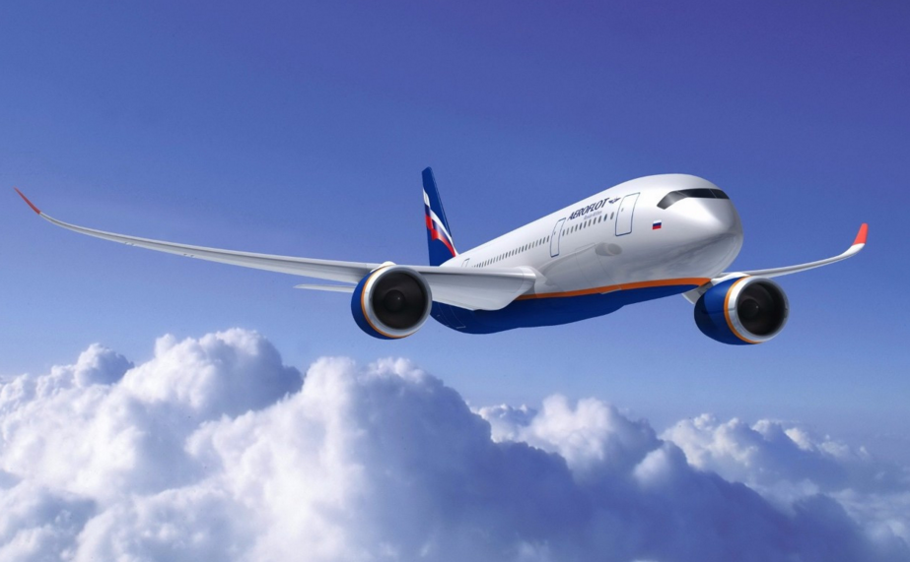

It is used for non-military purposes as an aircraft, a vehicle for carrying people and goods.

Double-decker plane：

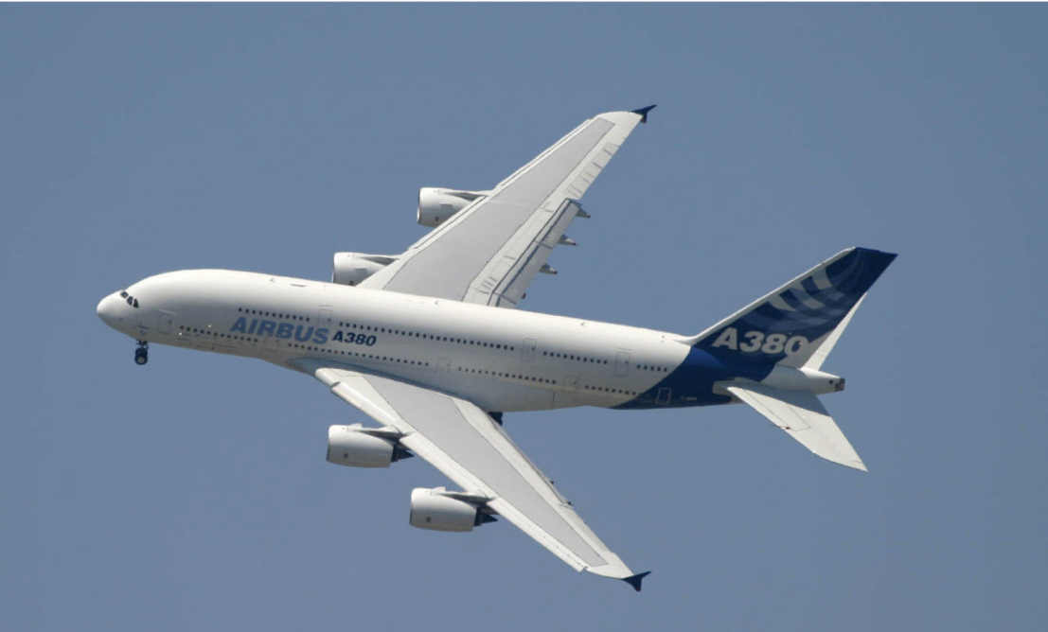

It is used to carry more people than a civilian aircraft.

The helicopter：

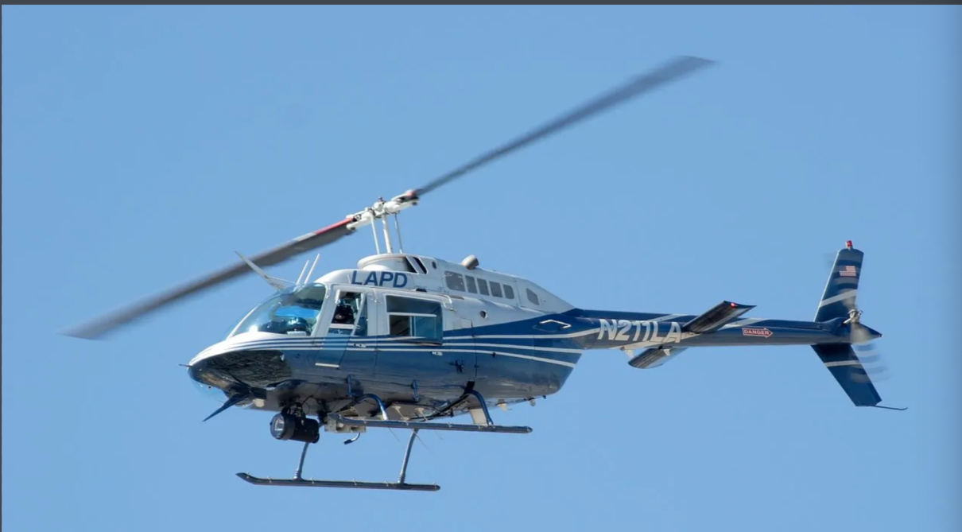

It is used in transportation, patrol, tourism, rescue and other fields.[IMG_256](https://www.baidu.com/link?url=Xh_s8AlCPCASu2f0FWnAiZ90ut-uU0AZrK4Y5n8OF7NzwlWP712rbnKve9HE60LPkeAklHbbUlhd3pgCP-RJluEMK2HPh_126mWYdRl-QpJrgOHcURlpM1rc5R7KUKzEXF_guu76H7FlrnqdFQrZ4pl_TaJINbH9XbshxB66AuuCfo0LL9Te7-V3qgrVhWxatFuMFNA0Eh0C2kwac6c3lIAj1VGUUM--_feaeaYevJU16m7iwsE4GAdYvM2FHkzYwldUWjyu3ZoAXEfhCnzJfOmpKdRlLHbQsVrDYtQm3MB1yiTTkUHz55a3mRJ137R_QiKpvEnjhnFB_LYknACEohGHMQAojTnClgkYaH6U5qg3jDDErNLFmgfmCxGPCLlr_lAC8h0hRBiHnxnyynJ_ZG7LpBatzsZl4Hn1wFMat3pt0eoiHaiZ94KHaAiFk8J3fjiDTF22PmeE0ATnM9BgTQdPcZuKUkXCtMjAfvZEGVfuhy5r6ZuURxEIIJl5TX9vavlQwRt9zsZuUnSNcDXha2ank8o-V1En_NUM-jKdU9Uy62M71uFuc14gg2kReWzA-KemUIhvDFKe4KAOcj3zo2oL0irCmHCFYsBpwtcuz3bq22ceETT8ZPBd1MSsz5-v&wd=&eqid=87debb14001dec8e0000000560ab9c56&click_t=1621859434466&s_info=1097_732)

[IMG_256](https://www.baidu.com/link?url=Xh_s8AlCPCASu2f0FWnAiZ90ut-uU0AZrK4Y5n8OF7NzwlWP712rbnKve9HE60LPkeAklHbbUlhd3pgCP-RJluEMK2HPh_126mWYdRl-QpJrgOHcURlpM1rc5R7KUKzEXF_guu76H7FlrnqdFQrZ4pl_TaJINbH9XbshxB66AuuCfo0LL9Te7-V3qgrVhWxatFuMFNA0Eh0C2kwac6c3lIAj1VGUUM--_feaeaYevJU16m7iwsE4GAdYvM2FHkzYwldUWjyu3ZoAXEfhCnzJfOmpKdRlLHbQsVrDYtQm3MB1yiTTkUHz55a3mRJ137R_QiKpvEnjhnFB_LYknACEohGHMQAojTnClgkYaH6U5qg3jDDErNLFmgfmCxGPCLlr_lAC8h0hRBiHnxnyynJ_ZG7LpBatzsZl4Hn1wFMat3pt0eoiHaiZ94KHaAiFk8J3fjiDTF22PmeE0ATnM9BgTQdPcZuKUkXCtMjAfvZEGVfuhy5r6ZuURxEIIJl5TX9vavlQwRt9zsZuUnSNcDXha2ank8o-V1En_NUM-jKdU9Uy62M71uFuc14gg2kReWzA-KemUIhvDFKe4KAOcj3zo2oL0irCmHCFYsBpwtcuz3bq22ceETT8ZPBd1MSsz5-v&wd=&eqid=87debb14001dec8e0000000560ab9c56&click_t=1621859447492&s_info=1012_732)