Wings of animals and insects

When people think of wings, the first thing that probably comes to mind is......

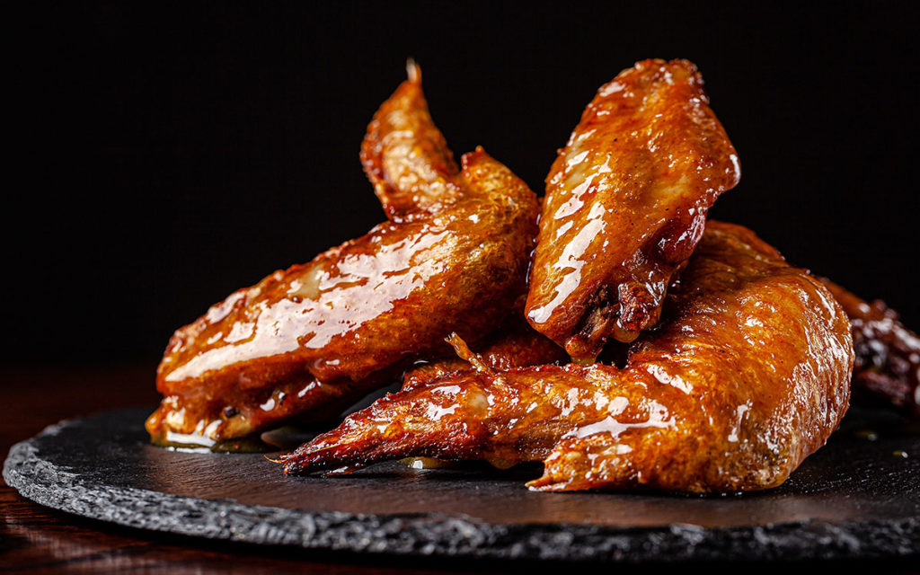

Or......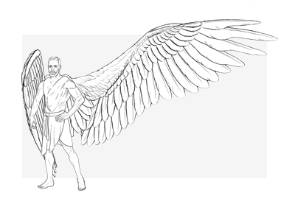

.........

Now what we're going to talk about is the wings of the flight organs of birds and insects.

The wings of insects are able to move in concert and carry out very efficient flight, because of the small "interlocking mechanism" between the powerful flight muscles and the hind wings. They can be folded on the back of the body when not in use, and the wings are generally triangular. A bird's wings have a special arrangement of flight feathers, each with a slight ability to rotate when the wings are spread out. So the constant up-and-down flapping of the wings creates a tremendous resistance to downforce, which enables the bird to fly forward quickly.

EAGLE

Eagle wings have a number of diversifications for the eagle’s fishing life, which is an example of eagle adaptations.

Form: Long, broad wings like an eagle take loads of vitality to flap, however, they are great for driving effortlessly on thermals. Like all birds, eagles should decrease the vitality they want for a flight over lengthy distances.

“Fingers” or slotted primaries: This gives extra to carry with much less weight–important for birds that trip thermals

Dimension: Eagle wings are large enough to hold the burden of the eagle PLUS the burden of a pretty big fish, which is an example of eagle adaptations.

And if the fish is just too heavy to drag out of the water, the eagle can use its lengthy wings to paddle to shore!

Colour: The pigment that makes an eagle’s wing feathers black additionally makes these feathers stronger, which is necessary when feathers hit the water whereas fishing and when flying, which is an example of eagle adaptations.

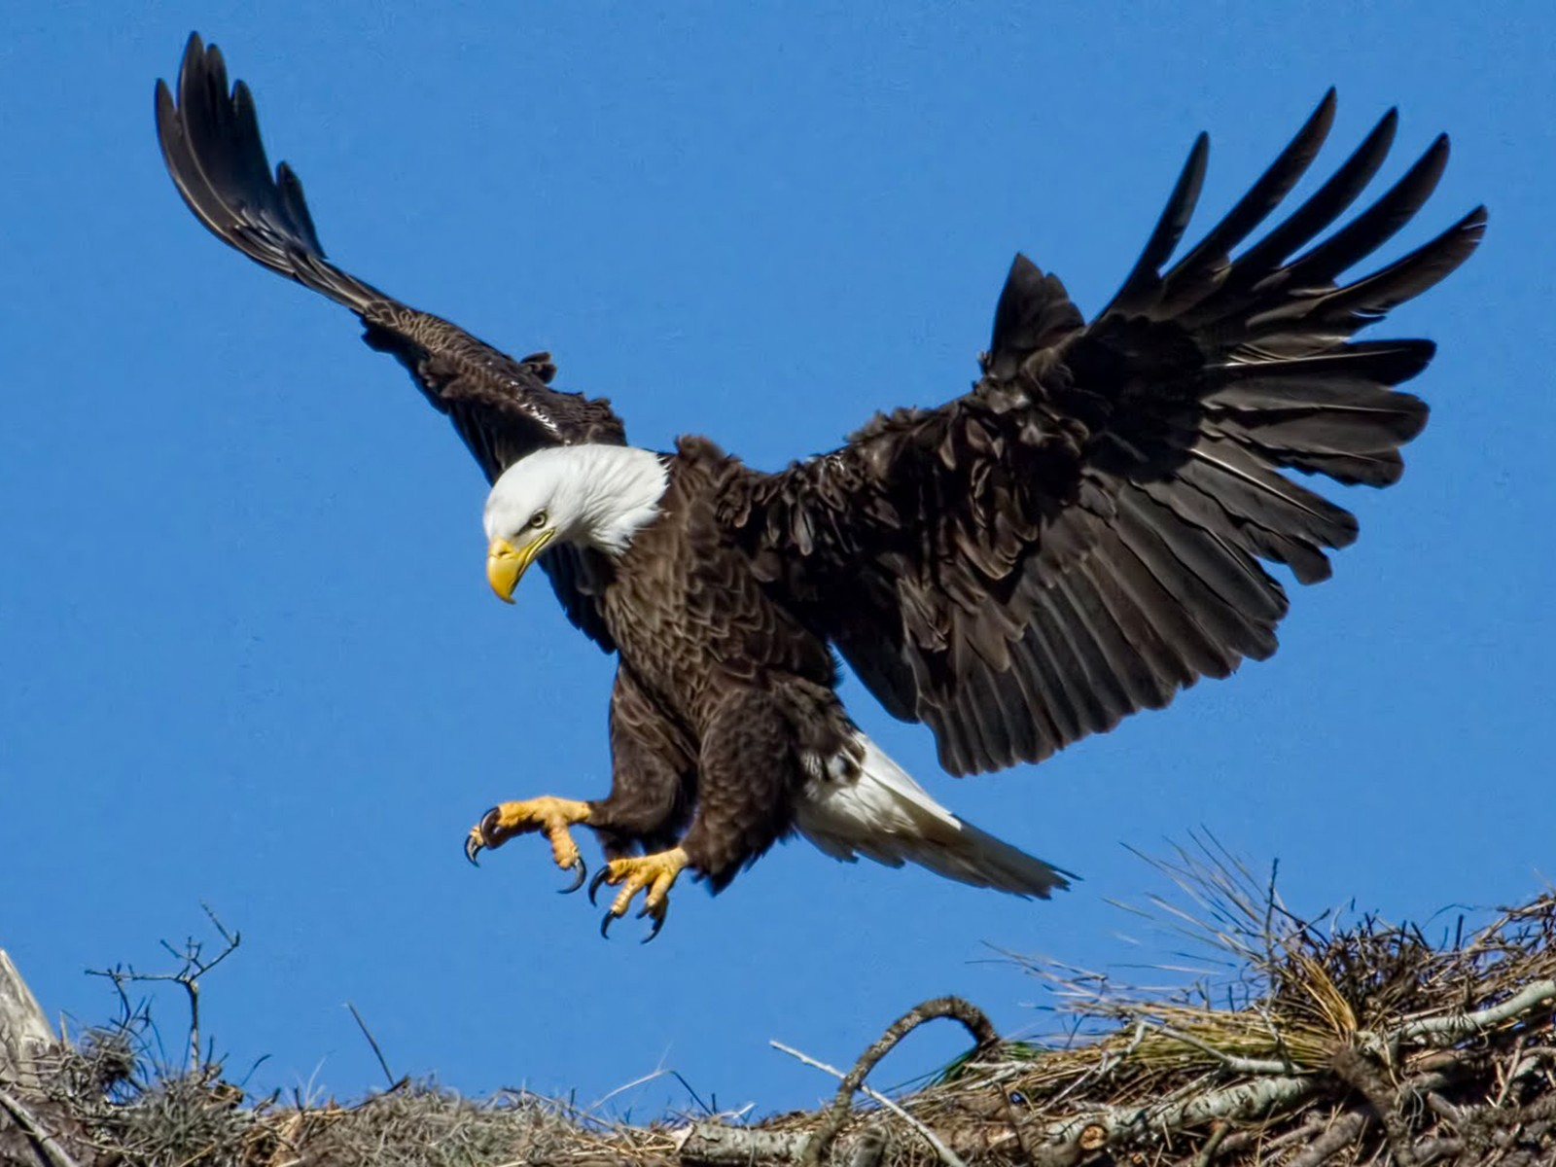

BEE

Bees have two pairs of wings and they are appendages of medium- and metathorax. Wings fully develop only in the transition from the bee pupa to an adult bee. They are laid in a bag-like rudiment of covers of the middle- and metathorax.

The pupa grows and this rudiment also does, its ventral and dorsal walls converge. The wing of the adult bee is a thin, elastic plate, with the veins, which are hardened pieces of hollow tubes.

During the formation of the wing hemolymph flows there, pulling wing plate.

Veins are mechanical support of a wing, they help to overcome air resistance in flight.There are different longitudinal veins, partially branching, and longitudinal cross-linking to each other. Between the veins the thin transparent membranes are stretched. Pattern of longitudinal and transverse veins is called venation.

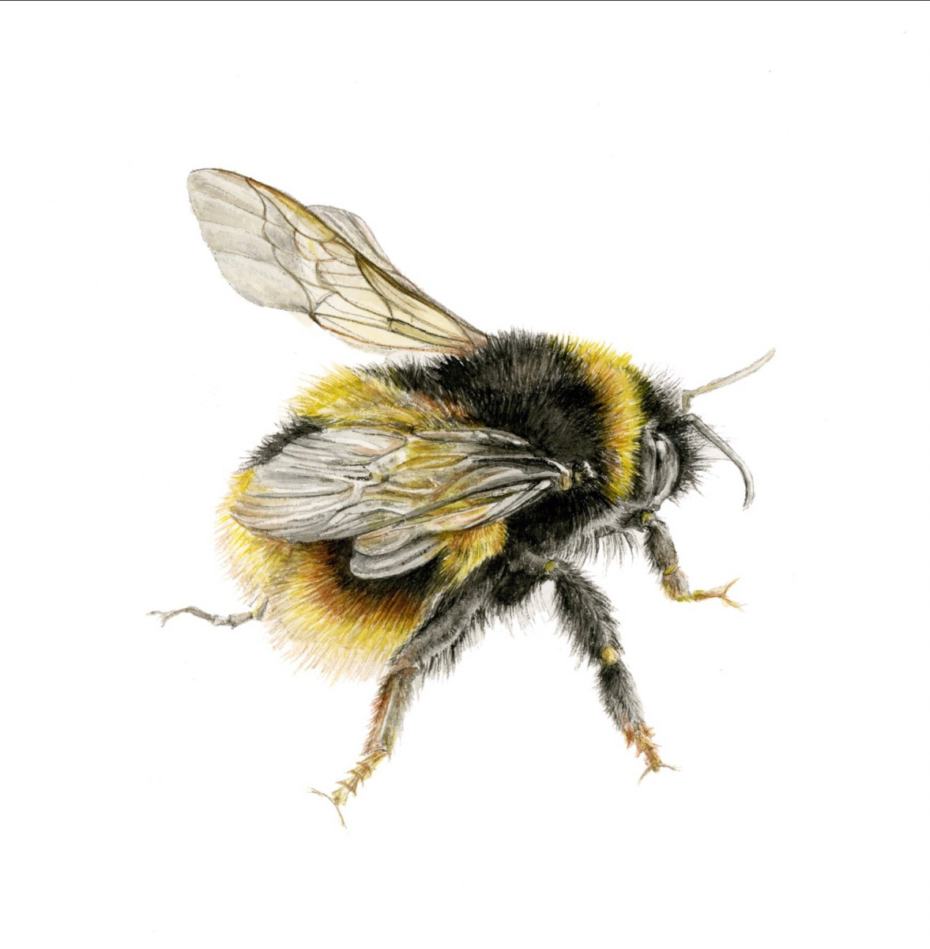

MOSQUITOE

On the face of it, mosquitoes shouldn’t be able to fly, because their entire angular wing sweep is only 40 degrees, less than half that of honey bees.

And while the wings beat rapidly, at a frequency of 800 Hz, their strokes are the shallowest of any known insect group.

Yet fly they can, and with devastating accuracy. Research led by Richard Bomphrey of London’s Royal Veterinary College has discovered exactly how.

In addition to generating lift through leading edge vortices – areas of low pressure at the front of the wing – the mosquitoes also make complementary vortices on wing trailing edges, and an additional type of lift mechanism generated by wing rotation.

Mosquitoes appear to be unique in utilising this mode of flying, and the evolutionary pressures that led to it remain unclear. The [study](http://nature.com/articles/doi:10.1038/nature21727) was published in *Nature Research*.

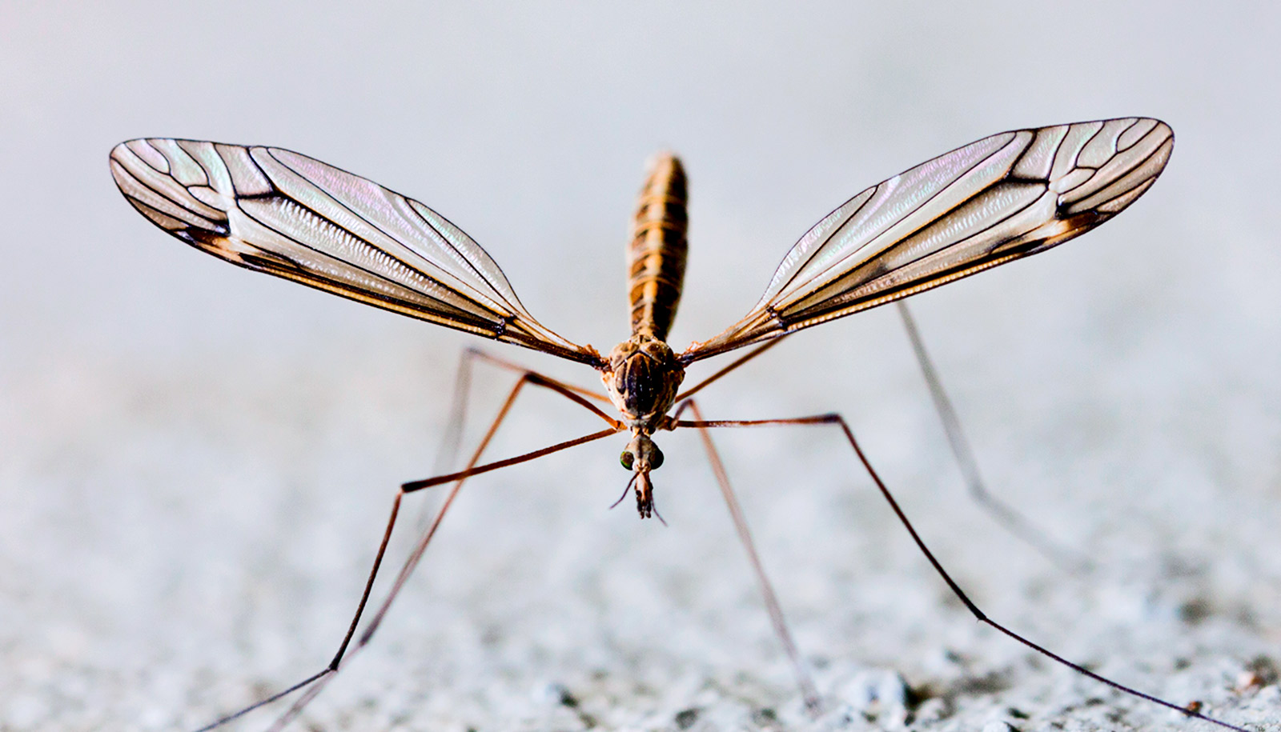

<http://keepingbee.org/bee-wings/#:~:text=Bees%20have%20two%20pairs%20of%20wings%20and%20they,also%20does%2C%20its%20ventral%20and%20dorsal%20walls%20converge.>

<https://cosmosmagazine.com/biology/mosquito-wing-s-the-thing>

<https://www.birdbaron.com/eagle-adaptations/>