**What can we take with us on the plane?**

First of all, there are two main categories of things. **Checked** and **carry-on**.

「GIF」

Besides the clothes in our suitcases, are there any things we can or can't take?

We can classify it in four quadrants.

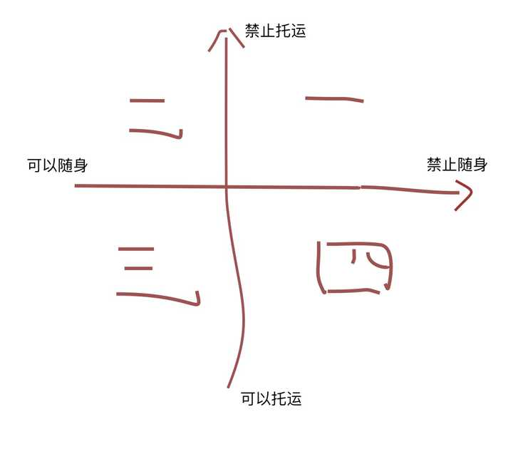

**First quadrant - No Checking / No Carrying**

* Dangerous goods and contraband

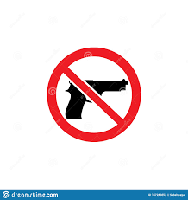

* Chargers and lithium battery devices（Capacity in excess of the gauge）

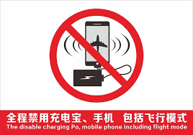

**Second quadrant - No Check / Carry**

* Charging treasure（Conforming capacity）

Tips：Usually less than 20,000 milliamps.

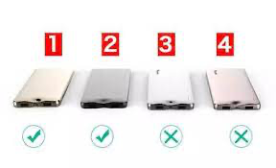

**Third quadrant - Check / Carry**

* Clothes and things like that

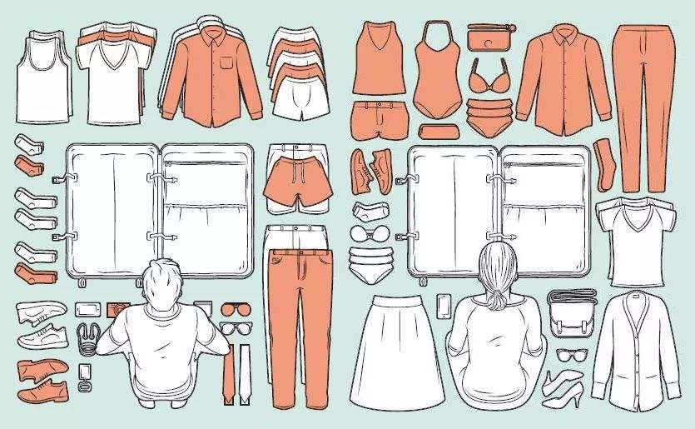

**Fourth quadrant - Check / No Carry**

* Liquor

Tips：Degree of alcohol <70%

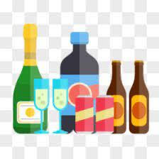

* Special liquid (Wash and care skin products）

Tips：Single bottle capacity <100ml（Limit 1000ml of personal toiletries）

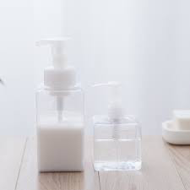

* Controlled cutting tool（Life and performance）

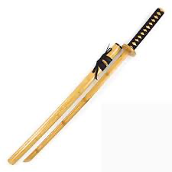

* Articles endangering aviation safety

Example：Sticks, clubs, screwdrivers, bows and arrows

Baggage size weight

**Baggage size weight**

**Carry-on luggage**

**size <= 20*44*50cm (20 "boarding box), weight <=5kg.**

* Carry-on baggage abroad and domestic flight regulations are the same, economy class free baggage allowance is 5 kilograms.

**Free checked baggage**

* **Domestic economy class usually can be checked for free: 1 piece of luggage *20kg.**

Tips：High-class cabins or international routes usually have some more quota, each varies, it is best to check the relevant airline regulations before buying tickets.

**Luggage more than weight?**

* **Lose weight**
* **Purchase allowance**

Tips：Buying online in advance will be cheaper than buying in person

* **Give it to fellow personnel to share**

**Luggage over size?**

* The general airport has a special oversized luggage handling office, more than the weight to charge, there may be a packing fee.

Tips：Depending on the airport