Guest Operations Automation
Case Study
  - Montien Thai academic demonstration
Darliree Brumfield | October 2026 | BUS 536
I designed and built a guest operations prototype using Microsoft Forms, SharePoint, and Power Automate. The system includes two forms, two lists within one SharePoint site, and three flows. Its purpose is to keep guest information organized and automate routine communication so staff can spend more time helping customers.
Project context: This academic case study uses test submissions. It is an independent portfolio demonstration, is not an official Montien Thai system, and is not affiliated with the restaurant. The examples do not represent actual guest activity or business performance.

My contribution
My work covered defining business rules, organizing form and list fields, configuring the flows, and generating a weekly summary email. The following pages explain the implementation and connect the steps to screenshots of the prototype. Screenshots are cropped for readability.
Tools used: Microsoft Forms, SharePoint Lists, Power Automate, the Approvals connector, and Outlook email actions.

Business rules and human decisions
Process | Automation rule | Human responsibility
Guest feedback | Ratings of 1 or 2 require follow-up and trigger a manager alert. | The manager responds to complaints and decides whether compensation is appropriate.
Event requests | Parties of 8 or more require manager approval. Smaller parties are approved automatically in the prototype. | The manager reviews larger requests, including seating, staffing, and special arrangements.
Weekly reporting | Summarize records created in the previous 7 days every Monday at 9 AM Eastern Time. | The owner reviews the counts and decides which issues need attention.

Intended value and proposed measurement
The system is intended to reduce manual data entry and routine emailing while bringing unhappy feedback to the manager sooner. These benefits were not measured in a live restaurant. One KPI I would track is the time between submitting a large-party request and completing the approval, with a proposed response goal of 24 hours.

1 Capture guest information
I created two Microsoft Forms so each submission starts the appropriate process. The feedback form, Montien Thai How Was Your Visit, collects a guest's name, email, visit date, overall rating from 1 to 5, and comments. The event form, Montien Thai Reservation Portal, collects contact details, the requested date, party size, occasion, and special requests.
The flows retrieve the submitted response details and use those values to populate SharePoint records and personalize emails. This connects data collection to the later automation steps.

2 Store responses in SharePoint
I created two lists within one SharePoint site. Feedback and event requests are stored separately because they need different fields and follow different business rules.
List | Information stored | Workflow field
Guest_feedback | Guest name, email, visit date, rating, and additional feedback. | Follow_Up records whether manager follow-up is needed.
Montien Event Requests | Guest name, email, requested date and time, number of guests, occasion, request type, and additional requests. | Status tracks Pending, Approved, or Declined.

Feedback record example
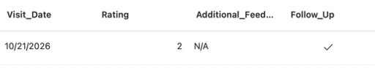
Figure 1. Detail of a saved feedback test record. The rating is 2 and the Follow_Up field is checked.
This record illustrates the saved state for feedback that meets the follow-up threshold. The feedback flow on the next page shows the actions that create the record, send an acknowledgment, and apply the triage rule.

How the records support reporting
The same lists supply the weekly owner report. Feedback records can be counted by their follow-up flag, and event requests can be counted by status. The reporting period uses the record creation date, so a request for a future event is counted in the week it was submitted.

3 Automate feedback triage
The feedback flow connects a form submission to a saved record, a guest acknowledgment, and a manager alert when the rating is low.
1. Start when a new response is submitted to the feedback form, then retrieve the response details.
2. Use the Compose action to hold an intermediate value before creating the SharePoint item.
3. Create the feedback record and send the guest a personalized thank-you email.
4. Check the rating. For a rating of 1 or 2, set Follow_Up to Yes and email the manager the guest's name, rating, and comments.
5. For ratings of 3 through 5, set Follow_Up to No. The record remains available for the weekly report.
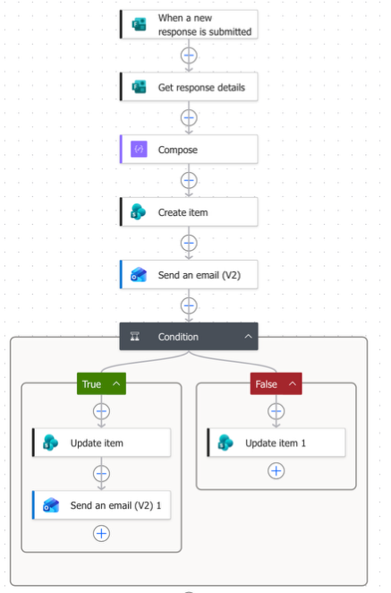
Figure 2. Feedback flow showing the Forms trigger, response retrieval, Compose, record creation, email action, and both condition branches.

4 Route event requests for approval
The event process saves each request before applying the party-size rule. The manager remains responsible for larger-party decisions, while the flow handles status updates and guest communication.
1. Start when a guest submits the event request form and retrieve the response details.
2. Create an item in the Event Requests list with a Pending status.
3. Check the number of guests. For parties of 8 or more, start an approval and wait for the manager's response.
4. Update the saved record and notify the guest according to the decision below.
Condition or decision | Saved status | Guest communication
Manager approves a request for 8 or more guests | Approved | Send a confirmation email.
Manager rejects a request for 8 or more guests | Declined | Send a polite decline that includes the manager's comments.
Request is for fewer than 8 guests | Approved | Approve automatically and send a confirmation email.

Event record example
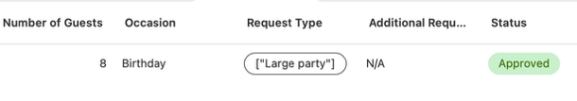
Figure 3. Detail of an event test record with 8 guests and an Approved status.

Why I chose the approval threshold
I chose eight guests because larger groups may require combined tables and more planning for seating and staffing. The manager should consider the requested date, available space, and any special arrangements before approving these requests.

Operational considerations
Automatic approval for smaller parties follows the prototype's business rule. Before live use, I would add checks for actual availability and capacity. I would also review failed email actions, since requiring an email field prevents a blank response but does not guarantee a correct address.

5 Generate the weekly owner report
I configured a scheduled flow to run every Monday at 9 AM Eastern Time. It summarizes records created in the previous seven days and emails the results to the owner.
1. Use the Recurrence trigger to start the weekly flow.
2. Retrieve the event and feedback items for the reporting period from their SharePoint lists.
3. Filter the retrieved records into follow-up feedback and Approved, Declined, and Pending event requests.
4. Count the feedback and event records, then include the counts in the owner's summary email.
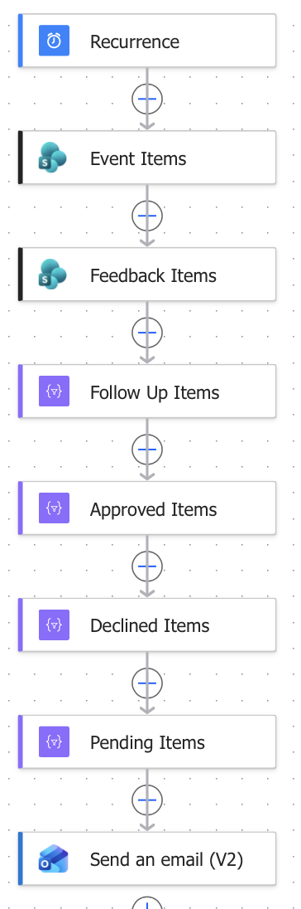
Figure 4. Weekly report flow showing the recurrence, list retrieval, filtered groups, and final email action.

6 Review the report output
The generated email shows the reporting period and the counts from the demonstration data. In this example, two of the three feedback responses require follow-up, and the single event request is approved.
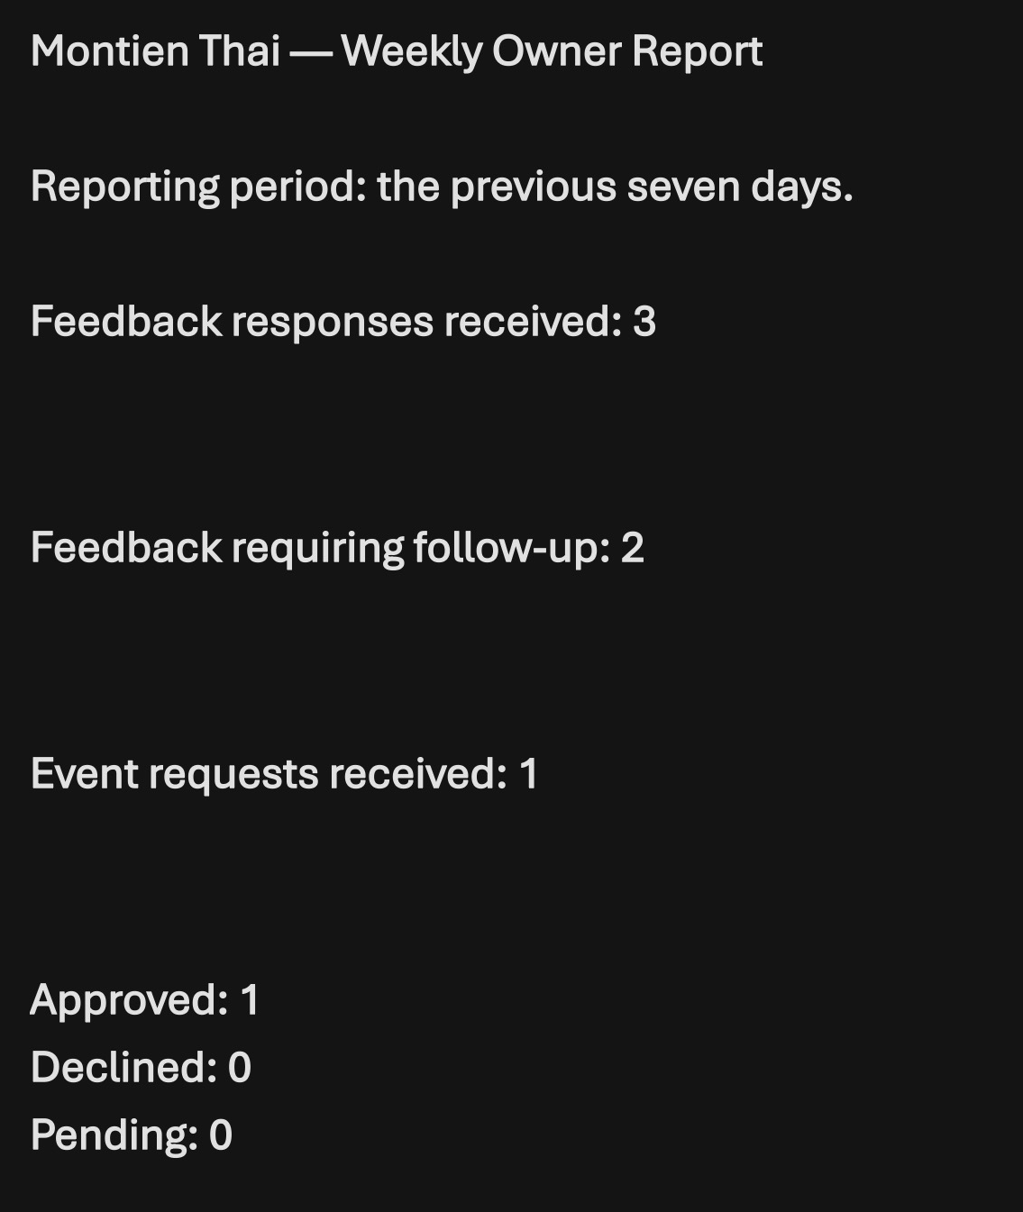
Figure 5. Weekly report email showing 3 feedback responses, 2 requiring follow-up, and 1 approved event request. Declined and Pending counts are both 0.
The two responses requiring follow-up would make the owner act. The owner would review the comments, confirm that the manager contacted the guests, and address any recurring service problems with staff.

Skills demonstrated
Skill | Project evidence
Process design | Defined triggers, outcomes, business rules, and decisions that stay with the manager.
Data organization | Mapped two forms to separate SharePoint lists with follow-up and status fields.
Workflow automation | Configured record creation, conditional updates, personalized emails, and approval routing.
Operational reporting | Retrieved and filtered records, counted categories, and generated a scheduled email summary.

