Montien Thai Restaurant Analytics and Growth Strategy Case Study
Darliree Brumfield | Portfolio case study | November 2026
I developed this restaurant analytics case study to determine whether Montien Thai should pursue a growth strategy serving both local and visiting customers in Boston's Chinatown. I used R to clean historical restaurant and neighborhood data, test three business questions, and revise the strategy when the evidence did not support the original Airbnb assumption.
The analysis supported a more focused recommendation: protect the restaurant's dependable local base, improve the experience of visiting customers already choosing the restaurant, and differentiate through Thai food, atmosphere, and a small tasting option. The project demonstrates how I connect statistical results to operating and growth decisions instead of treating analysis as the final product.
Project detail | Summary
Project type | Business analytics consulting case study and evidence-based growth strategy
My role | Business framing, data preparation, statistical analysis, visualization, interpretation, and strategy revision
Tools | R, tidyverse, janitor, broom, ggplot2, and knitr
Dataset | Restaurant performance, Airbnb concentration, and neighborhood data supplied for BUS 536
Analysis period | Historical observations from 2006 through 2019

Project context
This is an independent academic and portfolio demonstration. I did not work for Montien Thai, and the historical results do not describe the restaurant's current performance. Out-of-state reviewers were used as a practical indicator of visiting customers, but they do not prove that every reviewer was a tourist.

My contribution
I defined a mixed local-and-visitor business idea, translated it into testable questions, prepared the Chinatown comparison groups, selected appropriate descriptive and inferential methods, built the visualizations, and changed the final recommendation when the data pushed back on the original premise.

1 Dataset and analytical approach
The source file contained 16,060 observations and 55 variables. After standardizing field names and filtering to Boston's Chinatown, the working sample contained 451 observations across 62 restaurants. Montien Thai had one yearly observation for each year from 2006 through 2019, giving 14 annual records for the restaurant-level comparisons.
Data preparation step | Why it mattered
Standardized column names | Made the R workflow easier to audit and reduced naming errors.
Filtered to Chinatown | Kept the comparison aligned with the restaurant's neighborhood context.
Separated Montien Thai | Allowed direct comparison with other Chinatown restaurants without double counting.
Reviewed missing values | Prevented incomplete ratings or review counts from silently affecting results.
Weighted comparison ratings | Gave greater influence to restaurant-year observations supported by more reviews.
Table 1. Main data-preparation decisions used in the R analysis.

Questions tied to owner decisions
Analytical question | Method | Decision supported
Does Airbnb concentration relate to a larger visitor review share? | Descriptive statistics and simple linear regression | Whether visitor promotion should depend on Airbnb growth
Do local and visiting customers rate Montien differently from the neighborhood? | Weighted averages, normality checks, and paired t-tests | Which customer experience deserves the most attention
How did Montien's review activity change as more competitors appeared in the dataset? | Trend comparison and simple linear regression | Whether differentiation should be a strategic priority
Table 2. Each question was selected because its answer could change a business decision.

Analytical safeguards
- I treated regression and hypothesis-test results as evidence of relationships, not proof of causation.
- I kept Montien Thai out of the Chinatown comparison group so the benchmark remained independent.
- I reported results that were not statistically significant instead of presenting every visible pattern as a finding.
- I separated historical market context from claims about the restaurant's current competitive environment.

2 Visitor mix and Airbnb concentration
The original strategy assumed that increasing Airbnb concentration might create a growing visitor segment for nearby restaurants. I tested whether the out-of-state review share increased as Airbnb concentration changed. Descriptively, Montien Thai received a slightly larger share of out-of-state reviews than the other Chinatown restaurants, but the regression results did not support the Airbnb relationship.
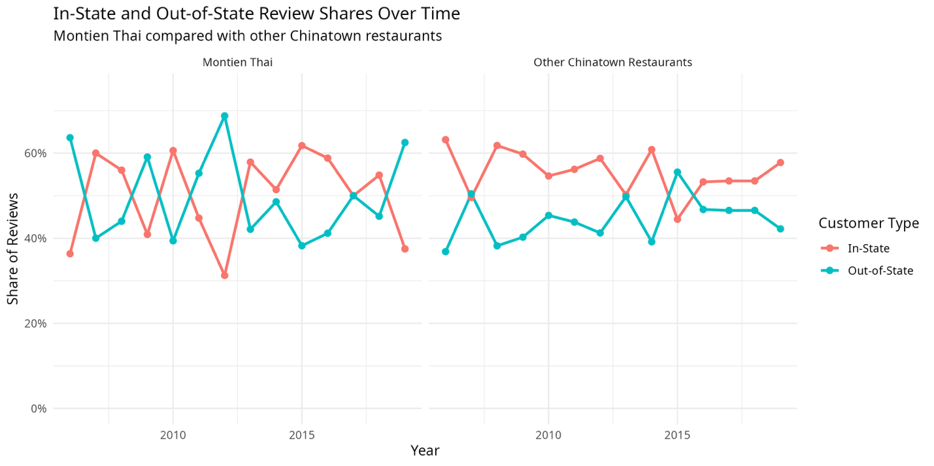
Figure 1. In-state and out-of-state review shares for Montien Thai and other Chinatown restaurants, 2006–2019.
Measure | Montien Thai | Other Chinatown restaurants
Average out-of-state review share | 49.8% | 44.5%
Average in-state review share | 50.2% | 55.5%
Airbnb regression estimate | −0.111 | 0.124
Statistical result | p = .719; R² = .011 | p = .431; R² = .053
Table 3. Descriptive results and simple regression tests for visitor review share.

Business decision
Neither regression was statistically significant, and both models explained very little variation. I therefore did not recommend building the growth strategy around Airbnb expansion. The more defensible decision was to improve the experience of visitors the restaurant already attracts while maintaining its local customer base.

3 Customer ratings and the clearest improvement opportunity
The second analysis examined whether local and visiting customers evaluated Montien Thai differently and whether either group differed from the Chinatown comparison. The clearest result was not the local-versus-visitor difference within Montien. It was the gap between Montien's out-of-state rating and the out-of-state rating for other Chinatown restaurants.
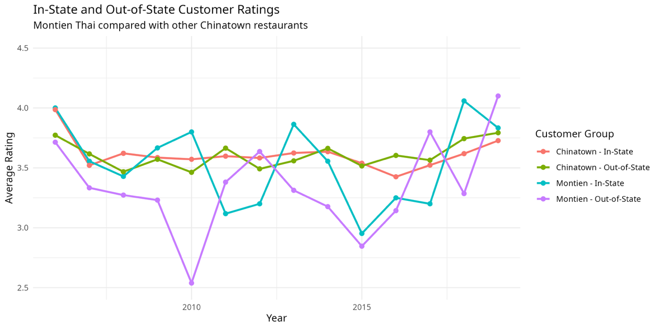
Figure 2. Average in-state and out-of-state ratings for Montien Thai and other Chinatown restaurants, 2006–2019.
Comparison | Average difference | p-value | Interpretation
Montien local vs. Montien visitor | +0.194 | .166 | Not statistically significant
Montien local vs. Chinatown local | −0.077 | .349 | Not statistically significant
Montien visitor vs. Chinatown visitor | −0.266 | .0123 | Statistically significant
Table 4. Paired comparisons based on annual rating differences.

Business decision
Montien's average out-of-state rating was 3.341 compared with 3.606 for other Chinatown restaurants. Because that difference was statistically significant, I treated the visitor experience as the strongest measurable improvement opportunity. The tasting option should therefore make the restaurant more approachable and memorable for existing visitors, rather than serving mainly as an Airbnb-focused attraction.

4 Competition and review activity
The final analysis used the number of other Chinatown restaurants represented in the historical dataset as an operational measure of competition. That count increased from 13 restaurants in 2006 to 53 in 2019. I then compared Montien Thai's annual review activity with the average review activity of the other restaurants.
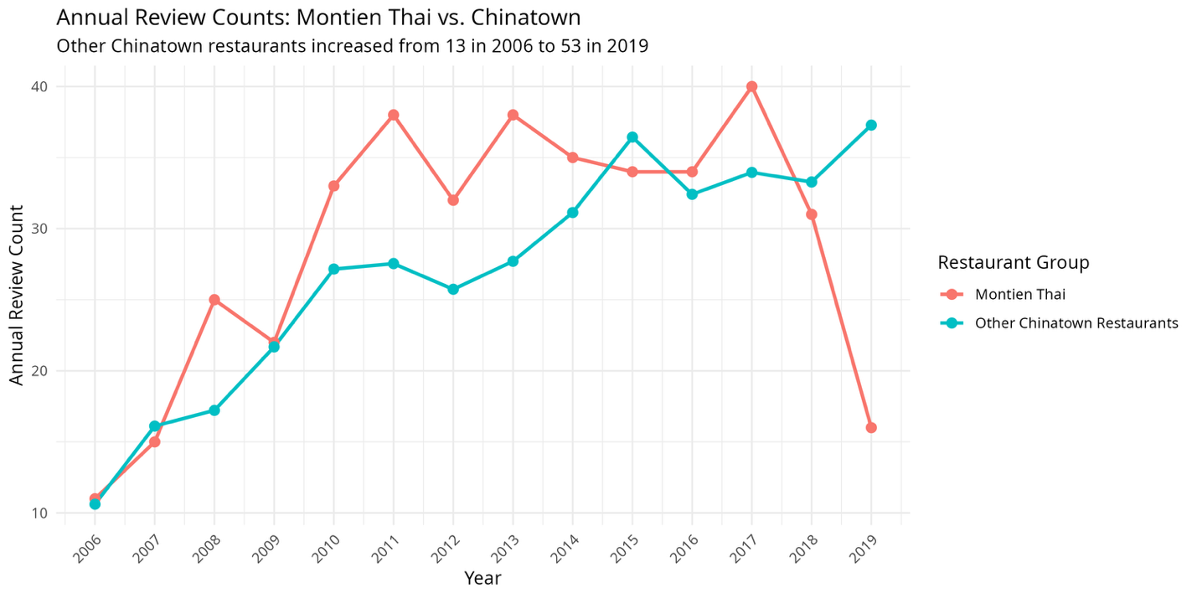
Figure 3. Annual review counts for Montien Thai and other Chinatown restaurants, 2006–2019.
Evidence | Result | Interpretation
Average annual reviews | Montien 28.86; others 27.02 | Montien averaged 1.84 more reviews across the full period
Montien trend | Estimate 0.234; p = .317 | No statistically significant increase
Other restaurants' trend | Estimate 0.588; p < .001 | Review activity increased consistently
Review-gap trend | Estimate −0.355; p = .0581 | Downward pattern, but not significant at .05
Table 5. Trend evidence used to evaluate the need for differentiation.

Business decision
Other Chinatown restaurants gained review activity more consistently, which strengthened the case for differentiation through Thai identity, food, atmosphere, and a focused tasting experience. I did not claim that competition caused Montien's results because the review-gap test narrowly missed the .05 significance threshold and the dataset does not capture every competitive factor.

5 How the evidence changed the strategy
The value of the project was not confirming the first idea. It was identifying which parts of the idea were supported, which needed revision, and what the owner should test next.
Original assumption | What the evidence showed | Revised strategic decision
Airbnb growth would expand Montien's visitor opportunity | No significant relationship between Airbnb concentration and out-of-state review share | Do not make Airbnb growth the foundation of visitor promotion
A tasting option should mainly attract tourists | Montien already had a meaningful visitor share, but visitor ratings trailed the comparison group | Use the tasting option to improve the experience of visitors already choosing the restaurant
More competition directly reduced Montien's visibility | Other restaurants' reviews grew consistently, but the review-gap trend was not significant at .05 | Differentiate clearly without claiming a causal competitive decline
Table 6. Strategy revisions made in response to the analysis.

Final recommendations
- Maintain a dependable, reasonably priced regular menu for the restaurant's local base.
- Test a small Thai tasting option that introduces visitors to the restaurant's food and identity without replacing the core menu.
- Use a simple repeat-visit reward to encourage retention and create a measurable return behavior.
- Monitor visitor ratings, tasting purchases, food cost, customer value, and repeat visits before expanding the concept.

Connection to the rest of my portfolio
- This analytics project established the evidence-based restaurant strategy.
- The guest operations project demonstrated forms, approvals, SharePoint records, and automated communication.
- The Business Intelligence project converted the recommendations into recurring KPIs and a dashboard the owner could review each week.

Skills demonstrated
Skill | Project evidence
Business framing | Converted a growth idea into distinct questions tied to owner decisions.
R analysis | Cleaned, filtered, summarized, modeled, tested, and visualized historical data.
Statistical judgment | Distinguished significant results from suggestive or unsupported patterns.
Consulting communication | Revised the strategy when the evidence did not support the original assumption.

