Montien Thai Business Intelligence Dashboard Case Study
Darliree Brumfield | Portfolio case study | November 2026
I designed and built a Business Intelligence dashboard prototype for Montien Thai. It tracks a Thai tasting option, repeat visits, food costs, and customer value through five KPIs. Its purpose is to give the chef, manager, and owner a consistent way to review the strategy and decide when changes may be needed.
The original prototype used Excel, OneDrive, Outlook, and Power Automate. I later rebuilt the dashboard in Data Studio using Google Sheets so it will remain accessible after my academic Microsoft account closes. The rebuild keeps the same KPI logic and management purpose in tools I can continue maintaining.
Project detail | Summary
Project type | Business intelligence dashboard and recurring management reporting prototype
My role | Strategy translation, KPI design, data planning, dashboard development, automation testing, and interpretation
Current tools | Data Studio and Google Sheets
Original prototype | Excel, OneDrive, Outlook, and Power Automate
Data status | Illustrative operating records developed for an academic case study

Project context
This academic case study uses illustrative operating records. It is an independent portfolio demonstration, is not an official Montien Thai system, and is not affiliated with the restaurant. The results do not represent Montien Thai's actual business performance.

My contribution
My work covered translating the earlier strategy into recurring decisions, defining the KPIs and proposed targets, organizing the sample records, designing the dashboard views, and testing the scheduled report. The following pages explain the solution and connect the decisions to screenshots of the prototype.

1 Business problem and KPI framework
My earlier analysis recommended maintaining a dependable regular menu, testing a small Thai tasting option, and using a simple reward to encourage repeat visits. It also showed that visiting customers' experiences needed more attention. A one-time analysis supported the strategy, but the owner would still need an ongoing way to monitor tasting feedback, repeat visits, food costs, purchases, and customer value.
The BI solution connects those measures to specific decisions. The chef reviews dish-level feedback before adjusting a tasting sample. The manager reviews purchases, value ratings, and food costs before recommending changes to menu placement, portions, or price. The owner reviews the rewards program and approves broader changes.
KPI | Result | Target | Decision supported | Review
Tasting sample rating | 3.5/5 | At least 4/5 | Keep, adjust, or replace a tasting dish after reviewing comments | Weekly
Rewards member return rate | 30% | At least 30% | Continue or revise the repeat-visit reward | Monthly
Tasting option food cost | 40% | 35% or less | Review recipe costs, portions, suppliers, or price | Monthly
Tasting option purchase rate | 20% | At least 20% | Review menu placement, staff explanations, and interest | Weekly
Customer value rating | 3.8/5 | At least 4/5 | Review affordability with costs before changing price or portion | Weekly
Table 1. Illustrative results and proposed decision rules used in the dashboard prototype.
The targets are proposed starting rules rather than verified industry benchmarks. A rating also needs enough valid responses before it should influence a change. The dashboard flags what needs attention, while the chef, manager, and owner remain responsible for deciding what to do.

Historical business context
The earlier dataset included 13 other Chinatown restaurants in 2006 and 53 in 2019. This supported the need for differentiation, but it does not describe the current number of competitors. I kept the context separate because it does not refresh with the weekly operating results.

2 Solution design and implementation
The original prototype stored feedback, rewards visits, menu costs, and tasting sales in separate Excel worksheets. Calculations produced the five KPI results and placed them in the dashboard and KPI_Report table. A scheduled Power Automate flow read that table and emailed the owner every Monday morning.
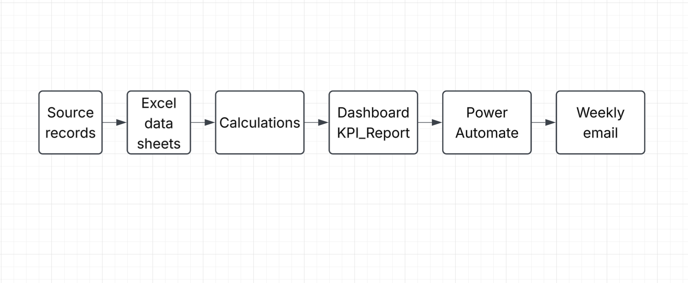
Figure 1. Original academic prototype data and reporting flow.

Prototype evolution
Stage | Technology | What it demonstrates
Original academic prototype | Excel, OneDrive, Outlook, Power Automate | KPI calculations, a scheduled Monday email, and a dashboard link
Portfolio dashboard rebuild | Google Sheets and Data Studio | A sustainable interactive dashboard that remains available after the school Microsoft account closes
Proposed next step | Google Forms and Google-based automation | Direct form-to-sheet collection, scheduled refreshes, and report delivery without relying on the school account
Table 2. The portfolio rebuild preserves the analysis while separating completed work from future integration.

Data responsibility and governance
- The manager would update the source records and check review dates, missing values, and duplicate submissions before each report.
- The chef would confirm recipes, standard portions, and ingredient costs before making food-cost decisions.
- The owner would approve price and reward changes instead of treating KPI thresholds as automatic decisions.
- Guest identifiers would remain restricted. The email report would contain summary results instead of names or contact information.
The Data Studio version reads prepared Google Sheets tables. The Google Forms are not yet connected to those sheets. POS imports, automatic review dates, and Google-based report delivery are also future improvements.

3 Executive dashboard
The executive view places the five KPIs at the top so the owner can compare results with their targets. The charts below compare local and visitor ratings and show daily tasting sales. These views help the owner see which result needs further review.
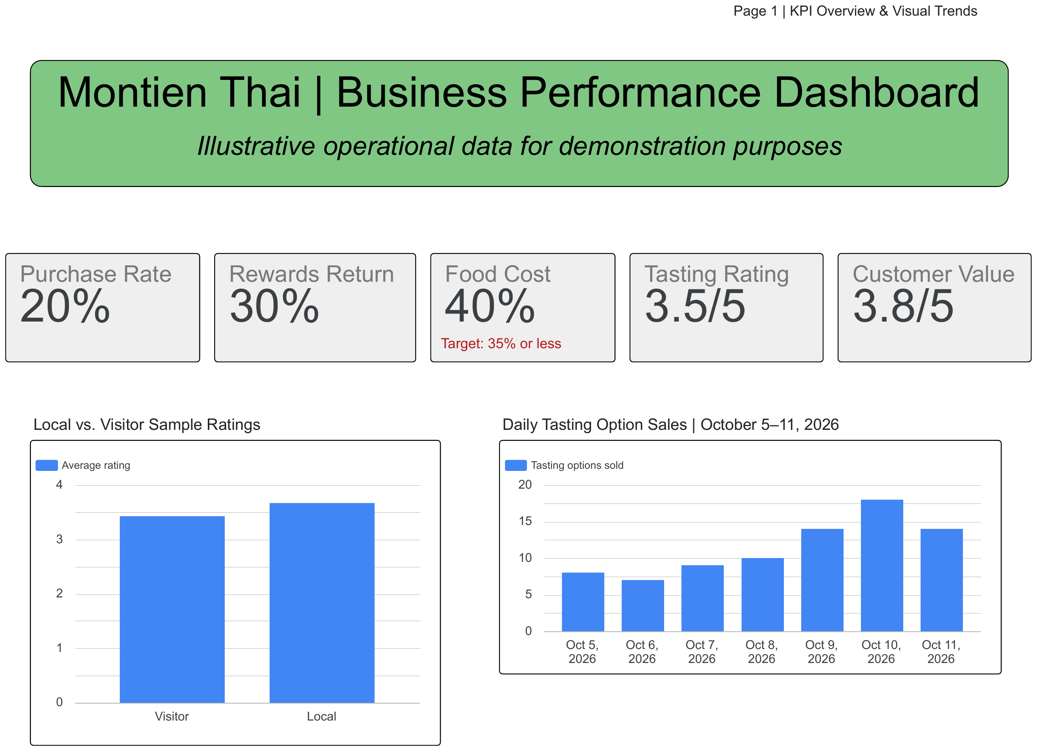
Figure 2. Data Studio executive KPI overview and supporting trends.

What the owner sees first
- The rewards member return rate meets the proposed 30% target.
- The tasting purchase rate meets the proposed 20% target.
- The 3.5 tasting rating and 3.8 customer value rating are below their proposed targets.
- The 40% tasting food cost exceeds the proposed limit of 35%.
These results do not automatically mean the tasting option should be removed or repriced. They show the owner what to investigate before making a change.

4 KPI interpretation and Monday decision scenario
The second dashboard page compares each KPI with its target and summarizes the management implications. This gives the owner a short review process instead of a set of charts without a clear purpose.
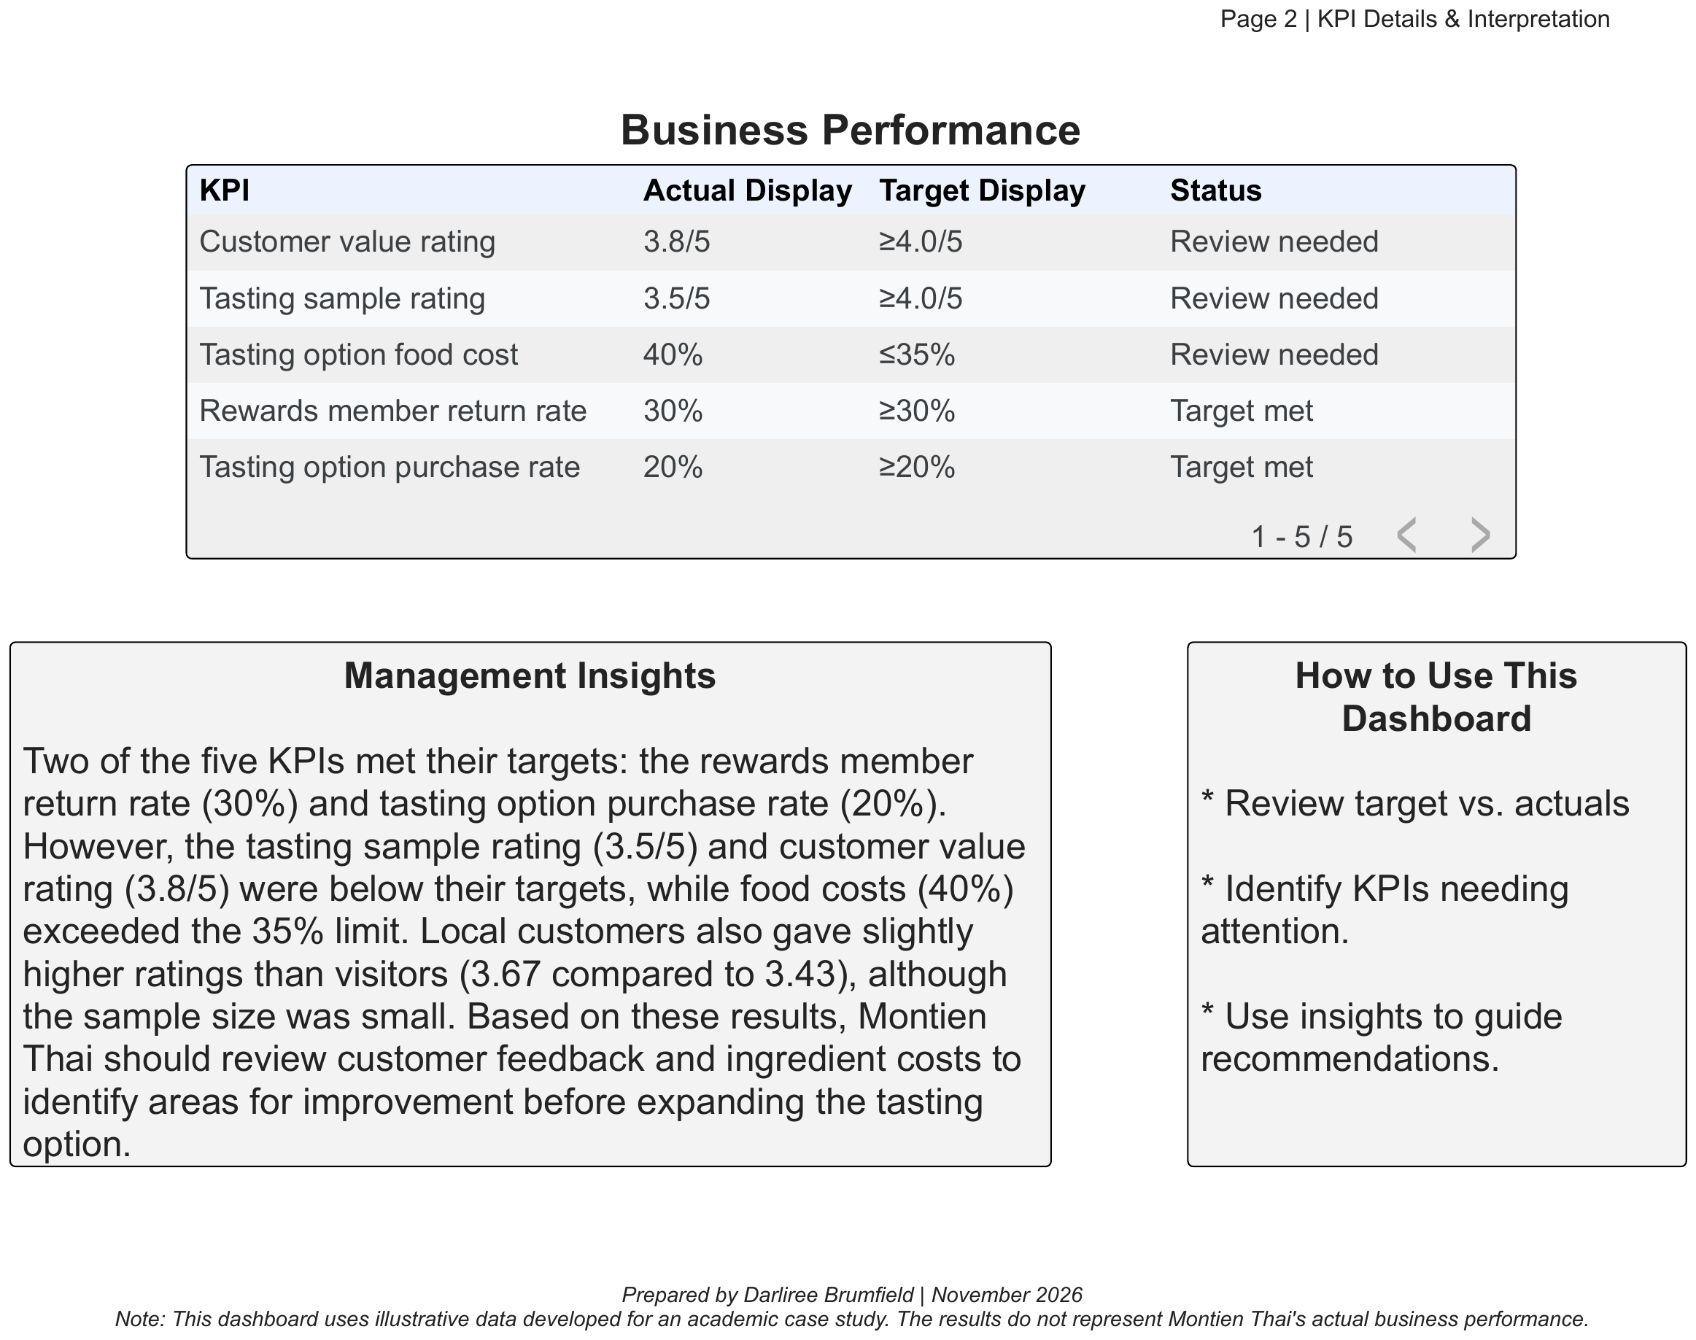
Figure 3. KPI details, status interpretation, and management guidance.

Monday morning scenario
- The owner receives the scheduled KPI report and sees that the tasting sample rating is 3.5, below the proposed target of 4.
- The owner opens the dashboard and reviews the comments before deciding what the average means.
- Repeated comments about sweetness prompt the chef to check preparation consistency and test a small sauce adjustment.
- The manager also reviews the 40% food cost and 3.8 value rating before recommending a price, portion, or ingredient change.
- The team monitors the next review period before deciding whether the adjustment should become permanent.
This scenario shows how the system supports a decision. The illustrative results do not prove that Montien Thai needs to change its recipes, prices, or portions.

5 Reporting automation, limitations, and next steps
I configured the original Power Automate flow to deliver the KPI report on a schedule. The flow used a weekly recurrence, retrieved the KPI_Report table, created an HTML table, and emailed the results. It automated report delivery while keeping the management decision with the owner.
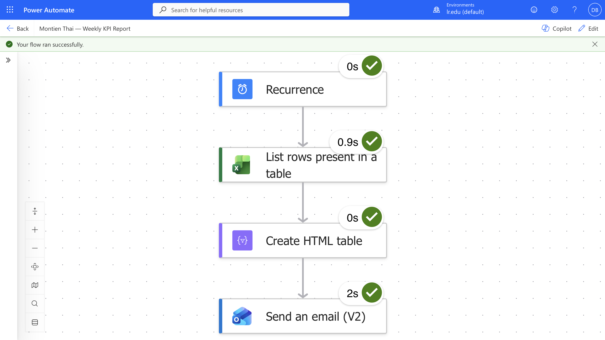
Figure 4. Successful Power Automate run for the original weekly KPI report.

What I would improve next
- Connect the Google feedback forms directly to the related Google Sheets tables.
- Add unique response and transaction IDs to manage duplicate, canceled, or refunded records.
- Automate the review-period labels and keep past KPI results for trend analysis.
- Replace the sample records with validated restaurant data and review the targets after a pilot period.

Skills demonstrated
Skill | Project evidence
Business intelligence | Translated recommendations into KPIs, targets, owners, and recurring decisions.
Dashboard development | Built executive and drill-down views in Data Studio using prepared Google Sheets data.
Workflow automation | Designed and tested a scheduled KPI report using Power Automate.
Data governance | Defined access, validation, privacy, and ownership responsibilities.
Decision support | Connected below-target results to an investigation and follow-up process.
Interactive dashboard: View the Data Studio dashboard

