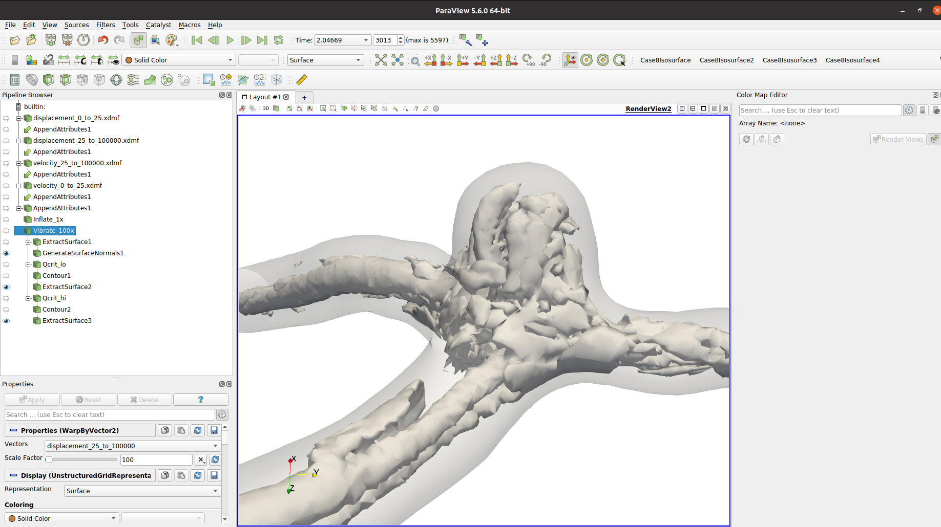
To make visualizations:
- In paraview, bring in High-Pass and Low-pass displacement and velocity. Append all attributes together and warp by 1x low pass disp and then another warp by 100x hi-pass (vibration).
- Make Q-Criterion isosurfaces, at Q=5000 for hi pass and Q = 50000 for lo pass. Extract surfaces for the Q-isosurfaces, and extract the outer, warped mesh surface and generate surface normals for a smooth surface.
- Export surfaces for desired timesteps, in this case it’s 2975 to 3013, just after peak systole. You want to find some range that roughly makes a loop, can be tricky.
- Run the pyvista script on the extracted surfaces to generate images of each timestep.
- Bring slideshow into kdenlive and make into a video

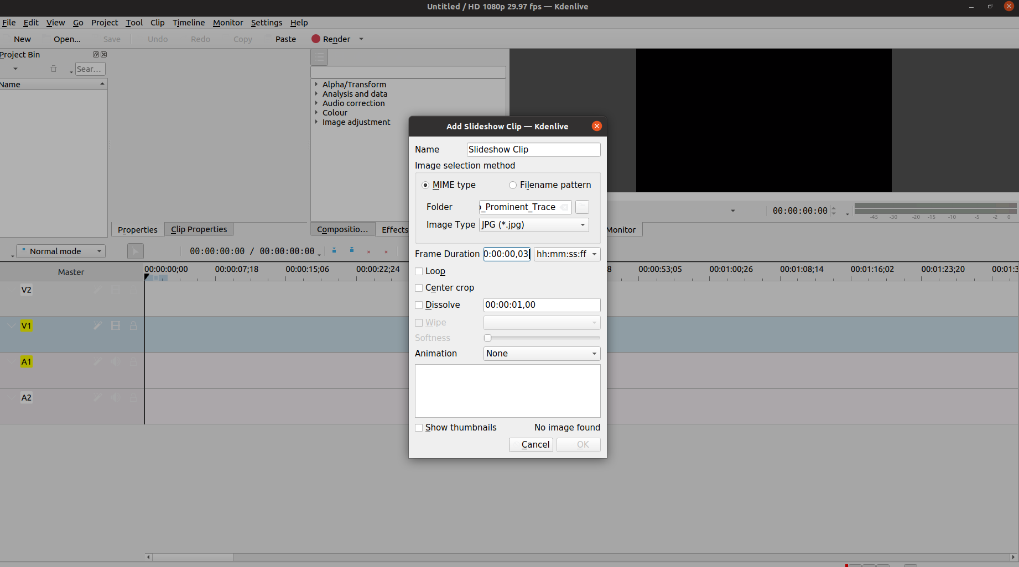
Paraview state file can be found in: scratch/s/steinman/dbruneau/7_0_Surgical/Pulsatile_Ramp_Cases/Case9_m047_predeformed_finerflow/file_case9_el047/1/visualization_hi_pass/Q_Displacement_Warped_For_Video2.pvsm

