Plane of Air Guide
By: Tashia of Xegony [Last Updated: Mar/2001]

Introduction

Plane of Sky is easily one of the best zones in Everquest, certainly one of the most interesting. It’s somewhat similar to the Temple of Solusek Ro in that a huge series of quests are available here. They are much harder than the temple Ro quests and they are all performed within the plane itself. These quests involve returning a series of items from slain MOBs. That’s not to say that MOBs only drop quest items, they don’t, they also drop some nice items to take home with you that aren’t necessarily linked to quests.
To enter the Plane of Sky, you'll need a Cloudy Stone of Veeshan and a wizard of level 46 or higher to port you there using a spell called "Alter Plane: Sky". The stone is used by the wizard as a reagent in casting the portal spell and one stone is required to take a party of 1-6 players into the plane (including said wizard). The stone is available in the Erudin library for approximately 220-250 platinum on the top floor of the library.
It is generally assumed that players bring at least 50 plat when being ported by a wizard to cover the costs of the reagent. You will also need to be level 46 or higher in order to be ported into the zone. If you die while you are in the zone and lose level 46, you will not be able to have a wizard port you in. The only form of entrance back into the zone in this case will be via clerical resurrection.
When you first enter Plane of Sky, you are not aggro, unlike entering many of Norrath’s other planes. You’ll find yourself standing on an island, all buffs wiped from your character. This island is the first of many in the plane, each one visitable via teleport. In general, clearing one island of MOBs provides the keys necessary to visit the next island in the chain using a locked teleport pad. Each key takes a single person, NOT a group. These keys are not soulbound and they are not no rent but they will disappear if you leave the plane. For this reason, if you get a key, you can camp or go link dead and still have the key but the moment you leave the plane, they’re gone. There are nine islands in total, as well as a small room inside the first island full of efreeti lords who give out the aforementioned quests. These islands float in mid-air. If you look down off the edge of an island, you’ll see sky below you.
To exit the plane, simply jump off an island and freefall until you eventually zone in mid-air. You’ll end up falling out of the sky in East Freeport into the water some distance off the docks. For this reason, you don't want to fall off an island while in battle. Once you've zoned out, you'll need a wizard to port you back in, hence, another Cloudy Stone of Veeshan, and you'll most probably be the one paying for it. Just as a side note to falling off islands: If you die while falling off an island (say to a DoT), your corpse will either lie at the bottom of the zone and be unrecoverable (in which case you’ll need a necro to Summon Corpse) or it may be teleported back to the first island for easier recovery by the AI.
Jumping off an island is the only form of exiting the plane. Gating is not allowed in the Plane of Sky. Many other spells are not allowed in this plane, including Call of Hero, Bind Affinity, Levitate, Dead Man Floating or any Memory Blur or portal spells. The only exception to this is “Alter Plane: Sky” which can teleport people back to the first island minus whatever aggro they had before they teleported. Again though, this would require another Cloudy Stone of Veeshan. Summon Corpse is allowed, thankfully, and Jade Inlaid Coffins used for summoning player corpses can easily be bought here from the Key Master on island one, who also charges the same outrageous costs as every other vendor in Norrath. He does NOT sell the stackable coffins. Some pets are unavailable or different in this plane. Mages can only summon air pets, which look different (like female genies with an annoying laugh). Necro pets are slightly less effective in this zone, and enchanter/shaman pets are the same as normal. Enchanters are somewhat cut down here as well. Mez works fine on the first and third islands but after that it starts to lose it’s effectiveness and color stuns have to be used with necros feeding mana.
It is generally never a good idea to either duel or cast area effect damage or stun spells in Plane of Sky. On the first island, dueling will aggro the quest based efreeti’s underneath in the quest room who will begin death touching players and wiping out the raid very quickly. Dueling on Gorgalask Island will cause passing MOBs to consider you free game and will begin attacking you immediately. Area effect spells also have similar effects. Even area spells with very small ranges like the enchanter line of color stuns will aggro
things like the efreeti’s under Key Master Island. Another thing to take note of are weapons that proc area effect damage or stuns as these will be just as dangerous. As a general rule, you never know what area effect spells or dueling will aggro, so try to avoid it if you’re not one-hundred percent sure.

Island One – Key Master Island (non-aggro)

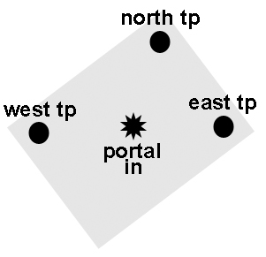

When you zone into the plane and find yourself standing on the first island, one of the first things you’ll see is a MOB called the Thunder Spirit Princess as well as a dwarf NPC called the Key Master. We’ll talk about them in a sec. First, let’s talk about the rest of the MOBs on the island. The outer edge of the island is dotted with a circle of eight Thunder Spirits (level 50), placed far enough apart that they don’t aggro each others when attacked. Because they are so close to the edges of the island, you want to surround them with tanks when attacking so as to prevent them falling off the island or getting too close to the other spirits/princess. They hit for up to 160 DMG and proc Choke, a low level DoT. After killing all eight Thunder Spirits, you should have a collection of 24 key pieces (Miniature Swords and Lost Rabbit’s Feet), as each slain spirit yields three swords and three rabbit feet. These can be collected by players and turned into the keys necessary for teleporting to the next two islands after killing the island “boss” (see below).
You’ll also see the Key Master (level 53) when you zone in. This is a little dwarven vendor who sells a selection of items including mana batteries, keys, and coffins for corpse recovery. Before you think about doing something stupid like attacking him, don’t. If you attack him, he'll death touch you. He's never been taken down and can't (he may be level 53 but he hits for 1800+) so don't get any zany ideas. You also don't want to attack him because once he gets out of position, he won't respond to hails or sell items. He'll start saying things like "I am too busy right now" and such. If you do aggro him through other means, such as an area effect spell off a procing sword for example, he'll attack the person responsible for the attack, but not the party or everybody else in air, just the person who ticked him off. The Key Master sells keys for the teleport pads. These are the Key of Swords (510pp), Key of the Misplaced (255pp), and Veeshan’s Key (1 copper). He also sells unstackable Jade Inlaid Coffins for use as a reagent in the necro spell Summon Corpse, but not the stackable version. Lastly, he sells a wide variety of Mana Batteries, as well as a Box of the Void.
There are three teleport pads on this island, used to take you further into the plane (stand on the pad, hold the appropriate key in your cursor, and click it on the pad). The teleport pad in the west corner of the island requires a Key of Swords, which takes you to the second island. The teleport pad in the east corner of the island requires a Key of the Misplaced, which takes you to the third island. The teleport pad in the north corner of the island requires Veeshan’s Key, which takes you to the quest room inside the first island.
Each island generally has a “boss” MOB of some sort. The “boss” MOBs generally drop uncommon/rare quest related pieces or other good items. On this first island, it’s the Thunder Spirit Princess (level 53), located in the center of the island. As a general strategy, you want to leave the “boss” on each island until the end and clear the rest of the island first. She will come to the aid of any Thunder Spirit being attacked so don’t let the spirits you fight get close to her when you fight them. She hits in the mid 200s and also procs the same Choke DoT as the regular Thunder Spirits. Because the middle of the island is somewhat depressed, pulling her to the outer edge of the island where you did the other spirits is a good idea, so as to reduce the risk of aggroing the quest efreetis under the island. This sometimes occurs when fighting her in the center of the island. When the princess is slain, a MOB you’ll come to know and love spawns in her place, a halfling called Sirran the Lunatic (level 63).
Sirran The Lunatic, like the Key Master, should never be attacked. He hits for 2000+ and death touches so you’ll pretty much be dead before you can say “mommy”. Once he spawns, he will despawn 45 minutes later. Do NOT hail or say anything to Sirran or he will begin attacking you immediately. Hey, he’s a lunatic, what do you want? Each player approaches him, one by one, handing him their tiny daggers and rabbits feet from the slain Thunder Spirits. In return, he will give you a Key of Swords (from Miniature Swords) or a Key of the Misplaced (from Lost Rabbits Foot). Whether you hand in both pieces at once or one at a time doesn’t matter. It also doesn’t matter if everybody does it at once. In this fashion, you can get the keys to islands 2 and 3 either by killing all the Thunder Spirits or buying the keys off the Key Master for an outrageous sum of money. When you hand in your pieces, Sirran shouts out, “These are the keys! Use them well! Hold them in your hand and touch them to the runed platforms! Guide you they will! Hah! The last to go, must tell me so, or be in for a [hassle]. If there is a hassle I will go!” Now I’ve never followed Sirran’s conversation, but I wouldn’t be surprised if it ends in death.
Both the Thunder Spirits and the Thunder Spirit Princess are on an eight-hour spawn cycle so you can get at least 24 keys for people every eight hours. If 24 keys aren’t enough for the people you brought up for your raid, you have three options. Either they can buy keys off the Key Master, wait another eight hours and do another wave of Thunder Spirits, or die and be corpse summoned / ressed up to an island by a necro and cleric combo team (see appendix) who do have keys.
The importance of collecting key pieces cannot be stressed enough. The first island is generally done very quickly so as to keep a good pace to the raid. Because the spirit corpses rot in approximately six minutes, you can’t let them rot while you’re fighting another spirit. Make a list beforehand of the people in the raid, listing necromancers with Summon Corpse first, then clerics (level 56+, then level 49+, etc.), enchanters (C2 capable first, then C1), all necros that can’t Summon Corpse, druids, shamans, wizards, mages, pallys, shadowknights, rangers, monks, warriors, and finally rogues. The reason for this seemingly bizarre pecking order is explained in the appendix under the paragraphs on corpse recovery after mass wipe-outs. After each MOB goes down, somebody should start shouting out three names at the top of the list and keep going until everybody had looted a MOB. If you can’t keep up, confusion ensues about who’s looted, who should loot, whether corpses have rotted, and this early in the raid that’s not good.

Island Two – Noble Island (non-aggro)

When you zone onto the second island, you’ll see three MOBs – the island is quite small in size. Set amongst this island is a rather sinister looking windmill. The first two MOBs are called Blade Storms (level 59). They hit for 360 DMG and are extremely magic resistant. They also proc a spell that taps stamina, HP, AC, and resists. On a rare occasion, they’ll drop something nice. The whole real point of this island, however, is the third MOB, Noble Dojorn (level 63).
Noble Dojorn is a big nasty efreeti who is quite magic resistant. Because the island is so small, some people pull the Blade Storms solo, kill those, then pull him into the windmill and fight him there to avoid falling off the island. Pulling the Blade Storms solo is difficult though so be prepared to fight him and the blades at the same time. He triple and quad hits for 350-400 DMG and casts a nasty area effect damage spell that is purely magic based. For this reason, you’ll need a lot of tanks with magic resist gear when you fight him, as well as clerics. He is guarded by the Blade Storms on this island. A good attack force for the noble would include 8 tanks (2800-3500 HP each), 8 clerics (CH only), 8 necros (twitching the clerics), 5 mages, 5 chanters, 2 druids, 5 bards, and 2 shamans with the mages having pre-made “mod rods” for all the casters. When hailed, the noble welcomes you to the island, requesting that you stay, now that his relatives are gone. Both Noble Dojorn and the Blade Storms are linked. If you attack the Noble, you’ll aggro the Blade Storms, and visa-versa. The Blade Storms circle the windmill in a repeatable pattern. Killing the noble spawns another efreeti lord “boss” on the fifth island, the Overseer of Air (level 55), much like Sirran the Lunatic being spawned as a result of killing island bosses.
On a side note, this island is also home to part of the Monk epic quest. There is a MOB called “a presence” (level 55) that is invisible, like a shadowed man, except for it’s name. If it is handed the charred scale from Eejag in Lavastorm Mountains, it spawns Gwan (level 57) who must be attacked and killed as part of the Monk epic. Aggroing him does not aggro Dojorn or the Blade Storms. He can be fought beside other MOBs on the island, but any ae procs or ae procing weapons will of course aggro the rest of the island. Gwan can be done approximately every two hours.
There are no teleport pads on this island and no MOBs drop keys to get off it. In that sense, it’s not entirely part of the chain of islands in this zone and those that come to Sky to do Gwan or Dojorn are here for a one way trip. The only option afterwards is jumping off the island. The Blade Storms are on an 8-hour spawn cycle. The Noble is on a 7-day spawn cycle.

Island Three – Azarack Island (aggro)

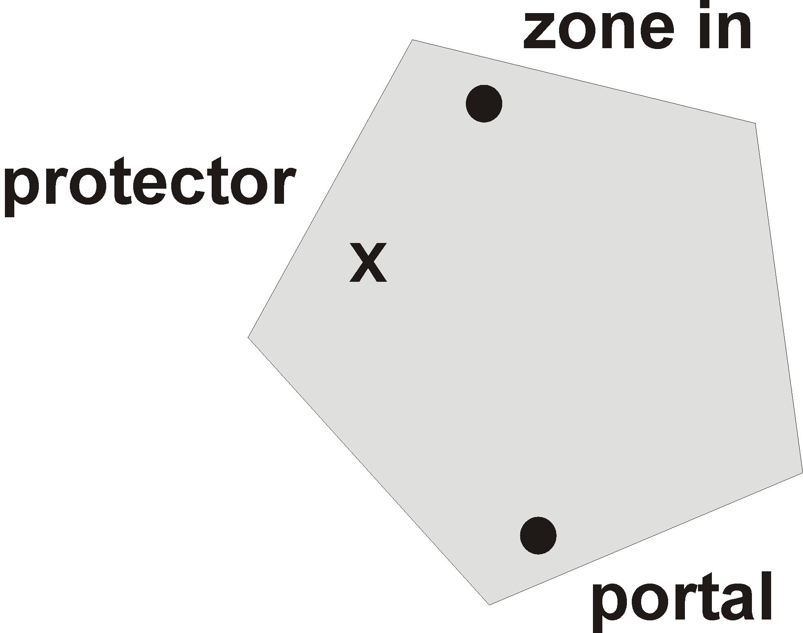

There are nine wandering Azaracks (level 53) that fly around. They look like imp protectors and are very aggro. They hit for around 190 and proc Whirlbolt, a 400 DMG targeted DoT. They also have a nasty attack that has a habit of tossing you a few feet into the air and making it difficult for you to look up or down, but still able to turn around (this could be an effect of Whirlbolt but I’m not sure). They have fairly low HP but odd resists. About half of the Azaracks have heavy cold resistances and the other half have heavy fire resistances. They drop Broken Mirrors, which are what are handed in for keys after the island is cleared. The “boss” for the level is the Protector of Sky (level 55), another azarack, who hits in the 300s and procs Whirlbolt as well. He is not on the island when you first get there, but rather is spawned after the death of the last wandering azarack on the island. He usually drops an uncommon/rare quest piece, four Broken Mirrors, as well as some other nice items. His death, much like the death of the Thunder Spirit Princess on the first island, triggers the spawn of Sirran the Lunatic, who, upon giving him a Broken Mirror, will give you a key (the Key of Misfortune) that will enable access to the fourth island. He will also shout out, “You move fast, you crazy kids! Keep going! Prod you I will! Stuck here I have been! Oh! Let me know when you are [done] or this will be no fun! Haha!” Like the first island, clearing a wave of azaracks will yield 24 key pieces (four of those from the Protector of Sky). Handing them in one at a time to Sirran will yield the key to island four, for which there is a teleport pad on the island. The Protector of Sky only appears after the last of the azaracks are killed. The Azaracks are on an 8-hour spawn cycle.
What makes this island difficult is that it’s aggro. When you first enter it, you will almost certainly be attacked. You can, however, reduce the risk of this happening. Shrink and invis everybody before going up. This will lower your aggro considerably. The imps fly overhead and the smaller you are, the less chance you stand of being whacked. Barbarians, being the tallest, stand the greatest risk of aggro. Once you come up, move along the left edge of the island to the back (walk along the left edge for about 10-15 seconds and you’re at the back of the island). You may get attacked along the way but hopefully not. The back of the island is the best place to pull from because you’ll get the fewest “adds”. On a good note, enchanters can actually do some crowd control here – mez can work but it’s sometimes difficult without a tash beforehand. Never let an imp go untanked though – if another imp comes (and it probably will), put a tank and a few clerics on it to keep it busy while everybody finishes off the rest.
Again, let me stress the importance of looting the corpses. Because the imps aren’t level 55+, their corpses are going to rot in six minutes. Chances are, you’re going to get rushed and have lots of dead people and dead corpses on the ground. Don’t let corpses rot in the confusion of battle. People should loot during the fight so as to avoid letting them rot. Quest items should be looted as well. All quest items are lore, but not no drop. They can be lottoed for after the fighting stops.

Island Four – Gorgalask Island (non-aggro)

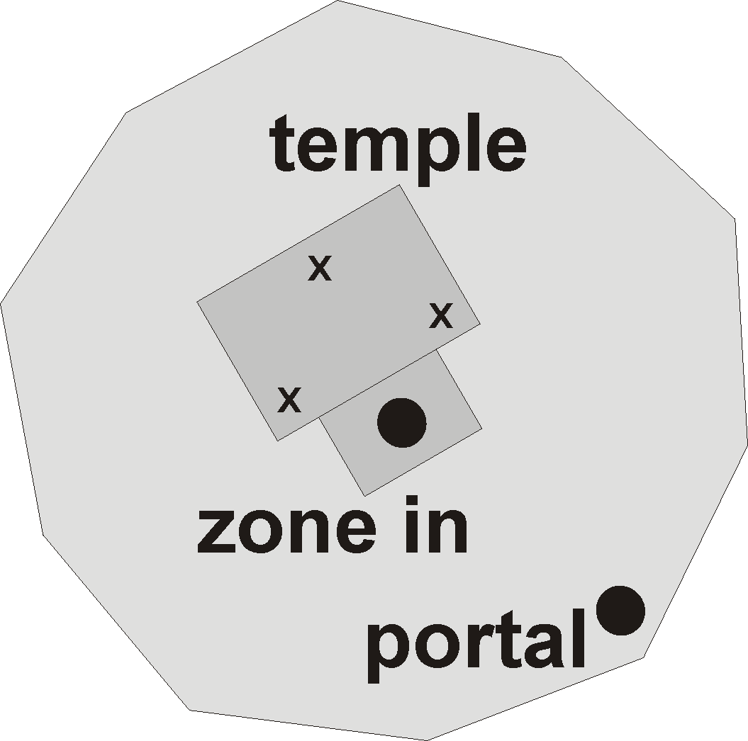

After having a nasty stint with the imps, it’s nice to be able to zone in to another island and not be jumped automatically. For this reason, raids will sometimes camp here for the night and come back the next evening. Most long term Plane of Sky raids take a few days to complete with camps outs every time in non-aggro spots. For this reason, a Plane of Sky raid requires a high level of commitment. The same people that are there the first night have to be there the second night and the third, etc. Gorgalask Island is large, which is nice – you finally have some room to move. A great place to set up camp and start pulling singles is the teleport pad although there is some small risk of aggroing the MOBs inside the temple, so be careful.
On this island there is a small temple with various MOBs moving around on the island and three named MOBs inside the temple. There are five types of MOBs to be found roaming around. We’ll go through them one by one, discussing their strengths, weaknesses and the overall strategy of taking these MOBs on.
The Gorgalasks (level 54-56) look just like the Gorgons from the Plane of Fear (a.k.a. Harpies with snaked tentacles coming out of their heads). There are four of them on the island, flying around. They have high HP, AC, and resistances. They hit in the low 300s and proc a targeted stun. Towards the end of the fight, they will become Enraged. This turns all melee attacks back on their targets, so during this period, it’s time for casters to let loose with all they’ve got and tanks to back off a bit or they’ll get shredded by their own weapons. Similar to the Gorgalasks are the Spirited Harpies (level 53). They look similar in appearance but don’t have snaked tentacles coming out of their heads. There are four of them on the island as well. They have all the fighting characteristics of the Gorgalasks but they also have a Harm Touch that gets recharged every five minutes and have a low-level necro pet with them.
Watchful Guards (level 55-56) look like Evil Eyes. They hit in the low 300s and have a low-level Enchanter pet. They cast standard enchanter DDs but also have area effect dispelling (4 buffs dispelled) and Gravity Flux. There are five of them on the island. Enchanters could probably get off a color stun on these but considering that you probably won't get it off every time, you might as well not bother, seeing as they'll eventually get a dispell through at some point.
Gusts of Wind (level 53) and Crystalline Clouds (level 53) look like air elementals. They hit in the 200s and cast stun. They can also be mezzed, which is a nice plus. Like any good air elemental, they also have the ability to invis themselves. There are five of these air elementals on the island, a mix of gusts and clouds.
Shimmering Meteors (level 55) sit atop the temple. They look like will-o-wisps except they’re coloured red. There’s one on the top of each pointed tip of the temple roof – five in total. They hit in the mid to low 300s and cast a Knockback spell. For this reason, fight them facing the edge of the island so that if you get thrown, you move backwards across the island and not off the edge. Another great way to fight these is inside the temple if you can. They have high HP, AC, and resists. These are generally fought after the elementals, evil eyes, and harpies have all been slain.
Once you’ve done away with all the inhabitants of this island, you can move in to finish off the “bosses”. There are three on this island, all located inside the temple. Inside the temple to the left is the Avenging Gazer (level 57-58), in the center is the Heart Harpie (level 58-59), and on the right is the Gorgalosk (level 61-62). The Avenging Gazer is a large, nastier version of the Watchful Guards. It hits in the high 300s and is an enchanter, casting the same spells as the Watchful Guards. It has very high HP, AC, and resists. The Heart Harpie is a large, nastier version of the Spirited Harpies. The harpie hits in the high 300s, casting the same spells as Spirited Harpies. It also has very high HP, AC, and resists. The most important MOB however, is Gorgalosk. Gorgalosk is a large, nastier version of the Gorgalasks. It hits in the high 300s and has the same spellcasting abilities as the smaller Gorgalasks, also having very high HP, AC, and resists. It will also become Enraged close to the end of the fight, much like with the other “bosses” in the plane. It’s the only MOB on the island that responds to hails, which is fortunate. That means you can pull the MOBs out, have somebody feign, and let the MOBs wander back while you keep the Gorgalosk around. The Gorgalosk also has triggers to continue chatting with it – don’t. Follow that conversation with the Gorgalosk far enough and it will aggro on you. There may also be a human MOB up in the temple called Gkzzallk. He can be ignored, as he is part of the necromancer epic quest and is not killed as part of the epic. If killed, he drops nothing. If he’s up, he’ll be in the far right corner of the temple as you’re looking into it, just right of the Heart Harpie.
Pulling MOBs from the temple can be difficult. You can pull the Gorgalosk out, hail it, wait for the others to go back to the temple, and do the Gorgalosk away from the other MOBs but then you get Sirran The Lunatic. The downside to that is, you have to do the rest of the island in the 45 minutes while Sirran is up and you risk aggroing him if you fight too close to him. There are different ways of pulling the temple, all of them dangerous. One of the most popular is to pull the MOBs out to the edge of the island, letting the puller die, then as the MOBs go back, take the last one to leave as your target. This will probably entail a few feigning pullers and probably some deaths.
All of the MOBs, whether they be wanderers or temple “bosses” drop an Animal Figurine. The figurine is handed into Sirran the Lunatic, who gives you the key to island five (the Key of Beasts) and shouts out, “Always want something for nothing? Oh yes, you gave me something! Here you go! Take this! Used one you have. [Teleport] away you will! Let me know, or no kill! Haha!”. Sirran the Lunatic will spawn directly after the death of the Gorgalosk. All MOBs here have a spawn time of eight hours, but the main “boss” MOBs might have a larger spawn time.

Island Five – Harvester Island (non-aggro)

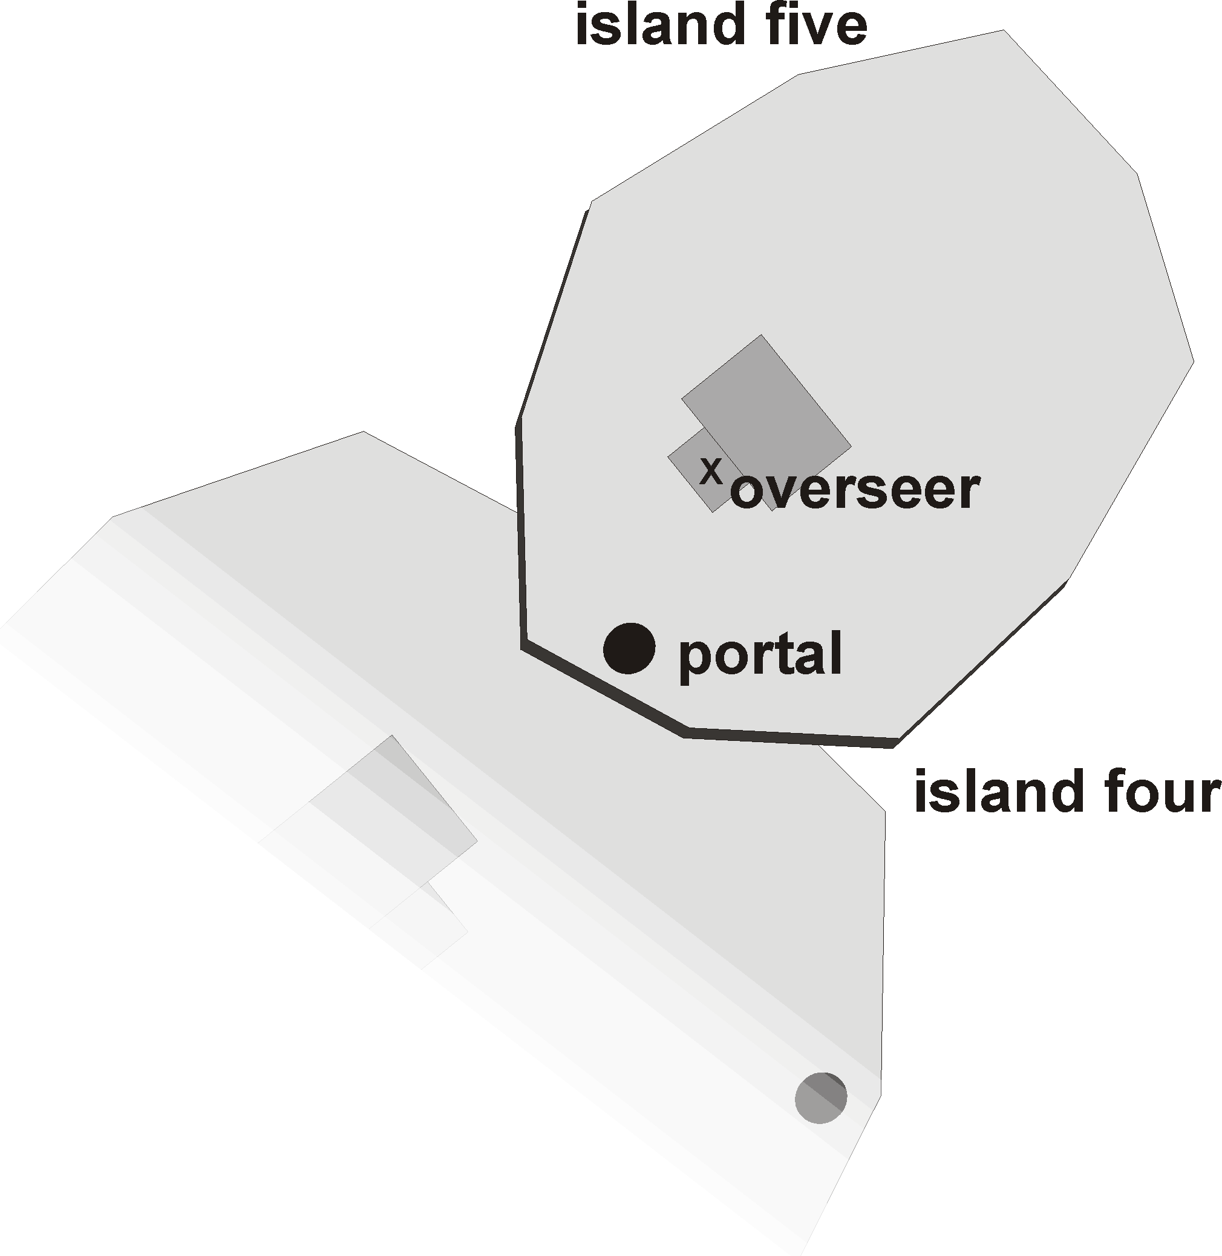
You’d think that after finishing off the fourth island, the natural progression would dictate you teleport up to the fifth island. Not so fast. The next island is full of flying horses and griffins that are not aggro but will assist each other. There’s really no room to fight effectively on this island without all hell breaking loose. It is far better to pull MOBs down to the fourth island after you’ve cleared it. So how is that done without levitate you ask? A cleric goes up, aggros a MOB, casts Divine Aura and jumps off the island to the fourth below them. In this fashion, the cleric is sure to live if they fall quickly enough to hit the ground while under the effects of DA. Hitting the fourth island below them isn’t too hard either – it sounds worse than it is. This can also be done with Safe Fall, but it’s not nearly as reliable. So let’s assume you’re on the fourth island pulling MOBs down from above you for the rest of this section. This leaves you with eight hours to clear both island four and five basically before four starts respawning, which shouldn’t be a problem at all.
There are 6 flying MOBs on the island, called either Soul Harvesters (level 52) or Essence Harvesters (level 52). This looks deceptively easy due to the lack of MOBs but it gets interesting, fast. The Soul Carriers look like griffins and the Essence Harvesters resemble flying Pegasus-like horses. They hit in the high 200s and cast stun. The griffins are susceptible to fire based attacks, where the “pegs” are vulnerable to magic based attacks. You only want to pull one and here’s why….
When these MOBs are attacked and killed, they split into two smaller versions of the MOB you just killed – which are smaller in size, NOT in level. The second generation of MOBs, known as Carriers instead of Harvesters, will both be level 54, but with higher HP, AC, and resists. They’ll also hit harder and despawn after 80 minutes if left undisturbed. It gets worse. When a Carrier is killed, it spawns another offspring, who is tougher as well. The offspring of a Carrier is a Tamer. Essence Tamers and Soul Tamers are level 56. Predictably, they have even higher HP, AC, and resists and hit even harder than the Carriers (in the 300s). They too will despawn after 80 minutes if left alone. Towards the end of fighting these, they will become Enraged so the tanks should be careful here. All of these MOBs drop Bird Whistles, 24 in all, just like on the other islands, and their respawn time on the first generation version of the MOB is eight hours as well. When the island “boss” is slain, these whistles are handed into Sirran the Lunatic for the key to island six.
There is one main “boss” to this island, known as the Keeper of Souls (level 58). It is NOT non-aggro; it will attack you on sight. It’s a large version of an Essence Harvester, the size of a dragon in fact. It hits in the 400s and casts stun as well as Death Touching. It will Enrage towards the end of the fight and when dead, it will drop 4 bird whistles out of the 24 available on the island. Killing it spawns Sirran the Lunatic. The Keeper of Souls isn’t automatically on the island when you first get there – it is a triggered spawn. Killing one of the 6 Harvesters off the island will spawn an NPC called Ekim Nottap. Ekim Nottap, in turn, despawns about an hour later, which, in turn, spawns the Keeper of Souls on the fifth island. Once spawned, the Keeper of Souls will remain up for 80 minutes before it despawns.
There is a second “boss” on this island, known as the Overseer of Air (level 63). The overseer is not exactly native to this island. He is a large efreeti lord that is spawned in front of the windmill on this island as a result of the death of Noble Dojorn. He will stay there for days after Dojorn is killed and does not have Blade Storms protecting him. Like Dojorn, he is not aggro. He does NOT have to be killed in order to progress to the sixth island, but if you intend to clear sky completely, you must. His death triggers the spawn of the Hand of Veeshan, the “boss” of island nine and the last MOB in the plane. He hits in the 700s and casts an area effect DD, a targeted DD, and Death Touches. He also dual wields daggers, which need to be disarmed at the beginning of the fight or he'll be able to quad attack. He has extremely high HP, AC, and resists. His death triggers the spawn of the Hand of Veeshan on the ninth island, the third and final efreeti of the plane.

Island Six – Spiroc Island (aggro)

Be careful when you enter spiroc island. You’re not going to get jumped when you zone in but nobody should move when they get in until everybody has zoned in, looked around, and gotten their bearings. If you move too far, you’ll aggro a wandering spiroc. A spiroc is a larger version of the multi-coloured, parrot-like aviaks in Ocean of Tears. There are several types of spirocs on this island. Of the 11 spirocs on this island, there are primarily three groups of spirocs. Each of these groups has a leader called a Spiroc Vanquisher (level 58) meaning there are three on the whole island. These must be killed before anything else on the island or other spirocs that you kill will start respawning back from the dead. Eliminate the Vanquishers and you eliminate that threat.
You want to set up camp right at the zone in. It’s a tight fit but necessary. The first pull is going to suck hard. You’re going to get two of the spiroc groups (6 MOBs in all, 2 vanquishers), but all three groups is more common (9 MOBs, 3 vanquishers) due to their very large aggro range. The good news is the spirocs can be mezzed. The bad news is the Vanquishers cannot be mezzed. Enchanters will be busy indeed. With the Vanquishers dead, you can move on to the remaining spirocs. These 4-6 birds will be any one of several types of spiroc. Spiroc Banishers, Walkers, Revolters, Explusers, Callers, and Arbiters (all level 51-52) make up the possible remainder of the spiroc groups. They hit in the 200s, cast Blind, Root, and an unresistable area effect DD called Lightning. The spirocs travel in pairs. The first pair is the Arbiter and Banisher (with Vanquisher in tow), Caller and Walker (also with Vanquisher), and lastly, the Expulser and Revolter (again, with Vanquisher). Spirroc Vanquishers (level 58) are tougher than their two followers. They fight with far more haste to their attack than the regular spirocs and they will become enraged toward the end of the fight. Once you’re finished with the 3 groups of spirocs, it’s time to take on the “bosses”.
The Spiroc Guardian (level 60) is a larger version of the other spirocs and casts similar spells. He hits for around 250 and becomes enraged towards the end of the fight as well. The Spiroc Lord (level 63) is the main “boss” of the island, however. He’s a nasty little aviak that hits in the high 300s, Death Touches, casts a stun much like the long stun off a Stone Spider in Solusek B, casts Blind, and has an unresistable area effect DD – very nasty.
All of the different spirocs drop Noise Makers, 24 in all. These are turned in to Sirran the Lunatic for keys to the seventh island. Sirran will, of course, spawn after The Spiroc Lord dies.

Island Seven – Bzzazzt Island (aggro)

There are only three MOBs on the seventh island. As usual, it sounds deceptively easy but it’s actually incredibly hard. The zone in process is pretty easy. The MOBs here don’t see invis, even though they have a huge aggro range. Once you zone in, look for a big gear embedded in the ground, go over to it and behind it. This is where you’ll handle the island from as you attack it’s MOBs, three deceptively easy looking bees. The Bzzazzt (level 50) look like wasps from Greater Faydark. They hit for 390 and cast Deadly Poison (a targeted 1200 DMG DoT). They aren’t very magic resistant at all, thankfully, which means they can be mezzed. Each of the Bzzazzt drop 8 Dull Dragon Scales, which are used to create keys for island eight with Sirran later on. Again, a total of 24 will drop over the course of clearing the island. The bzzazzt, much like the harvesters on island five, will split into offspring when killed. Their offspring are NOT mezzable and ARE magic resistant, except for perhaps Lure spells. All the offspring and beyond will become enraged towards the end of the battle as well which is pretty harsh considering the offspring hit in the 500s. The second generation of offspring is the Bazzzazzts (level 55) and the third generation is the Bizazzt (level 57), who hit in the 700s. The offspring don’t have a larger aggro range, so corpse recovery isn’t out of the question if you get wiped out BUT the offspring will despawn in 80 minutes, so you’ll have to be quick. This 80-minute timer also applies to the final “boss” of the island.
Now there is a specific pattern to pulling and clearing this island and we’ll refer to the MOBs from the perspective of behind the gear and looking at them. The left Bzzazzt will need to be taken out first. When it is pulled the other two will need to be mezzed immediately. The left Bzzazzt splits the same way as MOBs on island five (1 into 2 into 2, for a total of 5 MOBs). The next target will be the right Bzzazzt. This one splits 1 into 3 into 3 for a total of 7 MOBs so you’re looking at a tough fight indeed. In fact, you’re probably going to have to camp out a cleric at the “safe spot” behind the gear and res people in and finish off the rest of the 7 MOBs in a second wave. The center spawn is somewhat simpler. The Bzzazzt spawns another Bazzzazzt, which spawns the island “boss”, Bazzt Zzzt (level 63), a huge bixie. She looks cute, but get ready for pain. She hits for 850, Death Touches, has an area effect disease spell (it covers the whole island). If you survive all that, Sirran the Lunatic spawns. Hand him your Dull Dragon Scales and get a key for island eight.
Before moving on to island eight, there is some unfinished business with Sirran the Lunatic to take care of. He prompts you to tell him something, a phrase. The correct phrase to say is “?llaw eht htiw eno I ma” (“Am I One With The Wall?” spelled backwards). This sounds bizarre, but it makes sense if you’ve been following the things he talks about over the course of clearing the plane. Saying this to Sirran will spawn the Sister of the Spire on island eight. She is the “boss” of that island.

Island Eight – Drake Island (non-aggro)

This island contains a series of drake and sphinx MOBs. The island is completely non-aggro except for the Sister of the Spire. There is a large temple on this island with the Sister inside it. Killing the Sister will spawn the final Sirran who will provide you with keys for the final island. You can also pull the Eye or Hand of Veeshan down to island eight, but that’s pretty tough.
There are five Fatestealer Drakes (level 58) on this island. They’re the green ones. They have to be pulled first before the other drakes. They hit in the low 400s, proc a Whirlbolt-like spell (Levitate, Whirl-till-you-Hurl, possible DD or DoT) and cast Wizard spells. They have much higher HP, AC, and resistances than the black drakes, including resistance to Lure. There are also five wandering Heartsbane Drakes (level 56) – the black ones and the weakest ones. They hit for high 400s, proc a spell similar to Whirlbolt (Levitate, Whirl-till-you-Hurl, possible DD or DoT), and cast Wizard spells. They have very low HP and resistances. The Windrider Drakes (level 60) are the blue ones. There’s five of them as well and they’re easily the most powerful of the three types of drakes. They have to be pulled last due to their roaming paths around the temple – some are bugged and next to un-pullable. They hit in the high 500s, proc a spell similar to Whirlbolt and cast Wizard spells. They have very high HP and AC. It’s also been said that they’re not very magic resistant, but you have to stand very close to make the spell attacks land properly. All drakes drop a Replica of the Wurm Queen, which is your item to hand to Sirran for a key to island nine.
There are seven sphinxes on this island. Greater Sphinxes (level 54) are assembled in pairs around the temple. They hit in the high 300s, Death Touch, and cast Enchanter spells. They have an extremely small aggro range, which is a real blessing because they won’t aggro the other sphinxes when you pull one. Like the drakes, each Sphinx drops a Replica of the Wurm Queen. The other form of sphinxes are Great Sphinxes which are pretty much the same, except one level higher. Undine Spirits (level 53) are cleric based wisp creatures that are easy to mez. They’re found inside the ceiling of the temple, above the Sister’s spawn point. There are eight of them in all. Generally speaking, both the sphinxes and spirits drop the mage epic piece than many come to this island for, but it probably drops off the sphinxes more than the spirits.
Finally, there is the Sister of the Spire (level 63) in the temple itself, if you’ve spawned it on the previous island. She looks like the magician pets in sky and although she is technically aggro, her aggro range is very small. She hits in the 200s, casts an area stun spell, and Death Touches. She has very high HP, AC, and Resists. Like most “boss” MOBs here, she’ll become enraged near the end of the fight. Apparently, she’s an easier fight than the bixie “boss” on island eight and as an added bonus, she doesn’t see through invis. Her death spawns Sirran the Lunatic, who gives you Veeshan’s Key (the key to the last island) when you turn in the Replicas mentioned above. It looks and sounds the same as the key from the first island to get to the efreeti room. Who knows, maybe it even is the same key, but that’s doubtful.
There are two teleporters on this island, one around the back of the temple to the left, and one in front of the temple. If you get too close to the teleporter near the ninth island, you’ll aggro the Hand of Veeshan, who in turn will aggro the Eye of Veeshan (both MOBs on the ninth island) and you’ll be Death Touched from afar, so be prepared. I’m not sure which teleporter goes where, this is all second hand information at this point – sorry guys.

Island Nine – Butterfly Island (aggro)

So here it is, the final island. The Eye of Veeshan (level 63) looks like a cute butterfly. She is the only MOB native to this island so that makes her an automatic “boss”. She hits for around 170, procs an efreeti DD on almost every hit and also Death Touches. If you’ve done the pixie “boss” from island seven, you can probably do the Eye of Veeshan. The secret is apparently to rune the heck out of everybody to fight off the threat of lifetap, which she also procs. It’s a similar fight to Venril Sathir but with death touches. The fight overall is easier than doing Venril Sathir though because the melee damage from the eye is quite light. If you’re pulling it from below, the person who pulls is going to eat the Death Touch and somebody will pull it the rest of the way. You must pull it down to the island and have it level with you on the z-axis or none of the tanks are going to be able to hit it.
The only other MOB on this island is the Hand of Veeshan (level 63), who is the hardest MOB in the plane. It’s a triggered spawn, brought about by the death of the Overseer of Air and the final line in the series of three Efreeti lords in this zone. Suffice it to say that the damage this puppy deals out is staggering. Were talking around 1000 DMG, or so I’ve heard – extremely nasty indeed. Wish I could tell you more than that but I honestly don’t know anybody that’s engaged it or beaten it yet. Maybe nobody has, I’m not sure.

APPENDIX

Have a Goal!

When going to the Plane of Sky, one should go with a goal in mind. Most people don’t go with the express purpose of seeing how high they can get, it’s usually to complete pieces for people’s epic quests. The mage epic is probably the hardest, seeing as it involves getting to the eighth island. Mages also have some epic quest related MOBs in the efreeti quest room. Monks have epic MOBs on island two, and necros have epic MOBs on island four. Also, warriors need blades from The Spirroc Lord for their epic. Because of this, often the purpose of going to sky is to farm epic pieces from a particular island. Often, MOBs like Noble Dojorn are completely skipped, because they don’t really have to be done.
A raid to farm blades off The Spirroc Lord might see people getting as far as possible and then camping in a non-aggro spot so they can come back fresh the next day and farm The Spirroc Lord using a popular, yet questionable tactic mentioned above. A raid to the eight island for mage pieces could take several days. Be sure of what your goal is though before the raid is planned. Otherwise, everybody’s going to start bitching at each other about what to do, where to go, etc. once they’re inside the plane, and that’s no good at all.

Where Are The Maps?

There are some maps out there for sky. Almost all of them are excruciatingly bad. They don’t give an accurate picture of the way the islands are set up. The best way to do it is just jump in and experience it for yourself. Here are some maps .

What About All The Quests?

There are so many quests in sky that it’s simply mind-boggling. Trying to remember them all or what pieces are for what quests is almost impossible. Almost all items dropped in sky have to do with quests. Don’t let confusion rule and items rot! Be prepared and bring a chart listing what items go with what class/quest. There’s a great spreadsheet that careful outlines what is what. This is pretty much required reading for sky and whoever is in charge of lottos. You can find it here

What If We All Get Wiped Out Up There?

This is where things get interesting. There are two instances where you’re really screwed. Either you fall off an island and out of the zone or you all get wiped out on an island. Take a word of advice. Keep a cleric and necro (with Summon Corpse) camped on the first island and a cleric and necro (with Summon Corpse) on whatever current island you’re on. Let’s say you get wiped out on island four (non-aggro). The cleric logs in, resses everybody, and you’re back in business. That’s the easy recovery, but let’s talk about the harder instances.
Let’s say you all get wiped out on the Azarack Island. Try to get an invisible necro and cleric camped on the island before you get wiped. That way, the pair can log in, res a body while wanderers are away, invite them to the party, then be invised by the necro. Keep rinsing and repeating until you have enough people that the necro and cleric can camp out and let the others take over with that process. On the case of something like Bzzazzt Island, you don’t have this luxury. In a worst case scenario like this, you need to have everybody bite the bullet, buy new stones, zone up again like they did at the start, with enough money for coffins. They buy coffins from the Key Master, necros summon all the corpses down, then res ‘em, then you all start climbing back up again.
If you fall off an island, this process is more complex. A party must be formed in the raid, consisting of one necro and one wizard (not KoS in Erudin preferred), and space for the fallen party member (the wizard must be the party leader so he can invite). The player who fell off the island buys a stone for the trip back and the wizard invites them to the party. The wizard ports them back into Plane of Sky. Log in a camped cleric on the first island. Have the wizard and the player who fell off the island duel each other. The one who dies gets immediately Revived by the cleric on island one. Immediately after, the necro high above with the rest of the raid, summons their corpse. Finally, another cleric high above with the rest of the raid revives the player again using the summoned corpse and voila, they're back on the island. The cleric on the first island then meds up, duels the remaining party member, kills them, Revives them, and the Wizard is Summoned/Revived by the necro/cleric combo up with the rest of the raid. The cleric on island one can then camp and the rescue party can be dismantled so people can join their original parties.
A word of caution though here – you must be quick. If you don’t revive/summon/revive quickly, you won’t be able to revive the second time. The ability to revive is very short, only about three minutes. If the necro or clerics go linkdead in this relatively short time, it throws a serious wrench into the works. This also means that nobody should be killed unless the necro and both clerics are sure to have enough mana to do their work as soon as the player dies.

What If We Don’t Get Enough Keys To Take Everybody Up To The Next Island?

This process is similar to the above discussion about falling off islands. This is the prime reasoning behind giving key pieces to necros with the summoning ability and clerics. They can at least go up and bring up the ones who don’t have keys using this method.
Before going up to the next island, have a necro (with key) group with the players who don’t have keys. Then have the necro and a cleric (also with key) go up to the next island. Have a keyless member die to a duel, get revived a cleric down below, summoned by the necro above, and revived again by the cleric above with the necro. Rinse and repeat until those keyless members are up. This means you can do five keyless members for each necro with a key. Any more keyless members than that and you should probably wait for respawns for more key pieces.
Again, a word of caution here – you must be quick. If you don’t revive/summon/revive quickly, you won’t be able to revive the second time. The ability to revive is very short, only about three minutes. If the necro or clerics go linkdead in this relatively short time, it’ll mess things right up. This also means that nobody should be killed unless the necro and both clerics are sure to have enough mana to do their work as soon as the player dies.

What About Faction Issues?

Nothing killed in Plane of Sky results in a loss of any faction. You can come back repeatedly and everything that was non-aggro before will still be non-aggro. Some MOBs connected to epic quests give out faction losses, but these are usually faction losses specific to that epic and are not harmful for others to partake in.

Can Two Raids Co-Exist In Plane of Sky At Once?

It’s not too much of a problem but there is one issue that might become a problem and that’s Sirran. Let’s say a party of people up on island five spawn Sirran The Lunatic. Sirran must stay there for 45 minutes before depopping. That means that if a new raid comes into the zone and kills the Thunder Spirit Princess, Sirran will not pop while the other Sirran is up on island five. The party of raiders on island one is effectively screwed as a result. Working out who’s getting Sirran when should be an issue and it can totally ruin a raid high above that’s been going for days.

