ENSF381 – Lab06

**Section:** L03

**Date:** 2024-02-29

|  |  |  |
| --- | --- | --- |
| Created by: | | |
| First name | Last name | UCID |
| Hongwoo | Yoon | 30113779 |
| Steve(Hyunmyung) | Park | 30067689 |

# 2.5.1

https://github.com/dbsghddn21/Lab6

# 2.5.2

Github desktop commit history screenshot.

# 2.5.3

I chose ‘Githb Desktop’ since it was created by the github, which made me to think that it will be the most convenient and most secure.

# 3.6.1

https://65e15071d3db23f7624ac2a9.mockapi.io/students

# 3.6.2

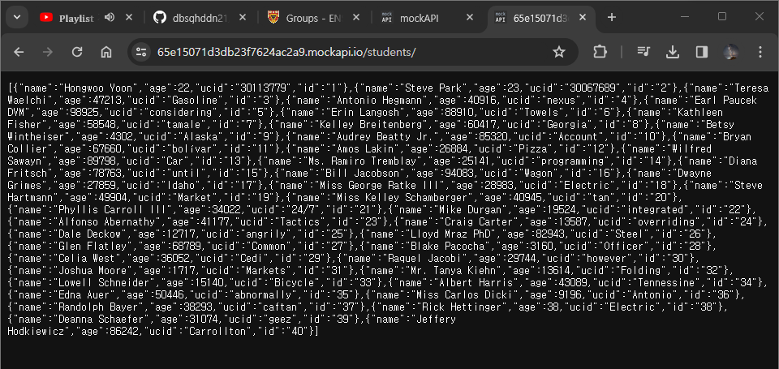

# 3.6.3

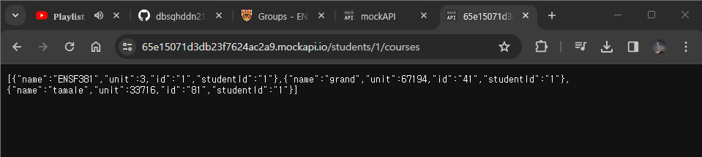

# 4.7.1

[Place for your answer]

# 4.7.2

[Place for your answer]

# 4.7.3

[Place for your answer]

# 4.7.4

[Place for your answer]

# 4.7.5

[Place for your answer]

# 5.4.2

[Place for your answer]