ENSF381 – Lab08

**Section:** L03

**Date:** 2024-03-13

|  |  |  |
| --- | --- | --- |
| Created by: | | |
| First name | Last name | UCID |
| Hongwoo | Yoon | 30113779 |
| Hyunmyung | Park | 30067689 |

# 2.4.1

https://github.com/dbsghddn21/Lab8

# 3.8.3

3.8.4

# 3.8.5

Since there is nothing under the path  "/product/add"

<Route path="*" element={<NotFoundPage />} /> {/* Catch all other route */}

This line will catch and show NotFoundPage for all the other routes that are not specified.

# 3.8.6

|  |
| --- |
| Pros |
| You can also pass an array of styles - the last style in the array has precedence, so you can use this to inherit styles. |
| it allows for quick styling and easy dynamic changes based on component state or props. |

|  |
| --- |
| Cons |
| it can lead to code redundancy and difficulties in maintaining styles for large projects. |
| It requires attention to syntax differences and nuances. |

Reference: https://codedamn.com/news/reactjs/how-to-use-inline-styles-in-react-js

# 4.3.3

[Place for your answer]

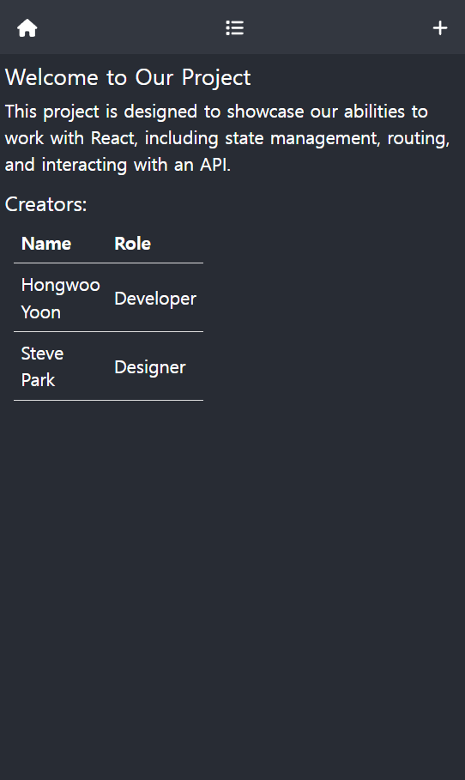

# 4.3.4

[Place for your answer]

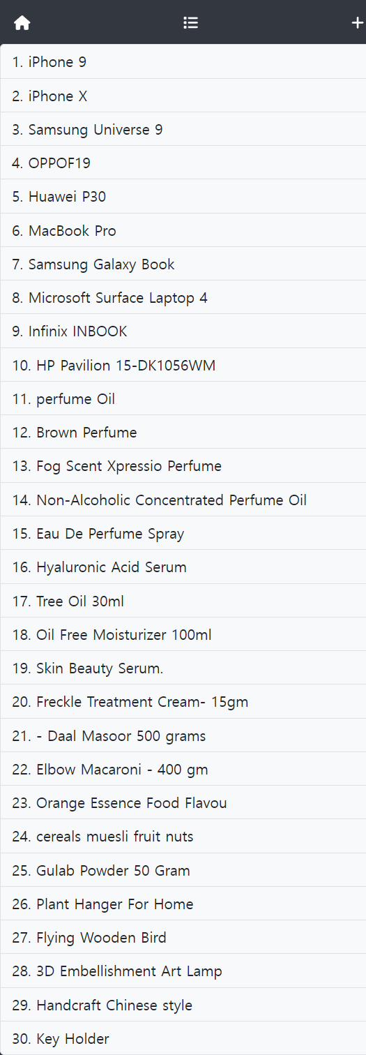

# 4.3.5

[Place for your answer]

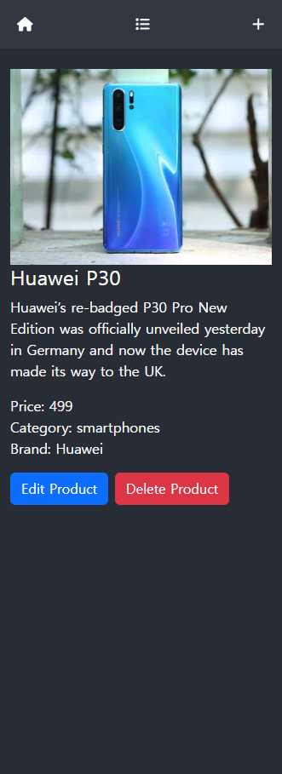

# 4.3.6

[Place for your answer]

