1. <https://www.npmjs.com/package/body-parser>
2. <https://github.com/expressjs/session>
3. <https://www.npmjs.com/package/connect-flash>
4. <https://www.npmjs.com/package/express-validator>
5. <https://www.npmjs.com/package/bcryptjs>
6. <https://mongoosejs.com/>
7. <http://www.passportjs.org/>
8. <https://github.com/expressjs/multer>
9. <https://www.dropzonejs.com/>

Các đoạn script thông dụng:

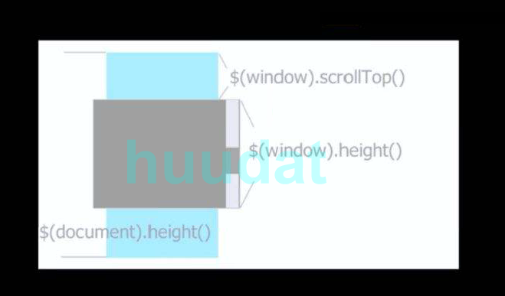

$(window).scroll(function(event) { // Khi kéo thanh scroll thực hiện hành động

if ($(window).scrollTop() + $(window).height() >= $(document).height()) {

setTimeout(function () {

…

},1500)

}

});

* Lấy địa chỉ URL: localhost/…..

window.localtion.pathname

* Convert Number to Money VNĐ

format_currency = function (money) {

money = money.toString().replace(/(\d)(?=(\d{3})+(?!\d))/g,"$1.");

return money;

}