Schedule

Laravel Schedule cho phép xác định lịch trình command trong chính nó.

1. Defining Schedules trong Kernel.php

- Có thể định nghĩa tất cả các công việc cần làm trong phương thức schedule ở App\Console\Kernel

<?php
namespace App\Console;
use Illuminate\Support\Facades\DB;
use Illuminate\Console\Scheduling\Schedule;
use Illuminate\Foundation\Console\Kernel as ConsoleKernel;
class Kernel extends ConsoleKernel
{
protected $commands = [
//
];
protected function schedule(Schedule $schedule)
{
$schedule->call(function () {
DB::table('posts')->insert([
‘title’ => ‘Schedules’,
‘content’ => ‘content posts’,
‘author’ => ‘laravel’
]);
});
}
}
2. Định nghĩa Schedules bằng Artisan Command (sử dụng với các task phức tạp, ví dụ: để lấy tin tức từ các nguồn khác nhau)
php artisan make:command PostCommand
→ app/Console/Commands/PostCommand.php

protected $signature=’post:create’;
public function handle() {
DB::table('posts')->insert([
‘title’ => ‘Schedules’,
‘content’ => ‘content posts’,
‘author’ => ‘laravel’
]);
}

Đăng ký tại file app/Console/Kernel.php
protected $commands = [
‘App\Console\Commands\PostCommand’
];
protected function schedule(Schedule $schedule){
$schedule->command(‘post:create’);
}

3. Run Schedule
a, sử dụng Command
crontab -e
Thêm câu lệnh sau vào dòng cuối
* * * * * php /opt/lampp/htdocs/laravel_5.8/artisan schedule:run
m H d m day_of_week
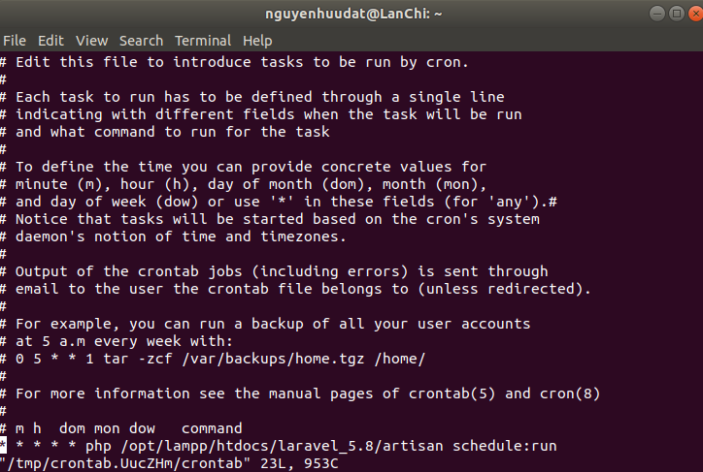
Sau đó :x để Save lại → crontab: installing new crontab // success
* Cứ mỗi phút thêm 1 records vào trong bảng posts trong CSDL
b, sử dụng các options của Laravel

Method | Description
->cron('* * * * *'); | Run the task on a custom Cron schedule
->everyMinute(); | Run the task every minute
->everyFiveMinutes(); | Run the task every five minutes
->everyTenMinutes(); | Run the task every ten minutes
->everyFifteenMinutes(); | Run the task every fifteen minutes
->everyThirtyMinutes(); | Run the task every thirty minutes
->hourly(); | Run the task every hour
->hourlyAt(17); | Run the task every hour at 17 mins past the hour
->daily(); | Run the task every day at midnight
->dailyAt('13:00'); | Run the task every day at 13:00
->twiceDaily(1, 13); | Run the task daily at 1:00 & 13:00
->weekly(); | Run the task every week
->weeklyOn(1, '8:00'); | Run the task every week on Monday at 8:00
->monthly(); | Run the task every month
->monthlyOn(4, '15:00'); | Run the task every month on the 4th at 15:00
->quarterly(); | Run the task every quarter
->yearly(); | Run the task every year
->timezone('America/New_York'); | Set the timezone

// Run once per week on Monday at 1 PM...
$schedule->call(function () {
//
})->weekly()->mondays()->at('13:00');
// Run hourly from 8 AM to 5 PM on weekdays...
$schedule->command('foo')
->weekdays()
->hourly()
->timezone('America/Chicago')
->between('8:00', '17:00');

Method | Description
->weekdays(); | Limit the task to weekdays
->weekends(); | Limit the task to weekends
->sundays(); | Limit the task to Sunday
->mondays(); | Limit the task to Monday
->tuesdays(); | Limit the task to Tuesday
->wednesdays(); | Limit the task to Wednesday
->thursdays(); | Limit the task to Thursday
->fridays(); | Limit the task to Friday
->saturdays(); | Limit the task to Saturday
->between($start, $end); | Limit the task to run between start and end times
->when(Closure); | Limit the task based on a truth test
->environments($env); | Limit the task to specific environment

