Thay vì định nghĩa tất cả các xử lý request ở file routes/web.php -> app/Http/Controllers

Controller cơ bản:

<?php
namespace App\Http\Controllers;
use App\User;
use App\Http\Controllers\Controller;
class UserController extends Controller
{
/**
* Show the profile for the given user.
*
* @param int $id
* @return View
*/
public function show($id)
{
return view('user.profile', ['user' => User::findOrFail($id)]);
}
}

// routes/web.php
Route::get(‘user/{id}’, ‘UserController@show’);
Nếu gom các controller của bạn vào thư mục Admin trong App\Http\Controllers => Route::get(‘URL’, ‘Admin\UserController@method1;’)

Controller Middleware:
Middleware có thể sử dụng trong route của controller
Route::get(‘user/show’, ‘UserController@show’)->middleware(‘auth’);
Tuy nhiên, sẽ tiện hơn khi chỉ định middleware trong controller constructor

class UserController extends Controller
{
/**
* Instantiate a new controller instance.
*
* @return void
*/
public function __construct()
{
$this->middleware('auth');

$this->middleware('log')->only('index');

$this->middleware('subscribed')->except('store');

$this->middleware(function ($request, $next) {
// ...
return $next($request);
});

}
}

RESTful Resource Controllers
Terminal: php artisan make:controller PhotoController --resource
- app/Http/Controllers/PhotoController.php
routes/web.php: Route::resource(‘photo’, ‘PhotoController’)

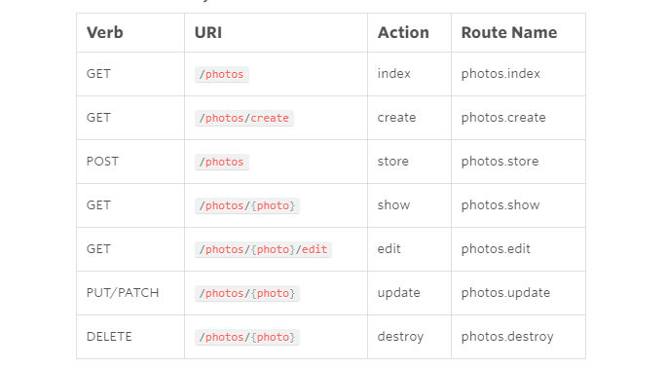

Dependency Injection & Controller
Sử dụng Type-Hint

<?php

namespace App\Http\Controllers;

use App\Repositories\UserRepository;

class UserController extends Controller
{
/**
* The user repository instance.
*/
protected $users;

/**
* Create a new controller instance.
*
* @param UserRepository $users
* @return void
*/
public function __construct(UserRepository $users)
{
$this->users = $users;
}
}

Route Caching
Closure routes không thể cached. Chỉ sử dụng routes Controller
Terminal: php artisan route:cache
Php artisan route:clear

