Rigid-motion correction in head cone-beam CT with a 3D flow-matching prior on the geometry bridge
Sungho Yunª, and Seungryong Choª
ªDepartment of Nuclear and Quantum Engineering, Korea Advanced Institute of Science and Technology (KAIST), Daejeon, 34141, South Korea

1. INTRODUCTION
Cone-beam CT is widely used for head and neck imaging in image-guided radiotherapy, interventional suites and point-of-care settings. A scan takes tens of seconds, and head motion within that window violates the static-object assumption behind analytic reconstruction, producing streaks and blur that compromise diagnostic value. Because the skull is rigid, this motion is well described by a 6-DoF pose per view, a parameterization that is compact but difficult to recover from the projections alone. The scan model is $y=A_{P(θ)}x$, where $x$ is the unknown volume and $θ$ the unknown per-view motion. Recovering both is a blind inverse problem. The measurement is bilinear in the operator–image pair, so the two unknowns are entangled: estimating the geometry requires a clean image, while reconstructing one requires the correct geometry. The joint objective is therefore non-convex, and it carries an exact SE(3) gauge: a global rigid transform applied to both object and orbit leaves the sinogram unchanged. Classical remedies add hardware or optimize an image-quality surrogate such as an autofocus sharpness criterion,¹ and learning-based work replaces that surrogate with a trained quality metric driving a gradient-based search.² Both perform well at small amplitudes but degrade as the amplitude grows, and neither models the distribution of clean CT images, so generalization is limited. A second line of work uses a generative model of clean CT as a plug-and-play prior inside an iterative solver.^{3,4} Its generative path, however, is fixed by construction to run from Gaussian noise to a clean image, so it never traverses the region of image space that a correction loop actually visits.
We take a different route. Flow matching is not restricted to a path that begins at Gaussian noise: its endpoints and the interpolation between them can be prescribed, so the path can be defined along the image space that a correction loop actually traverses. We use this freedom to train a flow-matching prior^{5,6} on a geometry bridge running from the uncorrected reconstruction at $t=0$, where inference starts, to the motion-free reconstruction at$t=1$. Its intermediate states are the images a correction loop passes through, so the prior remains well-defined at every iterate and supplies the improvement direction a joint update of image and motion requires. This work contributes (i) a 3D flow-matching prior defined on this bridge, (ii) a blind predictor–corrector loop in which the prior, the motion estimator and the data step bootstrap one another, and (iii) an evaluation on 30 held-out patients under a fully specified scan geometry.

2. METHOD

2.1 Forward model
Let $x$ denote the attenuation volume and $y$ the log-transformed projections acquired over $V$ views along the nominal circular orbit $P_{nom}$. Patient motion displaces view $i$ by a rigid pose $θ_{i}∈R^{6}$ (axis–angle rotation and translation), so the true acquisition geometry is $P\left(θ\right)\left[i\right]=P_{nom}\left[i\right] T\left(θ_{i}\right)$, where $T\left(⋅\right)$ maps a pose to its rigid transform and $θ∈R^{V×6}$ collects the per-view poses into one motion trajectory. The scan is then $y=A_{P(θ)}x$, with $A_{P}$ the cone-beam forward projector at geometry $P$. We seek the volume and the motion jointly, as the solution of
$$\underset{x, θ}{\text{min}} 1/2∥A_{P(θ)}x-y∥_{2}^{2} + λ TV(x) + R(x).$$
The first term enforces consistency with the measured projections at the current geometry estimate; $TV\left(x\right)$, weighted by $λ$, suppresses the streaks that survive an imperfect geometry; and $R$ is the learned flow-matching prior of Sec. 2.2, which enters the iteration through its velocity field.

2.2 A flow-matching prior on the geometry bridge
Flow matching learns a velocity field $v_{ϕ}(x,t)$ that transports one distribution into another along a prescribed path, by regressing $v_{ϕ}(x_{t},t)$ onto that path’s own tangent $dx_{t}/dt$. We set that path to the geometry bridge of Fig. 1(a): at flow time $t$ the motion is scaled down to $(1-t)θ$, the scan is simulated at that reduced motion, $y_{t}=A(x;P_{nom}T((1-t)θ))$,
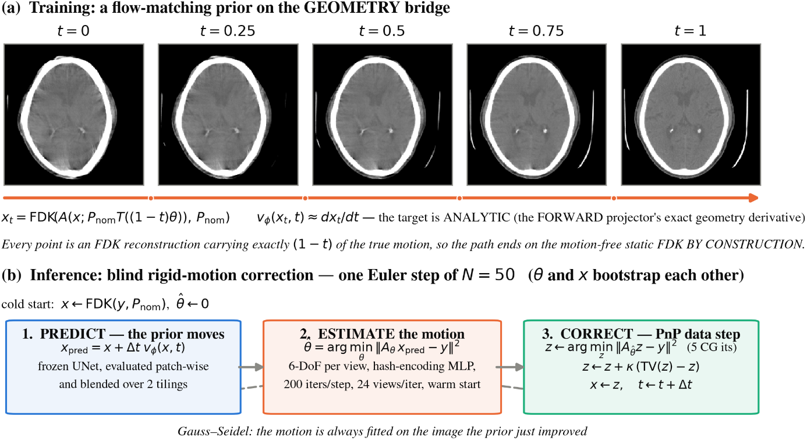
Figure 1. (a) The geometry bridge: each panel is an FDK reconstruction with $(1-t)$ of the ground-truth motion. (b) One step of the blind inference loop.
and reconstructed at the nominal geometry, $x_{t}=FDK(y_{t},P_{nom})$. Every point on the path is therefore an FDK reconstruction of the same patient scanned with progressively less motion, the amplitude decreasing linearly to zero.
At $t=0$ the scan is the measured one, so $x_{0}=FDK(y,P_{nom})$ is the uncorrected reconstruction from which inference starts. At $t=1$ the scan is motion-free, so $x_{1}$ is the static FDK, the best reconstruction the FDK operator can give in the absence of motion. The training target is also available in closed form. Because FDK is linear in the sinogram and $P_{nom}$ does not depend on $t$, the time derivative passes straight through the reconstruction operator:
$$\frac{dx_{t}}{dt} = FDK​\left(\frac{∂y_{t}}{∂t}, P_{nom}\right), \frac{∂y_{t}}{∂t} = - \frac{∂A}{∂P}[x;P_{nom}T((1-t)θ)]​⋅​P_{nom} \dot{T} θ,$$
where $∂A/∂P$ is the forward projector’s exact geometry derivative and $\dot{T}$ the axis–angle generator. The target is therefore computed directly rather than by differentiating through the reconstruction, at a cost of one forward projection and one backprojection per training sample. Training regresses the network onto it, $∥v_{ϕ}(x_{t},t)-dx_{t}/dt∥^{2}$, with $t∼U[0,1]$.

2.3 The blind posterior loop
Inference (Fig. 1(b)) is initialized with $x=FDK(y,P_{nom})$ and $\hat{θ}=0$, and takes $N=50$ steps along the bridge. Each step is a Gauss–Seidel sweep in which image and motion take turns improving each other. The frozen prior moves first, advancing the image by one step of the learned velocity, $x_{pred}=x+Δt v_{ϕ}(x,t)$, toward the low-motion end of the bridge.
That improved image is what makes the motion estimable. The trajectory is fitted by matching the reprojection of $x_{pred}$ to the measured scan, $\hat{θ}=\text{arg}{\text{min}}_{θ}∥A_{P_{nom}T(θ)}x_{pred}-y∥_{2}^{2}$, backpropagating through the projector’s geometry. Rather than optimizing the per-view poses independently, we predict them with an MLP that reads the view index through a multiresolution hash encoding,⁸ optimizing its weights with Adam. Fitting on $x_{pred}$ rather than on the current iterate is what lets the estimate improve from step to step, since the fit is only as accurate as the image it is made against.
The improved geometry then feeds back into the image. A plug-and-play forward–backward step enforces consistency at $\hat{θ}$ with five conjugate-gradient iterations on ${\text{min}}_{z}∥A_{\hat{θ}}z-y∥^{2}$, followed by a relaxed total-variation move $z←z+κ(TV(z)-z)$. Its output becomes the image the prior advances at the next flow time, so the two converge together as $t$ runs to 1. The loop returns both FDK($\hat{θ}$) and the final iterate $x_{t}$; we report both.

2.4 Implementation
The velocity field is a 3D U-Net acting on ${32}^{3}$ patches. At inference the prior is applied patch-wise and blended over two tilings. The prior was trained for 500k iterations (AdamW, cosine ${10}^{-4}​→​{10}^{-6}$, EMA 0.999, fp16, 64 patches per batch). All projection and backprojection use the modular-beam projector of LEAP,⁹ a differentiable CT library, so a single operator serves simulation, the estimator gradient and the data step. The estimator runs 200 iterations per flow step on 24 randomly drawn views, warm-started from the previous step, at half volume resolution until $t=0.5$.

3. EXPERIMENTS
We use the CQ500 head CT collection,¹⁰ 343 patients split 150 / 50 / 143 into train / validation / test, reconstructed at ${256}^{3}$ and 1 mm. Projections are simulated on a native ${612}^{3}$ grid at 0.42 mm, through a standard head-CBCT geometry: SOD 785 mm, SDD 1200 mm, a 700 × 500 panel at 0.64 mm pitch, and 360 views over a full turn. Training draws per-DoF amplitudes up to 15 mm / 20°, while evaluation uses a fixed 10 mm / 10° pattern, one per patient. We score 30 patients from the held-out split, matching the 30-patient protocol of Ref. 2. Because of the SE(3) gauge, volumes are rigidly aligned to the ground truth before PSNR and SSIM are computed. Motion accuracy is the reprojection error (RPE), the mean detector displacement induced by the pose error, quoted under a zero-mean gauge that uses no ground truth.

4. RESULTS
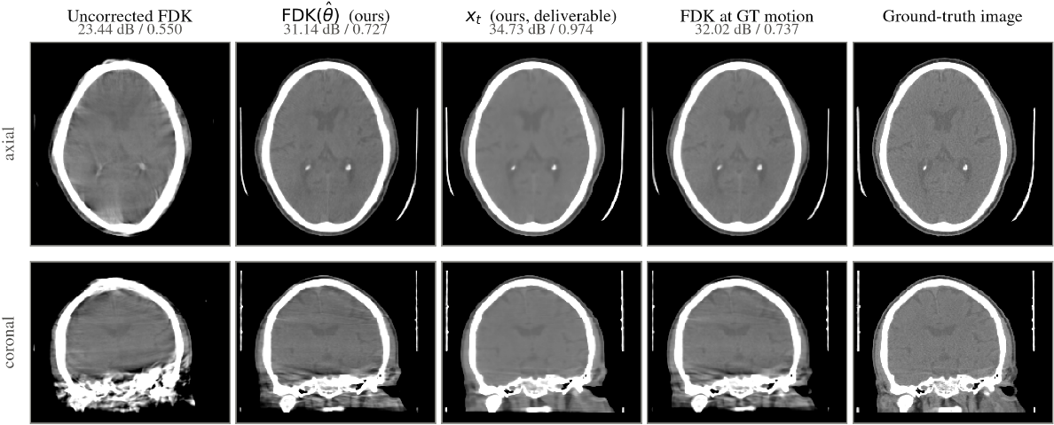
Figure 2. A representative test patient at 10 mm / 10° motion, brain window (level 40 / width 420 HU). FDK($\hat{θ}$) is visually indistinguishable from the ground-truth-geometry FDK; both retain artifacts that only $x_{t}$ removes.
Table 1. Blind rigid-motion correction on 30 held-out CQ500 patients, Akima motion¹¹ at 10 mm / 10°. PSNR and SSIM are computed against the ground-truth volume (mean ± sample s.d.). RPE is quoted under the zero-mean gauge.
Method | PSNR (dB) | SSIM | RPE (mm)
Uncorrected FDK | 23.29 ± 0.93 | 0.546 ± 0.035 | 6.12 ± 0.66
Ours: FDK($\hat{θ}$) | 31.76 ± 0.80 | 0.753 ± 0.032 | 0.28 ± 0.10
Ours: $x_{t}$ (final iterate) | 36.60 ± 1.68 | 0.978 ± 0.008 | 0.28 ± 0.10
FDK at the ground-truth motion | 32.38 ± 1.08 | 0.757 ± 0.033 | 0

Two comparisons locate the remaining error. First, FDK($\hat{θ}$) reaches 0.753 SSIM against 0.757 for FDK at the ground-truth motion, so almost nothing is left to gain from a better geometry estimate. Second, $x_{t}$ exceeds FDK($\hat{θ}$) by 4.8 dB and the motion-free FDK reference by 3.5 dB and 0.146 SSIM. The limiting factor is therefore the analytic reconstruction operator rather than residual motion, and $x_{t}$ is not subject to that limit. Residual pose error is 0.27° rotation RMSE, down from 3.63°, and 0.083 mm in the observable translation, down from 1.68 mm. Inference costs about 9.3 min per patient on one RTX A6000.
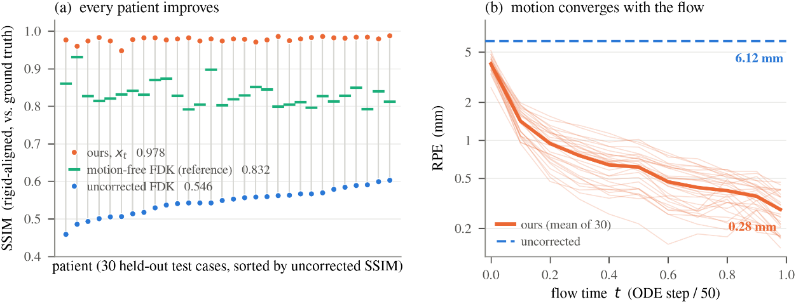
Figure 3. Cohort results over 30 held-out patients. (a) Per-patient SSIM; grey stems join each patient’s uncorrected and corrected score. (b) Reprojection error against flow time (thin: individual patients).

5. DISCUSSION AND CONCLUSION
The freedom to choose the path is what flow matching contributes here. The intermediate states of the proposed bridge are the images a correction loop actually passes through, so the prior remains well-defined at every iterate and supplies the improvement direction that a joint update of image and motion requires. A conventional generative prior does not have this property: its generative path is fixed by construction to run from Gaussian noise to a clean image, so it never traverses the region of image space that a correction loop actually visits. The results demonstrate the robustness of the proposed method. Across 30 patients, SSIM and PSNR increase consistently, and the reprojection error falls from 6.12 mm to 0.28 mm at an amplitude where surrogate-based methods typically degrade. Also, the key strength of the proposed method is reliability: because the loop returns FDK($\hat{θ}$) alongside the learned iterate, the recovered geometry can be verified independently. An analytic reconstruction at that geometry, containing no learned component, is within 0.004 SSIM of FDK at the ground-truth motion. Whatever the prior contributes therefore rests on a trajectory that an analytic reconstruction confirms. However, two limitations apply in our study. The motion is simulated, so validation on clinical data is the essential next step, and the model is rigid-only, which suits the skull but not the mandible or the neck.

REFERENCES
- Sisniega, A., et al., “Motion compensation in extremity cone-beam CT using a penalized image sharpness criterion,” Phys. Med. Biol. 62(9), 3712–3734 (2017).
- Thies, M., et al., “A gradient-based approach to fast and accurate head motion compensation in cone-beam CT,” IEEE Trans. Med. Imaging (2025).
- Venkatakrishnan, S. V., Bouman, C. A., and Wohlberg, B., “Plug-and-play priors for model based reconstruction,” in IEEE GlobalSIP, 945–948 (2013).
- Chung, H., Lee, S., and Ye, J. C., “Decomposed diffusion sampler for accelerating large-scale inverse problems,” in ICLR (2024).
- Lipman, Y., et al., “Flow matching for generative modeling,” in ICLR (2023).
- Delbracio, M. and Milanfar, P., “Inversion by direct iteration,” Trans. Mach. Learn. Res. (2023).
- Yang, T., Hu, J., Fessler, J. A., and Shen, L., “Local patches meet global context: scalable 3D diffusion priors for computed tomography reconstruction,” arXiv:2512.18161 (2025).
- Müller, T., et al., “Instant neural graphics primitives with a multiresolution hash encoding,” ACM Trans. Graph. 41(4), 102 (2022).
- Kim, H. and Champley, K., “Differentiable forward projector for X-ray computed tomography,” arXiv:2307.05801 (2023); LEAP, https://github.com/LLNL/LEAP.
- Chilamkurthy, S., et al., “Deep learning algorithms for detection of critical findings in head CT scans,” The Lancet 392(10162), 2388–2396 (2018).
- Akima, H., “A new method of interpolation and smooth curve fitting based on local procedures,” J. ACM 17(4), 589–602 (1970).

